TOPIC 7 TROUBLESHOOTING

PURPOSE

The purpose of this topic is to cover some of the common problems users may face when designing the reports. The main goal of this topic is to provide the user with the needed resources and contacts to assist them in this process.

OBJECTIVES

At the end of this topic, you will know how to:

- Request Views to be built in order to support your report

- Resolve common linking problems

- Use the online help options

- Use the Seagate Website and other recommended literature

Requesting Views
Many of the reports you will be requested to design will be satisfied by the available views in the MRDB. However, there may be times when everything you need in your report will not be satisfied by a single view or even by linking two views together. When this happens, you have a couple of options available for you to use.

- Check to see if any formulas can be written to provide you with the needed information.

- Request that a view be designed in order to support your reporting needs.

Option 1 requires you to obtain the view(s) that give you the greatest number of needed fields. Then you need to decide if any of these fields can be manipulated in such a way as to provide you with that additional data needed to complete your report.

Option 2 requires that you contact the Customer Resource Center. The CRC will take the request and work with experts to identify if a view exists which will meet the need or if it is necessary to create a new view. The CRC email address is:
Finance.CRCGroup@mail.state.ky.us. You will need to provide any necessary information to aid them with your request.

The following list provides an example:

- All MARS fields that are needed in the report

- Which tables information is needed from

- If your report is to be at the detail or summary level

- How the data is to be grouped

- Do you need FM or FY parameters entered in the report

- Any formulas that you will need to manipulate the MARS fields

- If your data needs to be Year-To-Date or daily

- Most importantly, the main purpose of your report and its audience

After you provide this information, they will determine if your request is feasible and whether or not they have the available resources to complete your request. If it is developed, you will then be able to pull this new view into your report and continue the design process.

Linking Problems
There will be times when you experience some difficulty linking multiple views together for reporting needs. Below are some valuable tips when trying to accomplish this.

- Remember to use your primary view (VW_FCT1 or VW_FCT2) as the from table. This means that you will link a KEY field from this view to your reference view (VW_ADV).

- Use the reference view (VW_ADV) as the secondary view. This means that you will link from the primary view to the associated KEY field on this secondary view.

- Remember to use the SQL linking option for Left Outer Join type.

- You can not link two VW_FCT1 views together. You can not link two VW_FCT2 views together. You can not link a VW_FCT1 to a VW_FCT2.

ONLINE HELP OPTIONS
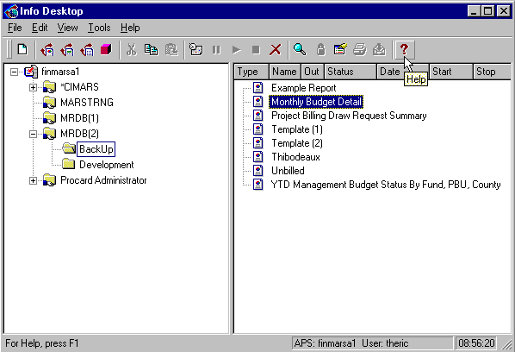

info desktop online help
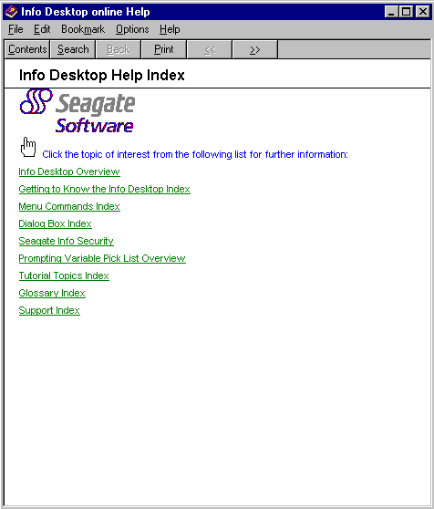

Online Help Options
Aside from this manual, you will want to take advantage of Seagate’s online help features. The Info Desktop’s help features the entire user manual that comes with this software. To access this online help menu:

From the Info Desktop, click on the Help button in the Toolbar. This will access the Info Desktop Online help menu. It contains a list of topics which you can enter by clicking on the appropriate link. You could also go into a more extended list by clicking on the Contents button located at the top of the screen. Or, you even have the option to search for a specific topic by clicking on the Search button and typing the keywords that you are looking for. This feature will help solve some of the more common problems you will run into while using the Info Desktop.

INFO REPORT DESIGNER HELP
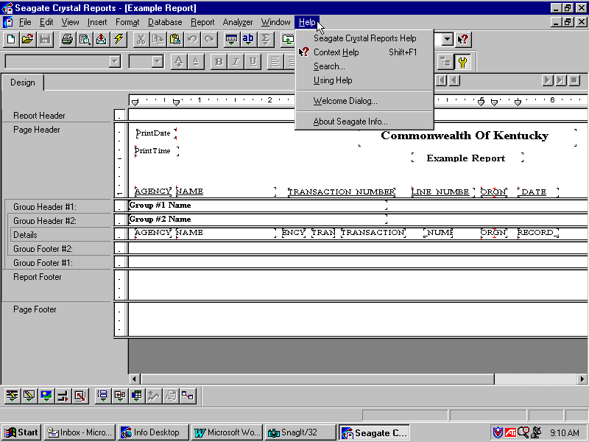

info report designer online help
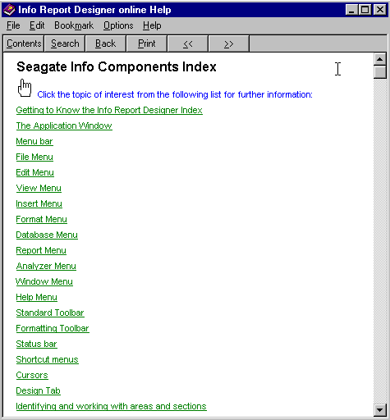

Info Report Designer Help
In addition to getting help with common Info Desktop problems, the Info Report Designer also offers a comprehensive help tool. To access this help feature:

Step 1 You must be using the Info Report Designer to access this tool.

Step 2 On the Menu Bar, click on Help, and then select the appropriate choice.

The first choice in this list is called Seagate Crystal Reports Help. The bottom screenshot on the previous page shows the main screen of this tool. Just like the help tool for the Info Desktop, this one gives you a list of topics to search through. You also have the option of using the Contents or Search button in order to speed up the process of locating your topic of choice. This tool offers hundreds of “How to” tutorials. It will also give you numerous tips and even a list of sample formulas for you to look at.
Finally, you can also use the Context Help by clicking on the Help button on the Toolbar. Your mouse will take on the shape of the Help button which allows you to click on a given field, text object or section of your report for some useful information.

Additional Resources
You may also visit Seagate’s web site: http://www.seagatesoftware.com/ This web site is where you may register as a user and access user forums for additional help. You may even post a question for discussion in this forum.

Another valuable resource is the book entitled “Seagate Crystal Reports 7 For Dummies” by Douglas J. Wolf. This book provides a fun and easy way to create reports and understand the programming language that the tool uses.

Finally, the Customer Resource Center (564-9641) is available to log any question you may have about the software and reporting issues you may come across. These calls will be logged and given to the appropriate expert to help you resolve the issue.

DATA DICTIONARY
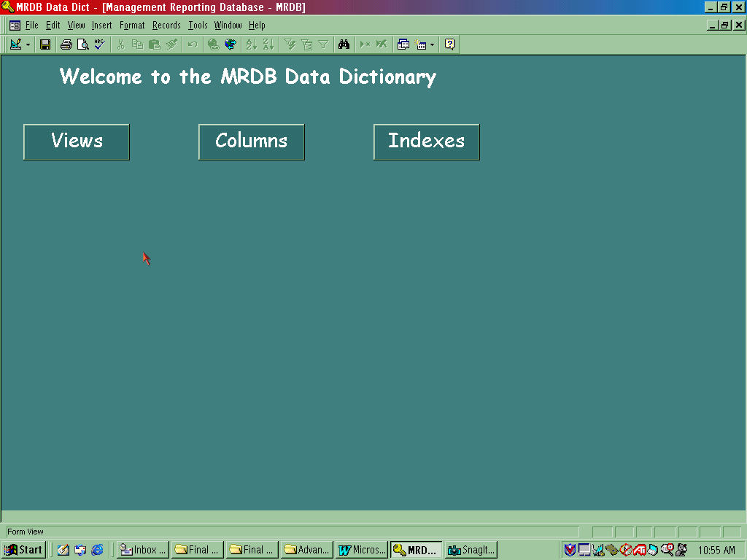

A valuable reference tool has been developed called the Data Dictionary. The Data Dictionary is a composite of definitions for the views data columns stored within the Management Reporting Database. The dictionary tool is intended to assist you in designing reports and queries through providing descriptive information about the data elements within the MRDB. In addition, the Data Dictionary can assist the user in locating where within MRDB you can find the data needed.

The instructor will now take you through a demonstration of this Data Dictionary to give you an idea what kind of information can be found using this tool. You should quickly realize how valuable this tool would be when designing reports or making an inquiry into the contents of the MRDB.

The screen shot shows the main screen of the Data Dictionary with its three main areas of interest.

Before we take a closer look at the Data Dictionary let’s discuss the steps to take to add a shortcut on your desktop.

CREATE SHORTCUT
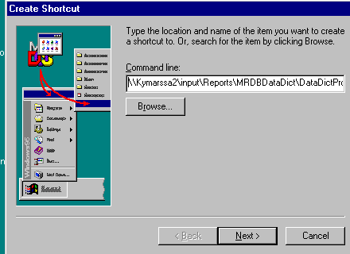

Create a Data Dictionary Shortcut
Step 1 Go to your desktop and right click your mouse.

Step 2 Select the<New> button.

Step 3 Select Shortcut. The Create Shortcut Box will appear.

Step 4 In the command line, key in the following directory path: \\Kymarssa2\MRDBDataDict\DataDictProd.mde

Step 5 Click the <Next> button.

Step 6 Select a name for the shortcut by typing in Data Dictionary.

Step 7 Click the <Finish> button. This will create a shortcut icon on your desktop for the Data Dictionary.

Step 8 To open the dictionary, double click on the icon.

The following pages show you some of the information that can be found using the Data Dictionary.

Data Dictionary

When you open the Data Dictionary, the database will offer you three different ways to access information.

Let’s look at the functionality of each option. The fist option is the <View> button.

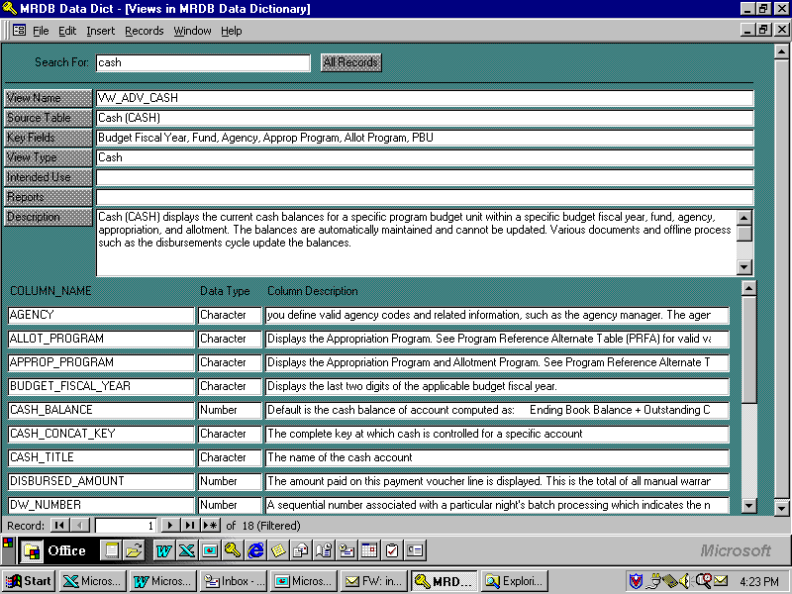
DATA DICTIONARY VIEW

This option provides a list of available views in MRDB. The VIEWS option should be used when the user is attempting to find the data you need for your new report or query. The user can search through a list of views within MRDB by selecting one of several different Search Buttons on the VIEWS screen.

Step 9 Click on the <VIEWS> button from the MRDB Data Dictionary Welcome Screen.

Step 10 In the SEARCH FOR field. Type Cash.

Step 11 Click on the <SEARCH> buttons next to the field needed for the search.

The first matching view is displayed on the screen along with other information pertaining to that view. When multiple views exist, the RECORD field will reflect the number of views found.
If more information is needed about a specific column with a view, click on the COLUMN NAME and additional information will appear.

Now let’s investigate the Columns option on the Data Dictionary Welcome Screen.

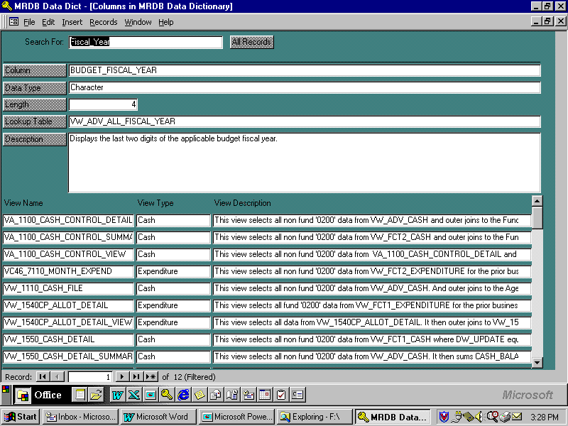

DATA DICTIONARY COLUMN

This option allows you to search against all the available columns within the MRDB. It provides information such as the definition of the column, and lists any views where the column is used. A user can search through a list of columns within MRDB by selecting one of several different Search Buttons on the COLUMNS screen.

Step 12 Click on the <COLUMNS> button from the MRDB Data Dictionary Welcome Screen.

Step 13 In the SEARCH FOR field. Type FISCAL_YEAR.

Step 14 Click on the <SEARCH> buttons next to the field needed for the search.

The first matching column is displayed on the screen along with other information pertaining to that column. When multiple columns exist, the RECORD field will reflect the number of columns found.

If more information is needed about a specific view, click on the VIEW NAME and additional information will appear.

Now let’s investigate the Indexes option on the Data Dictionary Welcome Screen.

DATA DICTINARY INDEXES
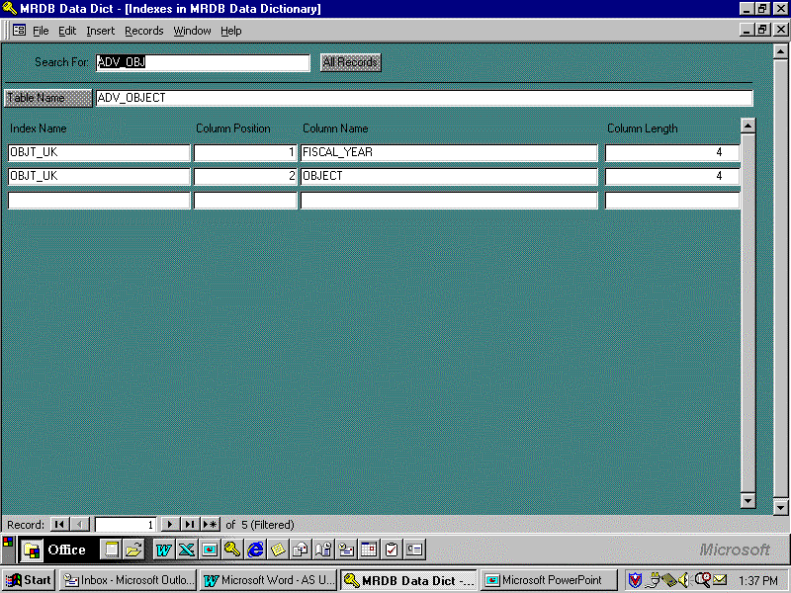

This option provides a list of indexes within the MRDB. This option is used when the user has decided which view(s) are needed for a new report or query. The screen will tell the user what indexes have been created for a specific table. By utilizing an index (selecting by or grouping by the columns in an index), the user can greatly improve the run time of a report or query. A list of indexes can be searched within the MRDB by selecting the Table Name button on the INDEXES screen.

Step 15 Click on the <INDEXES> button from the MRDB Data Dictionary Welcome Screen.

Step 16 In the SEARCH FOR field. Type ADV_OBJ.

Step 17 Click on the <TABLE NAME> button next to the field needed for the search.

The first matching table containing the index is displayed along with other information pertaining to that table. When multiple tables exist, the RECORD field will reflect the number of columns found.

In this topic we have learned how to:

- Request Views to be built in order to support your report

- Resolve common linking problems

- Use the online help options

- Use the Seagate Website and other recommended literature



Are there any questions concerning the information covered in this topic?

