TOPIC 6 ADVANCED REPORTING TECHNIQUES

PURPOSE

The purpose of this topic is to cover some of the more advanced features of this software. We will cover various tools within the Info Report Designer like the Selection Expert and Formula Editor tools. We will show how to insert Fiscal Year/Fiscal Month parameters into your report in order to group data for a given fiscal month. We will also cover some more report formatting techniques which will make the report easier to read.

OBJECTIVES

At the end of this topic, you will be able to:

- Use the Select Expert tool to limit the data in your report

- Develop and insert formulas into your report

- Suppress data that isn’t needed

- Insert parameters into your report to customize the scheduling periods

Advanced Reporting Techniques
In the previous topic, we covered a lot of the basics involved with designing a report. You will be using all of those basics each time you set out to create a report. There are, however, many more features of this software that you must be able to use to design some of the more complicated reports. This topic’s goal is to go through the most common tools for achieving these advanced reporting techniques.

We will be using three of our reports in the MRDB(2) folder. The first report that we will use is the Example Report that we used in a previous example.

Step 1 On the Info Desktop window. Highlight the MRDB(2) folder.

Step 2 Right-click on the Example Report object.

Step 3 Select Design from the available choices.

Again, you should get that warning message, like before, indicating that you need to save this report under a different name if you want to make changes. Like before, this is due to the report being owned by another user and the fact that multiple users are opening the same report at the same time.

Step 4 Click the <OK> button.

We will be using this report for the next few examples. The first tool we will look at is called the Select Expert tool.

Select Expert Tool
There are times when you want to limit some of the fields in your report from printing certain data. When you select records, you are basing your report only on those records that meet some conditions that you set. You base those conditions on what kind of information you want in your finished report.

Assume, for example, that you want a report that only shows a specific Agency’s data. Your challenge is to find the best way to identify those records that come from that Agency.

- If the View that you are using for your report has an AGENCY field, you can specify in your request that the program uses only those records where the value in the AGENCY field is equal to the Agency you want to report on.

- If the View does not have this field in it, there may be a way to identify that data using other fields. For example, if you know that the Agency in question is the only one to use a certain PROGRAM BUDGET UNIT, then you can limit your search using that field instead.

Let’s use this Agency example in our Example Report.
Step 1 While in the Example Report, click on the icon for Select Expert on the toolbar.

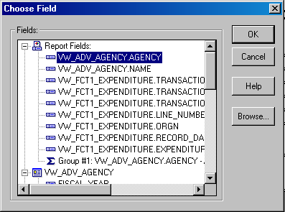Choose Field

Step 2 On the Choose Field dialog box, expand the Report Fields icon. This will list all the fields used in the report. Since we did use the field for AGENCY, it will appear in this list.

Step 3 Select the field for AGENCY (VW_ADV_AGENCY.AGENCY) and click the <OK> button.

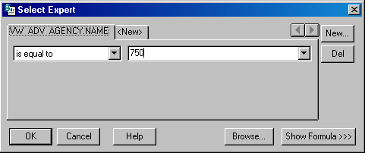Select expert

We will use the drop-down box to enter our selection criteria for the indicated field. The various choices all apply to the different methods of record selection. For our example, we are trying to limit our output for our Agency only, not multiple agencies (security permitting). For this reason, it makes sense to use the is equal to choice from the drop-down box.

Step 4 In the first drop-down box, make sure it displays is equal to. An Oracle SQL screen should appear.

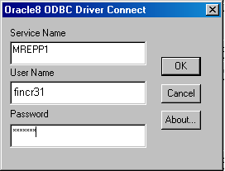Oracle log on dialog box

Step 5 Enter your Oracle User ID and Password and make sure mrepp1 is in the box for server. Click the <OK> button.

Step 6 In the second drop-down box, select the 750 or manually type it in from this third drop-down box.

The second drop-down box will display the Agencies contained in this View that you can report on. Remember, if your Oracle security says that you can only see one Agency’s data, then only that Agency will appear in the drop-down. However, someone scheduling this report might have access to many Agencies. Setting this Select Expert tool for one Agency prevents that individual from getting an instance with all those Agencies in which they have access displayed. Also, if you restrict this report to say, Agency 083, and someone who does not have access to that Agency schedules it, the instance will contain NO data.

Step 7 Click the <OK> button.
.

SCENARIO:
The person requesting this report has informed you that besides limiting the report to your Agency, they also want it limited to a certain date(s).

On your own, repeat the steps in order to add a second condition for this report. First, click on the tool for the Select Expert and click on the New tab. Notice that the condition we previously set is still in there. Second, choose the field for RECORD DATE (VW_FCT1_EXPENDITURE.RECORD_DATE).

For the two drop-down boxes used to set the conditions: choose is one of in the first box and pick any two dates that you would like to report on from the second drop-down box. As you select your dates, they will appear in the window just below the third drop-down box. When finished, click OK. Refer to the screen shots on the previous page for assistance.
We have now successfully set conditions for our report. When this report is run, it will display data ONLY for the Agency and dates that you selected. Let’s refresh the report to see the results.

Step 1 Click on the Refresh button in the Toolbar .

Once your report refreshes, take a close look at the results. You should see only one Agency being reported on. You should also have data for the two dates that you selected and nothing else. Also notice that this report is down to one page of information due to the limited selection criteria. You can see how valuable this tool can be in designing a report. (Recall: If you selected an Agency in the Select Expert tool that you do not have access to, your report will produce NO data).

We will now take a look at a related Tool: the Selection Formula Editor.

Selection Formula Editor
The Select Expert tool and the Selection Formula Editor are interactive. That is, record selection criteria entered via the Select Expert automatically generates a record selection formula that can be reviewed and modified using the Show Formula button in the Select Expert tool. Likewise, record selection formulas and modifications to existing record selection formulas automatically update the selection criteria in the Select Expert tool.

Let’s take a look at this relationship.

Step 1 On the Design tab, click on the icon for the Select Expert tool in the toolbar.

Step 2 Click on the select tab for VW_ADV_AGENCY.AGENCY.

Select expert
Click here to show the formula.

Step 3 Click on the Show Formula button in the lower right-hand corner.

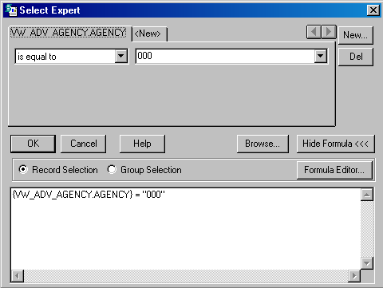SELECTION FORMULA EDITOR

This will display the formula for both the Agency query and the record date query. Let’s make a change and see what happens.

Step 4 Click on the Hide Formula button.

Step 5 In the second drop-down box, replace your Agency number with the number 000. You may have to Log On to Oracle again at this point.

Notice that the formula reflects the change that we just did. You can use either tool to enter your selection criteria since they communicate to each other. We will revisit this at a later time when we discuss developing formulas of your own. You may click on the Hide Formula button and then click the <OK> button. Now click on the Preview tab again. You should be prompted with a message box detecting a change to the selection criteria.

Dialog box
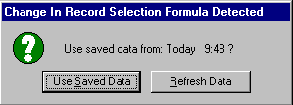

Step 6 Click the <Refresh Data> button. You should now have a report with NO data because you do not have access to Agency 000.

Step 7 Using the Select Expert Tool, return the agency to 750.

Inserting Parameters Into Your Report
Parameter fields are fields that prompt you to specify a value each time you refresh the data (or schedule) your report. When you supply a value, the program runs the report using that value. By using parameter fields in formulas, selection formulas, and in the report itself, you can create one report that you can modify quickly as your needs change.

We are interested in two specific types of parameters for monthly reports, Fiscal Year and Fiscal Month. Since daily reports are run each business day, we don’t need to specify any time period parameters. Monthly reports, however, need parameters in order to tell the program which Fiscal Month/Fiscal Year combination to use for the data. We will be using our newly created repport for this exercise. These steps can be repeated for any monthly report that you develop.

Step 1 Open our newly created report in Design.

Step 2 On the Menu Bar, select Insert: Field Object.

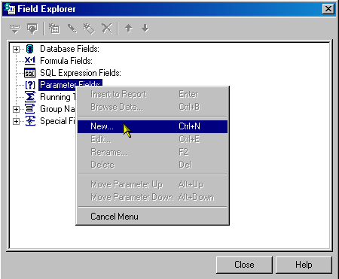Field Explorer

Step 3 Right click on the Parameter Fields and select New.

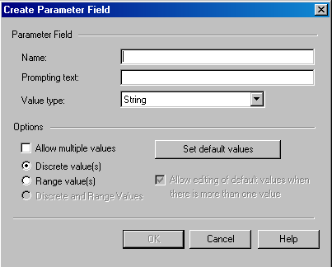Create parameter

Step 4 On the Create Parameter Field dialog box, enter FY in the NAME field.

Step 5 In the PARAMETER FIELD PROMPTING text box, type Enter Fiscal Year.

Step 6 In the VALUE TYPE field, select String.

Step 7 Click the <SET DEFAULT VALUES> button.

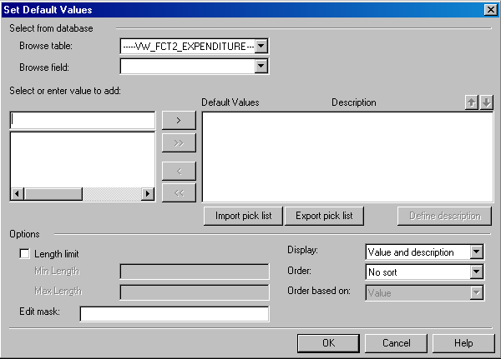Set Default Values

Step 8 In the BROWSE TABLE drop-down box, select VW_FCT2_EXPENDITURE.

NOTE: One of your selected Views must contain the field FISCAL_YEAR in order for this to work

Step 9 In the BROWSE FIELD drop-down box. Select FISCAL_YEAR.

Step 10 On the Oracle SQL log on window. Enter your User ID, Password and click the <OK> button. (If you were already logged on to Oracle, you will not have to sign in again at this point.)

Step 11 Just below the SELECT OR ENTER VALUE TO ADD, manually type the year 1999 and then click on the right direction arrow to place it in the DEFAULT VALUES box.

Step 12 Repeat Step 9 for the years 2000 and 2001.

Step 13 Click the <OK> button on the Set Default Values window and the Create Parameter Field window.

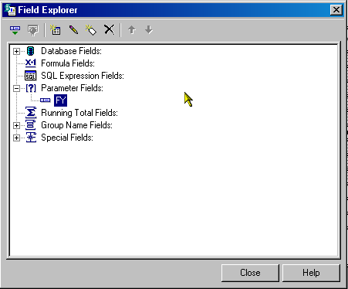Field Explorer

Step 14 On the Field Explorer dialog box, make sure your parameter is highlighted and click the <Insert> icon in the tool bar.

Step 15 Drag your cursor to the upper-right hand corner and click to release the parameter field. Refer to the screen shot on the previous page for assistance.

Now that we have successfully created a parameter for FISCAL YEAR, repeat the steps to create one for FUND.

Step 16 Click the <Close> button when finished.

At this time, you may place text fields in front of your parameter fields for identifying purposes. Go ahead and insert a text field that reads Fiscal Year: and place it to the left of the FY parameter field. Repeat this step for the other parameter, Fund.

The last step in this process is to enter our parameters into the Select Expert tool.

Step 1 On the Design tab, click on the Select Expert button in the Toolbar.

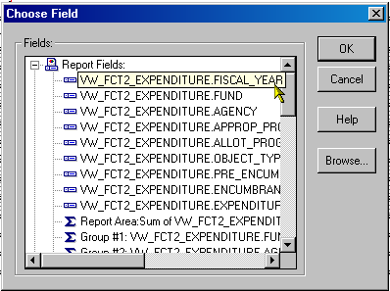choose field

Step 2 Under Report Fields on the Choose Field dialog box, select VW_FCT2_EXPENDITURE.FISCAL_YEAR.

Step 3 Click the <OK> button.

select expert
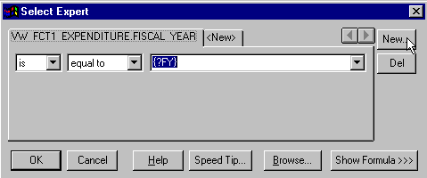

Step 4 In the first drop down box, select is equal to

Step 5 In the second drop down box, select {?FY}.

Step 6 Click on the <New> button and repeat Steps 2 through 5 for the Fiscal Month parameter.

This completes the process. We just created two parameters, FY and FM. We filled out the selection criteria to tell the program that it will be accepting two values by the user. These values will tell the program to pull out the data from the associated Views that correspond to a Fiscal Year/Fiscal Month combination. Let’s test our parameters out by refreshing our report one more time.

REFRESHING OUR REPORT
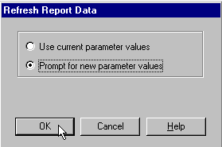

Refreshing Your Report
Step 1 On the Design tab, click on the Refresh button in the Toolbar.

Step 2 On the Refresh Report Data dialog box, select the <Prompt for new parameter values >radio button.

Step 3 Click the <OK> button.

Step 4 Highlight the FY parameter and select the value 2000 from the drop-down box.
Step 5 Highlight the FM parameter and select the value ☺☺ from the drop down box.

Step 6 Click the <OK> button.

Your report should start to run and the program will pull in all the data that corresponds to Fiscal Year and Fiscal Month you selected. These parameters should appear in your report where you inserted them (upper right-hand corner).

This is the complete process for a standard monthly report. After you save your report on the desktop, individuals who schedule that object will be required to specify those parameters before scheduling. This report will now reflect a specific Fiscal Month for a given Fiscal Year.

CONVERTING TO YEAR-TO-DATE
What if the report requestor tells you that they would like their report to be Year-To-Date?

Step 1 Ensure a Fiscal Month field is included on your report

Step 2 Set up a parameter field for Fiscal Month.

Step 3 Set up the Select Expert as follows.

select expert
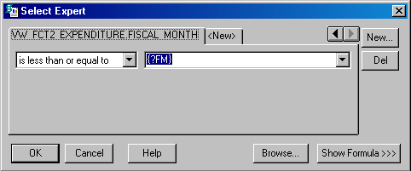

Step 4 On the Design tab, click on the <Select Expert> button.

Step 5 Click on the Select Expert tab for VW_FCT2_EXPENDITURE.FISCAL_MONTH

Step 6 In the first drop-down box, select is less than or equal to

Step 7 In the second drop-down box, make sure {?FM} is selected.

Step 8 Click the <OK> button.

OPEN THE MARS PROJECT REPORT
Let’s open the report we created in Topic 5. It should be saved in your private development folder in the Info Desktop.

Step 1 Highlight your private folder that you saved your MARS Report in.

Step 2 Right-click on the report object and select Design from the available choices.

Hiding Sections
Open the report you designed.

There are a number of properties you can set to keep particular parts of your report from printing. The Info Report Designer has three properties you can set in the Section Expert to hide report sections.

- Hide (Drill Down OK)
The Hide property hides the section whenever you run the report. You can use the Hide property, for example, in a summary report where you want to display only the summaries (groups) but not the details behind the summaries. When you apply the Hide property to a section, the section can become visible if you drill down to see the section contents from within the Group Tree window.

- Suppress (No Drill Down)
The Suppress property also hides a section when you run the report. Unlike the Hide property, however, you cannot apply the Suppress property and then drill down to reveal the section contents.

- Suppress Blank Section
The Suppress Blank Section property hides a section whenever there is nothing in it. If something is in the section, it remains visible.

Hiding Objects
The Info Report Designer has three formatting options in the Format Editor that you can use to hide individual objects.

- Suppress If Duplicated (Common Tab)
This option prevents a field from printing if it is identical to (a duplicate of) the value that comes immediately before it. The value does not print but the space in which it would have printed remains.

- Suppress If Zero (Number Tab)
This option prevents a value from printing if it has a zero value. The value does not print but the space in which it would have printed remains. To remove the blank space, toggle the Suppress Blank Section option on in the Section Expert.

- Suppress (Common Tab)
This option hides an object when you run the report. It is common, for example, to apply this property to formulas that are needed to do some report calculations but that you do not want to print when you run the report.

To set these properties, highlight the object, click the Object Properties button on the supplementary toolbar , and set the property in the Format Editor when it appears.

Page Breaking
We can also set some page breaking properties using the Info Report Designer. Using the Format | Section option will allow us to specify when we would like the page to break. For example, if your report groups all like Funds together and you want to have a page break whenever a new Fund is listed, you would set this property up here.

Let’s take a look at some of these properties using the MARS Project report that we previously designed.

HIDING SECTIONS OF YOUR REPORT
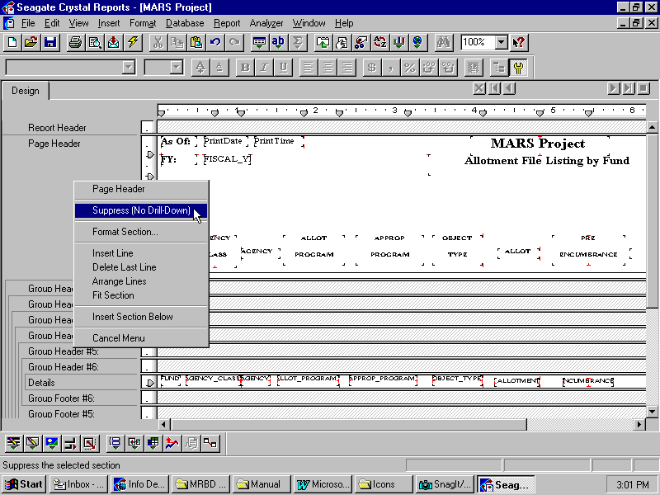

Recall from Topic 5 when we used the Hide property on the Group Header and Group Footer sections that we were not using. Let’s try another example with our Page Header.

Step 1 On the Design tab, right-click on the grey area for the Page Header.

Step 2 Select Suppress (No Drill Down) from the available choices.

Notice how this section of our report is now ‘greyed out’. Go ahead and refresh the report to see the affects of this option. You will have to Log On to Oracle at this time. (To reverse this option, right-click a second time on the Page Header and select Don’t Suppress).

HIDING SECTIONS OF YOUR REPORT
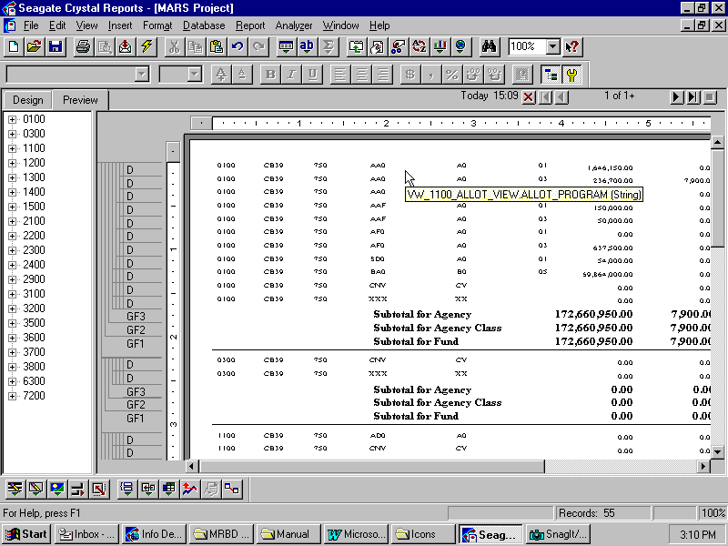

The screen shot above shows the Suppress option at work. Each page now begins with printing the Details of the report with no Header information present. We can repeat these steps for any other section in our report. Another common feature used for these reports is the Suppress If Zero option which falls under the Number tab in the Format Editor. Let’s take a look at how this is accomplished.

HIDING SECTIONS OF YOUR REPORT
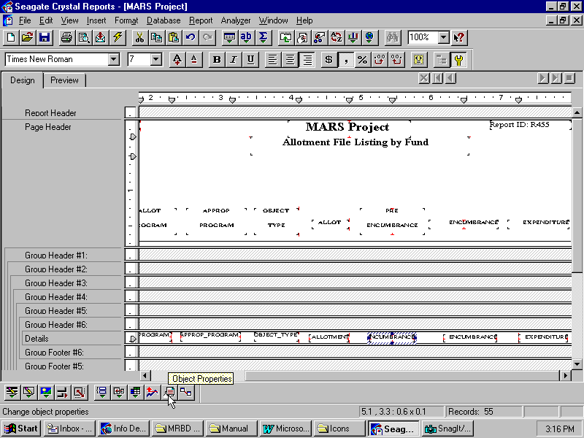

Let’s pretend that the individual requesting this report has asked you to suppress the PRE_ENCUMBRANCE field each time a value of zero appears. Here’s how you accomplish this.

Step 1 On the Design tab, highlight the PRE_ENCUMBRANCE field in the Details section of your report.

Step 2 Right click on the field and select Format Field. The Format Editor window opens.

HIDING SECTIONS OF YOUR REPORT
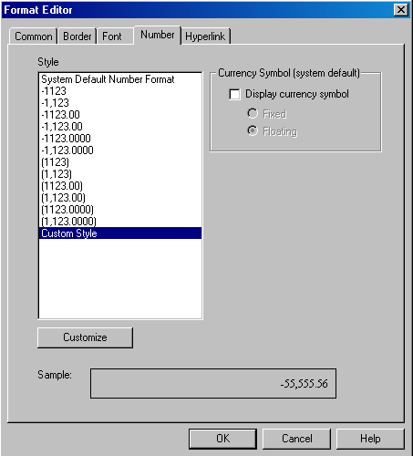

Step 3 On the Format Editor dialog box, select the Number tab.

Step 4 Click on the <CUSTOMIZE> button.

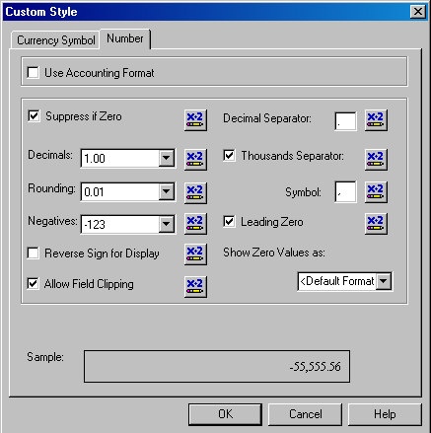HIDING SECTIONS OF YOUR REPORT

Step 5 Place a check mark in the box for Suppress if Zero.

Step 6 Click the <OK> button.

Now, refresh your report to see the changes that take place. Notice all the blank spaces under the PRE-ENCUMBRANCE field where zero’s used to be printed. The following page shows a screen shot reflecting our change.

Page Breaking
Another valuable formatting feature for designing reports is called Page Breaking. The Page Breaking option allows you to insert page breaks after certain sections of your report have printed. For example, let’s assume that the individual requesting the report would like a page break inserted each time the report prints a subtotal. The Info Report Designer allows you to set such conditions using the Format Section tool.

Let’s use our MARS Project report again for this example.

Step 1 Select the Design tab.

Step 2 On the Menu Bar, select Format : Section.

This Section Expert dialog box is where you can set various formatting options to any of the sections within your report. For this example, let’s assume that we would like to insert a page break after each Subtotal for Fund. We can see from our report that this subtotal is in the Group Footer # 1 section.

Select expert
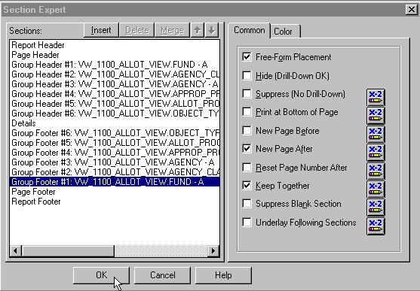

Step 2 In the Sections window. Highlight the Group Footer #1

Step 3 On the Common tab, place a check in the box for NEW PAGE AFTER.

Step 4 Click the <OK> button.

This tells the program to start a new page each time the report prints a subtotal for fund. Go ahead and refresh your report again to see this change. The screen shot on the following page shows the results from inserting the page break. At this time you may close out of the Info Report Designer and when prompted to save changes, click the <No> button.

Formulas 101
In many cases, the data you want to appear in your report already exists in fields within the database Views. Sometimes, however, you need to put data on your report that does not exist in any of the data fields. In such cases, you need to create a formula. For example, suppose you need to determine the amount of budget left in your report. This field in itself does not exist. However, the fields that determine this balance do exist within the given View that you are using. The Info Report Designer makes it easy for you to create such a formula.

Some of the typical uses for creating formulas are:

- Creating calculated fields to add to your report. For example, calculate the percentage of the budget that has been used.

- Formatting text on a report. You can change a given field to all uppercase letters.

- Pulling out a portion, or portions of a text string.

Creating a formula in the Info Report Designer is much like creating one in your favorite spreadsheet application. You can use:
- Fields
- Numbers
- Text
- Operators
- Functions
- Group Field Names
- Other pre-existing formulas

You combine all of these components into working formulas using the Formula Editor. This tool allows you to type the components into the formula directly, or, in the case of fields, functions, operators, group field values, and other formulas, to select them from lists of those items that are available.

The Formula Editor requires you to enter the various components according to a specific set of rules called syntax. Some of these rules include:

- text enclosed in quotation marks

- arguments enclosed in parentheses

- referenced formulas identified with a leading @ sign

- and so on

The Formula Editor checks the syntax and helps you debug (fix) problems before you enter the formula into your report. The following page shows a picture of this Formula Editor.

THE FORMULA EDITOR
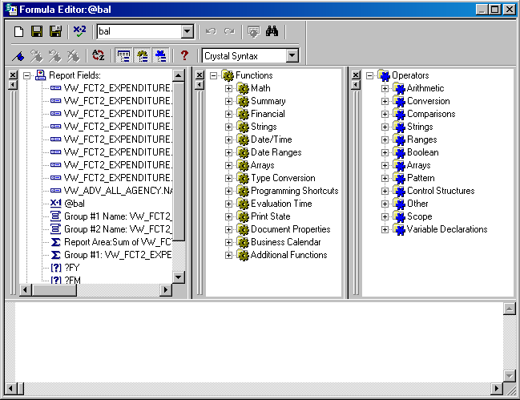
Fields Box
Functions Box
Operators Box

Formula Editor

Functions Box
The Functions Box lists the dozens of functions that are included with the Info Report Designer. These functions are built-in procedures that return values. They perform such calculations as average, sum, count, etc. All functions available are listed in this box with their arguments and arranged by their use.

Fields Box
The Fields Box contains all the fields you can use as formula arguments. Insert one of these fields into your formula by double-clicking on the field name.

Operators Box
The Operators Box lists the “action verbs” you can use in your formulas. Operators include such things as + (add), / (divide), -x (negative), etc. Search for Operators and Variables in the Info Report Designer online help for more information.

Let’s go ahead and try a simple example.

Open the Monthly Budget Detail Report
Step 1 On the Info Desktop window. Highlight the MRDB(2) folder in the folder tree.

Step 2 Right-click on the Monthly Budget Detail object and select Design from the available options.

This report is a monthly report with FM/FY parameters. It uses the VW_FCT1_PLANNING_EXPENDITURE view. It is grouped by Fund and by Program Budget Unit.

FORMULAS
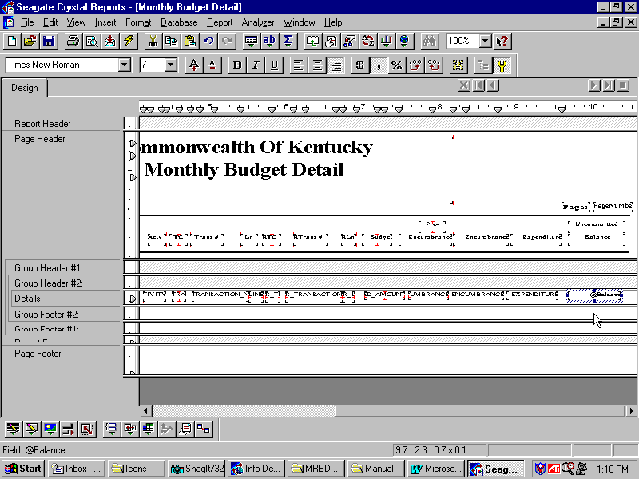

This report already contains a formula called @Balance. Let’s open up this formula in the Formula Editor to see what the formula actually does.

Step 1 Right-click on the @Balance formula field in the Details section of the report.

Step 2 Select Edit Formula from the available choices.

This should bring up the Formula Editor showing the format and contents of this formula called @Balance.

FORMULAS
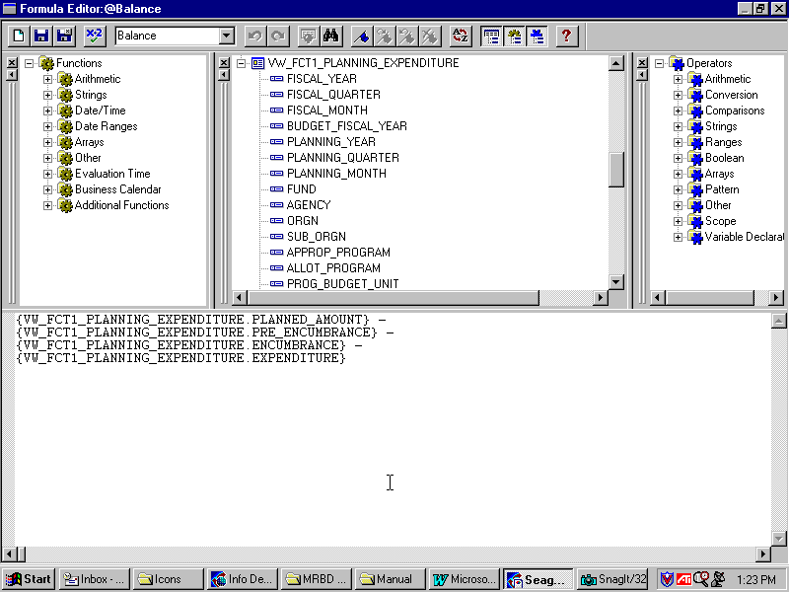
Report Field
Operator

This formula is pretty straightforward. It uses two components to make it up, database fields and operators. Translated into simpler terms, this formula reads:
Balance = Planned Amount - Pre-Encumbrance –Encumbrance – Expenditure
Let’s try to create a formula on our report. First, close out of the Formula Editor by clicking on the ‘X’ in the upper right-hand corner. This should bring you back to the Info Report Designer. Close the open report.

Inserting Formula

Step 1 Open your newly created Allotment report in design.

Step 2 Select Insert from the Menu Bar and then select Field Object from the available choices.

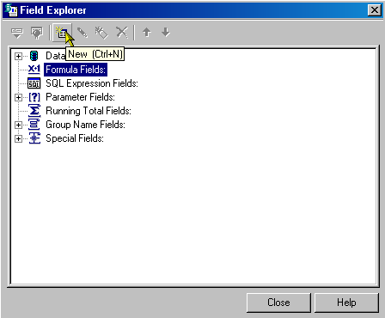Field Explorer

Step 3 On the Field Explorer window, highlight Formula Fields and click the <New> icon from the tool bar.

Formula Name
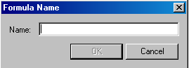

Step 4 In the Name field, type Obligated.

Step 5 Click the <OK> button. The Formula Editor Window opens.

FORMULAS
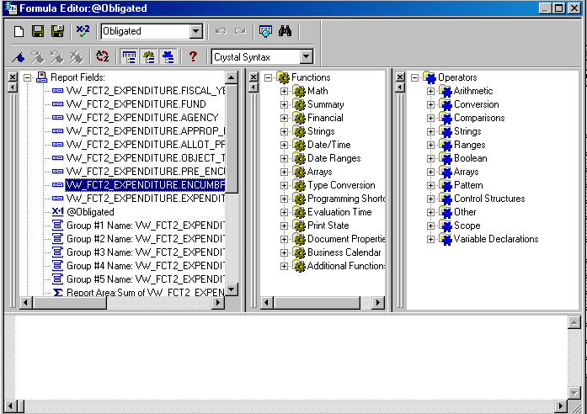

Recall that our formula uses both fields and operators. Let’s create a formula that represents the total obligated amount (encumbrances plus expenditures).

Step 6 Double-click on the report field: VW_FCT2_EXPENDITURE.ENCUMBRANCE.

Step 7 In the Operators box, expand the menu for Arithmetic by clicking on the + icon in front.

Step 8 Double-click on ADD.

Step 9 Press the Enter key on your keyboard.

Step 10 Double-click on the report field: VW_FCT2_EXPENDITURE.EXPENDITURE.

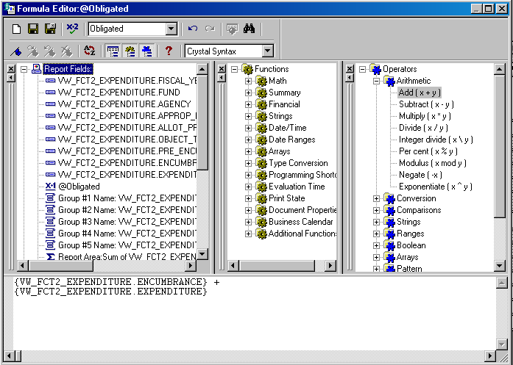FORMULAS

Now that we have our formula all written out, it is time to use Seagate’s formula check feature to see if there are any errors.

Step 11 In the Formula Editor window. Click on the <Formula Check> button on the toolbar.

dialog box
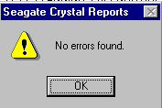

Step 12 You should get a message that says “No errors found.” Click the <OK> button.

Step 13 Click on the Save and close button on the toolbar. The Field Explorer window appears.

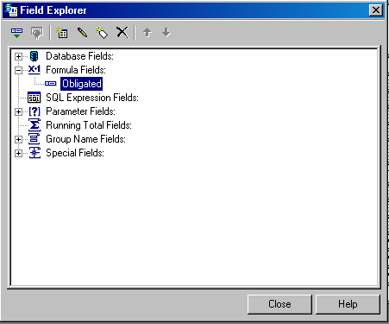Field explorer

Step 14 From the Field Explorer window, drag the formula, Obligated, into the Details section of the report. This may create another field label in the Page Header section. You can delete or edit the label if you choose.

insert fields
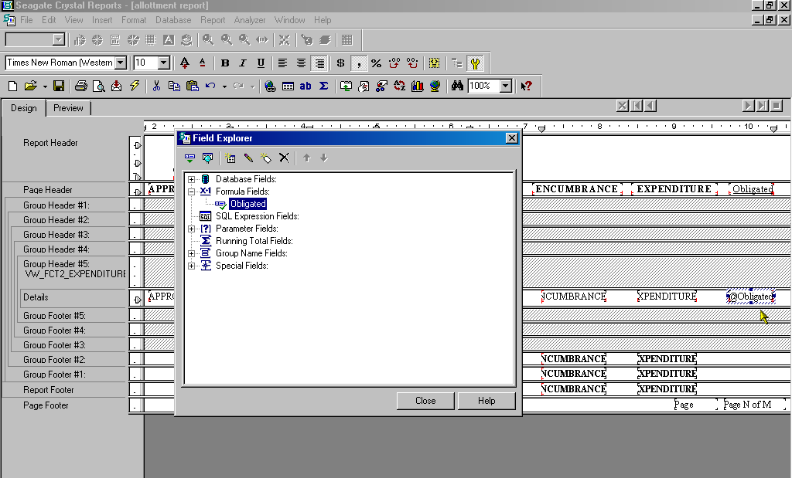

Step 15 On the Formula Editor window, click the <Close> button.

You may go ahead and refresh the report at this time to see the affects of this formula contained within the report. Use Fiscal Year ☺☺☺☺ and Fiscal Month ☺☺ for your parameters. You will also have to Log On to Oracle at this time. After you are finished looking at the report, go ahead and close out of the Info Report Designer and when prompted if you would like to save changes, click NO. You have been selecting NO for this save option throughout the course due to it being a training course. If this were actually your report out in production, you would ALWAYS save your changes.

In this topic we have learned how to:

- Use the Select Expert tool to limit the data in your report

- Develop and insert formulas into your report

- Suppress data that isn’t needed

- Insert parameters into your report to customize the scheduling periods



Are there any questions concerning the information covered in this topic?

