Topic 4 Basic Report Design

PURPOSE

The purpose of this topic is to discuss the fundamental principles when designing a report. We need to address the content of the report, the layout of the report as well as formatting the report.

OBJECTIVES

By the completion of this topic, you will be able to:

- Identify the purpose and audience of your report

- Identify which view(s) and database fields you will need for your report

- How to insert groups and totals into your report.

Content of the Report
Prior to designing a Seagate report, the report designer must first answer numerous questions about the purpose of the report. The purpose will give the user insight into which type of view(s) (detail or summary) is needed for the report. The user must also determine if any reference information, like Object Name or Vendor Address is required on the report.

Before you even open the design tool, you should outline the information that the person requesting the report wants you to provide. Use the following questions as a guideline in making that outline.

- What is the overall purpose of the report?

- Who is going to read the report?

- What is the report title going to be?

- What information do you need besides the title to identify the report?

- What identifying information do you want to appear at the bottom of each page? At the top of each page?

- Where will that information come from?

- What specific data do want to appear in the body of the report?

- Where will that data come from (views)?

- Does that data field exist or is it a formula?

- How is this data to be sorted?

- Do you want it broken down into groups? Which data fields are going to make up these groups?

- Do you want these groups to be sub-totaled? Grand totaled?

- Do you want the report to be based on all the records in the database? Just for a specific Fiscal Month/Fiscal Year combination?

As you can see, there is a lot of information that needs to be gathered from the person requesting this report. We will begin by talking about the main purpose of the report to be created.

PURPOSE OF THE REPORT
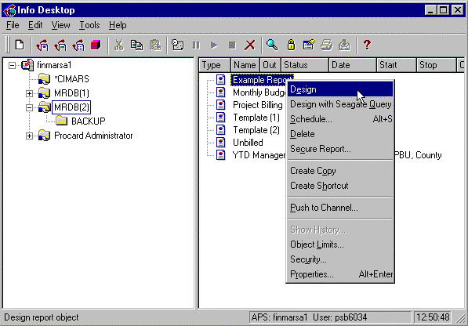

Purpose
Let’s open up our Example report for this part of our discussion.

Step 1 On the Info Desktop window. Highlight the MRDB(2) folder.

Step 2 Right-click on the object entitled Example Report and select Design from the available options. This report template will serve as a point of discussion for the remainder of the topic.

EXAMPLE REPORT
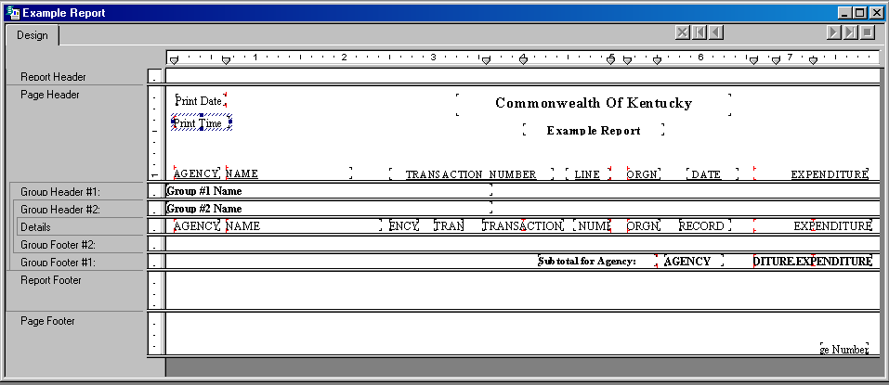

Purpose of the Report
The first crucial step in report designing is deciding what the overall purpose of your report is. The purpose of all the reports you create is to help individuals quickly grasp the essential elements and relationships found in raw data so they will be able to make effective decisions. For a report to be effective, it must present accurate data in a logical fashion.

A good starting place in the development of your report is to write out the purpose in a sentence or two. This will help you focus on the reports primary needs, and it gives your report both a starting place and a goal.

The purpose of the Example Report that we just opened is this: “To show an Agency’s expenditure information down to the transaction/line detail. This report will be sorted by Agency and Record Date with a subtotal for the Agency’s expenditures.”

Another example of a purpose statement would be: “To show monthly and year-to-date revenues for each District/Department within a given Agency.”

EXAMPLE REPORT
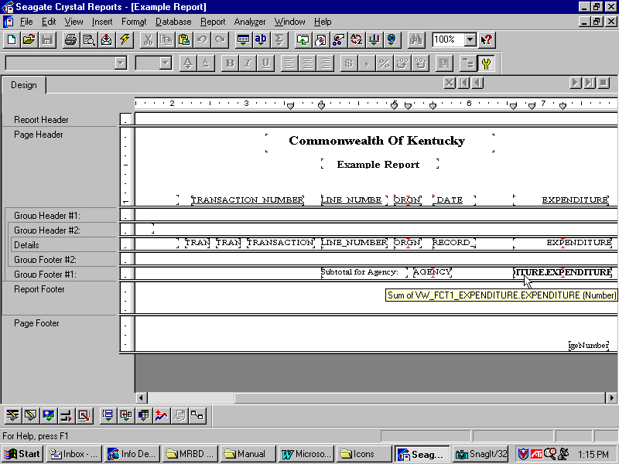
Manager’s Request
Other Employee’s Request

Readers
Who is going to read this report? A single report is often used by many individuals. Each of these individuals may be interested in different aspects of the report. For example, in our Example Report we just opened, a manager may be interested only in the total expenditure amount for his/her Agency while the other employees could be interested in the transaction detail for each line amount.

It is crucial to be able to incorporate everyone’s interests into this report. Let’s take a look at this report in order to determine if this proposed audience will be satisfied with the report content.

We can see from the screen shot on the previous page that both requests are met. The fields for TRANSACTION NUMBER and LINE NUMBER will provide the detailed information to meet one party’s needs while the subtotal field for the Agency will meet the manager’s need.

Recall the sample purpose statement that was used for this report. There are a few key points to take from this.

- “Show agency’s expenditures” indicates that we may want to use a View for the Expenditure table.

- “Transaction/line detail” indicates that this will be a View of a FCT1 table.

- “Sorted by agency and record date” indicates which groups we need to
- enter into this report.

- “Each agency’s expenditures subtotaled” indicates that we need to insert a subtotal for our agency on expenditures.

Title of the Report
What is the report title going to be? Is this an old STARS report that you are converting to Seagate that you will call the same name? Does the individual requesting the report have a name in mind?

Often report titles directly relate to the purpose of the report. In our example, an appropriate name could be Expenditure Report by Agency.

Layout of the Report
What kind of information do you need to place in the Header of the report?
Besides the report title, there are other sources of information that are usually placed into the header. You may wish to include the current date, the purpose of the report, range of dates covered.
Looking at our example on the previous page, we can see that there is a lot of information displayed in the Page Header. Recall that information placed here will print once at the top of each page. Besides the report title, we have the PRINTDATE and PRINTTIME fields that come standard with Seagate. We also have a heading name for each of the fields displayed in our report.

The current date can be inserted using the PRINT DATE field command on the Insert | Special Field menu. You can also place a block of text, like the title, anywhere in this section.

Recall that objects placed into the Page Footer area print at the bottom of each page. This would be a good section to place a PAGE NUMBER or a PAGE N OF M field. These fields can be inserted by using the Insert | Field Object menu command.

You can use special fields and text objects to create a PAGENUMBER field. Let’s try a simple exercise using the Example report that we already have open in the Info Report Designer. We will place this special field in the Page Footer section.

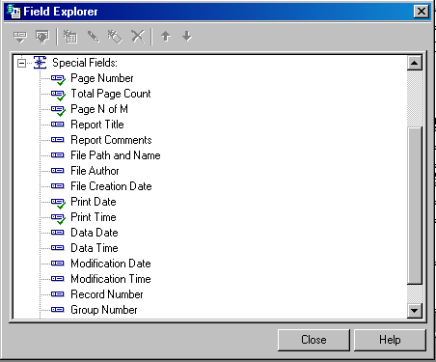INSERTING SPECIAL FIELDS

Inserting Special Fields
Step 1 On the Menu Bar, select Insert: Field Object

Step 2 Click on the + icon beside Special Fields to view your options

Step 3 From the available list. Select DATA DATE and click on the Insert icon in the tool bar.

Step 4 Drag your cursor into the Page Header section of the report. Once it is in the location you desire, single click your mouse.

Step 5 Click the <Close> button.

Step 6 From here, you can format the size, style and color of your field.

Data Sources
What are the specific data elements that you want to present in the body of the report?
When you think of a report, it is probably the body of the report that you are thinking of. The body should contain all of the data needed to fulfill the purpose statement you wrote for this report. It should also contain the data to support the various user audiences that you identified.

Once you determine the content of the data, you need to decide the location of this data within the MRDB. Remember that you can add reference data to an existing view (VW_FCT1 or VW_FCT2) to allow for more reporting flexibility using Seagate’s linking option that we discussed. Other points to keep in mind while selecting data:

- Much of the data in a typical report will be taken directly from data fields within the selected View(s).

- Other data will be calculated based on data fields. You need to determine which of these fields will be used in the calculation.

- Still other data will be placed directly into the report using text objects.

Record or Group Selection
Do you want the report to be based on all records or groups in the database or only on specified records or groups?

The Info Report Designer allows you to base your report on all records in a given database, or on a limited set of records from the database. Perhaps your report lists all of the funds associated with your Cabinet but you only need to report on one or two of these. You can use Seagate’s record and group selection tool to list your detail or summary information for just the funds you need, eliminating all information about the funds you don’t need. Or maybe you want the report to list the information for a given Fiscal Year / Fiscal Month combination. Let’s do a quick example of using the record and group selection tool, Select Expert, for the Example Report that we have opened in the Designer.

choose field
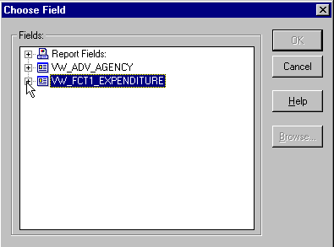
Step 1 On the toolbar, click on the icon for the Select Expert tool .

Step 2 On the Choose Field dialog box, select the VW_FCT1_EXPENDITURE view by clicking on the + symbol. (This is one of the database views that we previously used for our linking example. This view and the VW_ADV_AGENCY view are the two databases that are supporting this Example Report.)

SELECT EXPERT TOOL
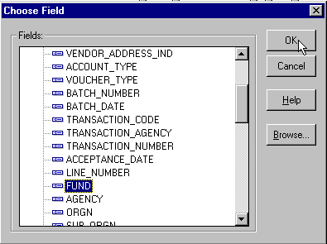

Step 3 From the list, select FUND and click the <OK> button.

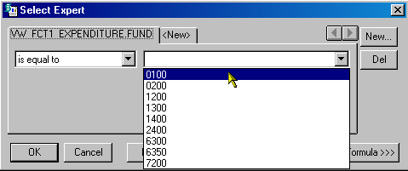select expert

Step 4 In the drop-down box, select is equal to. In the second drop-down box, select 0100.

NOTE: You may be prompted to log on to Oracle at this step. Just supply your Oracle user name and password.

Step 5 Click the <OK> button. You have now instructed the report to print all the detailed records associated with Fund 0100 only.

You may also use this tool for such things as entering fiscal month and fiscal year parameters and entering range parameters on fields (>, <).

Step 6 Close the Example report. Do not save the changes.

Groups
Do you want your data organized into groups?

Often you will want to group your data by certain fields. If your report displays information on more than one Agency, you may want to use this field for one of your groups. This will enable the report to keep the Agency information together (ex: list all records for Agency A first, followed by all the records for Agency B).

Grouping related data aids you in organizing your report. Often you will want to place more than one group into your report. Let’s take a look at another report to identify which groups it contains and the impact that these groups will have on the report.

Step 1 Open the Training Example report located in the MRDB(2) folder.

GROUPS

Step 2 From the Design tab, hold your cursor over each of the Group Headers in order to identify the field(s) used for the grouping of the report.

Step 3 Click on the <Refresh> button on the toolbar. You may have to Log On to Oracle at this point.

GROUPS
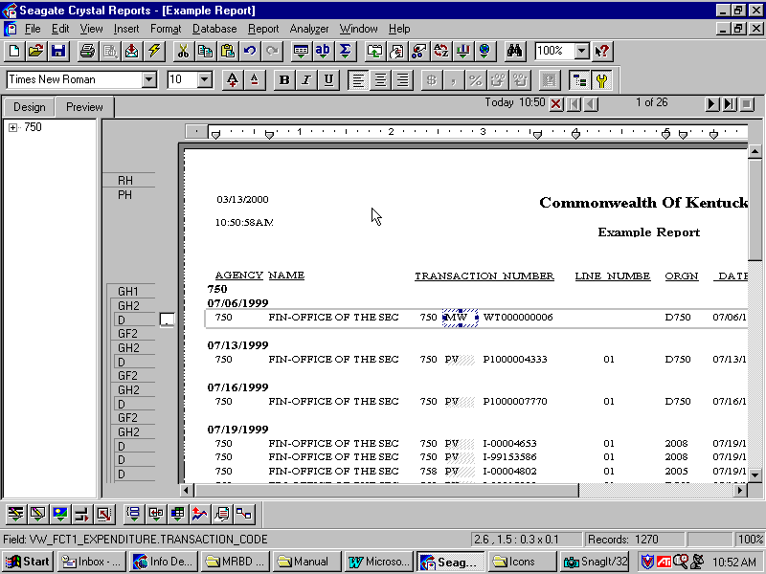

Groups
We can see that there are two groups in this report. Group #1 is for VW_FCT2_EXPENDITURE.FUND which indicates that the Fund field will be used for our first group. The second group indicates that the field Program Budget Unit (PBU) will be used for the second group within this report. When viewing a successful instance of this report, the grouping indicates that all like Funds will be kept together within this report. The second group indicates that WITHIN the first group (Fund), all like PBU’s will be kept together. This grouping will repeat each time a new Fund is introduced into our report. Let’s take a look at what this report will look like by refreshing it within the Info Report Designer.

After the report refreshes, you should notice the impact of these two groups. Now, let’s make a change.

Step 4 Click on the Design tab in the upper-left hand side of the Info Report Designer.

Delete group
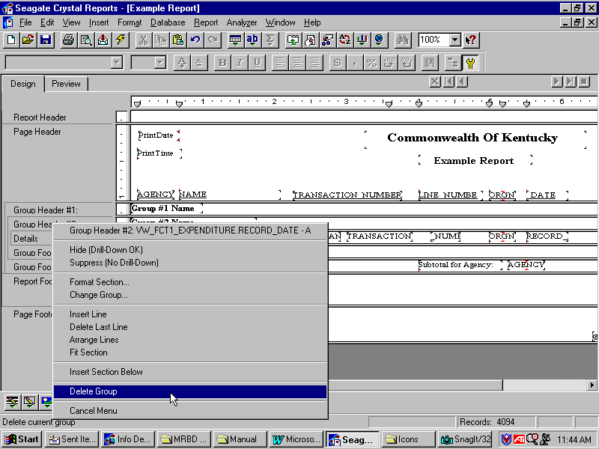

Step 5 Right click on the Group Header #2 and select Delete Group from the available options.

confirm command
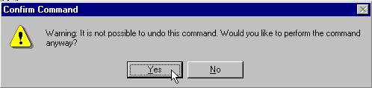

Step 6 Click the <Yes> button.

Step 7 On the Menu Bar, select Insert: Group.

insert group window
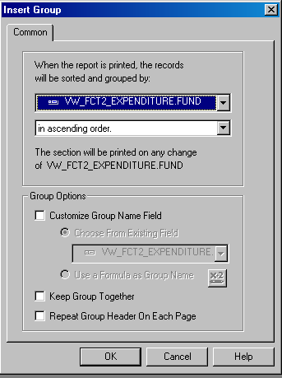

Step 8 From the available list, select VW_FCT2_EXPENDITURE.FUND under the first drop-down box. This is the field that we will be grouping.

Step 9 In the Keep group together box. Place a check mark.

Step 10 Click the <OK> button.

GROUPS
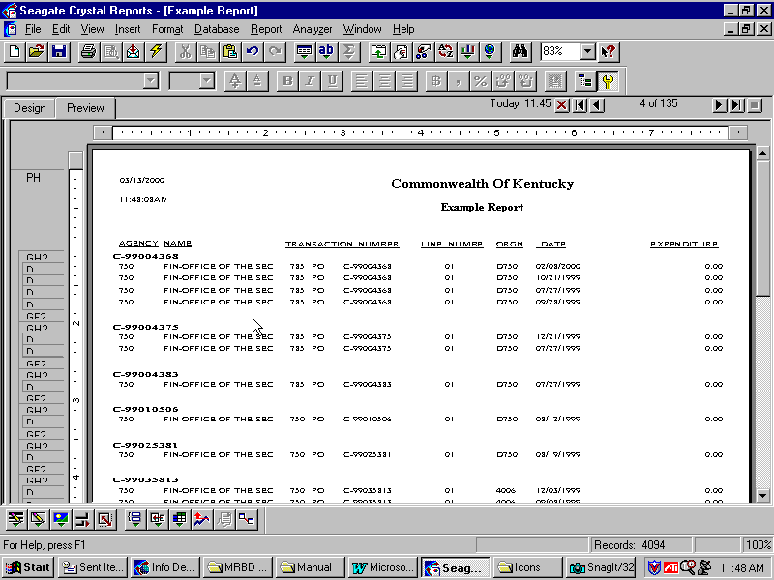

Changing Groups
Now, you can refresh your report again and notice the difference in it’s output. Group #1 is now PBU and Group #2 is Fund. If there are multiple transactions under a given PBU, they will be grouped in ascending order as specified.
Go ahead and delete both of the current groups in your Training Report and try inserting two new ones. After your finished, refresh your report and take a look at its output.

SUBTOTALS
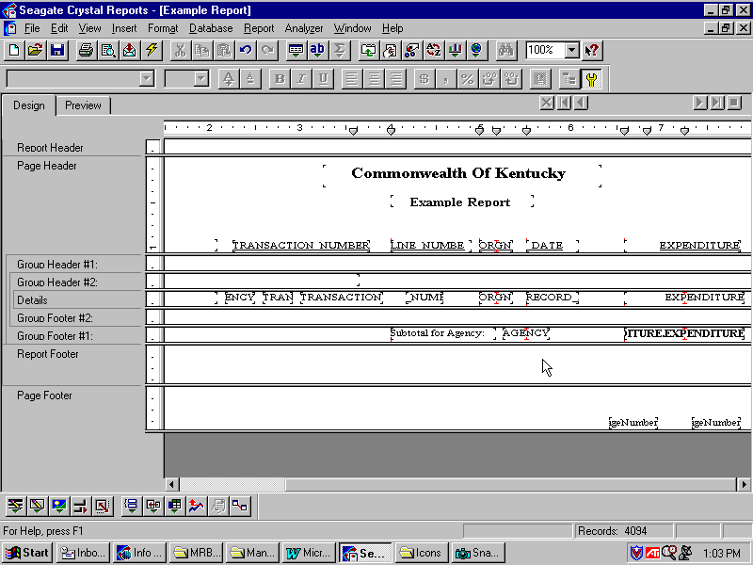

Subtotals
Many of your reports will use some type of subtotaling. For example, the report that we have been working with lists the associated expenditures for each transaction line. We may want to subtotal these expenditures for both of our groups. That way, the user will be able to determine the total expenditures attributed to each one of the funds within our report. You accomplish this by placing a subtotal on the expenditure field. Summaries at the group level allows you to calculate averages, counts and other group (aggregate) values.

Our Example report already has a subtotal on expenditures for the Agency group. Now let’s attach a subtotal for the newly created group: PBU.

Inserting Subtotals
Step 1 On the Design tab, right-click on the EXPENDITURE data field in the Details section of the report.

Step 2 From the available choices. Select Insert /Subtotal.

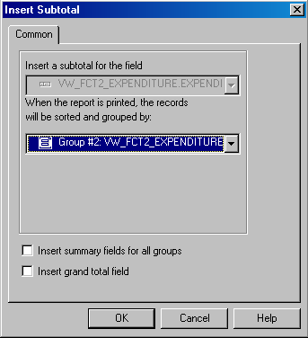insert subtotal window

Step 3 From the Insert Subtotal dialog box. Select Group #2: VW_FCT2_EXPENDITURE.PROG_BUDGET_UNIT from the group drop-down box.

Step 4 Click the <OK> button.

You should now see a summary field placed under the Expenditure field within the Group Footer # 2 section of your report. You may want to insert a text object saying “Subtotal for Transaction Number:” in the Group Footer just like the one for the Agency subtotal. Go ahead and refresh your report again to see this new subtotal within the report.

Grand Totals
Inserting a Grand Total is much like inserting a Subtotal. The main difference is that a Grand Total will appear at the very end of the report. Recall that we inserted a Subtotal for each Fund within our report. If we had five funds listed, we would have five separate Subtotals within the report. The Grand Total field would only appear once, at the end of the report that would sum up the five Subtotals for the funds.

Step 5 At this time, you may close out of the Info Report Designer and when asked if you would like to save your changes, Click the <NO> button.

In this topic we have learned how to:

- Identify the purpose and audience of your report

- Identify which view(s) and database fields you will need for your report

- How to insert groups and totals into your report.



Are there any questions concerning the information covered in this topic?

