TOPIC 2 MRDB STRUCTURE

PURPOSE

The purpose of this topic is to discuss the main features of the Management Reporting Database as well as the key differences of a File Base vs. a Relational Base platform. We will also take a closer look into the layout of the Views that we will be accessing in order to create reports. Finally, we will discuss the architecture of the data within the MRDB and provide some useful hints into table selection.

OBJECTIVES

By the completion of this topic, you will be able to:

- Describe the various types of tables within the MRDB;

- Search for the appropriate tables and perform table linking where necessary.

Database Structure
There are various types of database structures, each with their advantages for certain reporting requirements. The MRDB uses what is known as a Relational Base structure. We will begin by giving some general information regarding these database structures.

File Base
Another name for a File Base structure is a sequential database. In this type of database, records are inserted into a table in sequential order. The retrieval of data works in the exact same way, sequentially. This would be an appropriate database for someone’s personal records. Due to the tremendous amounts of data required by the Commonwealth, this format would not be feasible. Other concerns with this structure are both the tremendous amounts of table space required and the incredibly slow speeds that would result. It is for these reasons that the Commonwealth decided on utilizing the other popular database structure, the Relational Base.

Relational Base
The most popular architecture for database files used in the corporate world is the relational model. In a relational database, data is organized into a system of rows and columns. The rows are called records and the columns are called fields. Each record contains a collection of related data, all information relating to a specific project, for example. Each field refers to a common type of data that exists in all records, the name or number of an Agency, for example. Refer to the screenshot above for an illustration of these terms.

In the MRDB, data in two different tables can be related by a common field or group of fields. For example, an agency table will have an agency number field for each agency. A budget table will have that same agency number field for each of the budget amounts. This demonstrates a relationship between two tables. Tables in the MRDB can actually be linked together using the field that corresponds to that unique relationship. Relational databases significantly cut down on table space and dramatically improve the retrieval speed of data. It is for all these reasons that the MRDB uses the Relational Base architecture for their reporting needs.

MRDB Tables
The downloaded data is placed into table spaces. The tables are broken out by business areas. Currently there are nine different business areas defined which include:

- General Accounting
- Budget
- Cash Flow
- Disbursement
- Expenditure
- Inventory
- Job Costing
- Grants/Project Billing
- Revenue

The MRDB tables contain both detail and summary level information. The detail information is at the line level while the summary rolls up to the document level.

As a transaction is processed in the ADVANTAGE Financial system through a document (a PV document for example), it may contain multiple lines. Each line within the document will then be posted in a ledger file. This information is selectively captured from ADVANTAGE Financial during the MRDB nightly cycle through a set of cleansing programs. The result of this process is then stored in the appropriate MRDB table space. An example of a MRDB table would be FCT1_Expenditure. This table contains expenditure transactions.

Currently there are approximately 350 tables within the MRDB. This number will continue to grow as new tables are built.
Basic users do not have direct access to the table spaces in the MRDB; therefore, risk of deleting information is improbable. So how do you get to the information contained within these tables? Let’s discuss views.

MRDB Views
Like most databases, the MRDB tables may contain certain information that is needed in order to perform routine maintenance, to ensure data integrity (i.e. record update/insert flags and date/time stamps). Such data serves no purpose to the general reporting audience. Therefore, views are created to provide a means of filtering out unnecessary data while providing the data elements needed to address reporting needs. A view may contain all or some of the columns used within a table or group of tables, depending on the reporting need.

The MRDB also contains views that have been created to support reporting templates such as those available within the Seagate reporting software.

Currently there are approximately 563 views within MRDB. Just like the tables, this number will continue to grow as new views are built to meet reporting needs.

MRDB Structure and Naming Convention
We have discussed the various types of tables and views available within the MRDB. Now lets take a closer look at the structure and naming convention of the MRDB. Becoming familiar with the MRDB structure and naming convention will assist you in identifying where to go to get the data you need for your report(s).

The types of tables currently available within MRDB include; daily tables, tier tables (known as Fact tables) and references tables.

The diagram below displays the hierarchical structure of the MRDB tables, views and report templates.

Tables, Views, and Naming Convention
TABLES

VIEW 1
VIEW 2
VIEW 3

Report
Template
Report
Template
Report
Template

The information below provides you with the view prefix, a short definition of the view and what type of view it is.

VIEW INFORMATION

View Name Prefix | Short Description | Type of View
MREP.V#  (followed by a number, i.e. 750) | Created to meet agency specific needs. | Custom Data
MREP.VW_# (followed by a number, i.e. 1050) | Created to support the Seagate report template layouts. | Report Data View
MREP.VW_ADV | Provides ADVANTAGE Reference data. | Reference Data
MREP.VW_DLY | Provides ADVANTAGE Daily transaction data from previous business day. | Daily Data View
MREP.VW_FCT1 | Provides ADVANTAGE detail level data.  (Document and line level detail) | Tier I
MREP.VW_FCT2 | Provides ADVANTAGE summary level data. | Tier II
MREP.VW_FCT3 | Provides condensed summary level data of the ADVANTAGE FCT1 data. | Tier III
MREP.VW_PD | Provides Procurement Desktop (PD) data. | PD System Views

Let’s take a closer look at some of the MRDB views most commonly used.

Tier I – Line/Document Level Detail (FCT1 )
The Tier I table views are recognized by the prefix FCT1. For example, the Tier I Expenditure table view is named MREP.VW_FCT1_EXPENDITURE and contains the transaction line level information.

In some cases, two table views may be combined into a single view by the Central Finance Team. For example, the MREP.VW_FCT1_EXPENDITURE and MREP.VW_FCT1_PLANNING are combined to create the MREP.VW_FCT1_PLANNING_EXPENDITURE

The FCT1 detail table views represent data at the document and line level. These table views are NOT uniquely keyed; they behave like a sequential file. Therefore, although it is physically possible to link two or more FCT1 table views, it is not recommended. The reason is because such a link produces unpredictable results. Tier I table views are so large that it is difficult to use them for referencing information in queries and reports. That is where Tier II table views comes into play.

Tier II – Summary Level Detail (FCT2 )
The Tier II table views are designed to present a summary of accounting information. These table views are actually a summary of the Tier I data. Tier II combines like information, making it easier to find the desired information.

Tier II table views are keyed by their accounting distribution. If you are designing a query or report that does not need transaction and/or line level data, you will want to use a view of a FCT2 table view. FCT1 table views require a great deal of network resources and you only want to use them when line level data is absolutely necessary for your query or report.

Tier III Tables/Views – Line Level Detail (FCT3)
The FCT3 table views summarize the FCT1 table views at a higher level. The FCT3 table views summarize information to the Statewide Required Element level.

ADVANTAGE Reference Table Views
ADVANTAGE reference table views contain information that is redundantly used throughout the system. The use of reference table views eliminates the need to store this data in multiple places. Storing the data once and linking back to it as needed provides a more efficient means of utilizing the database storage. Examples of reference table views include but are not limited to; agency, agency class, fiscal year, object, object class, fund, etc. The information in these table views is downloaded into the MRDB and made available for reporting. Some users may prefer using the agency name within their report or query instead of the agency number; the use of reference table views makes this possible.

The ADVANTAGE reference table views are identified with the letters VW_ADV, while Procurement Desktop reference table views are identified by VW_PD_REF.

Knowing What Table View To Link
Knowing what table views to use is a big part of designing a query or report. A good starting point to assist you in identifying the type of data and view(s) needed would be to step through the following list of questions:

- What is the purpose or objective for the report? (i.e. identify all office supply expenditures)

- Is detail or summary level information needed? (i.e. Does my audience need to see line level information or rolled up totals)

- What type of data is needed? (i.e. expenditure, allotment)

- What fields are needed in the query/report? (i.e. fiscal year, fund, agency, org, object code, object class, amount, vendor name and number)

- Is year-to-date (YTD) or daily data needed?

By identifying the type of data needed you can narrow down the view selection. For example, if you were needing summary information you would not want to link to the MREP.VW_FCT1_EXPENDITURE table view. The MREP.VW_FCT2_EXPENDITURE table view provides the summary level information. However, if you are looking for detailed expenditure information, then the MREP.VW_FCT1_EXPENDITURE table view is what you would use.

Another tool available to assist you in identifying your data source is the Data Dictionary. The dictionary is a composite of definitions and data columns stored within MRDB. This tool will assist you in designing reports and queries by providing descriptive information about the data elements within the MRDB.

Which Tables Do I Use?
- A report is needed reflecting document and line detail that contains all expenditures. The long name for each agency is part of the request.

- Use VW_FCT1_EXPENDITURE
- Use VW_ADV_AGENCY
- Perform linking on the key field(s) from the AGENCY table

- A summary report is needed for all revenues by Fund to include the names of the Fund.

- Use VW_FCT2_REVENUE
- Use VW_ADV_FUND
- Perform linking on the key field(s) from the FUND table.

JOINING TABLES
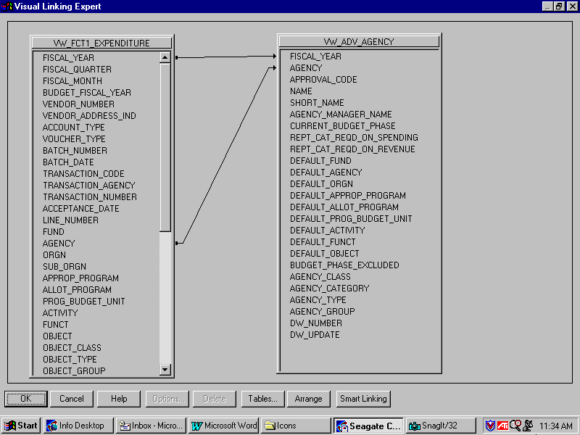

Joining Tables
You perform table linking so records from one table will match related records from another. When you link, you are using a field that is common to both tables. The Info Report Designer uses the link to match up records from one table with those from the other. The from table is used as a primary table while the to table acts like a lookup table where records are looked up by the primary table. In a simple link, the Info Report Designer examines the first record in the primary table and finds all matching records in the lookup table.

Above is a screenshot of two tables being linked within the Info Report Designer. The FCT1_EXPENDITURE table is acting as the primary table while the ADV_AGENCY table is acting as the lookup table. The two key fields on the ADV_AGENCY table are FISCAL_YEAR and AGENCY. If the FCT1_EXPENDITURE table did not contain these key fields, the link would not have been possible.
There are many different types of SQL (Structured Query Language) Joins. For our discussion we will be focusing on one main type: The Left Outer Join. This type is the predominant style used in the MRDB and should serve as the proper option in most every table linking operation. However, there may be exceptions to this rule. If you are having trouble getting the correct data when linking two or more tables in Seagate, read the troubleshooting section at the back of this manual for further instruction.

An SQL Join indicates how linked fields in two SQL tables are compared when records are read. The SQL Join Type options are specified using the Link Options Dialog Box. The result set from a Left Outer Join includes all the records where the linked field value in both tables is an exact match. It also includes a row for every record in the primary table for which the linked field value has no match in the lookup table. This way, if your record does not have a match in the lookup table, it won’t be dropped from the report. For example, if you were to use an equal join on the Agency field, Agency value C35 (Transportation) for the primary table will equal the Agency value C35 on the lookup table.

You have been asked to create a report that uses both the FCT1_EXPENDITURE table and the ADV_AGENCY table. We will assume for this exercise that a Left Outer Join exists between these two tables in regards to their key fields.

Let’s begin by logging on to Seagate and opening a pre-designed report template using the Info Designer.

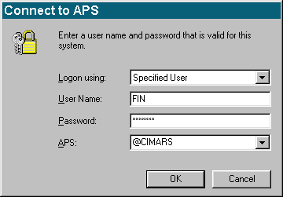
INFO DESKTOP LOG ON SCREEN

Logging into Seagate
LOGON USING. This defaults to Specified User and should not be changed.

USER NAME. Enter Your RACF ID or User ID.

PASSWORD. Enter your Seagate password (not your oracle password) Remember what case your password is because this is case sensitive.

APS. Automated Process Scheduler. This should be set to @CIMARS so that Seagate Info will get the first available server.

NOTE: If @CIMARS does not work use KYMARSSA1 or KYMARSSA2 in the APS field.

OPENING THE INFO DESIGNER
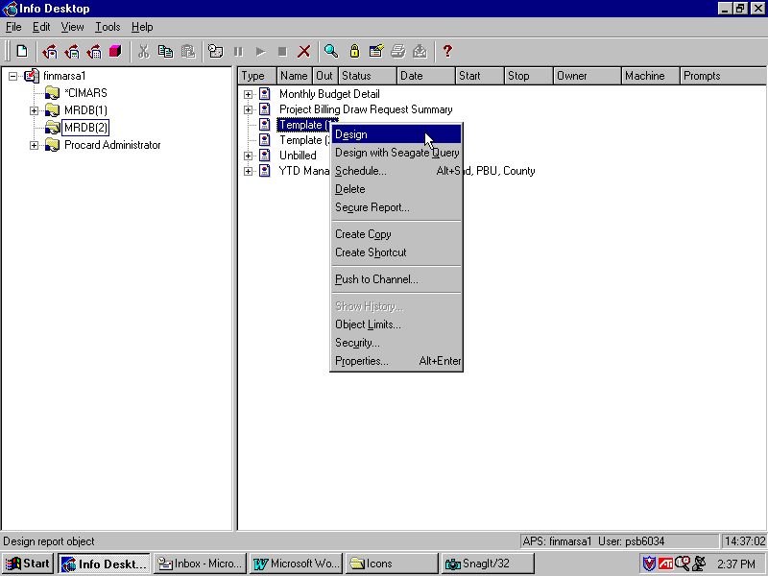

Step 1 Highlight the folder entitled MRDB(2).

Step 2 Highlight the object entitled Template (1).

Step 3 Right-click on this object and select Design from the available options.

This will open the existing report template in the Info Report Designer. Any time you need to modify an existing report template, you would follow these steps. Creating a new report from scratch will be discussed in a later topic.

TURNING AUTO SMART LINKING OFF
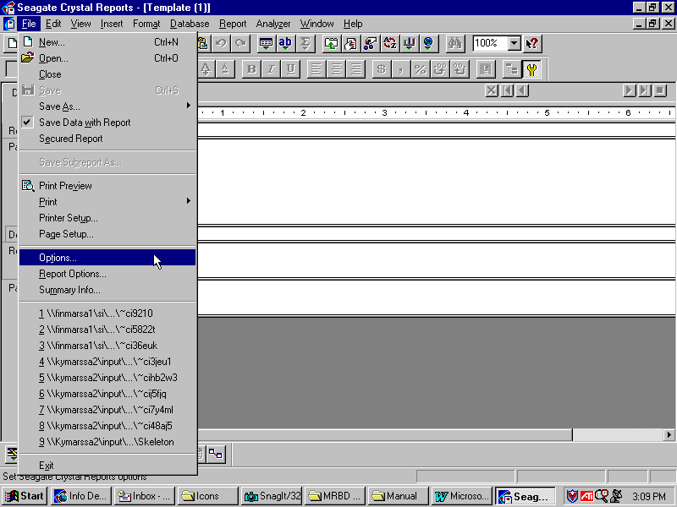

Seagate comes with a feature called Auto Smart Linking. When enabled, it will link multiple database tables automatically. The Commonwealth has designed its own database, the MRDB, that is not compatible with this feature in all cases. It is for this reason that we will be manually linking database tables instead of allowing Seagate to do it for us. The following steps are used to turn this feature off.

Step 4 On the Menu Bar, select File: Options. This will open the Options Dialog box on your screen.

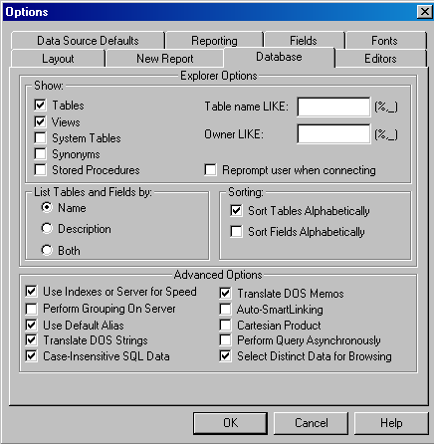
TURNING AUTO SMART LINKING OFF

Step 5 Select the Database tab.

Step 6 Find the checkbox option for AutoSmartLinking and deselect it. You do not want a checkmark placed in this field.

Step 7 Click the <OK> button.

With this option turned off, you will have to manually link all key fields when using two or more MRDB tables for the same report.

Note: Please remember to turn off Auto Smart Linking. This feature is not compatible with MRDB.

ADDING DATABASES TO YOUR REPORT TEMPLATE

Step 8 On the Menu Bar, select Database: Add Database to Report.

Before you can design reports in Seagate, you must have a valid Oracle Driver to gain access into the MRDB. We will be using a default Oracle driver that Seagate recommends.

Data explorer
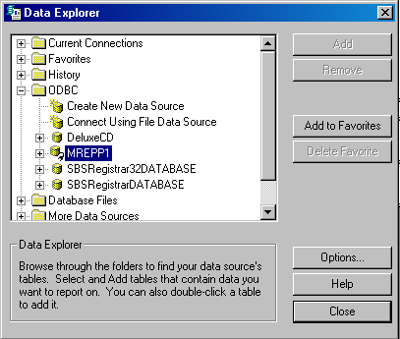

Step 9 On the Data Explorer dialog box, double click on the ODBC folder.

Step 10 Double click on the MREPP1 database within the ODBC folder.

Oracle Login
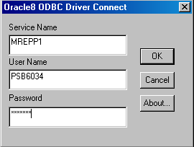

Step 11 On the Log On screen for that Oracle Driver. Type in your User Name and Password. The Server name should be MREPP1.

NOTE: This Password is not the same as the password used for Logging On to Seagate Desktop, this is your Oracle Password.

Step 12 Click the <OK> button. The Data Explorer window reappears.

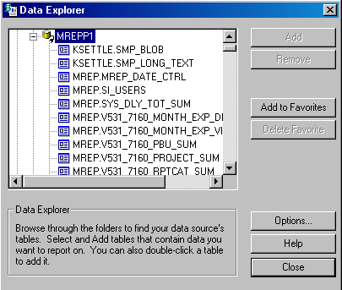Data Explorer

You should now have a Data Explorer dialog box opened that displays all of the current MRDB tables available. For our exercise, we will need two tables: FCT1_EXPENDITURE and ADV_AGENCY. Recall that we do not have access to the Physical tables and must use the Views instead. Here are the steps to add these two Views into our report template.

Step 13 Scroll down until you find ‘MREP.VW_FCT1_EXPENDITURE’, highlight it.

Step 14 Click the <ADD> button. This will add the selected table to your report template.

Step 15 Repeat Steps 13 and 14 to add the MREP.VW_ADV_ALL_AGENCY table.

Step 16 Click the <CLOSE> button. The Virsual Linking Expert window opens.

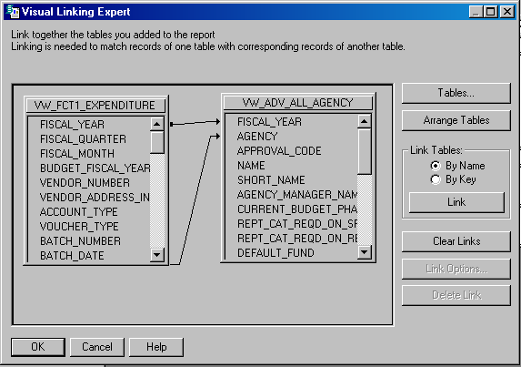Visual linking expert

Link Options
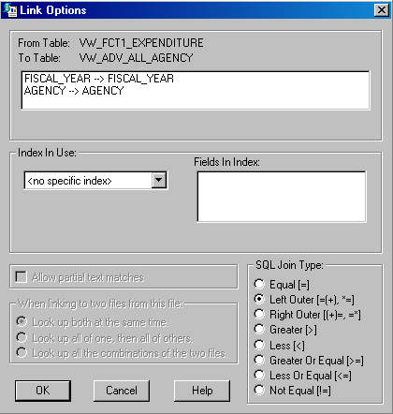

Linking Tables
Now that we have the two MRDB tables necessary for completing our request, it is time to link the KEY fields from the Primary table to the lookup table. Then we will have to set the link type for Left Outer Join.

Step 17 Click and hold your left mouse button on the field FISCAL_YEAR from the Expenditure table (primary table) and drag your cursor over to the FISCAL_YEAR field on the Agency table (lookup table) until you see the field highlighted with an arrow indicator next to it.

Step 18 Release your mouse button and a link should now be visible like the one shown on the previous page. Now right-click on this link and select Options from the menu.

Step 19 When the Link Options table appears, select the option button for SQL Join Type: Left Outer.

Step 20 Click the <OK> button.

Step 21 Repeat the Steps 17 through 20 for the AGENCY field.

Step 22 You may close out of Seagate Crystal Reports at this time and when asked if you would like to save your changes. Click the <NO> button.

GO to window
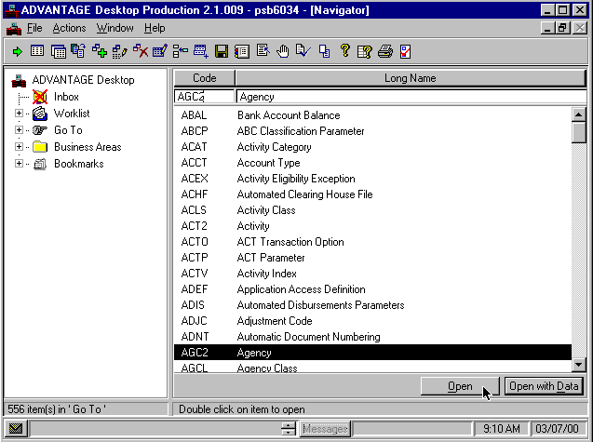

Identifying KEY Fields
One relatively easy method in identifying KEY fields is to use ADVANTAGE Financial’s field help tool to determine which fields in a given table are key, required or optional fields. Earlier we discussed that FCT1 tables are not uniquely keyed and behave as a sequential file. Therefore there are no key fields in our VW_FCT1_EXPENDITURE table. There are, however, key fields in the reference table that we inserted into our report template. We can use a feature called field help in ADVANTAGE Financial to determine which fields from our VW_ADV_AGENCY table are key. Let’s begin by logging in to ADVANTAGE Financial and opening this AGENCY table online.

Step 1 Double-click on your ADVANTAGE Financial icon to bring up the sign-on screen.

Step 2 On the Desktop Sign-on window. Enter your User ID and Password.

Step 3 Click the <OK> button.
Step 4 On the Workflow Sign-on window. Click the <Cancel> button.

Step 5 Maximize the Navigator Window. Select the Go To window.

Step 6 In the CODE field. Type AGC2.

Step 7 Click the <Open> button.

IDENTIFYING KEY FIELDS
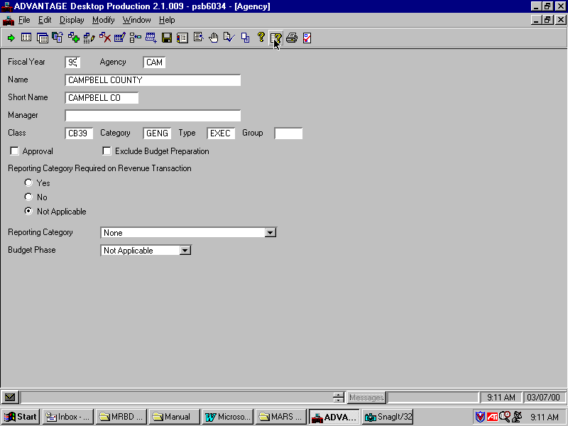

You should now be looking at the AGENCY Table in ADVANTAGE Financial. This table reflects the same information and field layout as the VW_ADV_AGENCY table that we pulled into our report template. We can use this online table in ADVANTAGE Financial to manually determine which fields are the Key fields.

Step 8 In the FISCAL YEAR field. Left-click and select Field Help.

IDENTIFYING KEY FIELDS
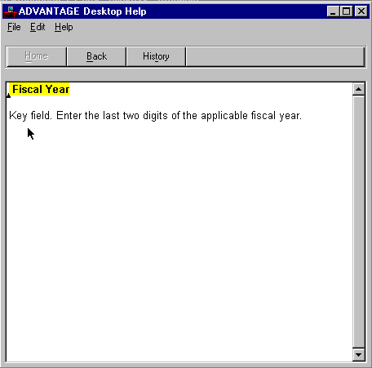
Fiscal Year inquiry.

agency name inquiry
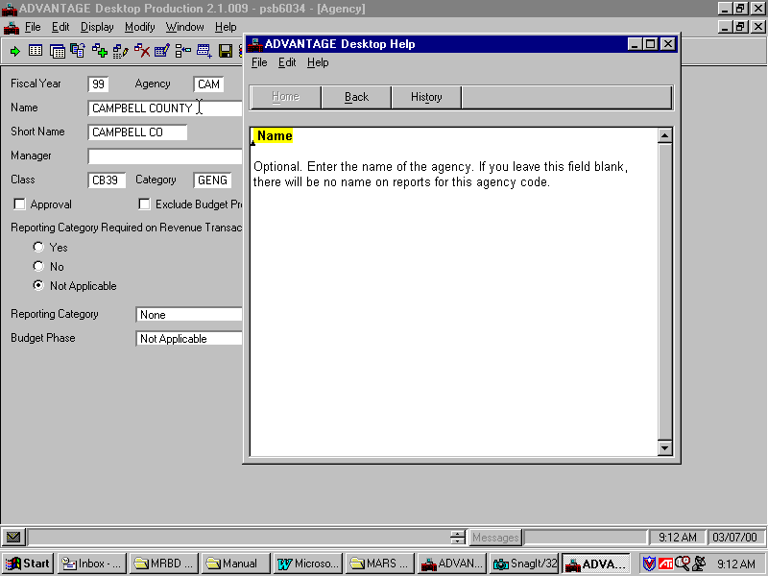

We can see that the Field Help tool gives us a message box indicating that the field Fiscal Year is indeed a key field. This would tell us that a link needs to be established from the FISCAL YEAR field in the VW_FCT1_EXPENDITURE to the FISCAL YEAR field from the VW_ADV_AGENCY table just like we did in our previous exercise. Go ahead on your own and repeat these steps for the rest of the fields from the AGENCY table in ADVANTAGE Financial. When you are finished, you may exit out of ADVANTAGE Financial.

On the previous page is a screen shot of the resulting inquiry into the Agency Name field. Recall that the main reason for pulling a reference table into your report is to provide background information, like the name of the agency you are reporting on. Since our field help revealed that this field is optional, it indicates the possibility of this field not being populated into the MRDB. Optional fields do not need to be entered in order to approve a given document. If you choose to report on one of these optional fields, keep in mind that some of your data faces the possibility of being empty.

Note: Data Dictionary is another tool that can be used to identify Key Fields.

In this topic we have learned how to:

- Describe the various types of tables within the MRDB;

- Search for the appropriate tables and perform table linking where necessary.



Are there any questions concerning the information covered in this topic?

