TOPIC 1 INTRODUCTION

PURPOSE

The purpose of this topic is to discuss the components of Seagate Info and the MRDB. We will revisit the two main viewing components of the Info Desktop as well as introduce Seagate’s design tool, the Info Designer. We will also discuss the basic security concepts of the MRDB.

OBJECTIVES

By the completion of this topic, you will:

- View the two components of Seagate, the Info Viewer and Info Analyzer;

- Discuss the basic concepts of the Info Report Designer;

- Be exposed to some basic MRDB security concepts;

- Describe the MARS Nightly Cycle process and how it relates to the MARS software tools such as Advantage Financial and Procurement Desktop.

MARS COMPONENTS AND THE MRDB

User

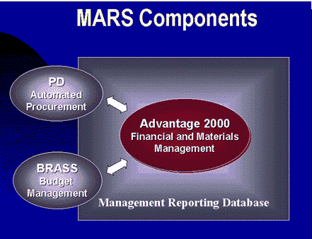
Seagate Info

Mars Components and the MRDB
Seagate Info is the front-end software package that you will be using to access report data in the Management Reporting Database (MRDB). You will actually be dialing in to a server, the Automatic Processing Scheduler (APS), in order to connect to Seagate Info. Once online, you will be accessing data within the MRDB whenever you schedule, view or design reports. This report data is coming from all the MARS components including ADVANTAGE Financial, Procurement Desktop (PD), and Budget Reporting and Analysis Support System (BRASS).

The MRDB is a data repository composed of different business areas merged into one single package. ADVANTAGE Financial is updated by PD and BRASS with the most current data during the nightly cycles. Once ADVANTAGE Financial is updated, it will then upload any of these changes or additions into the MRDB every night during its cycle.

Daily transactions in ADVANTAGE

Daily transactions in Procurement Desktop

Cleansing Processes

Cleansing Processes

Transfer data to MRDB

Mars Components and the MRDB
Every night, a process to capture the day’s business activity takes place. All of the documents generated or edited in ADVANTAGE Financial and Procurement Desktop need to be loaded into the Management Reporting Database. Once this Nightly Cycle process is completed, Seagate Reports will be able to view and query on that business day’s information. Therefore, within Seagate there is a one-day business lag.

This process consists of uploading all the day’s transactions from ADVANTAGE Financial, running a series of data cleansing processes, and then transferring this data into its respective MRDB tables. A similar process occurs in order to capture all the day’s activity from Procurement Desktop. The important thing to keep in mind when accessing this Oracle Database is that all the data will be up to date through the previous business day.

Overview of Seagate Components

Info Viewer
When you are using Seagate Info Desktop, there are two tools that you may utilize to view, query, export and print crystal reports. The default tool is known as the Info Viewer. This tool utilizes page on demand technology. If you were to view a crystal report using the Info Viewer, you would only be pulling one page at a time from the server to your PC. Each time you jump to another page, the Info Viewer will send the request to the server and retrieve the page in question and place it on your desktop.

The Info Viewer is a good tool to use for viewing and searching in a report. Other features such as exporting and printing are also supported by this viewing tool. The following page shows what a sample report would look like using the Info Viewer.

SEAGATE’S INFO VIEWER
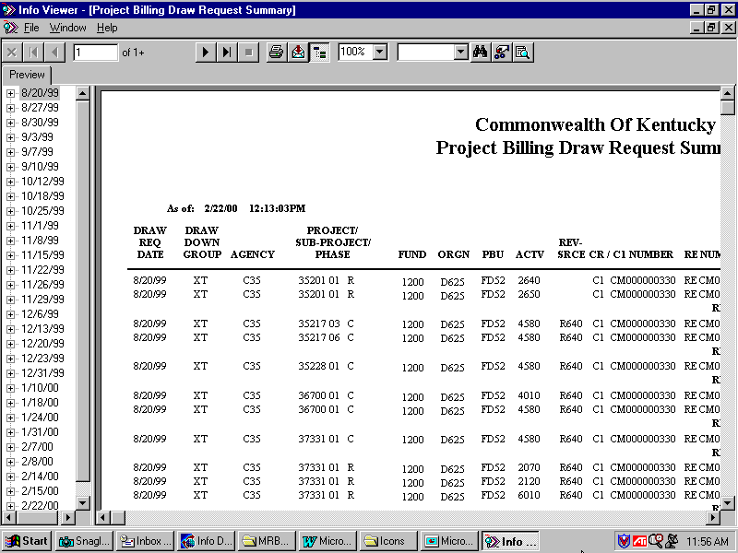

In order to use the Info Viewer, you must first go into the Desktop Options dialog box and make sure that the PAGE-ON-DEMAND FROM SERVER check box is toggled on. The steps are as follows:

Step 1 On the Menu Bar, select Tools: Options.

Step 2 From the Desktop Options dialog box, under Viewing Settings, make sure the PAGE ON DEMAND FROM SERVER checkbox is turned on.

Step 3 Click the <OK> button.

Step 4 From the JOB INFORMATION LIST BOX. Highlight a successful instance and click on the <View> button in the toolbar.

USING THE INFO VIEWER
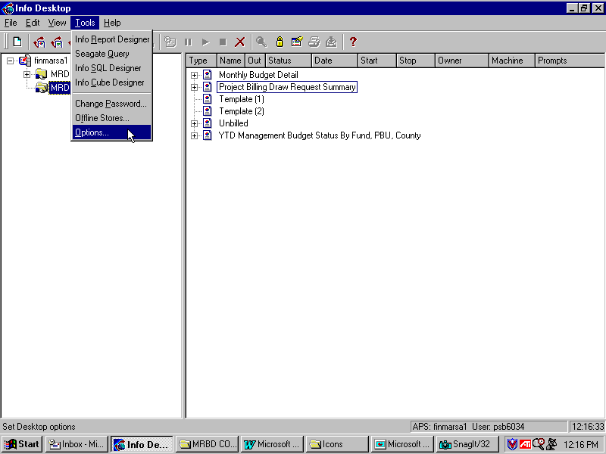

options
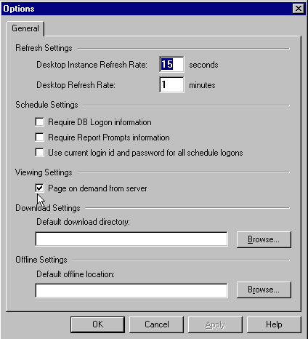

Info Analyzer
While the Info Viewer will only pull one page at a time onto your local computer, the Info Analyzer will pull the entire report. This means that if you open a successful instance of a 200-page report, all 200 pages will be pulled off the server onto your local computer. In order to utilize this viewing tool, you must turn off the PAGE ON DEMAND FROM SERVER option. The steps are as follows:

Step 1 On the Menu Bar, select Tools: Options.

Step 2 From the Desktop Options dialog box, under Viewing Settings, make sure the PAGE ON DEMAND FROM SERVER checkbox is turned off.

Step 3 Click the <OK> button.

Step 4 From the Job Information List Box. Highlight a successful instance and click on the <View> button in the toolbar.

NOTE: Due to configuration changes, Seagate requires an additional file (Registry Edit) to access Info Analyzer. If you receive the following message while attempting to view reports through Info Analyzer: Please contact your System Administrator for assistance.

Error Message
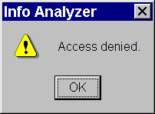

USING THE INFO ANALYZER

options
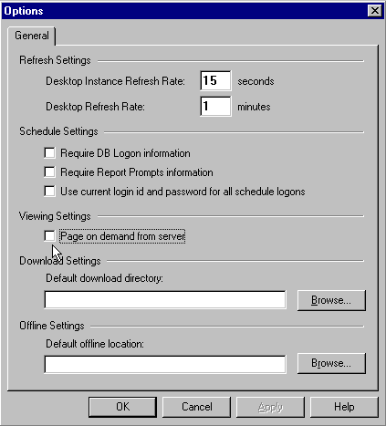

Since the Info Analyzer loads the entire report onto your local computer, there are more options and tools offered with this viewing component. Some of the extra features with this tool include: The Top N Expert, Chart Format, and the Sort Order tool. All the tools of both the Info Viewer and Info Analyzer are explained in greater detail in the Management Reporting Database Course. The MRDB manual is available at the MARS web site http://www.state.ky.us/agencies/adm/mars/mars.htm

Aside from having these additional tools, it has all the common tools that the Info Viewer has. The Info Analyzer also seems to perform a bit faster when searching through a report mainly because it does not have to use the server every time you jump to a different page. The following screen shot shows what a typical Seagate report would look like if being viewed by the Info Analyzer.

SEAGATE INFO ANALYZER
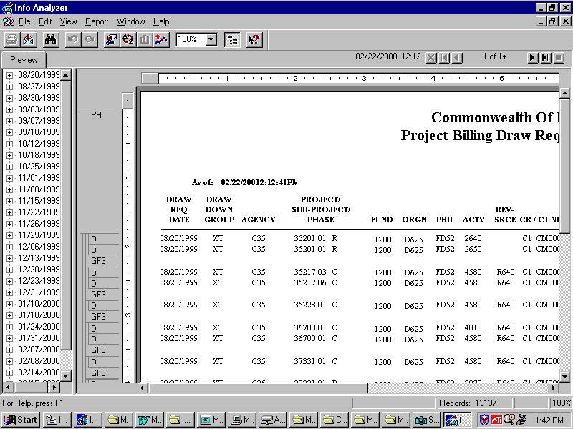

Info Report Designer
The Info Report Designer is the tool used to design and modify Seagate Crystal reports. This component of Seagate is available to the Commonwealth’s Report Designers only. A Report Designer is a person within an agency who has been issued a designer license and has been identified as a report designer. These users will have access to all of the components of Seagate with the ability to design custom reports for their agencies.

The other class of users is known as Basic Users. These individuals will have access to the Info Desktop and will be able to view, schedule, export and print Seagate reports. The Info Report Designer tool will be turned ‘off’ for these Basic Users.

The screen shot on the following page shows what a typical report would look like in the Info Report Designer.

SEAGATE INFO REPORT DESIGNER
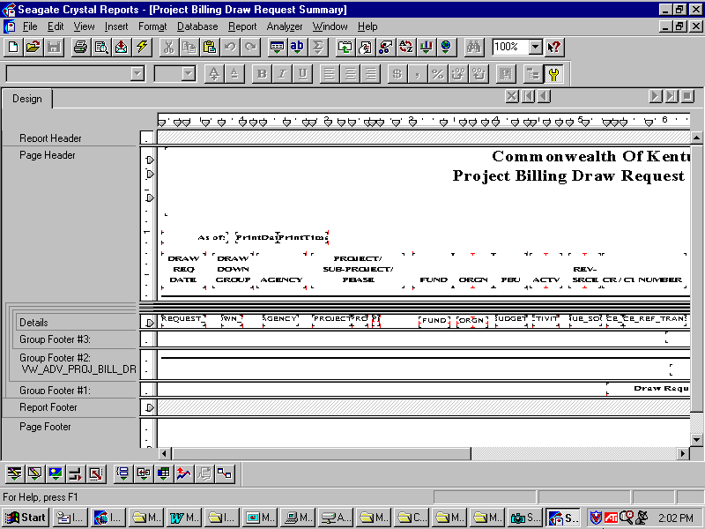

The Info Report Designer will be the tool used for virtually all aspects of report design and report modification. This tool also provides us with our link into the MRDB. In the later topics, you will learn how to use the MRDB database views and create both simple and advanced reports from these views. Some of the more common techniques of report design that we will be focusing on include: sorting, grouping, totaling and inserting parameters in order to specify a time period on which to report.

To open an existing Seagate report using the Info Report Designer, follow these steps:

Step 1 From the Job Information List Box. Highlight the report object that you would like to open.

Step 2 Right-click with your mouse and select Design from the following drop down menu.

INFO REPORT DESIGNER
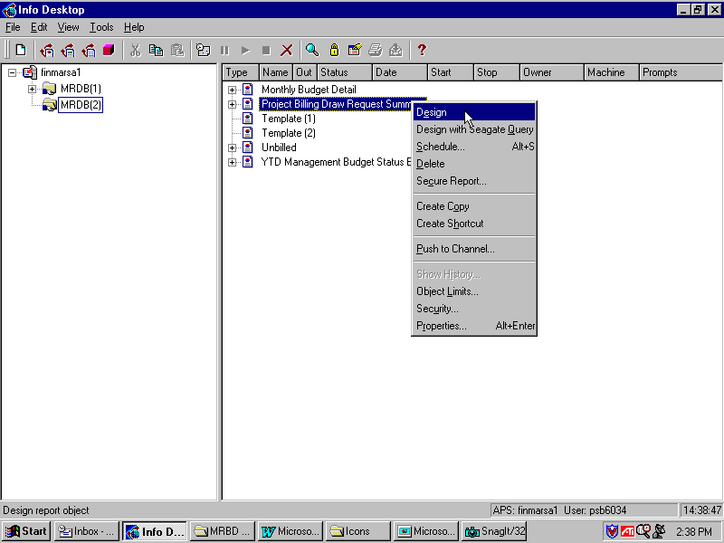

MRDB Security
Aside from having access to all the components that make up Seagate Info, there is some security information that you need to know. All of the MRDB database tables are known as physical or base tables. These tables are accessed by the Central Team only. This group has the ability to change table structures, add data to an existing table, delete records or create a new table from scratch. These tables are secured tables, preventing both the Basic User and Report Designer from accessing them.

Report Designers will be able to access the MRDB through what are known as Table Views. Another commonly used name for views is virtual tables. You may think of a view as a filtered MRDB table showing a select group of data. The only allowable action on these views is browsing. That means that these views are read-only, preventing the user from modifying or deleting its contents (This will be discussed in Topic 2). All of the views within the MRDB correspond to their physical table. The main difference is that the views filter out data from agencies that a given user is not allowed to access.

SCENARIO
Jack works for the Transportation Cabinet. He has just finished designing an expenditure report and decides to schedule the report in order to view the instance. When scheduling, he is required to supply his Oracle User ID and Password. This information has already been set up in security which will dictate the agency(s) he is allowed to access. His security file indicates that he is restricted to agency C35, which is Transportation. The successful instance that results from scheduling will contain expenditure data for agency C35 only.

Jill works for the Natural Resources Cabinet. She has also just finished designing an expenditure report for her agency. Her report uses the exact same expenditure table and fields from the MRDB that Jack’s did. Her Oracle User ID and Password has been set up restricting her access to agency 083 only, which is one of the agencies under Natural Resources. When Jill schedules her report to run, the instance will contain data from agency 083 only.

In summary, a view is a filtered, physical table extracting from MRDB only the data to which the Report Designer has access.

In this topic we have learned how to:

- View the two components of Seagate, the Info Viewer and Info Analyzer;

- Discuss the basic concepts of the Info Report Designer;

- Be exposed to some basic MRDB security concepts;

- Describe the MARS Nightly Cycle process and how it relates to the MARS software tools such as Advantage Financial and Procurement Desktop.



Are there any questions concerning the information covered in this topic?

