TOPIC 6 OVERVIEW OF INFO WEB ACCESS

PURPOSE

The purpose of this topic is to provide an overview of Seagate Info Web Access. This topic will cover the layout of the desktop when accessed through the Web. You will learn how to view and schedule objects via your web browser. You will also learn how to customize the Web Access desktop to better suit your needs.

OBJECTIVES

At the end of this topic, you will be able to:

- Gain access to the Info Web Access Desktop

- Navigate through the desktop main screen

- View reports on the desktop

- Schedule instances on the web

- Understand certain customization features of the web

Overview of Info Web Access
In addition to the Info Desktop, Seagate Crystal Info can also be used via the Internet. By using your web browser, you can gain access to the website and be able to perform many of the features that are available on the Info Desktop. Within this website, you will be able to schedule and view objects and use the drill-down feature to see the details behind summarized data.

Depending on what type of browser you are using, (Internet Explorer, Netscape Navigator, etc.), one of the following two desktop platforms can be used to access reports across the Internet.

- Info Desktop for HTML: Allows you to schedule and view reports in HTML (hypertext markup language).

- Info Desktop for Java: Allows you to schedule and view Crystal Reports and take full advantage of page-on-demand technology.

The Commonwealth of Kentucky will be using the following web site to access the Info Web access server: https://172.24.165.36/ciweb. This URL address will open the Seagate Software Web Access main page as seen from the screen view on the previous page.

On the main page, you will have to choose which platform you would like to run in, either in Info Desktop for HTML or Info Desktop for Java. Internet Explorer (latest edition) is required to run Info Desktop for Java. If you do have Internet Explorer set up as your browser, it is recommended that you run the Java platform due to its ‘Page on demand’ functionality. If you are using a different browser like Netscape Navigator, it is recommended that you run the HTML platform.

INFO WEB ACCESS- INITIAL WEB SITE
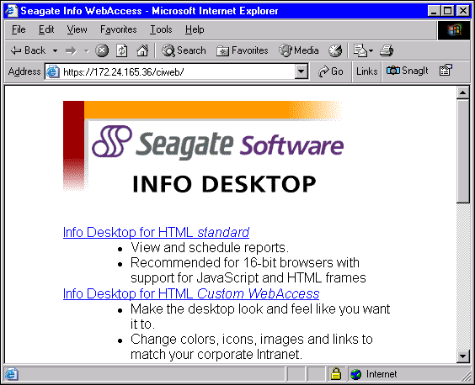

To select the version you would like to run on, simply click on the appropriate link, either Info Desktop for Java or Info Desktop for HTML. This will pull up a dialog box asking you to supply your Username and Password. Depending on which version of Info Web Access you selected, your logon screen will look like one of the screen views on the previous page. Recall that our APS is finmarsa1.

After typing in a valid APS, User Name, and Password, simply click on OK if using HTML, or Connect if using Java. This will pull up the Web Access desktop of your choice.

INFO WEB ACCESS- Html LOGON SCREEN
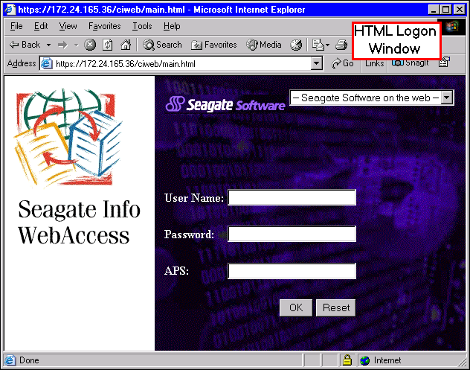

INFO WEB ACCESS- JAVA LOGON SCREEN
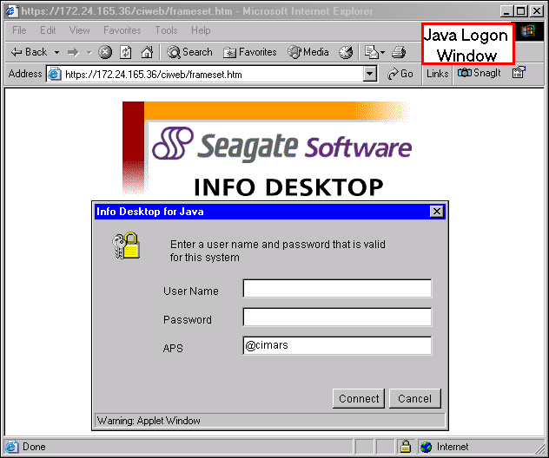

For the remainder of our lesson, you will be using the Info Desktop for Java.

INFO WEB ACCESS- DESKTOP LAYOUT (JAVA)
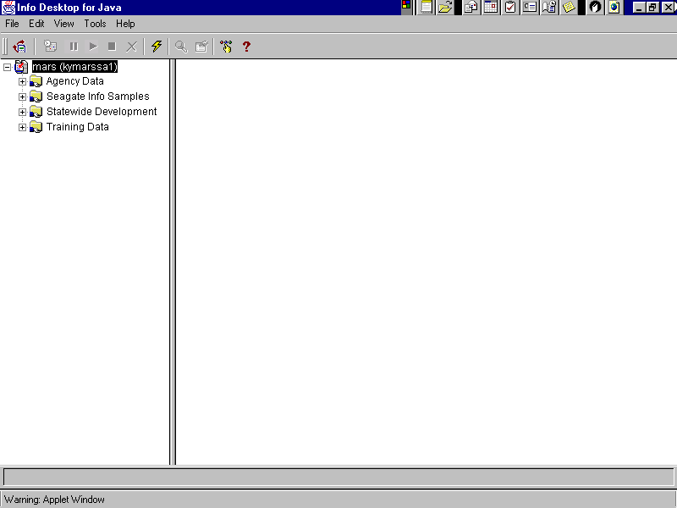

Desktop Layout (Java)
The Info Desktop for Java looks very similar to the Standard Desktop layout that you have been using. An example of this desktop layout is shown in the screen view on the previous page. Active drop-down menus as well as a toolbar are displayed across the top of the screen. The Folder Tree on the left displays the APS name and folders just as it did in the standard desktop. The right side of the screen displays the Job Information List Box in which the objects and instances are contained.

The Info Desktop for Java includes a toolbar with several buttons for you to use for common tasks. Some of these will look familiar to you as they are the same as in the standard desktop. For most common tasks you will be using the following:

Opens the Schedule dialog box.

Deletes the highlighted object/instance from the Desktop.

Refreshes the Folder Tree and Job Information List Box.

Opens a report for viewing in the Info Viewer.

Allows you to view properties for the selected folder, object, or instance.

Allows you to set custom options.

Provides Help for the Desktop.

The left side of the Info Desktop contains the Folder Tree just like the Standard Desktop did. Recall that in order to review or use the contents of a folder, simply click on the symbol to expand the contents or click on the folder itself to display the contents.

The right side of the Info Desktop contains the Job Information List Box. This will display the contents of the folder that you opened in the Folder Tree. Within the Job Information List Box, you can review properties, delete, and view the objects contained in the folder.

Info Standard Desktop vs. Info Web Access Desktop
There are, however, some key differences between the Standard Desktop and the Info Web Access Desktop. These are:

- You can only have one folder open at a time. Recall that in the Standard Desktop that you were able to open many folders at once in order to view their contents.

- You do not have access to the Report or Query designers. You are only permitted to create a new report or query from scratch within the Standard Desktop.

- Limited control over instances. Recall that in the Standard Desktop, you were able to limit instances in various ways. This functionality is not offered via the web.

- Unlike the Standard Desktop, the Web Access will not allow you to view queries or print the report. You can, however, print the report from the Internet toolbar on top, just like you would with any other page that you were viewing via the Web.

Now that you have been introduced to the Info Web Access, it is time for you to try to access this from your own desktop.

Logging on the Info Web Access Desktop (Java)
Step 1 Open up Internet Explorer on your desktop.

Step 2 In your Address window. Type https://172.24.165.36/ciweb and hit the <ENTER> key on your keyboard.

Step 3 On the Main screen. Choose Info Desktop for Java by clicking on its appropriate hypertext link.

Step 4 In the Log On screen. Enter your User ID, Password and APS (kymarssa1).

Step 5 Click the <CONNECT> button. This will connect you to the Info Web Access for Java Main window. All of the folders, objects, and instances are located here.

LOG ON SCREEN FOR JAVA
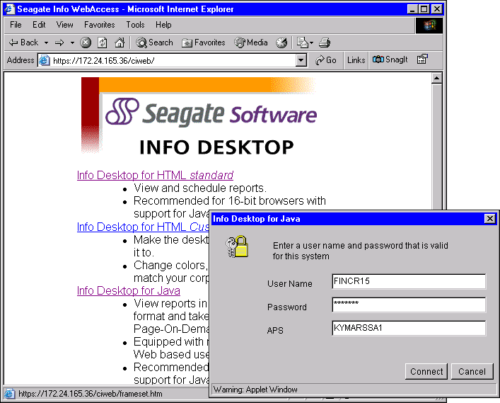

Scheduling via the Web (Java)
Just like the Standard Desktop, scheduling from the internet allows you to schedule objects for immediate processing, recurring processing, or processing at a specific date and time. To schedule a job in the Info Desktop for Java, simply highlight the object you wish to schedule and click on the <SCHEDULE> button. You can also access the Scheduling dialog box by clicking on EDIT|SCHEDULE from the menu bar.

This will activate the Schedule dialog box, which contains the same functionality in a similar format as the Standard Desktop. The screen view on the next page shows the Schedule dialog box with the Info tab active. You can see that the format is the same as it was in the Standard Desktop.

SCHEDULING ON THE WEB- INFO TAB
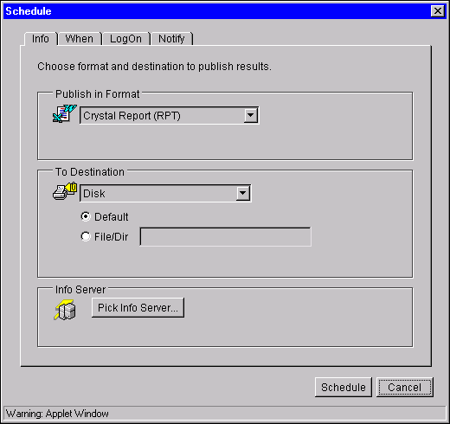

VIEWING INSTANCES
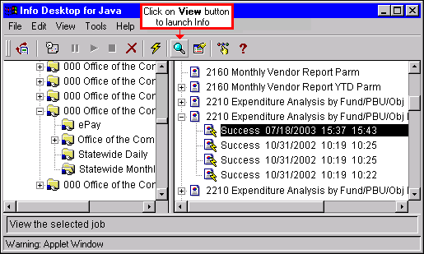

Viewing Instances (Java)
Once an object has been processed (scheduled to run with a successful instance), you can view the resulting instance from within the web browser. Both the Info Desktop for Java and HTML allow you to select the type of viewing mechanism you use to view reports and other objects. For this lesson, you will learn about the Info Viewer used in the Info Desktop for Java.

The Web Access Desktops are designed to schedule and manage report objects, while Info Viewers are used to view those instances that were run successfully. This functionality is the same as if you were in the Standard Desktop. The Info Viewer for Java allows you to view reports using the Page on demand technology. Recall that this means that instead of sending the entire report over the network, only the page that you request is sent. This will greatly reduce the network traffic and resources used. With the Info Viewer for Java, you can Drill-Down on any group, sort your data, as well as searching for data.

To view a report in the Info Viewer for Java, simply highlight a successful instance and click on the <VIEW> button. A report viewed with the Info Viewer in Java will look similar to the screen view on the previous page.

You will be able to drill-down on data just like you did in the Standard Desktop. After you are finished viewing a report, you may return to the Web Access Desktop by clicking on the <BACK> button of your web browser.

PROPERTIES OF AN INSTANCE - GENERAL TAB
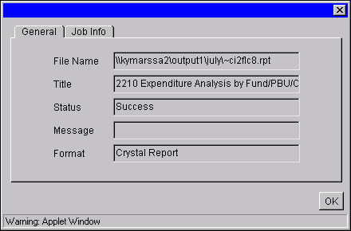

PROPERTIES OF AN INSTANCE - job info TAB
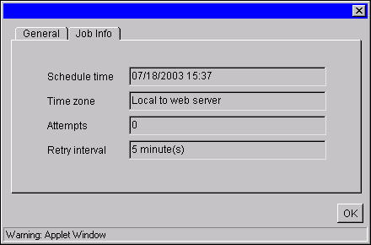

Properties of an Instance
After an object has finished processing, you may want to view property information on the resulting instance. Information such as start time, end time, or destination. The screen view on the previous page shows an example of a successful instance’s property information.

To view the properties of an instance, simply highlight the instance you would like to view the properties for in the Job Information List Box and click on the <PROPERTIES> button. You can also access these properties by highlighting an instance and selecting VIEW|PROPERTIES…from the menu bar.

This will open the Properties dialog box as seen on the top of the previous page with the General tab active. Information into the name, title, status, and format will be given within the General tab. Information into the scheduling of the object will be given in the other tab, the Job Info tab.

CUSTOMIZING THE DESKTOP
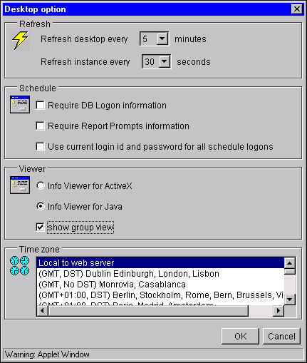

Customizing the Web Access Desktop
Seagate Crystal Info will allow you to customize your Web Access Desktop in various ways. There are three main areas in which the Desktop can be customized:

- Refresh rate
- Scheduler
- Viewer, and Time Zone

To get into the custom options, simply click on the <CUSTOMIZE> button. This will activate the Desktop Option dialog box as shown in the screen view. The first option to customize is the refresh rate for both the Desktop and instances. This will allow you to set how long the system should wait before it refreshes the screen with any updated information. The second option is to customize your scheduling features. Change this option according to how the log in process should function. The third option to customize is the viewer choice that you would like. For this lesson, you have been using the Info Viewer for Java. The last area to customize is the time zone in which you would like to do your scheduling.


In this topic we have:

- Gain access to the Info Web Access Desktop

- Navigate through the desktop main screen

- View reports on the desktop

- Schedule instances on the web

- Understand certain customization features of the web



Are there any questions concerning the information covered in this topic?

