TOPIC 5 EXPORTING DATA

PURPOSE

The purpose of this topic is to learn how to export these reports into different applications such as Microsoft Excel and Microsoft Word.

OBJECTIVES

At the end of this topic, you will be able to:

- Export a report from Info Desktop to Microsoft Excel

- Export a report from Info Desktop to Microsoft Word

Now that you’ve seen the process of accessing report data, let’s perform a walkthrough to export the instance.

EXPORTING A REPORT FROM THE INFO DESKTOP
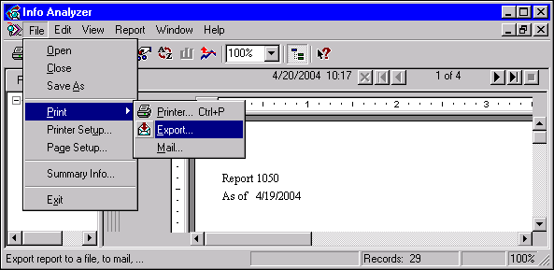

Exporting Reports
Seagate Report Instances can be exported from within Info Viewer or Info Analyzer. When viewing within Info Analyzer, Seagate Report Instances can be exported in a number of different formats. When viewing within Info Viewer, the formats are limited. For this lesson, you will export into Microsoft Excel and Microsoft Word. However, keep in mind, there are other options. The same steps that will be taken for these applications should fit most of the others.

While the Info Viewer and Info Analyzer are powerful tools to analyze reports, you may prefer other applications for doing certain tasks. For example, you can save report data in a format that can be viewed as a spreadsheet in Microsoft Excel.

NOTE: Microsoft Word and Excel 2000 users can only export via Info Analyzer.

Exporting a Report into Microsoft Excel
Step 1 Switch the viewer to Info Analyzer.

Step 2 In the Job Information List box. Open a successful report instance.

Step 3 On the Menu Bar, select File: Print: Export report (or click on the Export icon on the tool bar). The Export window is displayed.

Export Window
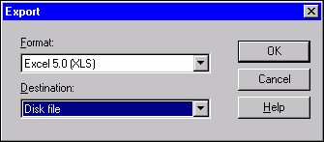

Step 4 In the Format drop down box. Select Microsoft Excel 5.0(XLS).

NOTE: For training purposes we are exporting to MS Excel and MS Word. However, any of the formats shown in the Format drop down box are available for export.

Step 5 Click on the <OK> button. The Choose Export File window is displayed.

Choose Export File Window
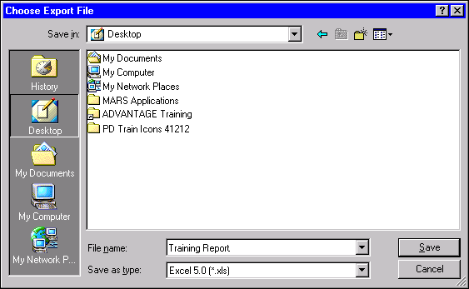

Step 6 In the SAVE IN field. Choose Desktop.

Step 7 In the FILE NAME field. Training Report.

Step 8 Click on the <SAVE> button. The Exporting Records window is displayed. This displays the progress of the exporting job. If your file is small, you may not even see this screen appear on your desktop.

Exporting Records
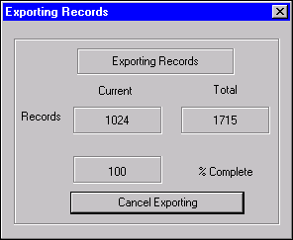

Step 9 On the Menu Bar, select File: Exit.

Now lets take a look at this report in Microsoft Excel format.

SEAGATE REPORT IN MICROSOFT EXCEL FORMAT
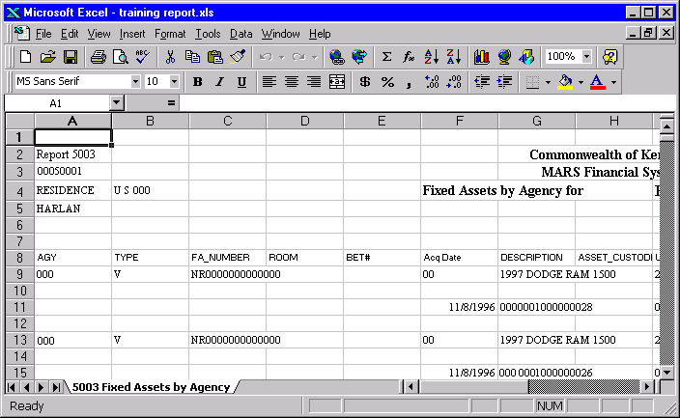

To open the Microsoft Excel file that you just finished exporting, go to the location that it was saved in and double click on the file to open it up.

Step 10 On your Desktop. Locate the Training Report icon and double-click on it.

As you can see, the report data has been transferred into Microsoft Excel. The Column headings appear in bold at the top of each column in Microsoft Excel. From here you can view the data, edit the data and print the data. Users who are proficient in Microsoft Excel will be able to enhance this report in many ways.

Exporting a Report into Microsoft Word
Step 1 In the Job Information List box. Open a successful report instance.

Step 2 On the Menu Bar, select File: Print: Export report. The Export window is displayed.

Step 3 In the Format drop down box. Select Word for Windows Document.

Step 4 Click on the <OK> button. The Choose Export File window is displayed.

Step 5 In the SAVE IN field. Choose Desktop.

Step 6 In the FILE NAME field. Training Report.

Step 7 Click on the <SAVE> button. You can now view your file.

EXPORTed REPORT IN MICROSOFT WORD
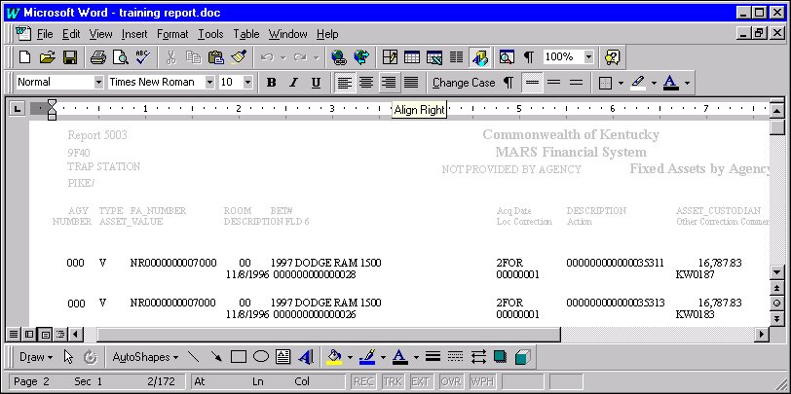

Step 8 On the Menu Bar, select File: Exit.

Step 9 On your Desktop. Locate the Training Report icon and double-click on it.

Step 10 Close and delete both the Excel and Word document you completed.



In this topic we have:

- Exported a report from Info Desktop to Microsoft Excel

- Exported a report from Info Desktop to Microsoft Word



Are there any questions concerning the information covered in this topic?

