TOPIC 4 ANALYZING REPORTS WITH SEAGATE

PURPOSE

The purpose of this topic is to familiarize you with the two main viewing mechanisms, Info Viewer and Info Analyzer, within Seagate Info Desktop. You will learn how to use the Group tree for navigating as well as various searching techniques for data location.

OBJECTIVES

At the end of this topic, you will be able to:

- Gain access to objects using the Info Analyzer

- Gain access to objects using the Info Viewer

- Use the Group tree and expert searching tools to locate and manipulate data

DESKTOP OPTIONS DIALOG BOX
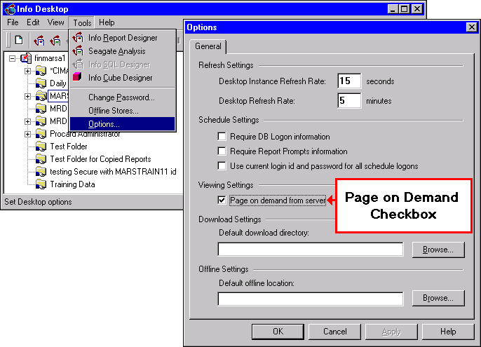

Info Viewer and Info Analyzer
Before viewing reports in Seagate, the user will need to select whether or not to view one page at a time or the entire report. To accomplish this, the user will need to go to the Menu Bar, select Tools: Options. Under the VIEWING SETTINGS field, place a check mark in the box for PAGE ON DEMAND checkbox this initializes Info Viewer. When using Info Viewer, only the page you are viewing is sent from the server, not the entire report. This enhances the processing speed for reports. To view the report in its entirety, leave the PAGE ON DEMAND checkbox blank which allows Seagate to use what is known as the Info Analyzer.

NOTE: If the box is checked, Info Viewer will be used to open the report. If the box is unchecked, Info Analyzer will be invoked for viewing the report.
Both the Info Viewer and Info Analyzer tools have certain advantages for viewing a report. While the Info Viewer is better for reducing traffic on the network, Info Analyzer offers more data and report manipulation functionality. Now you will examine the two main viewing mechanisms within Info Desktop.

Let’s start with the Info Viewer.

Info Viewer
Recall that the default view settings are set for Page on demand. This means that only the page you are viewing is sent from the server. We also discussed how a user can toggle back and forth between the two viewers by choosing TOOLS|OPTIONS and using the PAGE ON DEMAND checkbox. For this section, make sure your PAGE ON DEMAND checkbox is toggled on.

This section will focus on viewing, analyzing, and formatting Seagate Reports by
using the Info Viewer. To activate the Info Viewer, simply highlight a successful
instance and click on the <VIEW> button on the toolbar.

The Info Viewer offers two search options. The first option is a simple straight text search. This means that when you type text into the search box, the Info Viewer will look for an exact match in the records in any field or column of the report

Let’s perform a straight text search.

Info Viewer
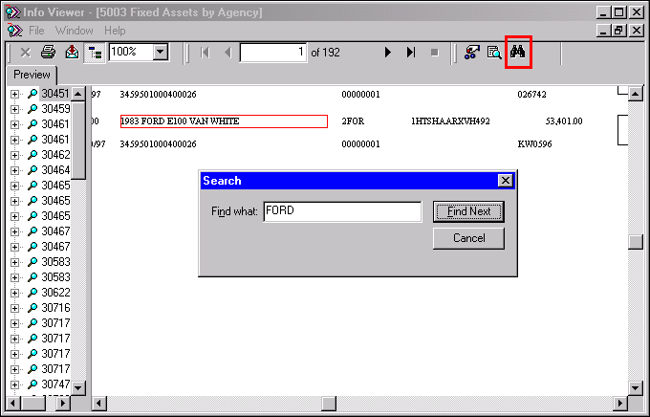

Straight Text Search
Step 1 Click on the MARSTRNG folder.

Step 2 Double click on 5003 Fixed Assets by Agency.

Step 3 Double click on the first successful instance.

Step 4 Click on the Search icon on the tool bar. The Search window is displayed.

Step 5 In the FIND WHAT field. Type the search criteria, FORD.

Step 6 Click the <FIND NEXT> button. Info Viewer searched for that text and highlighted the first instance found with a red box.

Step 7 In the Search window. Click the ‘X’ in the upper right hand corner.

Step 8 On the Menu Bar, select File: Exit.

Search Expert window
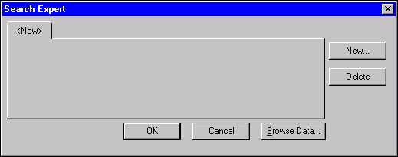

Search Expert
Another search option within Info Viewer is the Search Expert. This option is allows the user to search for more specific criteria. Let’s search using the Search Expert.

Step 1 Click on the MARSTRNG folder.

Step 2 Double click on 1050 Revenue Detail.

Step 3 Double click on the first successful instance.

Step 4 Click on the Search Expert icon on the tool bar. The Search Expert window is displayed.

Step 5 Click on the <NEW> button. The Fields window is displayed.

Fields Window
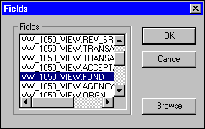

Step 6 Select VW_1050_VIEW.FUND as the field you would like to search by and click the <OK> button. The Search Expert window returns with a new tab.

Search Expert Window
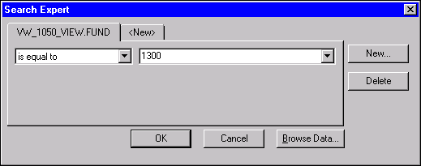

The Search Expert window contains two drop down list boxes: the operators, and the edit. These dialog boxes are dynamic in that different data types and selection criteria change the dialog box options. When you select a record with number, currency, or string fields, the operators drop down box will contain primary conditions. The type of field you are searching will determine the operator you select. Some example operators include:

- Is any value- select records that contain any value in the selected field.

- Is equal to- value in selected field is equal to the specified value.

- Is less than- value in the selected field is less than the specified value.

- Is greater than- value in the selected field is greater than the selected value.

- Is between- value in the selected field falls between or matches one of two values to be specified.

- Is one of- value in the selected field is one of two or more values.

- Is starting with- value in the selected field starts with the specified value.

- Is like- value in the selected field can be specified by using two commands: <?> for one character, <*> for many characters. If using Select Records on a date field, all of the choices listed above plus two others will appear in the operators’ drop down box.

- Is in the period- value in the selected field falls within the specified date range.

- Is not in the period- value in the selected field does not fall within the specified date range.

Step 7 In the OPERATORS drop-down box. Select is equal to.

Step 8 In the EDIT drop-down box. Select 1300.

Step 9 Click the <OK> button. Info Viewer searched for that Fund and highlighted the first record found with a blue box.

Info Viewer
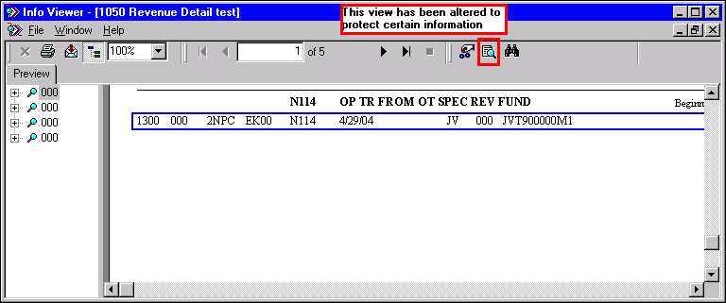

Step 10 On the Menu Bar, select File: Exit.

Select Expert Window
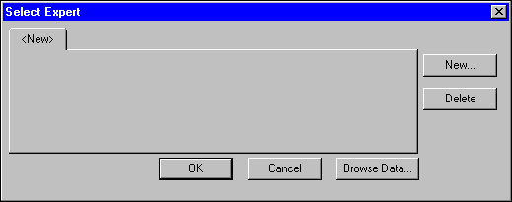

Select Expert
Info Viewer also offers a powerful tool for viewing specific data contained within a report. The tool is called the Select Expert. This command will allow you to select specific records to include in the report. This is useful when you do not want all the records contained in a given report.

For example, an expenditure or revenue report for your agency may contain data for all funds used by your agency. However, you may only be interested in the data relating to the General Fund (0100). The Select Expert enables you to restrict the report so that only the General Fund information is included without having to re-run the report. When using the Select Expert, Seagate will automatically generate a record selection formula based on settings specified in the dialog box.

NOTE: An important point to consider is that when selecting records, you are querying down on the data that is stored within the report file. Seagate is not hitting the database again to retrieve new records.

Let’s use the Select Expert to pull information for the General Fund only.

Step 1 Click on the MARSTRNG folder.

Step 2 Double click on 1051 Revenue Detail.

Step 3 Double click on the first successful instance.

Step 4 Click on the Search Expert icon on the tool bar. The Search Expert window is displayed.

Step 5 Click on the <NEW> button. The Fields window is displayed.

Fields window
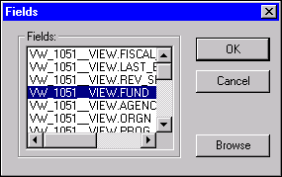

Step 6 Select VW_1051_VIEW.FUND and click the <OK> button. The Select Expert window returns.

Select Expert window
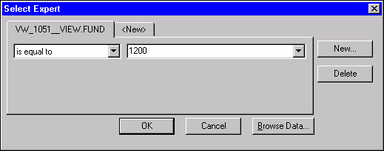

The Select Expert window contains two drop down list boxes: the operators, and the edit. These dialog boxes are dynamic in that different data types and selection criteria change the dialog box options. When you select a record with number, currency, or string fields, the operators drop down box will contain primary conditions. Some primary conditions are shown below:

- Is any value- select records that contain any value in the selected field.

- Is equal to- value in selected field is equal to the specified value.

- Is less than- value in the selected field is less than the specified value.

- Is greater than- value in the selected field is greater than the selected value.

- Is between- value in the selected field falls between or matches one of two values to be specified.

- Is one of- value in the selected field is one of two or more values.

- Is starting with- value in the selected field starts with the specified value.

- Is like- value in the selected field can be specified by using two commands: <?> for one character, <*> for many characters. If using Select Records on a date field, all of the choices listed above plus two others will appear in the operators’ drop down box.

- Is in the period- value in the selected field falls within the specified date range.

- Is not in the period- value in the selected field does not fall within the specified date range.

Step 7 In the OPERATORS drop-down box. Select is equal to.

Step 8 In the EDIT drop-down box. Select 1200.

Step 9 Click the <OK> button. Info Viewer searched for that Fund and returns a report including only the specified information.

INFO VIEWER
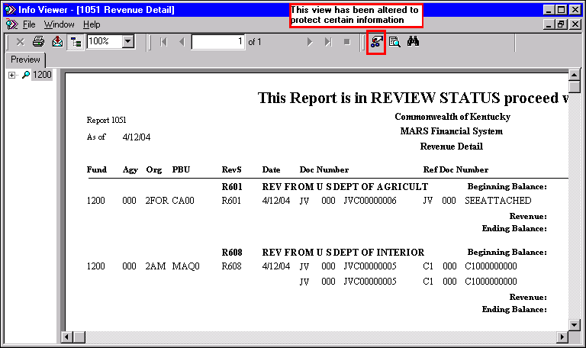

The criterion used for filtering was: VW_1051_VIEW.FUND is equal to 1200. After clicking on the <OK> button, Seagate Info searched the FUND field for records in which the value of the fund was equal to 0100. The above view shows the specialized report based on the criterion selected. Users will be able to print and export this report view. However, Seagate Info will not save this report. The report must be exported and saved to another location.

Step 10 On the Menu Bar, select File: Exit.

Let’s continue and look at the Group Tree within Info Viewer.

INFO VIEWER- DRILL-DOWN REPORTS
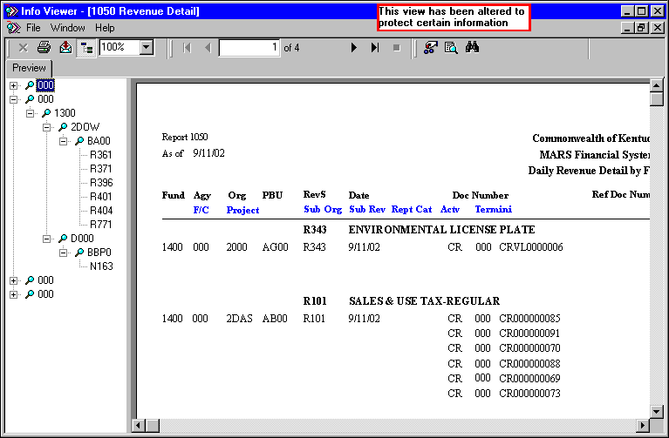

Group Tree
The Info Viewer supports a function called Drill-down on reports. When you place your cursor over a summary field, a magnifying glass will appear as shown in the screen view. Just double click on this field and the details behind that summary field will come up in a new report window.

You will also notice from the screen view that there is a left margin with summary field data in it. The fields that contain a magnifying glass to the left are the fields that Drill-down will work on. This margin on the left of the preview window is known as the Group tree-Smart Navigation. This Group tree can be turned off and on by clicking on the <GROUP TREE> button. Another method of doing this is to right click your mouse button on a white area in the report and select Group tree from the available options.

The Group tree functions similarly to a directory tree with a heading for each group in your report with the ability to expand that group to see deeper levels. In order to expand a group in the Group tree, simply click on the plus sign icon next to the group name. Clicking on a minus sign icon will collapse the group to its original state. If there are no plusses or minuses next to a group, it means that there is only one level of grouping.

All of the tools mentioned in this section will help you in viewing and analyzing reports in the Info Viewer.

Now, let’s look at the other tool for viewing reports, the Info Analyzer.

NOTE: Due to configuration changes, Seagate requires an additional file (Registry Edit) to access Info Analyzer. If you receive the following message while attempting to view reports through Info Analyzer, Please contact your System Administrator for assistance.

Error Message
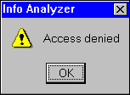

NOTE: A Reminder that although ADVANTAGE posts immediately; MRDB is NOT real time. MRDB runs in the nightly cycle and posts the following day. The results of these reports are one (1) day behind.

Info Analyzer
This discussion will focus on viewing and analyzing reports from the Info Analyzer. To work through this section, you will need to go to TOOLS|OPTIONS on the menu bar and toggle the PAGE ON DEMAND checkbox to the ‘OFF’ position. With the PAGE ON DEMAND toggled off, simply highlight a successful instance in the Job Information List box and click on the <VIEW> button. You will now be viewing your report using Info Analyzer.

The screen view shows a report being viewed by Info Analyzer. While Info Viewer and Info Analyzer show similar functionality, there are some important differences. Let’s compare the two ways of accessing information.

The Zoom Control feature in the Info Analyzer works the same as in the Info Viewer except for an additional feature called Custom Zoom. This can be activated from the preview screen in Info Analyzer by selecting VIEW|ZOOM from the menu bar. This will pull up the Magnification Factor dialog box in which the custom settings can be entered. A magnification factor from 25-400% can be used in this dialog box.

INFO ANALYZER- CUSTOM ZOOM
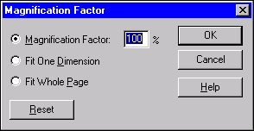

Info Analyzer Search Options
The search options in Info Analyzer are similar to the ones in Info Viewer. However, there are some more advanced features contained in Info Analyzer. To access the Search, you can either click on the Search icon or select EDIT|SEARCH from the menu bar when viewing a report. We will now discuss the main differences with the Info Analyzer’s Search and Search Expert.

Info Analyzer also offers a straight text search or Find option, as shown. Users simply type the text in the FIND WHAT field and click on the <FIND NEXT> button. This option searches the entire report for any instance of the text entered and highlights the first instance it finds with a box.

INFO ANALYZER- SEARCH/find
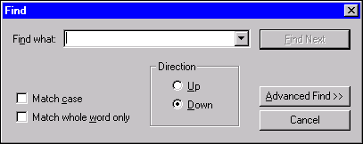

To open Info Analyzer’s Search Expert, click on the <ADVANCED FIND> button.

Info Analyzer-Search Expert
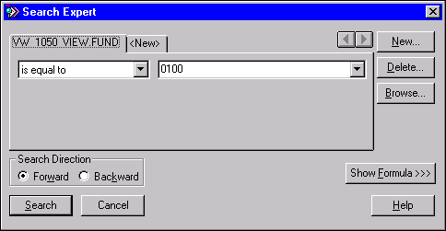

As in Info Viewer’s Search Expert, you will need to select a search field from the Field Window. Now you are ready to select an operator form the Operator drop-down box. Remember, the type of operator you selected is based on the type of field you are searching, i.e. date, currency, text. The Edit drop down box is where you will enter the value on which to base the search. You can either type a value directly into the box or click on the down arrow to open a list of values. In addition, when using Info Analyzer, you may click the <BROWSE> button. A dialog box will appear displaying a list of values. To choose one of these values, simply select one from the list and click the <PASTE> button to put it into the edit box.

The main difference between the two Search Expert tools is the forward and backward radio buttons when using Info Analyzer. You may select one of these radio buttons to specify the direction of the search. Use DOWN (the default direction) to search through the report. After you reach the end, select UP to return to a value in your report that had been previously located.

INFO ANALYZER- SORT DIRECTION

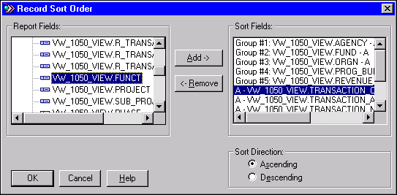

Info Analyzer Sort Option
Sorting is used to organize the order in which data appears within the report. The Info Analyzer provides you with a powerful tool to analyze your data. You will use Sort records to change the order in which records appear in the report. You have the capability to add, remove, and define the sort direction of sort fields for the data in the report. The sort direction may either be ascending or descending. A sort field is simply the data that the sort procedure will be based on.

To open the Record Sort Order dialog box as seen on the previous page, simply click on the <SORT> button when in Info Analyzer. The fields used in the report that you are viewing are listed in the Reports Field box. If there are any Sort Fields already established, they will be listed in the Sort Fields box.

- The <ADD> button will add the highlighted REPORT field.

- The <REMOVE> button removes the highlighted SORT field.

- The Sort Directions box is used to set the sort direction.

Sorting is done automatically for all groups. The sorts specified in the Sort Fields box will take lessor precedence than any group sorts. The Seagate Reports designer may have already added a sort criterion to the report before making it publicly available. The Info Analyzer allows the addition or modification of sort criterion in the report.

Now lets try an exercise dealing with some of the functions we have been discussing.


For this exercise, you must make sure that your Page on demand checkbox is turned OFF. Try viewing a successful instance of one of your Agency reports using the Info Analyzer. Now perform the following four tasks to this report:

- Zoom the report to the highest magnification level.

- Change the magnification to Page Width and toggle off the Group tree.

- Sort in descending order on one of the fields within the report.

- Perform a simple search for one of the selected records.

INFO ANALYZER- SELECT EXPERT
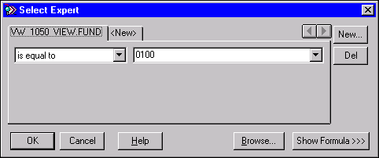

Info Analyzer Select Expert
The Info Analyzer also contains the Select Expert functionality, as did Info Viewer. Recall from the earlier discussion that when using Select Records Expert, Seagate automatically generates a records selection formula which is based on settings specified in the dialog box. To open this dialog box, choose the REPORT|SELECT EXPERT command or click on the <SELECT EXPERT> button when in Info Analyzer.

After selecting a field, you need to make selections under the two drop-down boxes just like you did for the Info Viewer. This Expert however, allows you to set up more complex selection criteria.

In order to gain more control over the formula that is generated, you can use what is called the Formula Editor. To open this Editor, click the <SHOW FORMULA> button from within the Select Expert dialog box. This will expand the dialog box and will display the <FORMULA EDITOR> button.

NOTE: We will not discuss the Formula Editor in this class. For more information concerning this functionality, please refer to the Crystal Reports class offered by the Governor’s Office of Technology, Information Technology Training.

INFO ANALYZER- TOP N/SORT GROUP EXPERT
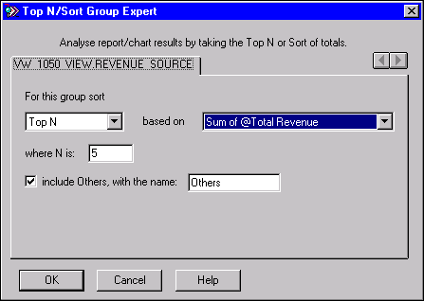

Info Analyzer Top N Expert
The Info Analyzer is also equipped with a special grouping functionality. A group is nothing more than a set of records that are related to each other in some way. The Info Analyzer allows you to modify group data in a variety of ways with a grouping feature called Top N Expert.

The Top N Expert allows you to modify an existing report and create a Top N report that focuses on the Top N or Bottom N groups- N being a number specified by you. For example, to find the top five Allotment balances by Agency when within an Allotment File report, you will use this feature to print only the information for the top five Allotments. To open the Top N Expert dialog box, click the <TOP N> button on the toolbar when in the Info Analyzer.

The Top N Expert dialog box will appear with a tab for each group field in the report. The name of each tab is the name of the field that triggers the summary.
The top left box is a drop-down list box that enables you to specify the number of groups to print in the report. This box contains three options:

- Sort all- The program will sort and print all groups.

- Top N- The program will sort and print the Top N groups. You will specify the number of groups.

- Bottom N- The program will sort and print the Bottom N groups. Again, you will specify the number of groups.

To the right of that box is the of drop-down list box. This box lists all of the summaries by which groups can be sorted. The selections that you make in this box will determine which subtotal the report is going to be sorted on and the Top N or Bottom N that will appear on the report. With the Top N or Bottom N options, you will specify the number to have designated as N. If choosing the Sort All option, a box will appear that lists the summary or summaries chosen to sort by. If you would like to remove a summary from the list, simply highlight it and click the <DELETE> button.

Once a report is accessed, you may want to print the report for others to see or export the report into other software applications. You would follow the same process whether you were using Info Viewer or Info Analyzer.

PRINTING A REPORT FROM THE INFO ANALYZER
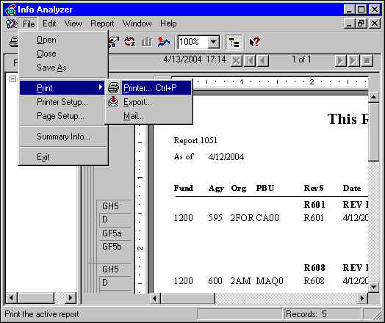

How to Print a Report within Info Analyzer
Step 1 On the Menu Bar, select File: Print: Printer. The Print Dialog box is displayed.

Step 2 Select the range and the number of copies you would like to print.

Step 3 Click the <OK> button.

To print a report within the Info Viewer simply click on the Printer icon.


In this topic we have:

- Gained access to objects using the Info Analyzer

- Gained access to objects using the Info Viewer

- Used the Group tree and expert searching tools to locate data



Are there any questions concerning the information covered in this topic?

