TOPIC 3 SCHEDULING IN SEAGATE

PURPOSE

The purpose of this topic is to provide hands on experience with scheduling reports within Seagate Info. Various scheduling such as calendars, dependencies and controlling instances will also be discussed.

OBJECTIVES

At the end of this topic, you will be able to:

- Schedule a standard Crystal Report

- Schedule a recurring Crystal Report

- Discuss output formatting and controlling instances

- Discuss some advanced scheduling features

- Schedule a parameterized Crystal Report

Scheduling Reports
Scheduling is probably the single most important tool within Info Desktop. This tool allows you to run objects such as reports. The scheduling feature can be set to run a report automatically or at specific times under specific circumstances and refresh automatically. Instances are created when a scheduled object runs successfully.

More advanced scheduling techniques allow you to schedule objects that depend directly on the successful instance of another object. For example, you can schedule a program to send an e-mail message to your Administrator only if a scheduled object produces a successful instance.

Depending on the type of report you want to schedule the Schedule window will contain four to six Scheduling tabs.

- The Info, When, Notify, and Log on tabs are always displayed.

- The Selection Formula tab is displayed when you are scheduling a report object that contains a selection formula.

- The Prompts tab is displayed when you are scheduling a report object that contains a parameter field.

Let’s look at examples of the Scheduling tabs.

REPORT SCHEDULING – INFO TAB
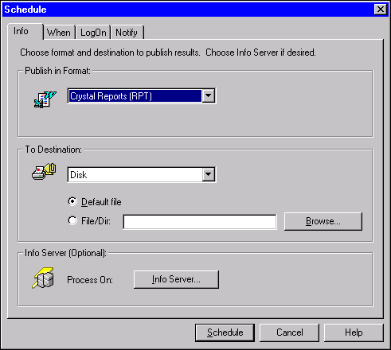

Info Tab
The Info tab is used to specify the format, destination, and output options that the Info Server should use when running a report. When you log on to Seagate the server is selected at that time and you will not need to specify the Info Server. The example on the screen view shows that the format to be published is Crystal Reports and the destination to publish our results is Disk.

The first step to take from within this tab is to specify the output format for that object. If a user doesn’t specify a specific output format, the program will default to Crystal Report (RPT) format as seen on the screen shot. Aside from this default value, there are numerous output options available to choose from.

If you choose from the following list: Crystal Reports, Excel, HTML, Lotus, Postscript, Rich Text Format, Tab-Separated Text, Text, or word formats, this step will be completed. If you choose Character-Separated Value, Comma-Separated Values, Data Interchange Format, Record Style, or Tab-Separated Values, you will also need to specify whether the program should use the same number and date formats as specified in the report. Once the publishing format has been selected, you must decide where you want the object output sent. The available choices are: Disk, Microsoft Mail, Mail/NotesMail, Fax Machine, Lotus Notes, MS Exchange Public Folder, Channel, or Printer.

If you choose Disk as your destination choice, you can specify a couple of criteria. You can select the DEFAULT FILE field, in which case the output is sent to the directory specified as the default output directory. It will be given a random file name and an extension based on the format you selected. The other option is to select FILE/DIR field. This will allow you to specify the file name and directory where you wish the output to be sent.

Another popular destination is to send the output to Microsoft Mail. You can specify the recipients of the report output, a subject and a message to accompany the report. This feature is extremely useful when your supervisor or other coworkers need to be notified when a report is scheduled along with the results from the process.

For our examples we will not change the default setting on the Info tab.

REPORT SCHEDULING – WHEN TAB
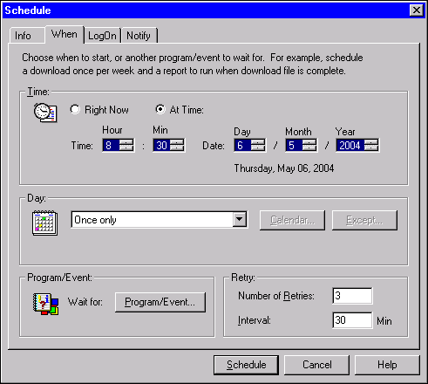

When Tab
The When tab is used to specify the date(s) and time(s) an object should run. You can also use this tab to specify certain dependencies. For example, if you wanted an object to run only on the completion of some other object or on the setting of an event, you can specify it using this tab.

Scheduling an Object at a Specific Date/Time
Step 1 In the Job Information List box. Highlight the report object you want to schedule.

Step 2 On the Info Desktop toolbar. Left click the Schedule icon. The Schedule window is displayed.

Step 3 Select the When tab to specify the time you would like the object to run.

Step 4 Click the At Time option button to display the edit boxes for setting date/time.

Step 5 Enter the following information for the corresponding fields:

TIME. You can set the time and date by clicking on the arrows to the right of each editing box. Select 8:30 as the scheduling time.

NOTE: MRDB is sometimes extremely busy during the early morning hours. Therefore, it is recommended that you set a time of 8:30 AM or after.

DAY. Notice in our example that the DAY field is scheduled for Once only. Select a day one week from today.

RETRY. This field gives the user the opportunity to select the number of retries, and set an interval, in case the object instance fails. Select 3 as the number of retries.

LogOn Tab
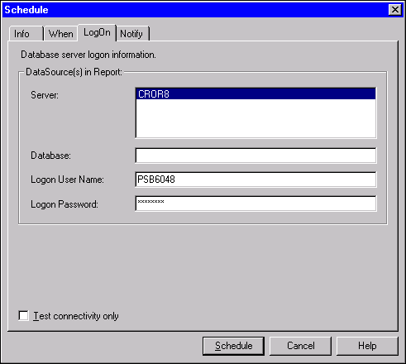

LogOn Tab
The Log On tab is used to specify the logon parameters. The Oracle database that you will be using is password protected. Therefore, you will be required to supply your Oracle Username and Password for scheduling objects. Do not confuse this with your Seagate password.

Step 6 Select the Log on tab.

Step 7 In the LOGON USER NAME field. Enter Your Oracle Username (usually your RACF ID/USER ID.

Step 8 In the LOGON PASSWORD field. Enter Your Oracle Password.

NOTE: When clicking on the Logon tab, the cursor defaults to the Database Field. Many Reports fail because users forget to tab down to the next field before entering their logon user name.

SCHEDULING REPORTS- E-MAIL NOTIFICATION
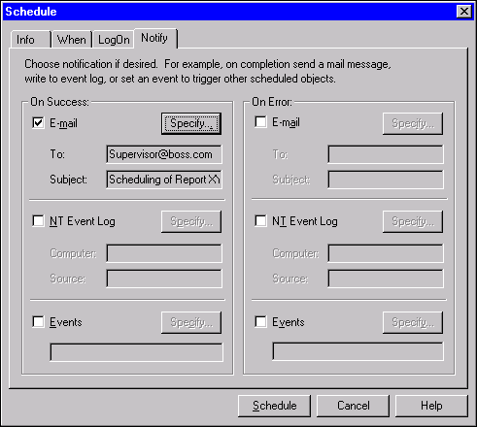

Notify Tab
When scheduling an object, you may want to notify yourself or someone else if the process has succeeded or failed. You can designate that an e-mail message be sent alerting whomever you choose about the results of the process. The Notify tab is used to set up those notification specifications for both successful as well as unsuccessful object completion. In the screen shot a successful report run will be made by way of E-mail.

Step 9 Select the Notify tab.

Step 10 In the ON SUCCESS field. Select the E-mail option box.

Step 11 Click on the <SPECIFY> button. The E-mail Notification window is displayed.

Step 12 In the TO field. Type Supervisor@boss.com.

Step 13 In the SUBJECT field. Type Scheduling Report XYZ.

Step 14 Click the <OK> button. The user will be returned to the Notify tab.

Step 15 Click the <SCHEDULE> button. The program is now scheduled to process at the date/time that you have specified.

REPORT SCHEDULING – SELECTION FORMULA TAB
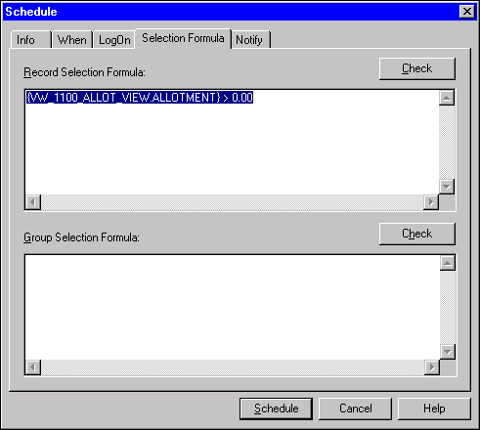

Selection Formula Tab
This tab is displayed if your report object includes a selection formula. This tab can be used to view and modify the selection formula. The <CHECK> button is used to test the formula for errors. If there is an error in the formula, you can modify it by directly changing its text.

REPORT SCHEDULING – Prompts TAB
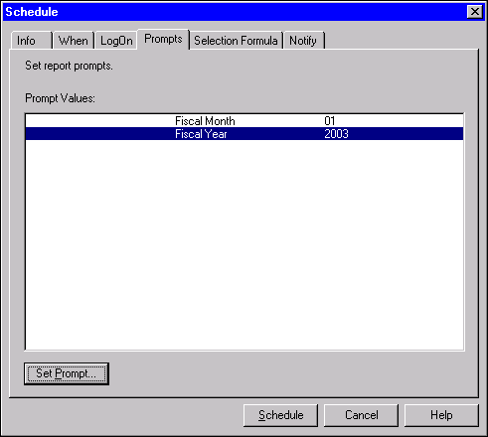

Prompts Tab
The Prompts tab is displayed when a report object includes prompting variables. This tab can be used to modify the variable values contained within the report object.

Now, let’s take a look at how to schedule a recurring report.

REPORT SCHEDULING – RECURRING
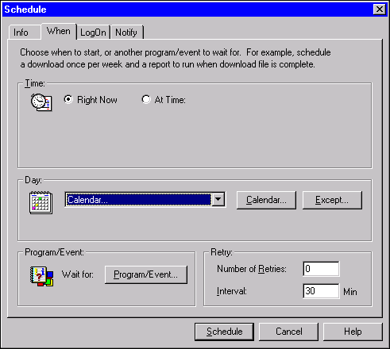

Scheduling a Recurring Report Object
The Info Desktop allows you to schedule objects for recurring processing. For example, you can schedule and object to run at a specific time every Friday.

If the user chooses Right Now as their option, the object will be processed immediately and at the same time every day, every week, etc. By choosing the <AT TIME> button, the object will be processed at the specified time every day, every week, etc. The Day drop down box is where you will specify the frequency of the recurring processing.

There are many options available here for recurring processing. Depending on the importance and size of the report, certain intervals and times will be best.

The Info Desktop provides many pre-defined calendars to use when scheduling reports, queries or objects. These calendar options include: Once Only, Every Day, Every Week, Every X Hours, Every x Months, Nth Day of every month, Last Day of every month, and First Monday of every month. Sometimes you will be required to run jobs repeatedly under a certain schedule that does not include one of the pre-defined calendars. A special function of the Info Desktop allows you to create your own calendar.

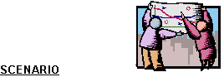
Your supervisor has asked you to provide a particular report every Friday morning so that the results can be discussed in the weekly staff meeting. We will schedule this report to recur so that it will automatically run every Friday morning.

Special Date/Day Window
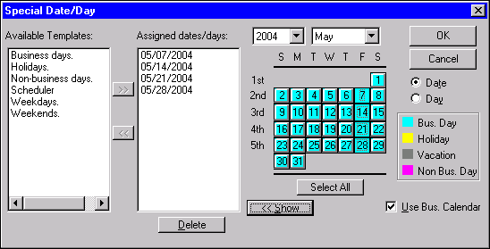

Your may choose from the available templates or select your own calendar. Since none of the available templates suit our need, we will set up our own calendar.

Step 1 In the Job Information List box. Highlight the report object you want to schedule.

Step 2 On the Info Desktop toolbar. Click the Schedule icon. The Schedule window is displayed.

Step 3 Select the When tab.

Step 4 In the Day drop down box. Select Calendar and left click on the <CALENDAR> button. The Special Date/Day window is displayed.

Step 5 Select the every Friday on the calendar through the next month by clicking each date.

NOTE: The Year and Month drop-down boxes allow you to choose dates far in the future.

Step 6 Click the <OK> button. You return to the When tab.

Now that we have selected the specific dates for scheduling, we must now indicate the time we want our report to run each day. This can be done by selecting the <AT TIME> button on the When tab. However, you may encounter difficulty, if the system is busy during the time you select. For recurring reports a Dependency should be established.

NOTE: In production, the Business Days Template will appear as Tuesday through Saturday. This is because MRDB is updated during the nightly cycle Monday through Friday resulting in updated data Tuesday through Saturday.

Wait For/Dependency Window
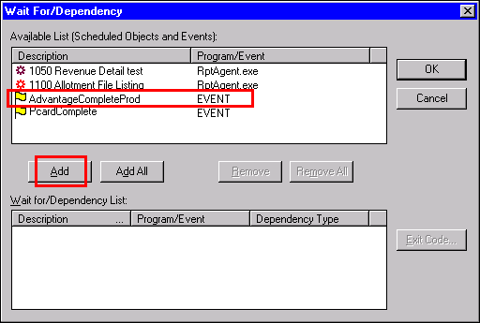

Object Dependencies
There may be a situation where you want to schedule an object to run only if a certain condition is met. These conditions are known as dependencies. For example, an object can be dependent on another object running first, on another object running and returning a specific value, or on a predefined event flag existing on the system.

Step 7 To set a Dependency, click the <PROGRAM/EVENT> button on the When tab. The Wait For/Dependency window is displayed.

Step 8 In the Available List box. Highlight the object or event flag that the object is to be dependent on.

NOTE: For production reports, select the ADVANTAGECompleteProd EVENT. This will trigger the report to run upon the completion of the ADVANTAGE nightly cycle.

Step 9 Click the <ADD> button. The object or event flag now appears in the Wait for/Dependency List box on the bottom.

Step 10 Click the <OK> button.

Step 11 Click on the Log On tab. Enter your Oracle User ID and password.

Step 12 Click the <SCHEDULE> button.

This report object is now set to schedule every Friday.

Once a report is scheduled it will immediately appear at the bottom of the list. Upon completion, the instance will move to the top.

There may be times when you need to hold or stop the report from scheduling. Let’s review how to control report instances.

Putting an INSTANCE on hold
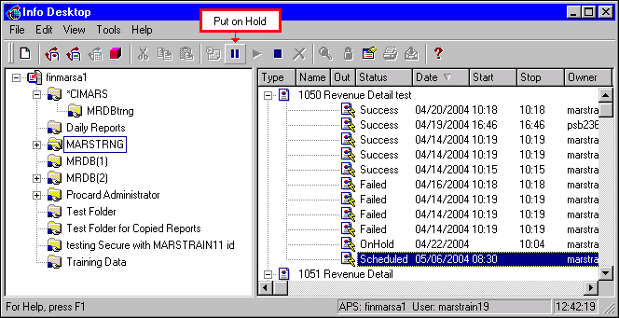

dialog box
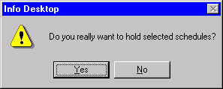

onhold status
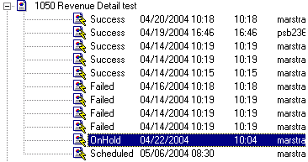

Controlling Instances
The last area of scheduling to be reviewed is the process of controlling instances. Sometimes it is the case that you will need to pause an instance that is scheduled to run. This can be accomplished by placing the instance on hold. You can put a hold on instances if they have either a scheduled or recurring status. Use the following two steps to put a hold on a given instance:

Step 1 Select the instance that you would like to put on hold and click the HOLD button on the Info Desktop toolbar.

Step 2 Click the <YES> button to hold the job. The program will change the status of the selected instance to OnHold.

You can also release an instance from hold. Let’s look at how to do this. To release an instance that is on hold follow these two steps:

Step 3 Select the instance that you would like to be released from hold and click on the Release button on the toolbar. A message box will appear telling you that if you release the instance, the scheduled job will run.

Step 4 Click the <OK> button to run the schedule as originally specified.

If the instance that was on hold was formerly a Recurring instance, then the Release dialog box will appear. You want to toggle the checkbox Catch Up on Previous Occurrence to the ON position if the job was scheduled to run earlier. If you do not toggle the checkbox on, the instance will run at the next scheduled occurrence.

Stopping an instance
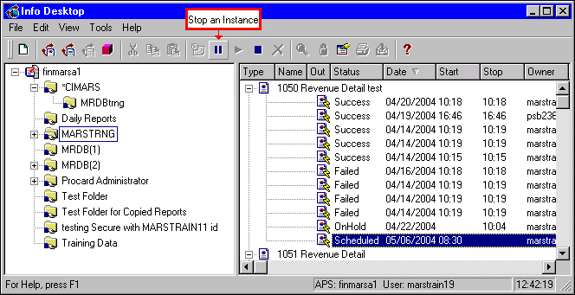

dialog box
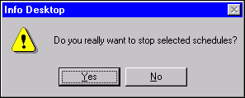

stopped status
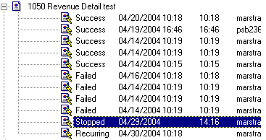

If you would like to stop a scheduled instance from running, do the following:

Step 5 In the Job Information List box. Highlight the scheduled instance that you would like to stop.

Step 6 Click the <STOP> button on the toolbar. A message box will then appear asking you to confirm the request.

Step 7 Click the <YES> button to stop the instance from running. The status of the instance will change to STOPPING until the process has been completed. Once completed, the status will change to STOPPED.

NOTE: A Stopped instance can not be released. If you are unsure, select the <HOLD> button.

Deleting an instance
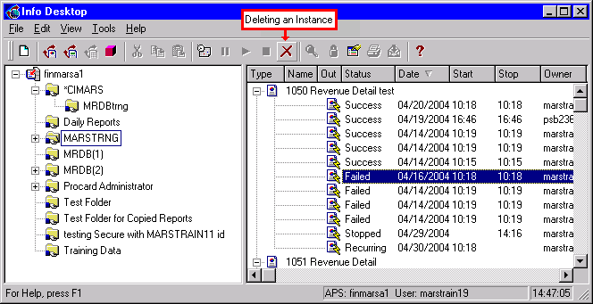

Dialog box
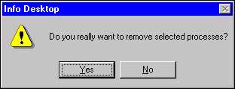

To delete an instance permanently from the desktop, follow these steps:

Step 8 In the Job Information List box. Highlight instance you would like to delete.

Step 9 Click the <DELETE> button on the toolbar. You will then be prompted to verify your decision.

Step 10 Click the <YES> button to delete the instance.

NOTE: Reminder to delete only your instances not those of other users.

Parameteratized Reports
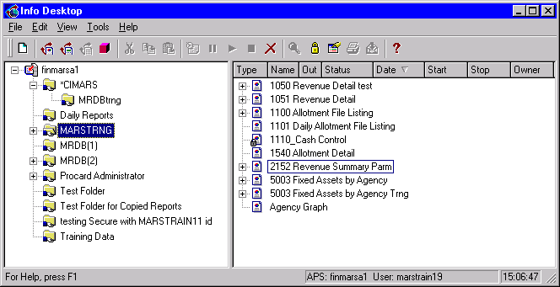

Prompts Tab
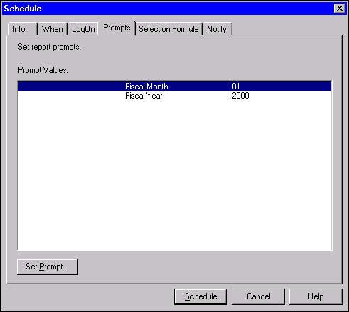

Parameterized Reports
Some reports contain parameters, which require the user to enter variables to build the report around. For instance, you may need to specify a particular Fiscal Year and/or Fiscal Month.

NOTE: All Statewide Parameterized Reports can be identified by PARM within the title. You can not set a parameterized report to recur.

Step 1 In the Job Information List box. Highlight the report object you want to schedule.

Step 2 On the Info Desktop toolbar. Click the Schedule icon. The Schedule window is displayed.

Step 3 Select the Prompts tab.

Step 4 In the PROMPTS VALUE field. Highlight Fiscal Month.

Step 5 Click the <SET PROMPT> button. The Parameter window is displayed.

Parameter Window
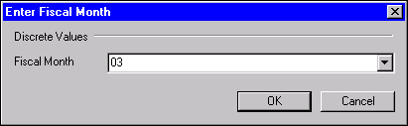

Step 6 In the FISCAL MONTH field. Enter the desired Fiscal Month or select it from the drop down box.

Step 7 Click the <OK> button.

Step 8 Repeat Steps 4-7 for the Fiscal Year parameter.

Step 9 Click on the Log On tab. Enter your Oracle User ID and password.

Step 10 Click the <SCHEDULE> button.


In this topic we have:

- Schedule a standard Crystal Report

- Schedule a recurring Crystal Report

- Discuss output formatting and controlling instances

- Discuss some advanced scheduling features

- Schedule a parameterized Crystal Report



Are there any questions concerning the information covered in this topic?

