TOPIC 2 INTRODUCTION TO SEAGATE

PURPOSE

The purpose of this topic is to present the content and various options available on Info Desktop’s Main window. You will learn the location and function of each pane, as well as the location and function of each of the bars.

OBJECTIVES

At the end of this topic, you will be able to:

- Locate the position and understand the functions of the Folder Tree and Job Information List Box on the Main window

- Locate the position and understand the options offered by the Tool, Menu and Status Bars

INFO DESKTOP LOG ON SCREEN
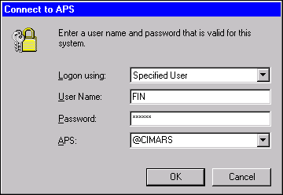

Logging into Seagate
Step 1 In the LOGON USING field. The default is Specified User. Leave As Is.

Step 2 In the USER NAME field. Enter Your RACF ID/User ID.

Step 3 In the PASSWORD field. Enter your Seagate password (not your Oracle password).

NOTE: Remember the PASSWORD field is case sensitive.

Step 4 In the APS field. This should be set to @CIMARS so that Seagate Info will get the first available server.

NOTE: If some reason @CIMARS does not work use KYMARSSA1 or KYMARSSA2 in the APS field.

INFO DESKTOP MAIN SCREEN
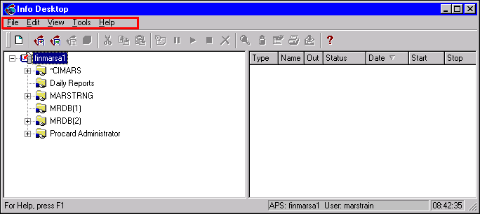

Menu Bar
The Menu Bar is the command center of Info Desktop. It is comprised of five basic options each having its own drop-down menu. The availability of some menu options is limited by factors such as security. For example, only Report Designers will be able to utilize the functionality required to design reports.

The File menu contains commands to create new folders, report objects, query objects and program codes. It provides the means to connect or disconnect from the Automated Process Scheduler (APS). Also included are commands for printing, previewing, exporting and downloading report instances.

The Edit menu contains commands that allow the user to schedule, hold, release, stop and delete objects. Furthermore, it contains commands that allow the user to modify the options of scheduled objects. As with other software, the copy, cut and paste options are housed here.

The View menu contains commands that allow Basic users to set instance limits for objects, refresh the Info Desktop, and view the status of an instance located within the Properties feature. It contains commands that allow Report Designers to view report designs, query objects, and modify existing object properties and security.

The Tools menu contains commands that allow access to the Info Report Designer and Seagate Analysis (these functions will be restricted to Report Designers). Additionally, commands for selecting desktop options such as refresh settings, the option to move from the Info Viewer to the Info Analyzer, and changing your Seagate password.

NOTE: To change your Seagate Password go to the Menu Bar, select Tools: Change Password. Remember the PASSWORD field is case sensitive, therefore take note to the case your are in when you change the password. This password does not expire, but it is recommended that you change it every 30 days and DO NOT make it the same as the ORACLE password.

The Help menu contains commands that open the Info Desktop online help and Seagate Software home page. It also includes information about the current version of software.

TOOL BAR
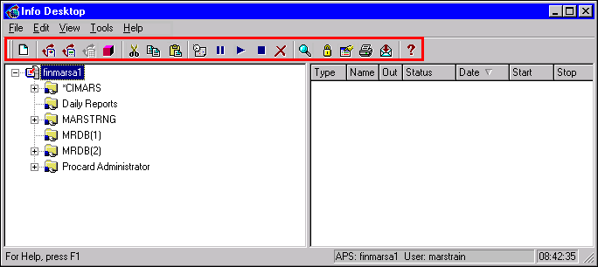

Tool Bar
The Tool Bar offers several commonly used functions available by a single click of the mouse. This bar provides a method to reach menu commands with less effort.

New Creates a new folder, report, or query
Info Report Designer Used by Report Designers Only

Seagate Query Used by Report Designers Only
Info SQL Designer Not used by Commonwealth

Info Cube Designer Not used by Commonwealth
Cut Allows for data manipulation
Copy Allows for data manipulation
Paste Allows for data manipulation
Schedule Schedules highlighted report object
Hold Holds a scheduled instance
Release Releases a scheduled instance
Stop Stops a scheduled instance
Delete Deletes the highlighted object/instance

View Opens highlighted object in either Info Viewer or Info Analyzer

Security Allows you to view security settings of current selection

Properties View properties of current selection

Printer Sends selected instance to the printer

Export Exports the selected instance to a file or e-mail

Help Enables context-sensitive help for the Info Desktop

FOLDER TREE
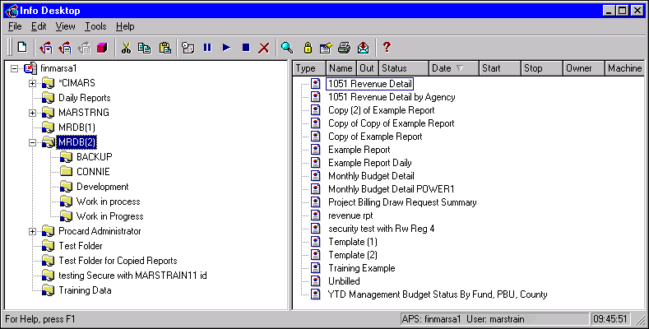

Folder Tree
The Folder Tree occupies the left pane of the Main window. It displays the server you are currently connected to, as well as public and private folder information. The contents of a folder can be revealed by a single click. The symbol to the left of the folder indicates that there are additional folders contained within the first folder. To expand the view, you can click on the symbol. A symbol indicates that all folders for a level are revealed. If neither the or symbol is present, then there are no additional folders.

FOLDERS
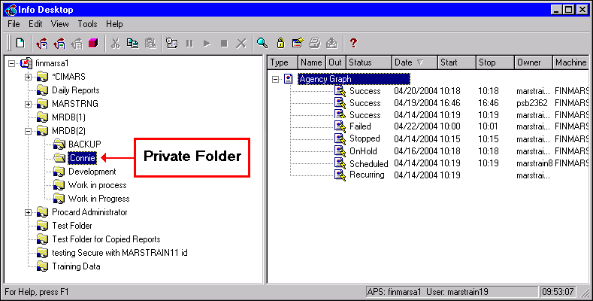

Folders
The folders in the Info Desktop resemble normal file folders. They are electronic files, as in Windows Explorer, that contain objects such as reports, queries, etc and function to organize the Info Desktop. These folders are located in the Folder Tree and marked with a folder icon.

Private Folders – These folders can only be viewed by the user who created them. Other users can not access them.

Public Folders – These folders can be accessed by multiple users with the appropriate rights.

The rights associated with each user group determine what functions each group can perform. For instance, one group may be able to view instances of a report but not modify any reports, while another group may have rights to view, modify and query.

Objects and Instances
In Seagate a report is referred to as an object. The object contains the layout of how the report will look. The basic layout consists of the data fields, report header and footer information, and selection criteria of the data.

The end result of a scheduled object is known as a report instance. The instance displays the data and arranges it as defined by the object. Seagate will assign a status to the instance when the schedule process has completed. An instance could result in any of the following statuses:

JOB INFORMATION LIST BOX
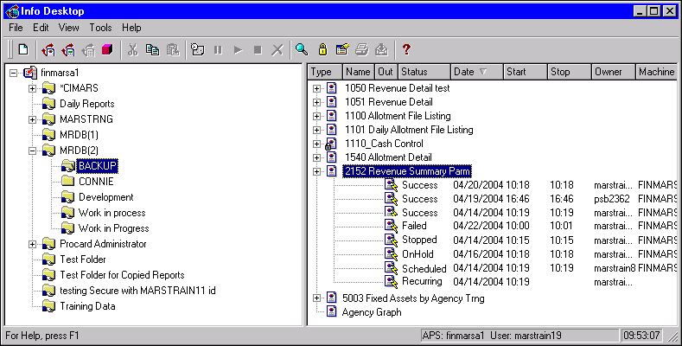

Job Information List Box
The Job Information List Box occupies the right pane of the Main window. It contains the contents of the highlighted folder in the Folder Tree. This pane is used to select an object to schedule, monitor the progress of scheduled objects, and identify instances.

Status Definitions
- Processing - This status indicates that the user has requested that the server process the object.

- Stopped - This status indicates the scheduling process for an object has been stopped. Stopping an object may be done manually by the user or automatically by the system. Once selected, it becomes permanent and cannot be restarted again.

- Recurring - This status indicates the object is automated to be scheduled on a recurring basis. Users may specify the date, time, and frequency of the recurring object. In addition, programs or events may be defined to trigger the recurring object. The most commonly used event is the ADVCompleteProd event. Selecting this event as a recurring dependency indicates the object will not be scheduled until the MARS nightly cycle completes.

- No Response – This status indicates the server did not respond to your request within a specific time interval. This may occur if the server is too busy, in which case your object queues until there is a server available. It may also occur if the server is down.

- Scheduled – This status indicates the APS has scheduled your object, but has not started processing it.

- Success - This status indicates the scheduled object successfully connected to the database and completed the process. A successful instances does not always indicate there is data to be displayed. For example, if a user schedules a daily expenditure report and Seagate successfully connects to the database (MRDB), and if no transaction exist for the specified date, this would result in a success with no data to display. It is however, the only instance in which data may appear.

- On Hold – This status indicates the scheduled object was placed on hold. If you chose to, this status can be restarted.

- Failed - This status indicates the scheduled process encountered errors and could not complete. Some of the most common causes of this status are related to invalid log on information or communication failure between the network, Seagate or MRDB.

- Stopping - This status indicates a request has been sent to the server to stop processing an object.

Now let’s take a look at some instances.

VIEW A SUCCESSFUL INSTANCE
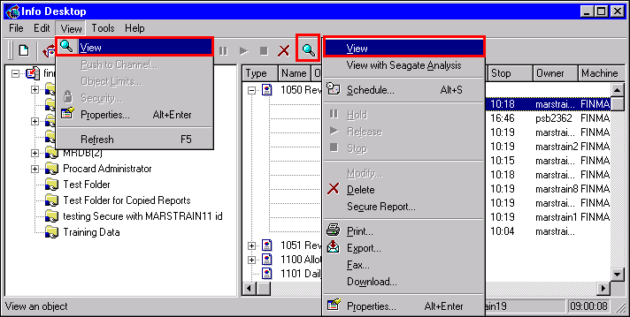

View a Successful Instance
Seagate provides several ways to view a successful instance.

- Highlight a successful instance and click on the <VIEW> button from the Info Desktop Toolbar.

- Highlight a successful instance, select View from the Menu Bar and then select View again from the drop down menu.

- Highlight the report instance, right-click the mouse button and choose View Report.

- Double click on the successful instance.

Now let’s look at how you evaluate why an instance has a status of failure.

INSTANCE PROPERTIES
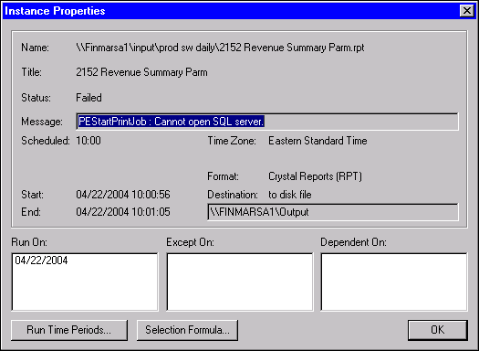

Failed Instance Status
Complete the following steps to determine why an instance has failed.

Step 1 In the Folder Tree. Select the MARSTRNG folder.

Step 2 In the Job Information List Box. Select a 2152 Revenue Summary Parm.

Step 3 Click the plus box to expand the report object

Step 4 Right-click one time on the failed instance.

Step 5 On the short-cut menu. Choose the Properties option at the bottom. The Instance Properties window is displayed. The message section of the Instance Properties box that is displayed will reveal the cause of the failure.

NOTE: The above listed error message usually means the server is down or there is a problem with the ORACLE password.

STATUS BAR
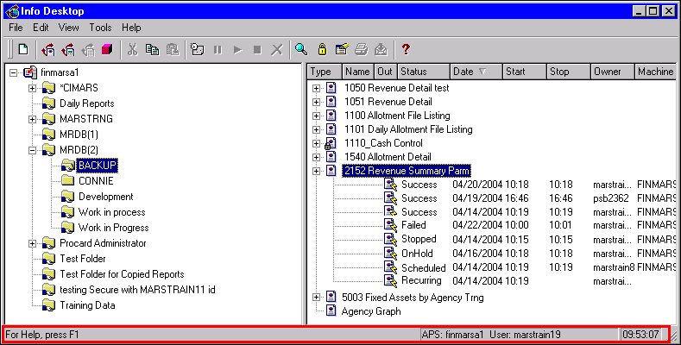

Status Bar
The status bar along the bottom of the Info Desktop window keeps you informed of your progress. It also displays information for function key help, user name and time of day.



In this topic we have:

- Located the position and understand the functions of the Folder Tree and Job Information List Box on the screen

- Located the position and understand the options offered by the Tool, Menu and Status Bars



Are there any questions concerning the information covered in this topic?

