TOPIC 1 INTRODUCTION TO MRDB

PURPOSE

The purpose of this topic is to provide general information about the functionality of the Management Reporting Database (MRDB). Information regarding the relationship between MARS and MRDB will also be discussed in detail. We will also address the steps necessary to obtain security and Ad Hoc reporting.

OBJECTIVES

At the end of this topic, you will be able to:

- Explain what the MRDB is

- Understand the role of Seagate Info, ADVANTAGE Financial, PD, and BRASS

- Understand Seagate/MRDB security requirements

- Distinguish between a Basic User and a Report Designer

MARS COMPONENTS
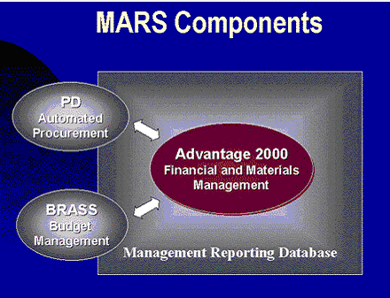

Where the MRDB Fits In
The Management Reporting Database (MRDB) is the component (in other words, the database), that contains the data needed in order to prepare, format, and access reports. You can think of this database as a large warehouse where data is stored and organized in such a way as to make locating information relatively easy.

The MRDB will interact with ADVANTAGE Financial and Procurement Desktop to consolidate data so that reports can be generated. For example, a financial report showing expenditures by object code, associated agency, and organization can be created using the MRDB. Another example would be a report showing all commodities procured by a specific buyer.

The MRDB supports reporting and data analysis needs by providing Standard Reports, Ad-Hoc reporting and query capabilities, and the ability to export data for mail merge and other related uses.

RELATIONSHIP BETWEEN MRDB AND MARS
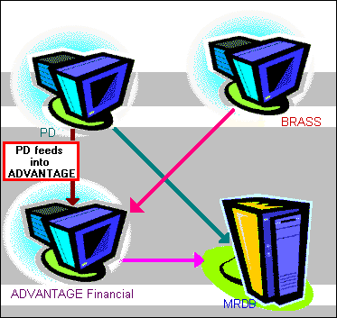

Relationship Between MRDB and MARS
The components of MARS are Procurement Desktop (PD), BRASS, and ADVANTAGE Financial.

These components interact with the MRDB using ADVANTAGE Financial as the core. This type of integrated system ensures the accurate exchange of information between the financial, procurement, budget management, and reporting processes.

Interaction between these three components permits the elimination of duplicate data entry and reconciliation between systems. This means that when information is entered into BRASS, this information is then uploaded into ADVANTAGE Financial, which in turn, updates the rest of the components. This eliminates the need to copy the same information into various software components. It not only saves tremendous amounts of time but also ensures that changes are processed immediately…in real time.

The most important thing that MRDB does is the collection of information from ADVANTAGE Financial, PD, and BRASS. You will have access to your Agency's financial, travel, procurement, and budget information online based upon your level of security. This online approach will provide:

- The ability to view standard management reports through Seagate and Microsoft Access.

- The ability to create custom queries and reports in an easy to develop and understandable manner.

- The ability to export information and use it in Microsoft Word to complete a mail merge project or in Microsoft Excel to finish that spreadsheet you need.

- The ability to view standard management reports through the Internet.

Advantages of the MRDB
One of the biggest advantages of the MRDB and MARS is the ability to combine different custom systems into one single functional unit. This allows communication between all software components. In addition, it eliminates the need to replicate data and makes the managing and sharing of information faster and easier.

The MRDB is a composition of different business areas merged into a single structure. It is focused on giving you maximum flexibility in reporting, while maintaining a high degree of freedom with your querying needs. From a simple report on monthly revenue to a complex report on comparing budget versus actual expenditure, you will be able to find a table within the MRDB that will provide you with the needed information.

ROLE OF SEAGATE INFO
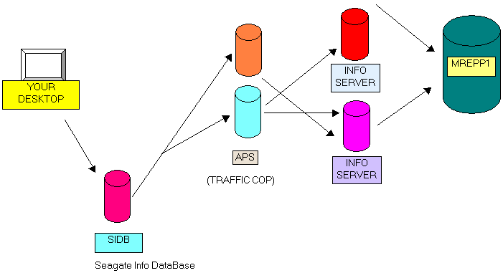

Role of Seagate Info Desktop
Seagate Info Desktop is the front-end software to access data within the MRDB. Front-end software is simply the tool used to extract information from another source, namely, the MRDB. When you first log on to Seagate Info, you actually are dialing in to the Automated Process Scheduler (APS). This functions as a link between the user’s desktop and the MRDB. Every time you schedule an object for processing, Seagate Info uses its connection to the APS to enter the MRDB and make the necessary changes.

The MRDB only contains tables that are of interest to reporting. It is also a read-only database, making accidental deletions impossible. During the nightly cycle, only additions and changes to the tables of interest are captured. We do not delete records from the MRDB for historical values. Once the reports are extracted from the MRDB and imported into Seagate Info, you will have the option to not only view this data but make changes as well.

Basic User vs. Report Designer

Basic User
A Basic User is anyone who uses Seagate Info to view, print, and schedule reports on a regular basis. The Basic User needs to know how to navigate effectively within Seagate Info in order to find the information that they need. These users also need to have an understanding of what the MRDB is, what kind of information it contains, as well as a clear understanding of the powerful functionality that the MRDB possesses.

Report Designer
A Report Designer is any individual who uses Seagate Info to create reports and other objects using tools such as the Report Designer. Report Designers will also create queries and Ad Hoc reports (custom reports) using both Seagate Info and the MRDB. These individuals will also perform all of the tasks as the Basic User. Report Designers must have extensive knowledge of the tables and reference groups contained within ADVANTAGE Financial as well as the MRDB. A very small percentage of the Commonwealth will consist of Report Designer.

Ad Hoc Reports
Ad Hoc Reports are customized agency reports created by the agency Report Designer. How do I get an Ad Hoc Report?

- Contact your agency’s Report Designer. This individual has the necessary rights to create reports in the requested format. If you do not know the Report Designer for your agency, please go to the following website: http://mars.ky.gov/MRDB%20Seagate%20Designer.htm

- Contact the accounting or procurement area in your agency.

- Contact the Customer Resource Center in the Finance and Administration Cabinet.

MRDB and Seagate Security
Users needing access to Seagate or the MRDB should contact their MARS Agency Security Lead (ASL). To assist you in identifying your ASL, a list of Agency Security Leads is posted on the MARS web page at
http://ky.gov/agencies/adm/mars/agencycontacts.htm.

A valid RACF/CICS ID is required to access Seagate and MRDB. The ASL will work with their agency’s RACF/CICS Administrator to obtain the CICS ID. If necessary, the RACF Administrator will contact Governor's Office for Technology (GOT) to establish a new CICS ID.

Once the User’s ID has been established, the ASL will need to provide an e-mail request to Donald Sweasy (Donald.Sweasy@ky.gov) or Jill Williams (AJill.Williams@ky.gov) within the Finance and Administration Cabinet, Office of the Controller with the following information:

- User RACF/CICS ID
- User Name
- ADVANTAGE security profile needed
- PD security profile needed (if applicable)
- MRDB security profile needed (if applicable)

NOTE: The ADVANTAGE Financial security dictates the data a users has access to within Seagate and the MRDB. For instances, if a user can only see document in ADVANTAGE for agency 750, then they will only be able to access data for agency 750 within MRDB or Seagate

Agency Role in System Maintenance
There are a number of things agency users can do to help improve system performance:

- Before scheduling a new report, check your agency folders ~ someone else in your agency may have already scheduled the report you need.

- If you have report instances that are no longer used by you, please delete them. DO NOT delete other users instances.

- Limit the recurrences you establish to only those reports your agency needs on a routine basis.



In this topic we have:

- Explained what the MRDB is

- Discussed the role of Seagate Info, ADVANTAGE Financial, PD, and BRASS

- Discussed Seagate/MRDB security requirements

- Distinguished between a Basic User and a Report Designer



Are there any questions concerning the information covered in this topic?

