Materials Management Setup & Usage Strategy

Version 2.0
January 7, 1999

Final

NOTE: This document is formatted for duplex reproduction, which is the Commonwealth of Kentucky standard. Blank pages are intentionally inserted throughout the document so that the document will reproduce correctly.

List of Authors:
Robert J. Rossman
Rakesh Peter
David Schoenfield
Ashley Camic
Afifa Rahman

Table of Contents
Page
1 Introduction 5
1.1 Document Organization 5
1.2 Implementation 5
1.3 Data Management 6
1.3.1 System Setup 6
1.3.2 System Maintenance 7
1.3.3 System Impact 7
1.4 Assumptions 8
2 Data Setup 10
2.1 Attachment 10
2.2 Organization 11
2.3 Preferences 12
2.4 Procurement Types 13
2.5 Scheduling 14
2.6 Shipping 16
2.7 User Type 16
2.8 Units 17
2.9 Source Banks 18
3 Workgroup Template Maintenance 19
3.1 Checklist 19
3.2 Milestone 19
3.3 PALT (Procurement Action Lead Time) 20
3.4 Clauses 21
3.4.1 Clause Setup 21
3.4.2 Template Setup 22
3.5 Reference Library 23
3.6 Directories 24
3.7 Route 25
3.8 Evaluation Criteria 26
3.9 Accounting 27
4 Business Requirements Setup 29
4.1 Catalog Maintenance 29
4.1.1 Item Data 29
4.1.2 Loading Items 29
4.2 Product/Service Codes (Commodity Codes) 30
4.2.1 Commodity Code Structure 30
4.2.2 Fixed Assets 30
4.3 Fixed Asset Exception 31
4.4 Organization Maintenance 32
4.5 Vendors 33
4.5.1 PD Vendor Maintenance 33
4.5.2 PD Vendor Lite 33
4.5.3 Vendor Registration Procedures 35
4.6 Procurement Card Reconciliation 35
4.7 Audit Trail 36
4.8 Fixed Asset Configuration and Use 37
4.8.1 Recording a Fixed Asset Acquisition 37
4.8.2 Recording a Fixed Asset Betterment 41
4.8.3 Recording Fixed Asset Dispositions 43
4.8.4 Processing Fixed Asset Reorganizations 45
4.8.5 Tracking Construction-In-Process 47
4.8.6 Recording an Internal Sale 48
4.8.7 Recording Modifications to Fixed Assets 48
4.8.8 Tracking Repairs and Maintenance 50
4.8.9 Recording Depreciation 51
4.8.10 Key Data Structures 51
4.8.11 Off-line Processes 52
4.8.12 Set-up of User-maintained Tables 54
4.8.13 System-Maintained Tables 62
4.9 Inventory Configuration 63
4.9.1 Setup of Inventory Tables 63
4.9.2 Inventory Setup ‘Task Plan’ 70
4.9.3 System Maintained Tables 71
4.9.4 Key Off-line Processes 71
4.9.5 Key Inventory Reports 72
5 Procurement Desktop Security 72
5.1 Class 72
5.2 Group 73
5.3 User 77
5.4 Document Approval Setup 79
5.4.1 Approval 79
5.4.2 Auto Approval 80
5.5 Authority Type 83
5.6 Team 84
5.7 Warrant 85
5.8 Procurement Profile 85

Appendix A: Materials Management Data Forms 86

List of Figures
Page
Figure 1. Reference Data by Role Responsible 6
Figure 2. Data Management 8
Figure 3. Attachment Examples 10
Figure 4. Organization Task 12
Figure 5. Prefs Task 13
Figure 6. Proc Types Task 14
Figure 7. Scheduling Examples 15
Figure 8. Payment Terms Screen 15
Figure 9. User Type Examples 17
Figure 10. Units Task 17
Figure 11. Checklist Task 19
Figure 12. Milestone Task 20
Figure 13. PALT Task 21
Figure 14. Clauses tab on a Solicitation 22
Figure 15. Clauses Task 23
Figure 16. Reference Library 24
Figure 17. Directories Task 25
Figure 18. Route Task 26
Figure 19. Evaluation Criteria Task 27
Figure 20. Accounting Task 28
Figure 21. Prod/Svcs Task 31
Figure 22. Organization Maintenance 32
Figure 23. Vendor Maintenance – Main Screen 34
Figure 24. Vendor Maintenance – Address Information 34
Figure 25. Procurement Card Maintenance Task 36
Figure 26. Fixed Asset Acquisition Description Panel 40
Figure 27. Fixed Asset Acquisition Responsibility Center Panel 40
Figure 28. Fixed Asset Acquisition Funding Sources Panel 41
Figure 29. Fixed Asset Betterment Acquisition Panel 42
Figure 30. Fixed Asset Betterment Funding Source Panel 42
Figure 31. Fixed Asset Disposition (FD) Document 44
Figure 32. Fixed Asset Disposal Text Inquiry 45
Figure 33. Fixed Asset Transfer Document 46
Figure 34. Fixed Asset Reorganization Table 47
Figure 35. Fixed Asset Modification Document 49
Figure 36. Funding Source Modification Document 50
Figure 37. Repairs and Maintenance Table 51
Figure 38. Inventory Adjustment 71
Figure 39. Class Code Examples 73
Figure 40. Class Access Tab 76
Figure 41. Menus Tab 76
Figure 42. Object Classes Tab 77
Figure 43. User Task 79
Figure 44. Approval Task 80
Figure 45. Document Tab 81
Figure 46. Document Template Tab 82
Figure 47. Commodity Tab 82
Figure 48. Buyers Tab 83
Figure 49. Authority Type Task 84
Figure 50. Team Task 85

List of Data Forms
PPD 1. Attachment Templates 87
PPD 2. Organization Maintenance 88
PPD 3. Procurement Type Information 89
PPD 4. Award Type Maintenance 90
PPD 5. Scheduling – A/P Reference Data 91
PPD 6. Scheduling – Payment Terms Setup 92
PPD 7. Shipping Information 93
PPD 8. Manifest Route Template 94
PPD 9. Milestone Template 95
PPD 10. PALT Codes 96
PPD 11. Class Information 97
PPD 12. Group Information 98
PPD 13. User Profile Information 99
PPD 14. User Profile - Management Information 100
PPD 15. User Type Information 101
PPD 16. Checklist Templates 102
PPD 17. Team Information 103
PPD 18. Warrant Information 104
PPD 19. Procurement Profile Information 105
PPD 20. Route Template 106
PPD 21. Clause Template Setup 107
PPD 22. Cited Authority Types 108
PPD 23. Request for Audit Trail Trigger 109
PPD 24. Best Value Criteria 110
PPD 25. Evaluation Criteria Template 111
PPD 26. Accounting Template 112
PPD 27. Fixed Asset Exception Information 113
PPD 28. Procurement Card Setup 114
PPD 29. Identify Approval Profile 115
PPD 30. Identify Document Criteria 116
PPD 31. Identify Buying Profile for the Document Criteria 117
PPD 32. Identify Buying Profile for the Commodity Criteria 118
PPD 33. Commodity Buyer Information 119
PPD 34. Identify Commodity Criteria 120

Introduction

The purpose of this document is to identify the tasks required to configure MARS to support Kentucky’s EMPOWERed purchasing, bidding, payables, inventory, fixed assets, and disbursements business processes. The ADVANTAGE and Procurement Desktop (PD) products are designed to be flexible enough to support both centralized and decentralized processing and control. This flexibility, along with the proper configuration of each system’s implementation-specific components, is critical to supporting the reengineered materials management process and achieving Kentucky’s business process improvement objectives.

Materials Management is the process of providing goods and services for use by the Commonwealth. It includes the acquisition process from need identification through the receiving and management of Commonwealth inventory and fixed assets. To support the Materials Management function this document is designed to cover the critical information needed in all aspects of the Procurement Desktop system and the Fixed Assets and Inventory modules of the ADVANTAGE system. The Setup and Usage Strategy highlights the System Administration tasks associated with this critical data, describes how this information will be used, and how it affects the system.

System Administration in ADVANTAGE and Procurement Desktop controls the configuration of the system for use. Within this task System Administrators can customize the system to most effectively meet the needs of Kentucky. This customization includes things such as providing reference data to populate drop-down menus, creating user document templates, defining business rules, and configuring system security features.

Document Organization
This document describes the type of information that will be needed for the Materials Management reference data and business rules and includes forms to aid in collecting this information. The document is organized into the following sections:
- Section 2—Data Setup will include administration responsibilities pertaining to the setup of system reference data.
- Section 3—Workgroup Template Maintenance will detail the administration of system functions specifically related to procurement templates such as checklists, milestone plans and attachments.
- Section 4—Business Rule Setup will include a discussion of the administrative setup of system business rules and materials management related procedures such as fixed assets, inventory, procurement card processing, etc.
- Section 5—Security will detail the administrative setup of system security including user authorities, groups, approvals, and workgroup organizational structure.

Implementation
One of the most involved tasks in the implementation of the MARS Materials Management system will be the definition and collection of the critical data needed to set up the PD system and ADVANTAGE Fixed Asset and Inventory subsystems. This document will act as a guide to these implementation activities.

For each item to be ready for production a recommendation is made regarding the collection and maintenance of the required information. This data is categorized into the following areas:
- Central System Administration – this data will be collected by the Central Implementation team and entry and ongoing maintenance will be handled by central administration.
- Agency Administration – this data will be collected by the Agency Implementation teams and entry and ongoing maintenance will be handled by agency administrators.
- Central Administration with Agency Input – responsibility will be shared between central and the Agencies. Collection of information will be the responsibility of the Central Implementation team, however Agency Implementation teams must review data to ensure that their individual requirements are met. Maintenance will be handled by central administration however Agencies will be assigned specific roles in the maintenance of certain tasks.
Figure 1. Reference Data by Role Responsible shows the breakdown of centralized v. decentralized information.

Figure 1. Reference Data by Role Responsible
Central System Administration | Agency Administration | Central Administration with Agency Input
Audit Trail  Catalog  Class  Directories  Organizations (Reference Data)  Preferences  Procurement Types  Product/Services (Commodity Codes)  Schedule  Shipping  User Type | Accounting  Attachments  Checklist  Clause Templates  Commonwealth Organizations  Evaluation Criteria  Milestone  PALT  Procurement Card  Route  Team  User | Authority Types  Units  Approval  Clauses  Group  Reference Library  Fixed Assets  Fixed Asset Exceptions  Inventory  Vendors

Data Management
In an effort to provide more information on the setup and maintenance of these system features, each task has been given a rating to give implementation teams an indication of the work required with each task. A summary of this analysis is provided for each system task in Figure 2. Data Management.

System Setup
We have given a rating to each data point regarding the effort of initial setup. This rating indicates how much work will go into the research and setup of the data.
- Low setup indicates that the setup effort will be minimal (less than 8 hours).
- Medium setup indicates that the setup will require some additional effort (8 – 40 hours) in researching the data and/or entry into the system.
- High setup indicates that the setup will require significant effort (more than 40 hours) in researching the data, preparing the data for use in the system and arranging the data to support Commonwealth business functions.

System Maintenance
We have rated each data set regarding the frequency of maintenance the data will require. This is to indicate how often maintenance of the data will occur.
- Stable data indicates that this data will rarely change and will only require periodic review to determine pertinence. There will be a one-time setup and changes and additions will generally be made only as a special request.
- Regular data indicates that this data will change on a regular basis and should be reviewed with regularity to determine pertinence. Changes and additions will be made as needed.
- Dynamic data indicates that the data will change frequently and maintenance will occur on a regular basis. Changes and additions will be ongoing.

System Impact
We have rated each data set in terms of system impact. This rating defines how critical the data will be to the operation of the system.
- Low impact data indicates that the data does not affect the daily operation of the system and collection and entry of this data is a low priority.
- Medium impact data indicates that the data will affect the daily operation of the system. The collection and entry of this data is a priority but is not critical to the system.
- High impact data indicates that this data will be the basis for certain operating aspects of the system. The collection and entry of this data is very important to the proper operation of PD and it should be given the highest priority.

Figure 2. Data Management
Data | Impact | Setup | Maintenance
Authority Type | High | High | Stable
Catalog | High | High | Regular
Clauses | High | High | Stable
Commodity Codes | High | High | Stable
Document Approval | High | High | Regular
Fixed Assets | High | High | Dynamic
Fixed Asset Exceptions | High | Med | Regular
Groups | High | High | Stable
Inventory | High | High | Dynamic
Organization Maintenance | High | High | Dynamic
Procurement Card | High | High | Stable
Property | High | High | Dynamic
User | High | High | Regular
Vendor Maintenance | High | High | Dynamic
Accounting | High | Med | Dynamic
Class | High | Med | Stable
Procurement Types | High | Low | Stable
Units | High | Low | Regular
Evaluation Criteria | Med | High | Regular
Attachment | Med | Med | Stable
Audit Trail | Med | Med | Stable
Organization  Data Setup | Med | Med | Stable
Schedule | Med | Med | Stable
Shipping | Med | Med | Stable
PALT | Med | Low | Regular
Preferences | Med | Low | Stable
Reference Library | Low | High | Stable
Checklist | Low | Med | Regular
Milestone | Low | Med | Regular
Route | Low | Med | Regular
Team | Low | Med | Regular
Warrant | Low | Med | Stable
Procurement Profile | Low | Low | Stable
User Type | Low | Low | Stable

Assumptions
This document makes the following general assumptions regarding the implementation of the setup and usage strategy:
- Implementation Managers at central and within each agency will be responsible for the collection, organization and implementation of the data covered in this document as is required to prepare the system for use;
- System Administrators will be assigned by the Commonwealth to manage the setup and maintenance of the System Administration functions. These System Administrators will have access to PD System Administration training to guide them in the use of System Administration tasks;
- The Purchasing and Payables, Inventory and Fixed Assets System Usage Analysis documents define the business processes to be supported by the Materials Management portion of the MARS system;
- As detailed functional specifications are written, certain System Administration tasks may be created, modified or removed to fit Kentucky’s needs. Additional tasks may also be incorporated in System Administration to satisfy specific Kentucky functional requirements.

Data Setup

Attachment
The PD application enables users to designate commonly used word processing, spreadsheet and other files as templates to be used in procurement activities. These files can be attached directly to procurement documents in PD.

For example, if a user has a document that is frequently used as a cover letter for an Invitation for Bid, they can add this to PD as a template. Then each time the user sends out an IFB, they can attach that particular letter directly to the Solicitation document created in PD. This document will now follow the Solicitation document as an additional information source for the IFB.

In order to utilize this function, the Commonwealth must define the files to be incorporated as Attachments in the procurement cycle. The Attachment task in PD Systems Administration provides the ability to define these templates.

Within the Attachment task in PD Systems Administration, template documents can be imported into PD and associated with a particular module. Assigning templates to a module dictates the types of documents to which the template can be attached. For example, an award justification attachment associated with the Award module can be associated with a Contract, Purchase Order, Delivery Order, etc. PD currently supports only files created in Microsoft Word and Excel for Attachment templates. Some other file types may be used as attachments, but not templates.

To properly setup Attachment templates, PD requires the following information:
- Attachment Title is the name used to reference the Attachment template in PD;
- File Name is the name of the originating file assigned as the Attachment template;
- PD Module indicates the procurement functions in which the user can access and utilize the template. The modules and their associated functions are:
- Correspondence – attachment can be used as new correspondence from the Procurement menu;
- Post Award – attachment can be used with any Post-Award Document or Modification;
- Pre-award – attachment can be used with a Solicitation or a Pre-released award;
- Purchase Request – attachment can be used with a Purchase Request document;
- Buyer;
- System Administration;
- Vendor.

Examples of Attachment template files are included in Figure 3.

Figure 3. Attachment Examples
Attachment Title | File Name | OA | PD Module
Award Justification Letter | AwdJust.doc | Word | Pre-Award/Award
Invitation for Bid Letter | IFBlet.doc | Word | Pre-Award/Award
Vendor Evaluation Spreadsheet | Evaluate.xls | Excel | Post-Award
Award Renewal Notice | Renewal.doc | Word | Purchase Request

Data cannot be filtered by Agency, so the proliferation of attachment templates may make it difficult to find Agency specific files. Therefore when planning for the creation of attachment templates, Agency implementation teams should attempt to identify documents that can be used across agencies to minimize the number of documents used. For templates that are Agency-specific, teams can define a naming convention to identify the files of each agency so users can find documents more efficiently. For example, each Agency could be assigned a two or three character code that should precede the document name such as DOT AwdJust.doc for a Transportation Cabinet award justification letter.

The documents referenced and used may differ by Agency, so collection and maintenance of this information should be conducted at the Agency level. Use Data Form PPD 1. Attachment Templates in Appendix A to aid in the collection of procurement Attachment information.

Organization
The PD application provides the ability to maintain information on organizations used within the system including Commonwealth internal organizations, vendor organizations and banks. While working in the Organization Maintenance module users are presented with drop-down fields which provide descriptive information for organization maintenance such as address type and contact type. The Commonwealth must provide the data to populate the tables driving these descriptive menu fields.

This descriptive reference data is maintained in the Organization task in PD System Administration, as shown in Figure 4. The system collects the following information within this task:

- Address is the list of address types to be associated with Commonwealth organizations. The baseline software includes several organization address types that are hard-coded into PD such as Invoice Address, Delivery Address and Administering Office. This means that PD will include these address types in the reference data and do not have to be provided by the Commonwealth. These pre-coded address types will be indicated in red;
- Vendor is the list of categories to be associated with different vendor types such as Sole Proprietorship and Corporation;
- Contact is the list of categories to be associated with different Commonwealth internal organization contact types such as Primary or Technical;
- FOB is the list of different FOB types used for freight shipments;
- Region is the list of geographical region categories to be associated with vendors;
- Program is the list of DBE’s to be associated with vendors;

Since most of these categories will be consistent across Commonwealth Agencies, collection and maintenance of this information should be conducted through central administration. However, each Agency should review the data to determine if additions need to be made. Use Data Form PPD 2. Organization Maintenance to collect information for this task.

Figure 4. Organization Task
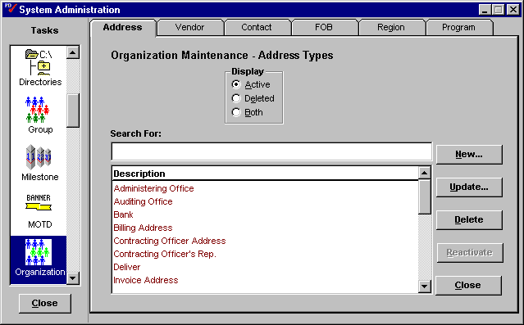

Preferences
When creating a new user profile in PD there are several user preferences pertaining to system configuration that can be pre-set as defaults. The Commonwealth will be required to set these default preferences for any new user profile. An administrator can define the following preferences to default each time a user profile is created:
- Whether the system will ask for confirmation each time the user exits PD;
- Whether the system will save the current desktop configuration of the user;
- Whether the system will notify the user of new items in the inbox;
- The time delay for new item notification.

This information is defined in the Prefs task in PD System Administration as shown in Figure 5.

Figure 5. Prefs Task
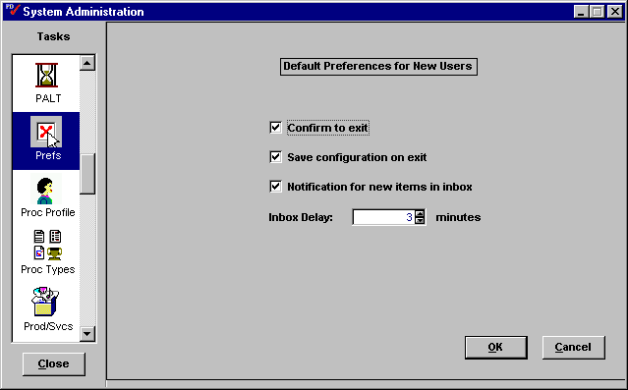
The user can customize these settings at a later time. Since this information will be consistent for all new profiles across Procurement Desktop, these defaults should be determined by central administration.

Procurement Types
As users create and maintain the different types of procurement documents available in PD, they are presented with drop-down field choices that provide description for certain documents. The Commonwealth must define the reference data that will populate these fields.

The list tables that drive these fields are maintained in the Proc Types task in PD System Administration, shown in Figure 6. The values entered here will become the choices available to users when creating certain documents or accessing menu items:
- Solicitation Type is the reference data for the type of solicitation being created such as Invitation for Bid or Request for Proposal;
- Contract Type is the reference data for the type of contract being created;
- Cancellation Reason is the reference data providing reasons for canceling a document;
- Suspension Reason is the reference data providing reasons for suspending a document;
- Award Type is the reference data for the type of award being created. The Commonwealth must define the following award type information:
- Document Type;
- Document Sub-type;
- Award Type description;
- Whether the award is an internal order.

Figure 6. Proc Types Task
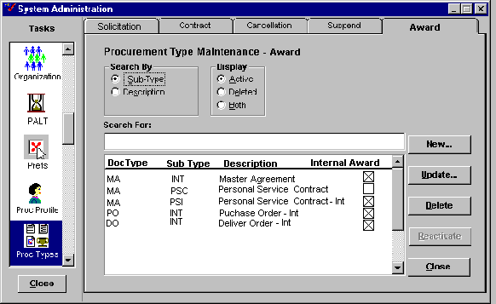

Since these procurement type fields will be consistent across all Commonwealth Agencies, this data should be collected and maintained by central administration. Use Data Forms PPD 3. Procurement Type Information and PPD 4. Award Type Maintenance to aid in collecting this information.

Scheduling
The PD Accounts Payable module utilizes an algorithm to determine the optimal payment date for vendor invoices. The payment scheduler compares the vendor invoice discount terms with the return on Commonwealth funds to determine the date of payment that will optimize the return to the Commonwealth.

The Scheduling task in PD System Administration provides the ability to specify the terms driving the scheduling algorithm. This task also provides the ability to populate certain reference data tables that drive menu choices in the A/P module. Within this task the following sections are populated:
- Holds is the list of reasons available for a payment hold;
- Overrides is the list of reasons available for a payment date manual override;
- Disbursements is the listing of disbursement types and their typical lag time in days;
- ROI (Return on Investment) defines the annual return percentage earned on Commonwealth funds that will be used in disbursements. This table is critical in calculating payment dates. The Commonwealth must define the return earned by Kentucky central funds.
Examples of these data are shown in Figure 7.

Figure 7. Scheduling Examples
Hold Reason Code | Description
NONCOMP | Non-Compliance with Contract
FUNDING | Insufficient Funding
INVCORR | Awaiting Invoice Correction

Override Reason Code | Description
RUSHPMT | Rush Payment
MANUAL | Manual Check Needed

Disbursements Code | Description | Lag Time
ECH | Electronic Clearinghouse | 5
Check | Check | 10

Fund Source | Annual Percentage
Kentucky Funded | 5.00%
- Payment Terms provides the ability to set up payment terms templates that can be defaulted when creating a non-matched invoice, as shown in Figure 8;
- Accounts is the reference data that drives the drop-down field choices referring to bank account types.

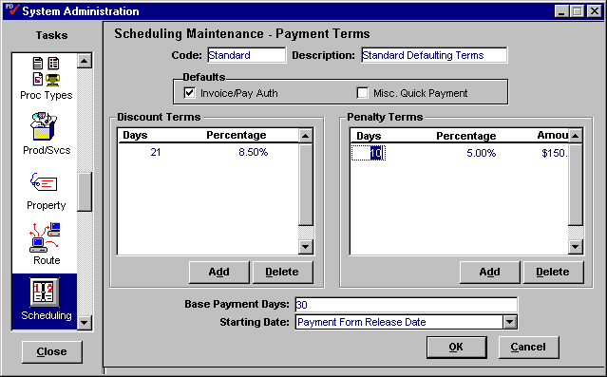
Figure 8. Payment Terms Screen

Base Payment Days is the final payment day stipulated in the payment terms. For example, if the payment terms were 2% 10 net 30, the base payment days is 30.

Starting Date is the date that the system will begin counting payment days such as Receiving Date or Date of Invoice. These Starting Date codes are hard-coded into PD.

Since Commonwealth statutes dictate the standard payment terms for disbursements, and the remaining data will be of concern to AP personnel, this information should be maintained by central administration. Use Data Forms PPD 5. Scheduling – A/P Reference Data and PPD 6. Scheduling – Payment Terms Setup to help collect this information.

Shipping
Within the PD Shipping and Receiving modules users are presented with drop-down field choices that describe aspects of the Shipping/Receiving process. The Commonwealth must determine the reference data that will populate these fields.

The list tables that drive these fields are maintained in the Shipping task in PD System Administration. The values entered here will become the choices available to users when accessing the following drop-down fields:

- Carriers is the list of available freight and parcel carriers to indicate who handled/shipped the goods;
- Methods of Shipment is the list of available choices to describe how the goods were shipped, such as Air Freight or Common Carrier;
- Payment Types is the list of available choices to describe the delivery’s method of payment for freight charges such as Collect or Prepaid;
- Discrepancy Types is the listing of available choices to describe a discrepancy between the received amount and the ordered amount, such as Overage or Under Shipment;
- Not to Specs is the list of available reasons that can be attributed to a shipment to be declared “Not to Specifications” when received such as Crushed Box or Wrong Model;
- Route is used to pre-define manifest shipping routes for goods to be delivered from the warehouse after being received. It is unclear at this time whether Kentucky will use this feature.

Since the data should be consistent across all Agencies this information should be collected and maintained through central administration. If the Commonwealth should choose to use the Manifest feature, Manifest Routes information should be collected and maintained at the warehouse level. Use Data Form PPD 7. Shipping Information and Data Form PPD 8. Manifest Route Template to aid in collecting this information.

User Type
The PD application provides the ability to manually assign procurement work to specific individuals, as outlined in their user profile, using the PD Workload module. As workers are grouped within a manager’s user profile (refer to Section 5.3 User) they are associated with a particular User Type such as Buyer, Supervisor or Contract Specialist. When making assignments in the Workload module, the manager has the ability to view all people with a particular User Type.

The User Type task in Procurement Desktop System Administration provides the ability to define categories of users for the assignment function in the Workload module. The Commonwealth must define the user types as shown in Figure 9.

Figure 9. User Type Examples
User Type | Description
PROCUREM | Procurement User
CONTRACT | Contract Specialist
REQUISIT | Requisitioner
MANAGER | Manager

User types will differ based on the assignment of users to workgroups so therefore this data should be collected and maintained at the Agency level. Use Data Form PPD 15. User Type Information to aid in collection of user types.

Units
The Units task will determine the units of measure that populate the system as a description for ordering and receiving items. The unit codes used in Procurement Desktop must match those used by Advantage. The Unit of Weight field checked indicates that the unit is used as a weight measurement and will appear on the appropriate menu. The Units System Administration task is shown in Figure 10.

Figure 10. Units Task
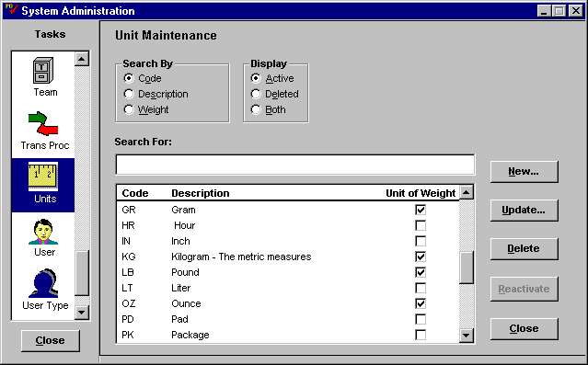
The units of measure data must be consistent across MARS. The initial setup of this data will be included in the conversion process as outlined in the Data Conversion Plan. Since the data will be consistent across the MARS system, it will be maintained by central administration. However, Agency personnel may wish to review the conversion data to see if any additional units of measure are required.

Source Banks
The Procurement Desktop application provides the ability to define the banks used to fulfill electronic transactions, such as Automated Clearing House (ACH) payments. This information is setup and maintained in the Source Banks task in PD System Administration. Since the disbursement function will be handled in ADVANTAGE, the Commonwealth will not use this task although it will remain in the baseline version of PD.

Workgroup Template Maintenance

Checklist
The PD application provides the ability to create a checklist, or a listing of tasks that need to be completed for a particular procurement document. These checklists are attached to procurement documents to guide the user, who can check-off each task as it is completed. The system will date and time stamp the completion of each task.

PD provides the ability to design checklist templates and associate them with specific modules, which dictates the type of documents to which they can be attached. These templates are created and maintained in the PD Checklist task shown in Figure 11.

Figure 11. Checklist Task
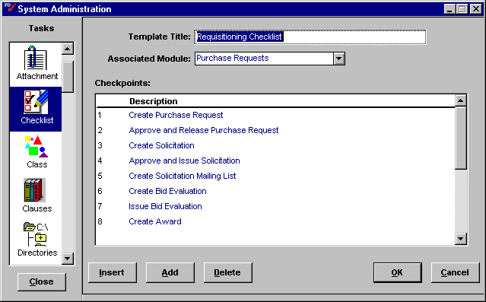
These checklists will be specific to each Agency, so this information should be collected at the Agency level. Use Data Form PPD 16. Checklist Templates in Appendix A to specify Commonwealth Checklist Templates.

Milestone
The PD application provides the ability to assign a Milestone plan to a procurement action that tracks the progress of each task based upon the expected completion dates of each milestone. A milestone plan is assigned to a particular document and will include the following:
- The expected time that is required to reach each milestone;
- Setup for milestone reminders and their time intervals;
- Precedence relationships (dependency) between milestones and;
- Whether each milestone is required.

PD provides the ability to design commonly used milestone plan templates in the system. The Milestone task in PD System Administration enables the creation of these milestone templates as shown in Figure 12.
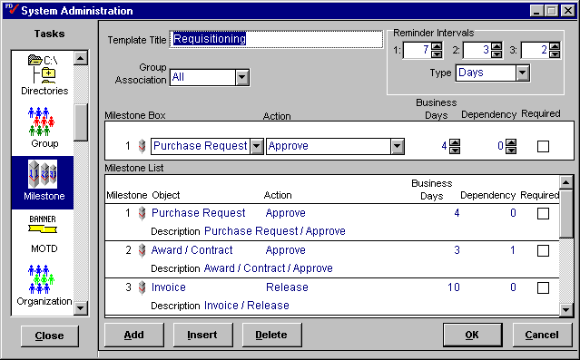
Figure 12. Milestone Task

Since Milestone requirements will differ by procurement action or type of document, they will generally be specific to each Agency. Therefore Milestone template information should be collected and maintained at the Agency level. Use Data Form PPD 9. Milestone Template to aid in collecting this information.

PALT (Procurement Action Lead Time)
When a manager assigns a contract for action within the Workload Management module of PD the contract is assigned a Procurement Action Lead Time (PALT) code. The PALT code gives the buyer some idea of the complexity and time involved in completing the purchase, and allows the manager to monitor the progress of the purchase regarding its estimated completion time.

PALT codes are defined in the PALT task in PD System Administration as shown in Figure 13.

Since procurement action completion times will differ by Agency, this information should be collected and maintained at the Agency level. Please use Data Form PPD 10. PALT to help gather this information.

Figure 13. PALT Task
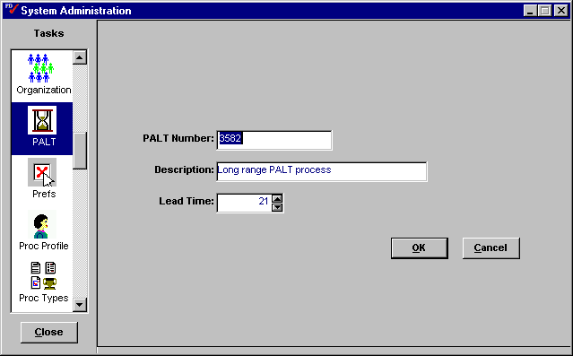

Clauses
The PD application provides the ability to include terms and conditions, referred to as clauses, directly within different procurement documents such as Awards and Solicitations. These clauses are set up as reference documents in the system. When a user creates a procurement document, these clauses can be accessed directly from the document creation screen. The Clauses tab on a Solicitation form is shown in Figure 14.

The PD application also provides the ability to create clause templates for standard groups of clauses. The following sections outline the procedures to setup the clauses for use in PD and to setup clause templates.

Clause Setup
Terms and conditions to be included on procurement documents must be setup in PD to be available for use. Terms and conditions documents must be provided as Microsoft Word documents. These Word documents will be converted to Rich Text Format (RTF) which will then be incorporated with the PD application to be accessible from the Clauses tab in document creation screens.

The system administrator will use a series of scripts to convert the clauses presented in the Word documents into RTF files. Each RTF file will represent a specific clause that can be referenced individually by the user. These RTF clause files are organized by section and placed on a file server to be accessed when procurement documents are created. The file access path for these clauses is specified in the Directories task in PD System Administration. For more information on the Directories task, see Section 3.6 Directories.

This information will be consistent with Commonwealth statutes and will be uploaded and maintained centrally based on agency supplied data. Implementation teams must review the clauses to be used in PD to eliminate duplication among Agency specific clauses. In the case where similar clauses exist with different language, a determination must be made whether each individual clause must be used or whether one standard clause will meet Commonwealth needs.

Figure 14. Clauses tab on a Solicitation
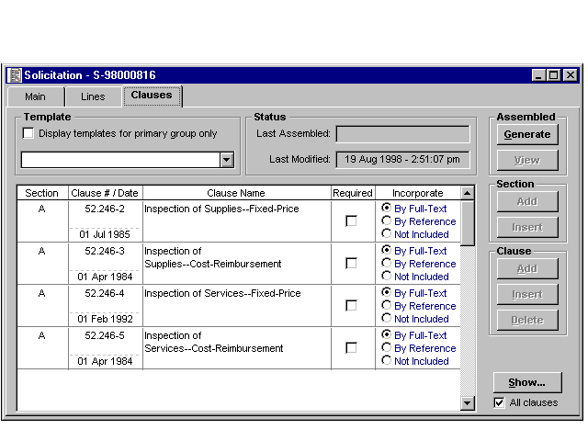

Template Setup
Recognizing that terms and conditions can be standard for different types of documents and procurements, PD provides the ability to group commonly used terms and conditions as templates that can then be associated with specific documents in the system. When a user is creating a procurement document they can elect to use a template to list the appropriate clauses rather than specify each clause individually. The Commonwealth must define the groups of clauses that should be included in templates for users to access when creating procurement documents.

The Clauses task in PD System Administration provides the ability to group clauses into templates, assign Group access to the template, and indicate if each clause will be referenced on the document or included as full text.

The Clauses System Administration task is shown in Figure 15.

There are sets of terms and conditions that will be standard across all Agencies for specific contract types, commodity types and document types. These standard clause templates should be identified and maintained by central administration. However, each Agency will have standard terms and conditions that will apply solely to their purchases. These templates should be identified and maintained at the Agency level. Use Data Form PPD 21. Clause Template Setup to aid in collecting information on clause templates.

Figure 15. Clauses Task
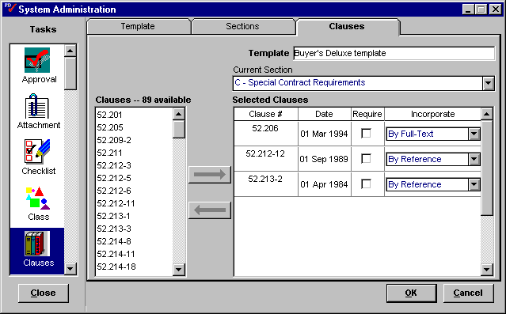

Reference Library
The PD Reference Library is a repository of critical reference information presented in a simple online format available to the procurement professional using a Java-enabled Web browser. Documents and information commonly used in procurement activities are generally included in the Reference Library. Reference information may include:
- Policies and Procedures manuals;
- System documentation;
- Necessary procurement forms;
- Product specifications;
- Vendor listings or links to Federal debarment listings;
- Links to pertinent documentation on the Internet.

The Reference Library can be utilized by browsing for information or using cut-and-paste procedures to add content to documents and contracts.

The Commonwealth will require many documents to be added to the Reference Library. Each Agency should review the documents that their professionals use in daily activities to potentially include in this reference instrument. In order to convert these documents into a Web-enabled format, they must be provided to the Reference Library Administrator as either a Word document or in Rich Text Format (RTF). This will enable the Administrator to convert the documents into HTML format in order to publish them on the Web server.

The Reference Library is presented in a frames-based format for access using a Web browser as shown in Figure 16.

Most of the documents included in the Reference Library will consist of information pertinent to all PD users across the Commonwealth. Therefore the collection and maintenance of the Reference Library should be handled by central administration. However it is critical that each Agency review their documentation for items that their procurement professionals may need in this format in addition to items that may be valuable across the Commonwealth.

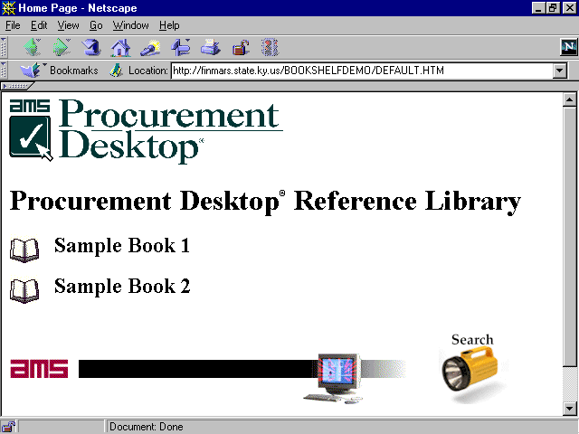
Figure 16. Reference Library

Directories
The system administrator must provide the directory location of the files that will be used as clauses and the files used in the reference library. These directories are managed through the Directories task in PD system administration. The Directories task provides the ability to provide the file path for PD to access Reference Library files and contract Clauses as shown in Figure 17.

Figure 17. Directories Task
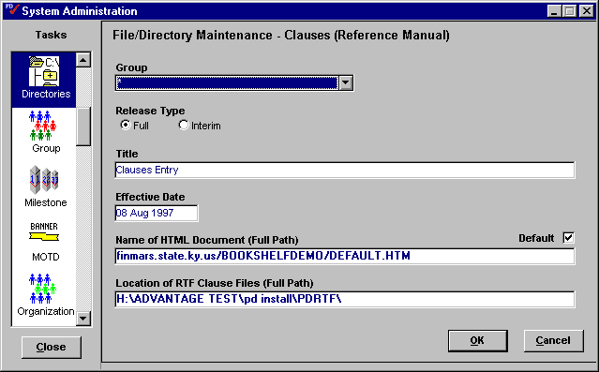
These directory locations will be setup and maintained by central administration.

Route
While routing activities related to document approvals can be automatic based on the Functional Design – Line Level Approval Routing document, users will still have the ability to route documents for review or collaboration with other users. The PD application provides the ability to create lists of users to set as routing templates in the system. Routing templates are created and maintained in the Route task within PD system administration as shown in Figure 18.

Routing templates will be customized based upon the needs of each user therefore this information should be collected and maintained at the Agency level. Use Data Form PPD 20. Route Template to aid in collecting Routing information.

Figure 18. Route Task
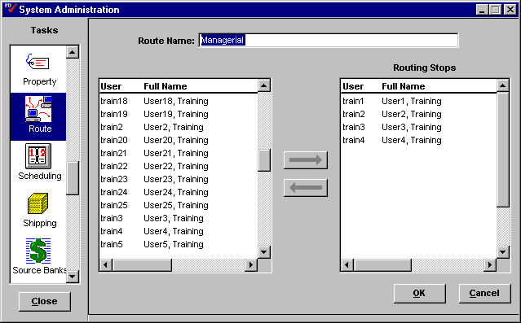

Evaluation Criteria
The PD application provides the ability for a user to collect vendor responses to a solicitation and compare each response using a Bid Evaluation document. To best support the needs of the Commonwealth, PD users will be able to evaluate responses according to cost based criteria or best value criteria. Users will be able to select from a pre-defined list of best value criteria, select a best value template, or customize criteria based upon the specific solicitation. The Commonwealth must define the best value criteria that will populate this function.

The Commonwealth must provide the detailed criteria that will commonly be used in evaluating vendor bids to include:
- Criterion description;
- A unique identifier;
- Description of associated commodity.

Identifiers will be unique to each criterion. Careful consideration should be taken in determining how users will utilize these criteria and how these identifiers should be assigned to most easily find the needed criteria. Examples of identifier naming conventions could be to code them based upon Agency or commodity code reference.

Criteria can be associated with particular commodity groups since some criteria can be unique to a specific type of product. For instance, certain criteria will apply specifically to computer vendors and should be associated with the Computers commodity group.

The PD application will also provide the ability for Commonwealth users to associate groups of best value criteria into evaluation criteria templates. The Commonwealth must define the elements of each of these templates to include:
- Template name;
- Associated Group;
- Template Description;
- Criteria to be included in template.

Best value criteria and template maintenance will be handled in the Evaluation Criteria task in PD system administration. This system administration task is illustrated in Figure 19.

Figure 19. Evaluation Criteria Task
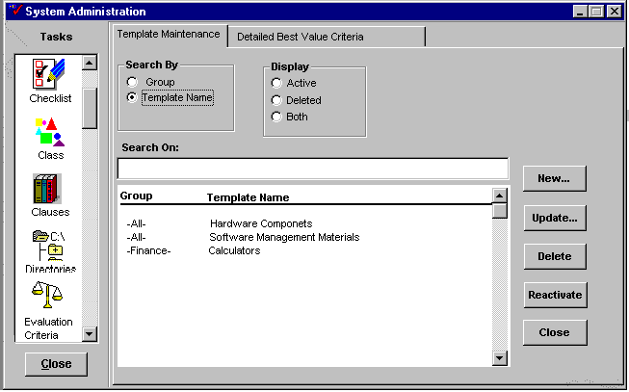

These best value criteria and evaluation templates will differ based upon the type of purchase being made and the agency making the purchase. Therefore this information should be collected and maintained at the agency level. Use Data Forms PPD 24. Best Value Criteria and PPD 25. Evaluation Criteria Template to aid in collecting this information.

Accounting
The Procurement Desktop application will provide the Commonwealth with the ability to automatically populate fund/account distributions based on user defined criteria. For example, a single $100 transaction can be funded with two fund distributions: $80 to fund A and $20 to fund B. This will be accomplished by providing users with the ability to select accounting templates to apply this pre-defined funding information to the appropriate document. The Commonwealth must provide the information needed to create these accounting templates.

The accounting template information will be managed in the Accounting task in PD System Administration as shown in Figure 20. The Accounting templates require the following information:
- Template description;
- Selected funds and percentages for each;
- Selected users who will have access to each fund template.

Figure 20. Accounting Task
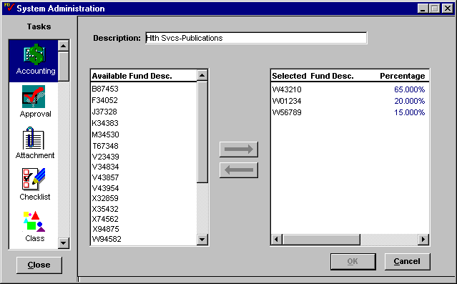

The funds will be managed in the ADVANTAGE system and will be loaded into PD as a part of the integration function as outlined in the PD/ADV Integration Detailed Design.

Accounting information will be specific to each Agency so this information should be collected at the Agency level. Use Data Form PPD 26. Accounting Template to aid in collecting this information.

Business Requirements Setup

Catalog Maintenance
The Procurement Desktop system provides a means for users to search through the items listed in existing Master Agreements. The items that will be contained in these Master Agreements must be loaded into the catalog system. As a result, the Procurement Desktop supports an automated tool designed to facilitate the process.

Item Data
For the automated catalog setup tool to work, the vendor must provide line item data, in the form of a “flat” ASCII file, to the Commonwealth. This file should contain all pertinent line item information, required and otherwise; in addition, the vendor must present this information in a prescribed format using a specific set of data elements. These elements may include the following fields:

- Description;
- Extended Description;
- Unit Price;
- Units of Issue;
- Product/ Service Code and Description;
- Manufacturer;
- Product/Catalog Number;
- Model Number;
- Color;
- Size;
The Commonwealth must define the specific elements that will be required in each catalog file. The selected vendor must provide the information in the order dictated by the Commonwealth list. The final chain, for each item/record, should represent a continuous string of characters. Any failure to meet the prescribed format would prevent the successful utilization of the Desktop’s loading mechanism. Once the awarding organization receives the line item file, an authorized user can “attach” the embedded items to an appropriate Master Agreement.

Loading Items
To “attach” the items of interest, the administrator can initiate the loading process using the Desktop’s automated import tool. The system will automatically parse each record into its constituent parts and insert the data into the corresponding database columns. The time required to perform this process, for all items, may vary according to the size of the ASCII file and the number of lines it contains.

During the import process, the Desktop will validate the inbound data and ensure that it meets the prescribed item format. If any items fail validation or otherwise fail to properly load, the system will halt the import process and produce a corresponding error message. Otherwise, the Desktop will display an import confirmation message, indicating that all line item data has successfully been associated with the current Master Agreement. At this point, the administrator should search for a handful of items, to ensure that the import indeed met expectations.

Administrators can overwrite existing item information by (re)importing line data. If line items have already been associated with a Master Agreement, and another ASCII file is imported, the system will produce a confirmation message. This message informs the user that an additional import will overwrite any existing line information with data from the “new” file.

Catalog maintenance will be conducted at different levels within the Commonwealth organization. The elements that will be required for vendor catalog files must be established at the central level and followed by each Agency as they work with their vendors. For Master Agreements that are available to all purchasers across the Commonwealth, central administration will handle the setup and maintenance of these contracts. Master Agreements that are specific at the Agency level may be setup and maintained at the Agency level.

Product/Service Codes (Commodity Codes)
The Procurement Desktop system provides the ability for purchasers to categorize items by product classes to help identify the type of item in question. These product classes or commodity codes are a series of standard numeric codes that indicate the specific type of product being purchased. These commodity codes will describe a specific category of items as compared to a stock inventory item, which refers to a specific item. A commodity code can be used to describe a group of inventory items, (i.e. copy paper), but the inventory item would refer to the specific stock item (i.e. copy paper, 8.5x11, white, 84 bright, 500 count case).

Commodity Code Structure
The Commonwealth has elected to utilize the National Institute of Government Purchasing (NIGP) commodity code structure, which is an eleven-digit code identifying the spectrum of goods and services available for purchase by the Commonwealth. This NIGP commodity code structure will be provided via CD and will be loaded into the commodity code tables during data setup and loading. The structure and use of the commodity codes are maintained in the Product/Service task in PD System Administration, as shown in Figure 21.

In addition, Commodity code structure is related to inventory stock items. Each stock item on the Inventory Table (INVN) must exist on the Commodity table, and inventoried commodities must be indicated as such by setting the inventory indicator on each commodity entry. Stock item description on the Inventory table is then inferred from the Commodity item description when establishing stock items.

Fixed Assets
Commodity codes are the primary method of categorizing items during the purchasing process. As a result, PD provides the flexibility to utilize these codes in a variety of ways. Commodity codes interact with the approval process (see Section 5.4 Document Approval Setup) to drive the line item approval function. Commodity codes also interact with the fixed asset process to help identify a fixed asset. This process identifies an item as a fixed asset when the item’s invoice is approved and released. PD then prompts the creation of a fixed asset shell in ADVANTAGE for that item.

The Product Service task in PD System Administration will enable the user to indicate which items are fixed assets. The Commonwealth will need to define the items that will be identified as fixed assets in MARS.

Exceptions to the fixed asset status of a commodity code relating to dollar value or purchasing group will be handled by the Fixed Asset Exception task in PD System Administration (see Section 4.3 Fixed Asset Exception).

Figure 21. Prod/Svcs Task
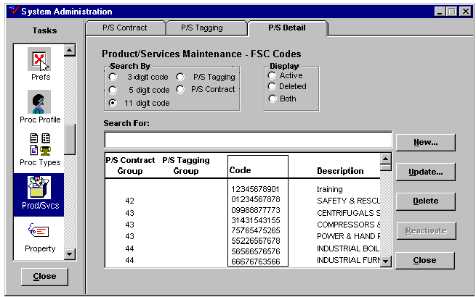

The PD application also provides the ability to manipulate the code structure within the Product/Services task. If it were determined that the NIGP coding structure did not adequately cover all of the goods and services purchased by the Commonwealth, an administrator could edit a commodity code or create a new one to cover the missing good or service. The NIGP coding structure is a very comprehensive commodity grouping so edits and additions to this data are not expected.

Since the product service code structure affects the entire Commonwealth, this information will be entered and maintained centrally. Items that are determined to be fixed assets across the Commonwealth should also be maintained centrally. The exceptions will be handled at the agency level.

Fixed Asset Exception
Throughout the procurement cycle items will be purchased that will have to be treated as fixed assets or personal property, and thus depreciated. The Procurement Desktop application will provide the Commonwealth the ability to identify items as fixed assets so they can be properly handled within the ADVANTAGE Fixed Asset sub-system.

PD will identify a fixed asset by the commodity code of the purchased item as is indicated in Section 4.2 Product/Service Codes (Commodity Codes). However in certain circumstances, exceptions will exist to the fixed asset status for a particular commodity code. These exceptions may have to do with the dollar value of the item being purchased, or the buying entity of the group making the purchase. For example, snowplows are treated as fixed assets in many Commonwealth agencies yet the shortened useful life of snowplows in the Transportation Cabinet requires that they be treated as an expense. The identification of these exception scenarios will occur in the Fixed Asset Exception task in PD System Administration.

In order to setup the Fixed Asset Exceptions, the Commonwealth will need to determine the following:
- The commodity code of the item to which the exception applies;
- The Buying Entity to which this exception applies;
- The dollar range for which this exception applies.
Since exceptions will generally differ by Agency, collection and maintenance of this information should be conducted at the Agency level. Please use Data Form PPD 27. Fixed Asset Exception Information to aid in collecting this information.

Organization Maintenance
Throughout the PD application users must access information on internal Commonwealth organizations to determine offices, contacts and addresses when creating most documents within the system. These documents require users to enter the appropriate organizations that will act as agents within the procurement process including contract administration offices, delivery addresses, payment addresses, requesting offices, etc. The Commonwealth must determine which organizations need to be entered into PD for the MARS system.

The management of internal Commonwealth organizations will be handled in the Organization Maintenance module under Utilities from the main menu in Procurement Desktop. The Organization Maintenance module is illustrated in Figure 22.

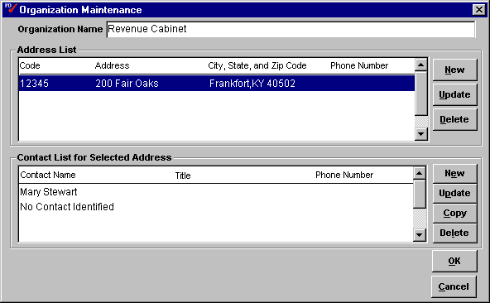
Figure 22. Organization Maintenance

The contact and address data for internal organizations should be collected and maintained at the Agency level. Each Agency will be responsible for collecting and entering the pertinent address and contact information that will be needed by PD users within their organization.

Vendors
The PD application will manage the vendor information for the Kentucky MARS system. This indicates that maintenance and handling of vendor information will be conducted in Procurement Desktop, and this information will be integrated with ADVANTAGE as outlined in the PD / ADV Integration Detailed Design.

New vendor information will be entered into MARS in three ways:
- By an authorized Commonwealth employee via the Vendor Maintenance portion of the Organization Management module in the PD client/server application;
- By an Agency representative via a Vendor Lite form routed through the workflow approval process;
- By the vendor or a Commonwealth PD Web user, via the Web, as outlined in the Vendor Web Registration Detailed Design.

PD Vendor Maintenance
The PD application manages vendor information within the Organization Management module, under Utilities from the main menu. PD maintains the information that is needed to support the procurement and A/P functionality that is available in the system. This information includes basic data such as the vendor name, address, and contact information, in addition to vendor status information, vendor debarment status, payment terms information, tax information and other vendor information.

The basic vendor information is collected and maintained in the main Vendor Maintenance tab as shown in Figure 23. Vendor address, payment terms and disbursements information for each vendor is maintained using the Address screen shown in Figure 24.

In order to minimize the amount of manual data entry necessary, the initial setup of vendor information will be converted from STARS/KAPS as outlined in the Data Conversion Plan. A concerted effort must be made to convert the best quality data possible, so the current vendor records must be reviewed for accuracy and usefulness. Vendors who do not meet certain criteria for active vendor status should not be converted into MARS. The ongoing maintenance of vendor information will be handled by the Customer Resource Center (CRC).

PD Vendor Lite
The PD application will provide Commonwealth users with the ability to enter information on a proposed vendor into an electronic form, which will be routed through the approval process to the inbox of a CRC representative. After review and approval by the CRC representative, a vendor record is created in the PD Vendor table.
Figure 23. Vendor Maintenance – Main Screen
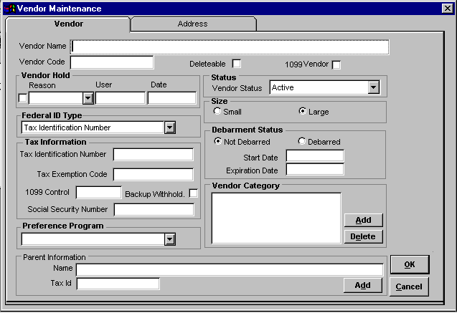
Figure 24. Vendor Maintenance – Address Information
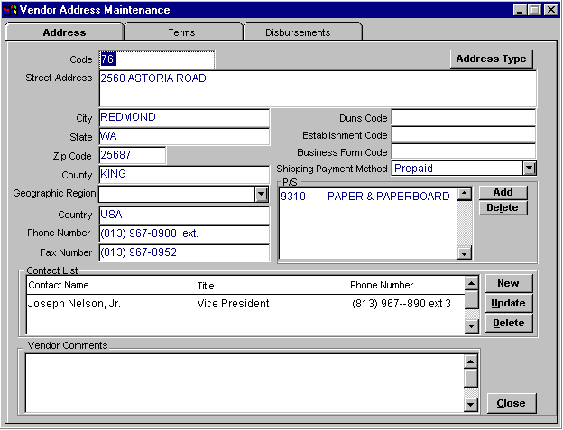

Vendor Registration Procedures
The Procurement Desktop application will allow a potential vendor to register to become an active Commonwealth vendor via the Web. The vendor must initiate a new Web “account” by registering as a Commonwealth vendor through the Commonwealth’s website. Approved vendors will receive a randomly generated password, which they must use to gain access to their account and make changes to their profile.

After becoming an active vendor in the Commonwealth system the vendor can use their password to access their profile from the Web and make changes including address change information, commodity information and payment terms. Specific details on vendor registration via the web will be detailed in the Functional Specification – Vendor Web Registration.

As new vendors are entered into the system, whether via the Web or through PD, they will automatically be given a status of Potential. From this point a representative of the Customer Resource Center (CRC) is notified of the new entry and is required to review the vendor for approval. Only the CRC will be authorized to change the status of a vendor. Once the vendor status is Active, only the CRC will be authorized to make changes to the vendor profile.

The Commonwealth must identify those individuals who will be assigned CRC authority to activate and maintain this vendor information. CRC personnel will be identified in the user’s profile in the User task in PD System Administration (see Section 5.3 User).

Procurement Card Reconciliation
The Commonwealth requires the ability to accept procurement card information from outside the system, bring it into Procurement Desktop and reconcile the financial information with ADVANTAGE. The PD application will provide the ability to electronically receive procurement card transactions and submit them to the appropriate procurement card administrator for processing. Details of this process will be outlined in the Functional Specification – Procurement Card Reconciliation.

The Commonwealth will be required to provide specific information to facilitate the processing of procurement card transactions. This information will include:
- Users who will act as procurement card administrators;
- Procurement card users who will be assigned to each administrator;
- Accounting information that will be associated with each procurement user.

Each administrator will be responsible for maintaining their list of procurement card users and the procurement card account and funding information that will be associated with each user. This information will be maintained in the Procurement Card Maintenance task in PD System Administration, as shown in Figure 25.

Figure 25. Procurement Card Maintenance Task
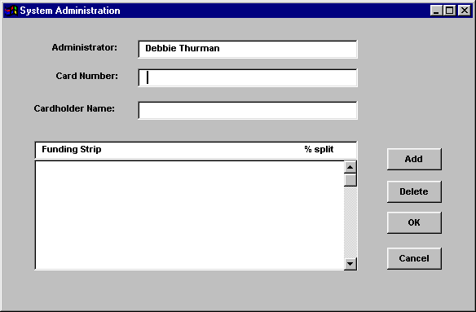

Procurement card administrators will be identified in the user’s profile in the User task in PD System Administration (see Section 5.3 User). Each administrator will be given a ProCard Administrator Id which will identify them as procard administrators and assist the offline processing utility in matching the procurement card transaction to the correct administrator.

Each Agency will be responsible for identifying the personnel who will act as procurement card administrators for their organization, and providing the list of procurement card users that will be assigned to each administrator. Each administrator will then have the responsibility for setting up the information on the procurement card transactions that they will manage. Use Data Form PPD 28. Procurement Card Setup to assist in collecting this information.

Audit Trail
The Commonwealth requires the ability to track the changes made to a document throughout the procurement cycle. The system will enable users to retrieve a history of data that is modified or deleted on documents and reference data. This history is referred to as the audit trail. The details of the functionality included in the audit trail capability are presented in the Functional Specification – Audit Trail.

The PD system will be able to track the changes that are made to certain attributes of PD documents that may include the following:
- Item quantity;
- Short description;
- Unit of Issue;
- Commodity Code;
- Unit Price;
- Date and time of change;
- Userid of the person making the change.

The Commonwealth must determine what document attributes will be tracked within this task. As each additional attribute is added to the audit trail, more system processing is required to track changes. Therefore special consideration must be given to system performance when determining how many changes to track. The Commonwealth must decide which fields provide enough information to support the functionality while minimizing the effect on system performance.

For each document field a trigger will be used in the system table to indicate that it is to be tracked. The setup and maintenance of these triggers will be managed centrally by the Kentucky DBA. However, it is critical for Agency Implementation teams to review the information present in PD documents to help determine which fields should be tracked to support their procurement processes. Use Data Form PPD 23. Request for Audit Trail Trigger to collect data on the audit trail function.

Fixed Asset Configuration and Use

The MARS Fixed Asset Subsystem is designed to use a series of on-line transactions, on-line inquiry tables, batch programs, and reports to facilitate fixed asset management. System Administration in ADVANTAGE and Procurement Desktop controls the configuration of the system for use. The Fixed Asset Configuration section includes setup of reference tables, defines system wide options and includes the key requirements to create Fixed Asset documents.

Sections 4.8.1 through 4.8.6 discuss the Fixed Asset documents. The Fixed Asset reference tables must be populated prior to processing documents. This will ensure that all codes on the Fixed Asset documents are valid on the reference tables. For a detailed description of the fields on all fixed asset documents and tables described in the following sections, please refer to the ADVANTAGE User Documentation.

Recording a Fixed Asset Acquisition

Fixed Asset acquisition is the process of acquiring a new fixed asset at historical (i.e. original) cost by a governmental entity. For governmental funds, a Fixed Asset acquisition transaction (FA) generates the appropriate General Ledger entries for the General Fixed Asset Account Group. For proprietary funds, a Fixed Asset acquisition transaction (FA) generates the appropriate Fixed Asset and General Ledger entries. The FA establishes a master record and the first detail record for the asset in the online system.

- FA created from Procurement Desktop (PD): PD determines an item’s eligibility to be classified as a fixed asset based upon the commodity table, agency rules, and exceptions. PD then generates the appropriate number of Fixed Asset shells (FA) based on the line item quantity for those commodities that qualify as Fixed Assets. The generated FA shells are routed to the Inventory Officer to be further updated with the tag number, responsible level fund, and other informational fields, for example, serial number.
- FA created from scratch: A Fixed Asset may be generated in ADVANTAGE if the purchase was not recorded in Procurement Desktop. For example, purchases from ProCard, donated, confiscated, or “just appeared” assets will require the creation of a FA from scratch. The Inventory Officer populates all panels of the Fixed Asset. The asset may have a zero value but a valid accounting strip must be referenced. The inventory officer should enter the appropriate proprietary or governmental fund responsible for this asset.
- The information recorded on the FA document updates all associated tables and ledgers when the Inventory Officer processes the document to acceptance. These updates include the Fixed Asset Summary tables (FAS1 and FAS2), Fixed Asset Betterment Table (FBT1 and FBT2), Balance Sheet Account Balance (BBAL), Fixed Asset Location Summary Screen (FALC), Fixed Asset Group Location Screen (FAGL) and the Fixed Asset History table (FHIS).
- The Fixed Asset Summary Inquiry (1 of 2) display the responsible fund and accounting distribution by the Fixed Asset Number (tag number). The Fixed Asset Summary Inquiry (2 of 2) display the equity accounts and the accumulated depreciation against the responsible fund.
- The Funding Source Inquiries (FFSR and FFS1) display the detailed funding sources that purchased the asset. The FFSR inquiry displays a view of the funding sources of the asset by Payment Voucher and Payment Voucher Line Number. The FFS1 inquiry displays a view of the funding sources of the asset by Fixed Asset Number, Betterment Number, Fixed Asset Type, and Asset Line.

Outlined below are the various sections of information required to process a Fixed Asset Acquisition (FA) document:

- Fixed Asset Tag number

The Inventory Officer will populate the Fixed Asset number in the header section, which will be used to represent the tag number in ADVANTAGE. The fixed asset tag number must be a unique identifier and will not be carried over from PD.

- Responsible center panel on the FA document

This panel contains the detailed accounting distribution for the Responsibility Center that owns the asset. The responsibility center includes Fund, Agency, Organization, Appropriation Unit, Activity, Function, Object, Revenue Source, Job Number, Reporting Category and BS Account.

PD will populate the responsibility center panel of the FA document shell with the first accounting strip from the payment document. However, PD will not populate the responsible fund, as this information will not be known at the time of shell creation; the Inventory Officer must populate the responsible fund once the FA shell is routed. If left blank, the responsible fund will default to “9900”, a governmental fund type. For Fixed Assets generated from scratch, the Inventory Officer populates all applicable data on this panel.

- Funding Source panel on the FA document

The funding source panel provides for the entire accounting strip to be recorded. These fields include: PV Number, PV Line, Fund, Agency, Organization, Appropriation Unit, Activity, Function, Object, Revenue Source, Job Number, Reporting Category and BS Account.

PD will populate the third panel for funding source on the FA shell with the accounting strip of the funds that paid for the asset. For FA’s created from scratch, valid funding strips are required. If a direct Payment Voucher document was created in ADVANTAGE to purchase this asset, the Payment Voucher (PV) document number and PV line number should be entered as well. The Payment Voucher information may not be required if the asset was not purchased; for example, a donated asset would not need a Payment Voucher reference.

- Equity Distribution panel on the FA document

The inventory officer does not need to populate the equity accounts. The equity accounts will automatically default to “Investment in General Fixed Asset” for governmental fund types and “Retained Earnings” for proprietary funds.

- Description Panel on the FA document

This panel contains additional information about the asset, including:

Data Element | Automatically Populated in Shell?
Asset Description | Yes
Room Number
Location
Commodity Code | Yes
Insurance Policy Type | Yes
Cost Type
Asset Custodian
Manufacturer Number | Yes
Model Number | Yes
In Service Date | Yes
Serial Number
Type of Warranty | Yes
Duration in Days | Yes
Agreement Number
Effective Date
Expiration Date

As noted above, PD will populate the Asset Description, Commodity Code, Insurance Policy Type, Manufacturer, Model Number, In Service Date, Type of Warranty, Duration Days, if available. The inventory officer must populate the remaining information in ADVANTAGE, and can optionally update fields populated by PD if needed.

- Acquisition Panel on the FA document

This panel consists of the Acquisition Date, Acquisition Method, Purchasing Authority, Vendor Number and Name. PD will populate the above fields, if available. Otherwise, the inventory officer will populate the above fields.

- Valuation Panel on the FA document

This panel contains data elements related to the valuation of the asset. These elements include Valuation Date, Valuation Amount, Useful Life, Closing Costs, Replacement Date, Salvage Value, Depreciation Method, Memo Disposition Value and Total Asset Value.

The Commonwealth will use Straight line Depreciation for all assets that will be depreciated. PD will populate the Total Asset Value. The inventory officer will populate the remaining fields.

Figures 26, 27 and 28 illustrate the Fixed Asset Acquisition document panels.

Figure 26. Fixed Asset Acquisition Description Panel
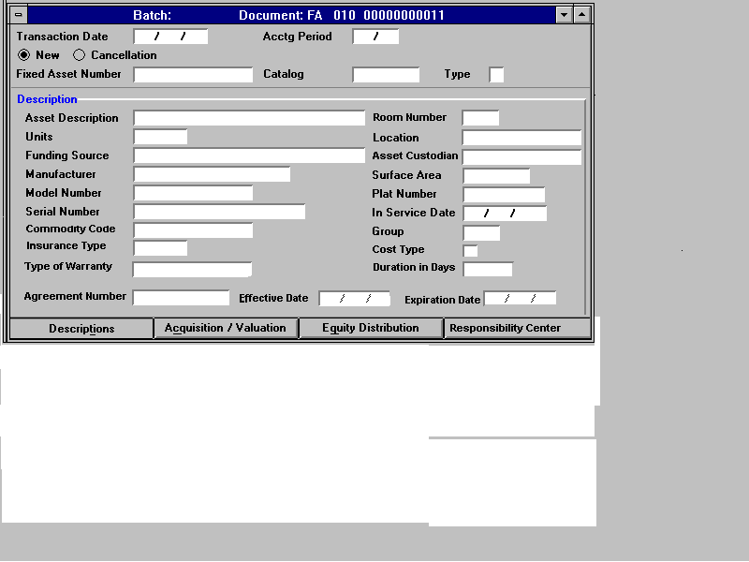
Figure 27. Fixed Asset Acquisition Responsibility Center Panel
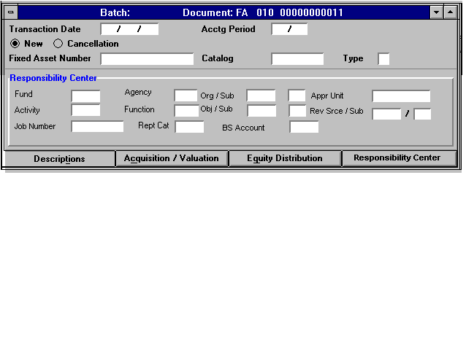
Figure 28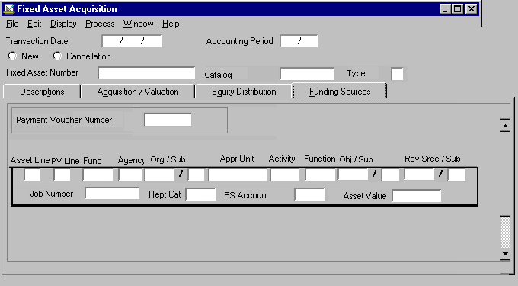. Fixed Asset Acquisition Funding Sources Panel

Recording a Fixed Asset Betterment

Betterment refers to the addition to or improvement of existing recorded assets. Betterments are recorded in the system through the Fixed Asset Betterment (FB) document. In MARS, betterments can be entered and tracked independently of other betterments as well as independently of the original asset. PD will determine the item’s eligibility to be classified as a fixed asset based on the commodity table, agency rules, and exceptions. The invoice will then generate the appropriate number of shells based on the line item quantity.

The Inventory Officer must then make a determination if the item is a betterment to an existing fixed asset. If the item represents a betterment, the previously generated FA shell should be deleted and a FB document created using the same information for those items classified as betterments. Betterment documents may be created from scratch if a FA shell was not generated from PD. The accounting implications and entries generated are essentially the same as the acquisition.

The Responsibility Center of the betterment will be the same as the original fixed asset. Betterments will provide a Funding Source, Equity and Acquisition and Valuation panel similar to the Fixed Asset Acquisition document (FA). When processed, the betterment document updates the same tables as a FA document. The Fixed Asset Betterment panels are shown in figures 29 and 30.
Figure 29. Fixed Asset Betterment Acquisition Panel
Figure 30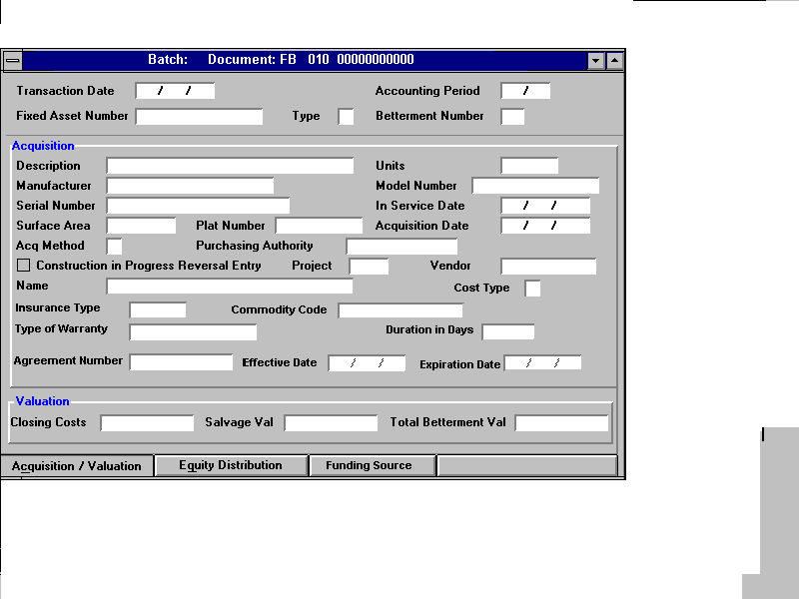. Fixed Asset Betterment Funding Source Panel
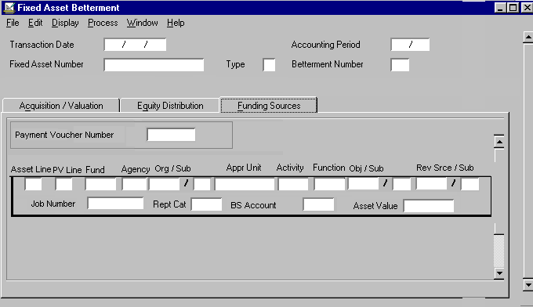

Recording Fixed Asset Dispositions

A Fixed Asset Disposition Document (FD) may be processed with the appropriate disposition method. The disposition methods are pre-defined in the ADVANTAGE Fixed Asset Disposition table (FADM). For example, the item may be destroyed, become obsolete, traded in, sold, trashed, donated, etc. For sales to the general public, a Cash Receipt (CR) document may be required. The Cash Receipt (CR) recognizes cash and revenue.

The FD calculates depreciation as of the disposition date before generating the disposition ledger entries. Using FD, betterments can be disposed of independently of the original asset. If the agency does not have the authority to dispose the fixed asset, the asset is routed to the appropriate authority in the Finance Cabinet or their agency whichever is appropriate.

Creation of a Fixed Asset Disposition Document (FD)

The following information is required to process a Fixed Asset Disposition:

- The Fixed Asset Number (tag number), Type and Betterment Number must be populated to identify the asset or betterment to be disposed.
- The Acquisition Date, Asset Value and Asset Description are inferred fields (display only) and cannot be populated.
- The Disposition Date, Disposition Method, Disposed Authority, Selling Price and Disposal Reasons/Comments must be populated.
- Several tables are updated when a Fixed Asset Betterment (FB) document is processed. These include the Fixed Asset Summary table (FAS1 and FAS2), Fixed Asset Betterment Table (FBT1 and FBT2), Balance Sheet Account Balance (BBAL) and the Fixed Asset History table (FHIS).

Figure 31 illustrates the MARS FD document.

Figure 31. Fixed Asset Disposition (FD) Document
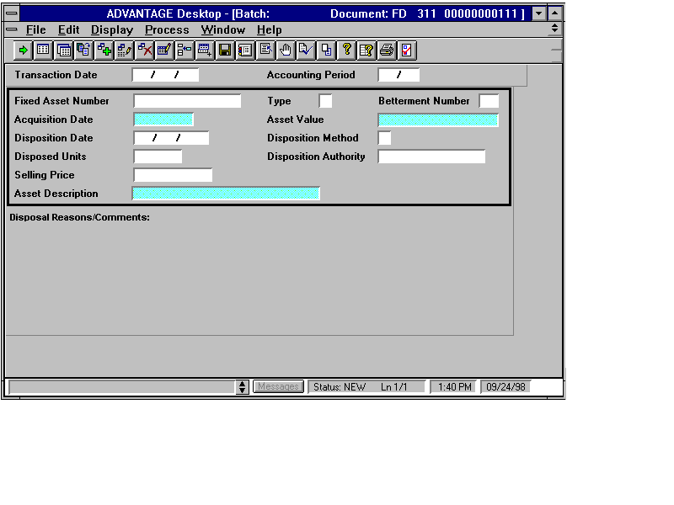

Auto generation of FD documents

MARS provides functionality to all for disposing multiple assets in batch and generating a detailed report of assets selected to be disposed. This method is expedient when agencies have a large number of different assets that need to be disposed. In addition, this process may also provide an efficient method of disposing a large number of assets to Surplus Property or for a local sale. This process reduces data entry and enhances tracking of assets delivered to Surplus Property or for other large-scale agency disposal purposes. The steps for this process are defined as follows:

- Users first select multiple fixed assets for disposal on the Fixed Asset Disposal Selection table (FADS) and populate key disposition information on this table. Next, the user updates the Fixed Asset Disposal text table (FDTX) with additional disposition information. Disposal may be scheduled for a future date.
- The FADS batch process will automatically update the Fixed Asset Disposal Generation table (FDGN).
- FD documents are generated and enter workflow with a report to Surplus Property or to other agencies.
- Surplus property or the receiving agencies approve the FD documents based on the report of assets received for disposal or sale. Any discrepancies should be reported to the agency disposing the asset.

Entering Fixed Asset Disposition Text

The Fixed Asset Disposition Text (FDTX) table, shown in figure 32, is a continuation of the Fixed Asset Betterment Inquiry. This table captures the disposal comments/reasons text from the Fixed Asset Disposition Document (FD) and provides online inquiry into the text.

Figure 32. Fixed Asset Disposal Text Inquiry
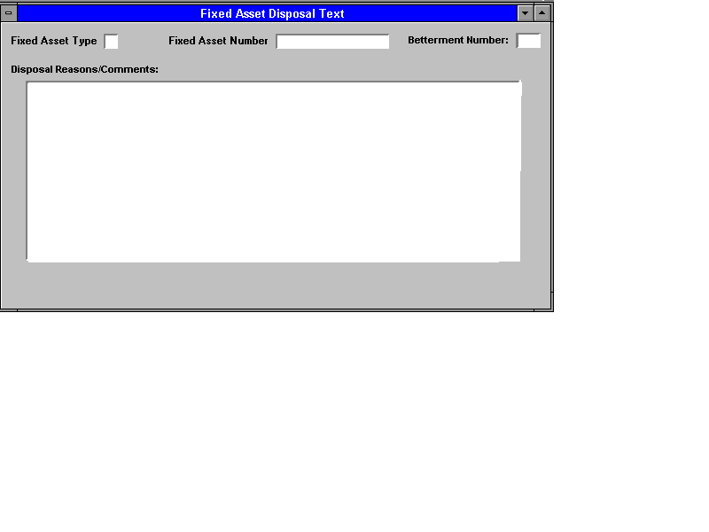

Processing Fixed Asset Reorganizations

Reorganizations between Governmental Funds or between Proprietary Funds

Using the Fixed Asset Transfer Document

When there is reorganization between governmental funds or between proprietary funds, an item or items can be transferred using the Fixed Asset Transfer document (FT). The FT document transfers ownership (changes account codes) between two governmental fund type assets. The FT document will be controlled centrally.

When entering an FT document, the following guidelines should be followed:

- The Type of Transfer code should be set to “2” in order to transfer the fixed asset from one account code to another within the same proprietary fund or between two entity funds.
- The Fixed Asset Number (tag number), Type, identify the Fixed Asset to be transferred.
- The Responsibility Center includes Fund, Agency, Organization, Appropriation Unit, Activity, Function, Object, Revenue Source, Job Number, Reporting Category, Balance Sheet Account, Room Number, Location and Asset Custodian.
- If one of the accounting attributes is changed, the entire accounting distribution must be re-entered.
- The FT document updates the Fixed Asset Summary table (FAS1 and FAS2), Fixed Asset Betterment Table (FBT1 and FBT2), Balance Sheet Account Balance (BBAL) and the Fixed Asset History table (FHIS) when processed to acceptance.

The Fixed Asset Transfer document is shown in figure 33 below.

Figure 33. Fixed Asset Transfer Document
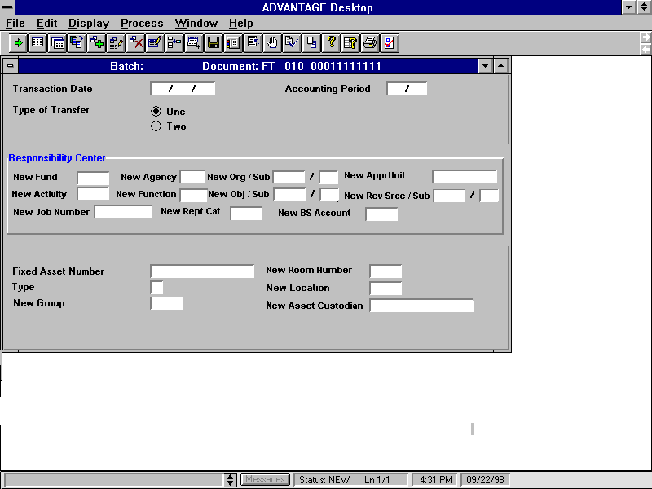

Using the Fixed Asset Reorganization Process

The Fixed Asset Reorganization process (FARO) performs a mass change to all fixed assets when a reorganization in the accounting code structure or a change in location occurs. The process is user-controlled by populating the FARO table and is useful for mass reorganizations. The fields to be populated on FARO are identical to the Fixed Asset Transfer document (FT).

The Fixed Asset Reorganization Table (FARO) allows users to utilize an online process to facilitate the reorganization of a new accounting code, location, and complex building, etc. for each individual asset. In addition, users will have the ability to facilitate reorganizations to the detailed accounting strip. The FARO table is shown in figure 34.
Figure 34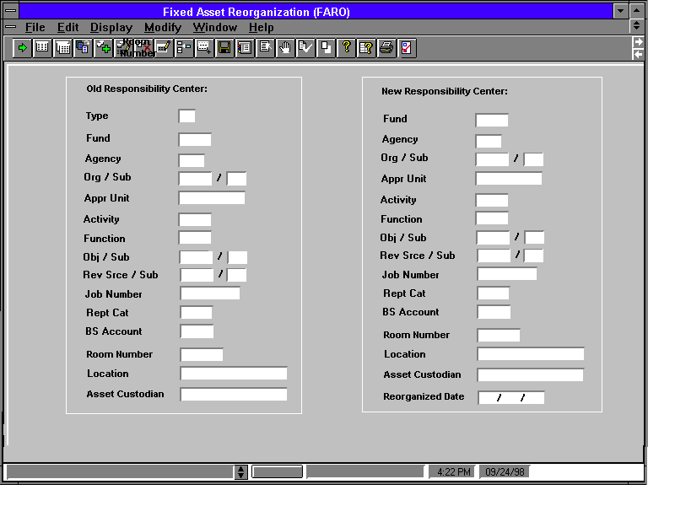. Fixed Asset Reorganization Table

Reorganization between Governmental and Proprietary funds

When the reorganization is between government and proprietary funds and the funding source does change, a Fixed Asset Disposition document (FD), followed by a Fixed Asset Acquisition document (FA) should be processed. The new FA Number (tag number) should be recorded with a sequential number, for example, if the old tag number is Z12345, the new tag number will be Z12345-1. Thus, the physical tag number does not have to be changed, but the system will sequentially track the number of reorganizations against that tag number.

For reorganization between governmental and proprietary funds, when the funding source does not change, a Fixed Asset Sale document (FS) should be recorded. The FS will not change the FA number (tag number). The FS will record gain/loss when the proprietary fund is the entity.

Note: For creation of a FD, FA and FS document, refer to the Disposition, Acquisition and Internal Sale sections of this document.

Tracking Construction-In-Process

MARS Fixed Assets support the handling of projects that have been classified as construction work-in-progress. Projects are reviewed and flagged at their inception if capitalizable. All projects are re-evaluated on a yearly basis to determine if they should be capitalized. While in the initial year of a project, items are recorded as fixed assets, in subsequent years items are recorded as betterments. Under these scenarios, original asset and betterments, an Acquisition Method of “C” (construction work-in-progress) should be utilized.

When a project is finished a Fixed Asset Transfer (FT) document with a Type of Transfer of “1” should be processed to transfer the project to the completed asset account. For creation of a FT document, refer to the Reorganization section of this document. CAFR reports will be generated as required to identify assets that have an Acquisition Method of ‘C’ for construction-in-process.

Recording an Internal Sale

For sales between agencies, process a Fixed Asset Disposition Document (FD) followed by a Fixed Asset Acquisition document (FA) to record the new tag number. The appropriate disposition method should be used, for example, sale or trade-in. The disposition methods will be set up on the Fixed Asset Disposition table (FADM).

Following these documents, and Intergovernmental payment voucher (Type II) is required to transfer funds between agencies. If the agency does not have delegated authority to dispose the Fixed Asset, FD documents may be created in batch and routed to Surplus Property for disposal, or to Finance Department for approval, or other agencies for local sale. The Insurance Coordinator will then be notified.

For sales between proprietary and governmental entities, a Fixed Asset Internal Sale (FS) may be processed based upon approval. The FS will result in the asset being recorded under its new owner. In addition, the FS posts applicable General Ledger entries including calculation of gain or loss on the sale. For proprietary fund, Fixed Asset Dispositions that are classified as Internal Sales will also require an inter-governmental Payment Voucher (Type II) to transfer funds between the agencies. However, The FD document followed by the FA document is the recommended method for all sales.

Recording Modifications to Fixed Assets

The Fixed Asset Modification document (FC) records changes or adjustments to existing assets at the individual betterment level. Most informational fields may be corrected using a Fixed Asset Modification document (FC). However, the accounting distribution cannot be changed with a FC transaction. Likewise, the equity accounts cannot be changed with a FC transaction if depreciation has been booked against the asset. Other fields that cannot be changed with the FC include the responsibility center information and the tag number. If the responsibility center needs to be changed, refer to the Fixed Asset Reorganization and Disposition processes.

If an FC is processed to update the asset value, a warning message “Update FFSR” will be issued. This indicates that the Funding Source Modification document (FF) should be processed to update the asset values on the Funding Source tables (FFSR and FFS1). Since the depreciation process uses the information on this document, changing any of these fields affects the next depreciation run.

The Fixed Asset Modification is shown in figure 35.
Figure 35. Fixed Asset Modification Document

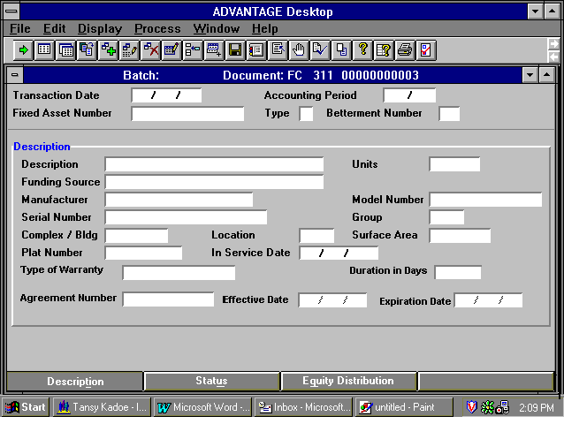

Changes to existing asset values may be made using a Funding Source Modification document (FF). This document will be controlled with a high degree of security because the FF document can be used to redistribute the funding source, or adjust apportionment of asset values. The original asset/betterment number and line of the fixed asset has to be referenced.

The FF will allow changes to the accounting distribution fields: PV Number, PV Line, Fund, Agency, Organization, Appropriation, Activity, Function, Object, Revenue Source, Job Number, Reporting Category, Balance Sheet Account. In order to change the funding source information or the PV number and PV line Number the record has to be decreased to zero using the Inc/Dec radio button and a new record added. The old line will still display a zero dollar amount on FFSR table.

The Funding Source Modification document is shown in figure 36.
Figure 36. Funding Source Modification Document

Tracking Repairs and Maintenance

MARS provides a table to track Repairs and Maintenance for assets. The RPMT table (shown in figure 37) can be populated to record the detailed repair and maintenance information. This table records and tracks repair information and reference warranty and maintenance contracts purchased on the asset.

If a warranty exists when purchasing the asset, Procurement Desktop (PD) will populate the Type of Warranty and Duration in Days fields when generating the FA shell if applicable. For Fixed Asset Acquisition (FA) and Fixed Asset Betterment (FB) documents generated from scratch, the user should add any warranty and agreement information purchased on the asset. When the FA and FB are processed, the warranty and agreement information will be populated on the Fixed Asset Summary Inquiry (FAS1) and the Fixed Asset Betterment Inquiry (FBT1).

The Repair and Maintenance (RPMT) table is a table for users to record the detail of repairs performed on assets and betterments. RPMT is also an inquiry table where users can look up information regarding repair, warranty, and maintenance. The RPMT table serves as informational data only, does does not update any ledgers.
Figure 37. Repairs and Maintenance Table
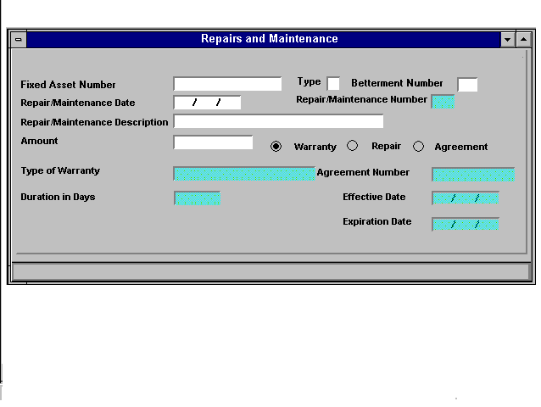

Recording Depreciation

The allocation of the net costs of the fixed asset over its estimated useful life is accomplished by decreasing the value of an asset by the amount of this allocation (depreciation). The Depreciation process may be run when a financial manager requests it. It is an off-line process (FADP) which allows the automatic computation of depreciation. The Commonwealth will use the Straight-Line (SL) method for depreciation. Depreciation will be recorded against the responsible fund (proprietary) and depreciation will be recorded against that fund. All assets and personal property will be depreciated within the fixed asset Subsystem.

The straight-line depreciation method should be specified for each asset when it is acquired, using the Fixed Asset Acquisition (FA) document. The latest values of useful life, acquisition date, asset value, accumulated depreciation, and salvage value will be used to compute current period depreciation. This allows changes made during the month to be automatically included when depreciation is run. All assets in the fixed asset module will be depreciated.

The Commonwealth has chosen to depreciate proprietary entities and record only memo depreciation entries for governmental entities. The Memo Depreciation field on the Fund table (FUN2) is used to determine whether calculated entries should be posted to the General Ledger. By setting this field on the FUN2 table, the system will post depreciation to enterprise funds, but use memo depreciation calculations for general fixed asset reports.

Key Data Structures

On-Line Transactions

- Fixed Asset Acquisition (FA)
- Fixed Asset Betterment (FB)
- Fixed Asset Modification (FC)
- Fixed Asset Funding Source Modification (FF)
- Fixed Asset Disposition (FD)
- Fixed Asset Internal Sale (FS)
- Fixed Asset Transfer (FT)

User Maintained Tables

TABLE | TABLE  ID
Fixed Asset Acquisition/ Disposition Table | FADM
Condition/Last Inventory Date Update Table | FADU
Fixed Asset Reorganization Table | FARO
Fixed Asset Type Table | FATP
Fixed Asset Catalog Table | FCLG
Fixed Asset Group Class Table | FGCS
Fixed Asset Group Category Table | FGCT
Fixed Asset Group Table | FGRP
Fixed Asset Location Tables | FLCS  FLCT  FLOC
Fixed Asset Valuation Table | FVAL
Cost Type Table | CTYP
Insurance Policy Type Table | ITYP
Repair and Maintenance Table | RPMT
Fixed Asset Disposal Selection Table | FADS
Manual Depreciation Input | MDEP

System Maintained Tables:

TABLE | TABLE  ID
Fixed Asset Document Inquiry Table | FAPV
Fixed Asset Summary Table | FAS1  FAS2
Fixed Asset Group Location Table | FAGL
Fixed Asset Betterment Table | FBT1  FBT2
Asset Custodian Inquiry Table | CUSD
Responsibility Center Inquiry Table | RESP
Serial Number Inquiry Table | SNUM
Purchasing Authority Inquiry Table | PANM
Funding Source Table | FFSR  FFS1
Fixed Asset Disposal Text Table | FDTX
Fixed Asset Disposal Selection Table | FADS
Fixed Asset Disposal Generation Table | FDGN

Off-line Processes

Fixed Assets offline processes are described in detail in the ADVANTAGE System Administration Guides. Key processes include:

- Fixed Asset Depreciation
- Fixed Assets Ledger Summary
- Fixed Asset Mass Revaluation
- Fixed Asset Disposal Generation
- Out of Sync Program (FBT1 and FSRC)
- Fixed Asset Disposition Purge
- Fixed Asset Annual Pre-Processing
- Fixed Asset Annual Closing
- Fixed Asset Reorganization

Set-up of User-maintained Tables

In order to enter and process transactions in the Fixed Asset Subsystem, the System Administrator should set-up data in the following user maintained tables:

- System Special Accounts Table (SPEC)
- Acquisition /Disposition Table (FADM)
- Fixed Assets Type Table (FATP)
- Cost Type Table (CTYP)
- Insurance Policy Type Table (ITYP)
- Fixed Asset Location Table (FLOC)
- Fixed Assets Location Class Table (FLCS)
- Fixed Asset Location Category Table (FLCT)
- Condition/Last Inventory Date Update Table (FADU)
- Fund Table (FUN2)
- Balance Sheet Account (BAC2)
- Object Table (OBJ2)
- Revenue Source Table (RSR2)

System Special Accounts Table (SPEC)

The SPEC table defines default accounts and some special-purpose accounts for the entire financial system. The following codes need to be set-up/defined on the SPEC table:

- GFAAG Fund: Identifies the Fund code for the Government Fixed Assets Account Group.
- Contribution to Fixed Assets: Blank (not used by the Commonwealth).
- Investments in General Fixed Assets: Default Code for the Equity Account of Governmental fund types.
- Retained Earnings: Default Code for the Equity Account of Proprietary fund types.
- Depreciation Expense: Object code for depreciation expense.
- Sale of Fixed Asset: Revenue source code for the sale of fixed assets
- Gain/Loss Account: Revenue source code for accumulating gains (or losses) on the sales or disposition of fund assets.
- Gain/Loss Object: Object code for accumulating gains (or losses) on the sales or disposition of fund assets.

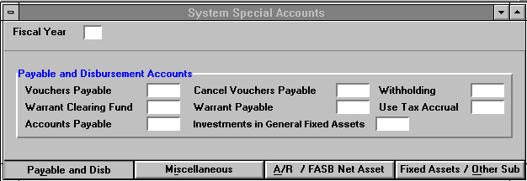

Acquisition/Disposition Table (FADM)

The Acquisition/Disposition (FADM) allows users to define the valid acquisition and disposition method codes. Whenever an acquisition or disposition transaction is processed, the method of acquiring or disposing an asset specified in the document will be checked against the FADM table to ensure the validity of the method. If an invalid method code is entered, the system will issue an error message and reject the transaction. The FADM also permits posting expense or revenue accounting entry for each acquisition or disposition method.
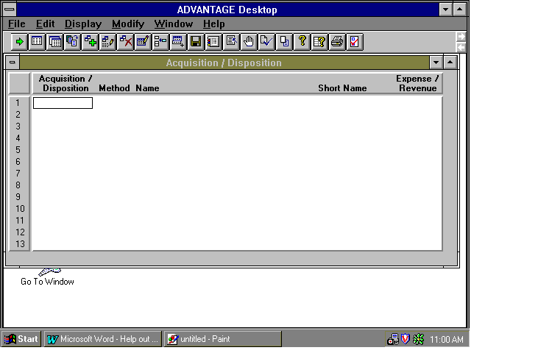

Fixed Asset Type Table (FATP)

The Fixed Asset Type (FATP) allows users to define the major types of fixed assets allowed in the Fixed Asset Subsystem. For each type, a name and short name are defined for use on reports. Users must also define two balance sheet accounts: the asset account (land, buildings, etc.) and the accumulated depreciation account. The Depreciation Indicator determines whether that type of asset is depreciated. This field should be set as ‘N’ for land and construction and ‘Y’ for all other types of assets.

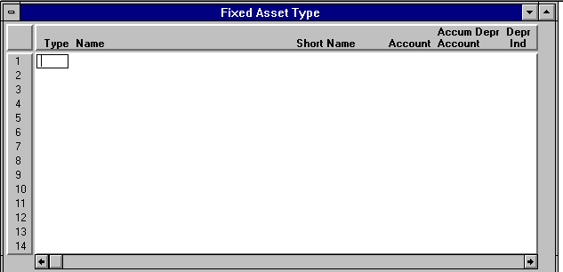

Cost Type Table (CTYP)

The Cost Type (CTYP), a new table added to the Fixed Asset Subsystem, allows users to define and describe the types of Cost.
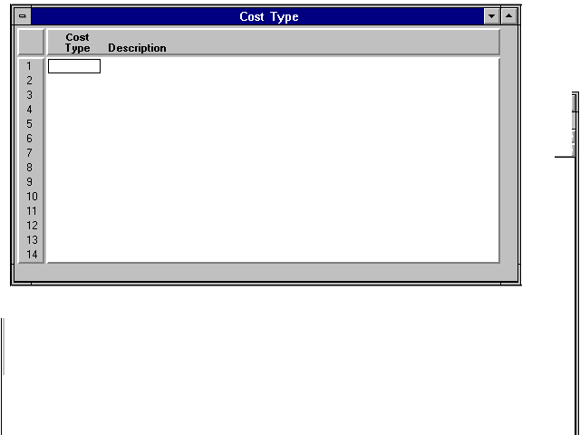

Insurance Policy Type Table (ITYP)

The Insurance Policy Type (ITYP), a new table added to the Fixed Asset Subsystem, will allow users to define and describe the types of insurance policies.
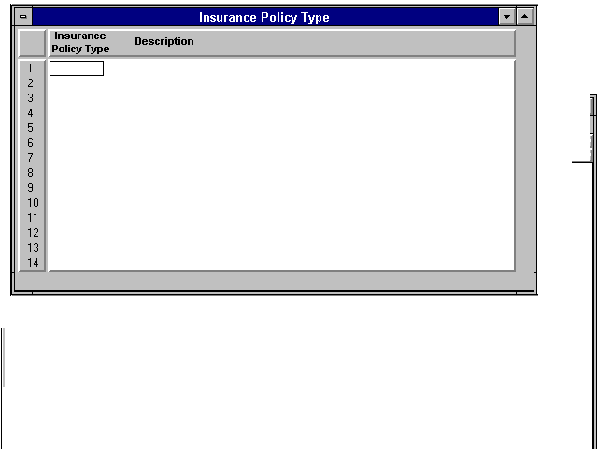

Fixed Asset Location Table (FLOC)

Fixed Asset Location (FLOC) will be used by the Commonwealth to pre-define building codes. Location is the lowest level of a three-level classification hierarchy. The progression is as follows: 1. location; 2. location class; and 3. location category.

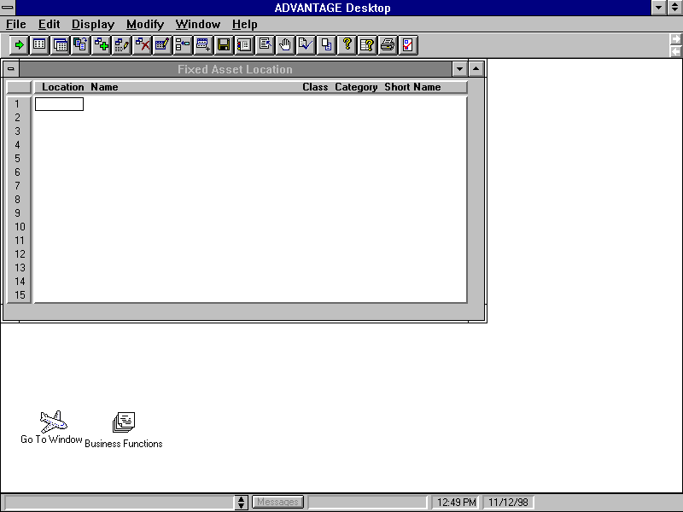
The user must associate every fixed asset with a location code. Location class and category are optional codes used to group fixed assets on reports. For example, the category might be North Greenville, the class, 500 Main Street, and the location, Building # 567.

Fixed Asset Location Class Table (FLCS)

Fixed Asset Location Class (FLCS) is optional and used for reporting purposes only. Location classes group related location codes. For example, the location code could define the building number and the location class code could define the street address of the building. The assignment of locations to location classes occurs in Fixed Asset Location (FLOC).
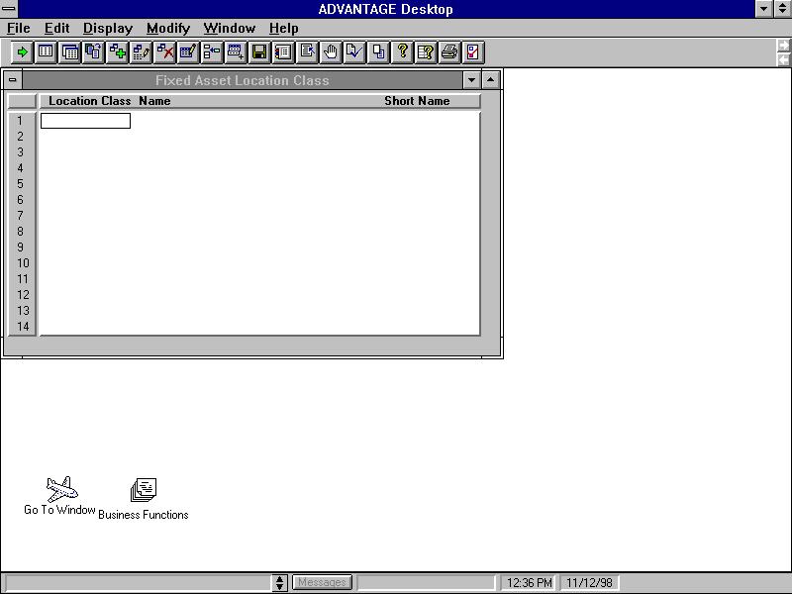

Fixed Asset Location Category Table (FLCT)

Fixed Asset Location Category (FLCT) is optional and used for reporting purposes only. Location categories group related location class codes. The assignment of location classes to location categories occurs in Fixed Asset Location (FLOC). For example, the category might be North Greenville, the class, 500 Main Street, and the location, Building # 567.

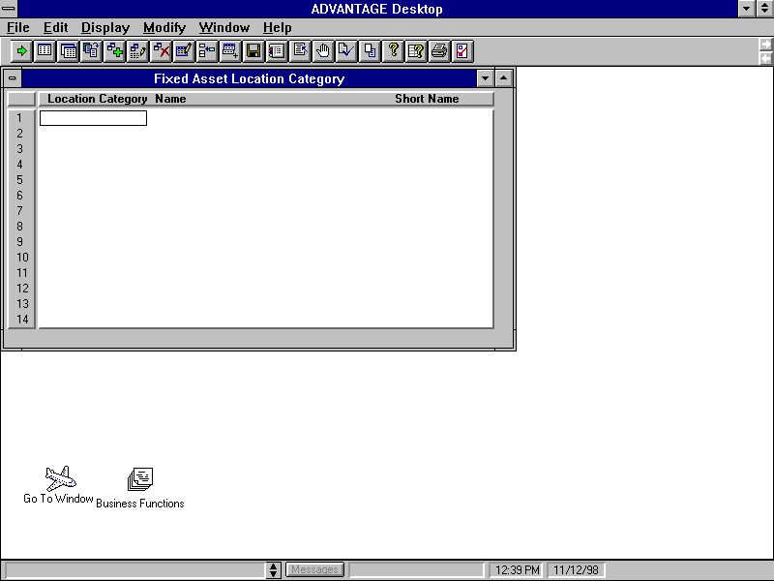

Fund Table (FUN2)

The Fund Table (FUN2) displays values for all valid funds in the System. The Fund code is always required. The Memo Depreciation indicator should be selected for governmental funds. De-select the indicator for proprietary funds. The GFAGA fund defined on the SPEC table must be set up on the FUN2 table. Fund ‘9900’ should be set up as a governmental fund. Fund ‘9900’ will default if the fund is blank on Fixed Asset documents.

Balance Sheet Account (BAC2)

The Balance Sheet Account (BAC2) defines codes for each asset, liability, reserve, or fund balance account in the System. The equity accounts (Contribution to Fixed Assets and Investments in General Fixed Assets) defined on the System Special Accounts Table (SPEC) must be valid on the BAC2 table. The asset accounts defined on the Fixed Asset Type Table (FATP) must be valid on the BAC2 table.

Object Table (OBJ2)

The Object table (OBJ2) defines objects of expenditure that appear in the expense budget and on spending transactions. The Depreciation Expense and the Gain/Loss Object codes defined on the SPEC table must be set up on the Object Code Table (OBJ2).

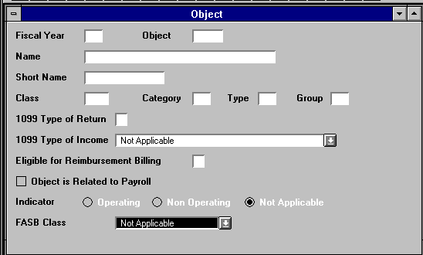

Revenue Source Table (RSR2)

The Revenue Source Table (RSR2) defines revenue sources that appear in the revenue budget and on revenue transactions. The Sale of Fixed Asset and the Gain/Loss Account revenue source codes must be valid on the RSR2 table.

System-Maintained Tables

The key system-maintained tables are described below:

- The Fixed Asset Summary Inquiry (1 of 2) (FAS1) displays summary information for all existing assets. All data that pertains to the entire asset (original asset and all of its betterments) are stored in this window.
- The Fixed Asset Summary Inquiry Table (2 of 2) (FAS2) displays summary information for all existing fixed assets. Fixed Asset Summary Inquiry (FAS1) displays all data except the equity distribution. This window displays the equity distribution of the entire asset (the original asset and all of its betterments).
- The Fixed Asset Group Location Inquiry (FAGL) is an alternate view of Fixed Asset Summary Inquiry (FAS1). This alternative view has different key fields than FAS1 and the window entries are displayed in a different order. The entries are sorted by the fixed asset group, location, fixed asset type, and fixed asset number.
- Fixed Asset Location Inquiry (FALC) provides an alternate view of Fixed Asset Summary Inquiry (FAS1 and FAS2). The information on this window is sorted by location, fixed asset type, and fixed asset number.
- The Fixed Asset Betterment Inquiry (1 of 2) (FBT1) displays one entry for each fixed asset and one entry for each betterment to the asset. The user can view this inquiry from two windows. This first window (FBT1) stores all data except the equity distribution. The second window (FBT2) stores the equity distribution for the original asset or the betterment.
- The Fixed Asset Betterment Inquiry (2 of 2) (FBT2) displays one entry for each fixed asset and one entry for each betterment to the asset. This window stores the equity distribution for the original asset or the betterment.
- The Funding Source Table (FSRC) displays a view of the detailed funding sources of the asset by Payment Voucher and Payment Line Number.
- The Funding Source Table (FFS1) displays a view of the detailed funding sources of the asset by Fixed Asset Number, Betterment Number, Fixed Asset Type and Asset Line.
- The Asset Custodian Inquiry Table (CUSD) displays information on the asset custodian name or number. This table allows users to look up Fixed Asset Type, Fixed Asset Number, and Asset Description by entering the Asset Custodian look up key. Processing a FA document will update the CUSD table.
- The Responsibility Center Inquiry Table (RESP) allows users to look up Organization, Location, Fixed Asset Type, Fixed Asset Number, and Asset Description by entering the Responsible Agency look up key. Processing a FA document will update the RESP table.
- The Serial Number Inquiry Table (SNUM) allows users to look up Fixed Asset Type, Fixed Asset Number, and Asset Description by entering the Serial Number look up key. This table will be useful to track assets if the tag has fallen off the equipment. Processing a FA or FB document will update the SNUM table.
- The Purchasing Authority Inquiry Table (PANM) allows the users to look up Fixed Asset Type, Fixed Asset Number, and Asset Description by entering the Purchasing Authority look up key. This table will be updated when a FA or FB document is processed.
- Fixed Asset History Inquiry (FHIS) allows you to track updates made against each fixed asset. Information is added to this window by the Fixed Asset document (FA) processors if Fixed Asset History on System Control Options (SOP2) is selected [Y].

Inventory Configuration

The Inventory Control Subsystem is designed to support the requisition processing, inventory management, purchasing, and physical inventory reconciliation functions of inventory management through a set of highly interactive capabilities. The Inventory Control subsystem is fully integrated with the base financial system.

The Inventory subsystem provides the following capabilities:

- Provides information on the availability of stock items.
- Facilitates timely requisition processing and provides up to date information on the status of stock requisitions.
- Automatically records and services back orders.
- Minimizes inventory investments consistent with service objectives by basing purchasing decisions on usage history.
- Provides automated tools to assist servicing, purchasing, and management of inventory.
- Improves financial control of inventory through charge-backs to user organizations and by periodic reconciliation of physical counts with system inventory balances.

Setup of Inventory Tables

The Inventory Control subsystem requires that users setup the following user-maintained tables. All data entered into the system is edited and validated by the Inventory Control subsystem.

- ABC Classification Parameter table (ABCP)
- Warehouse Management table (WHS2)
- Inventory Inquiry tables (INVN, INV2, INV3)
- Adjustment Code table (ADJC)
- Return Code table (RETC)
- Warehouse Group table (WHSG)
- Item Group table (ITMG)

The fields that are required/optional and their descriptions for each of these tables are explained in detail in the Inventory Control User’s Reference Guide.

ABC Classification Parameter (ABCP) table

The ABCP table is used to set management parameters (for example, forecast methods, order quantity methods) for stock items with similar management needs. ABC classifications are used to group these items together. For example, expensive items may be in one ABC classification while inexpensive items are in another.
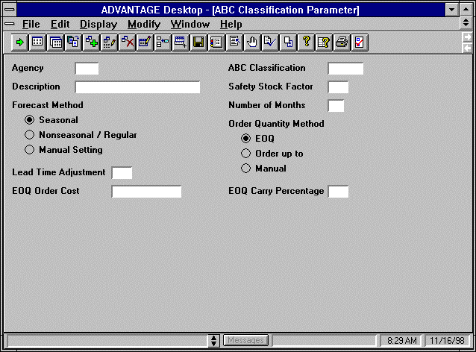

Warehouse Management table (WHS2)

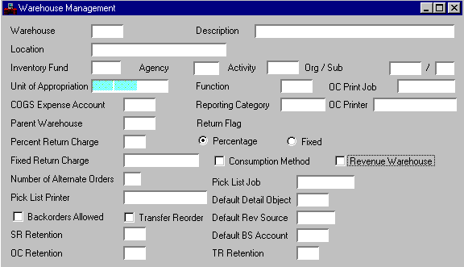
The WHS2 table consists of related information for each storage facility. It displays general information as well as specific operation conditions.

Inventory Inquiry table (INVN)

The INVN table is the most essential screen used and maintained by the Inventory Control subsystem. It stores information about each stock item stored at each storage facility. This window maintains descriptive, purchasing, historical use, reorder and cost information. It also maintains backordered, reserved, released, and in-transfer stock balances. A record is added to this window each time a new stock item is accepted by ADVANTAGE. It is updated when document processors and other off-line processes are accepted.
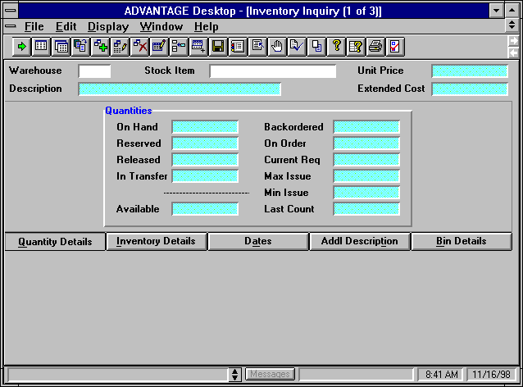

Inventory Inquiry table (INV2)

The INV2 table is an inquiry screen that displays all system-maintained item information. If Transfer Reorder is selected [Y] (for the issuing warehouse) on Warehouse Management (WHS2), the system updates the Issue Plus Transfer Quantity fields (for the issuing warehouse) to reflect the quantities transferred-out using Stock Transfer receipt (TR) documents.
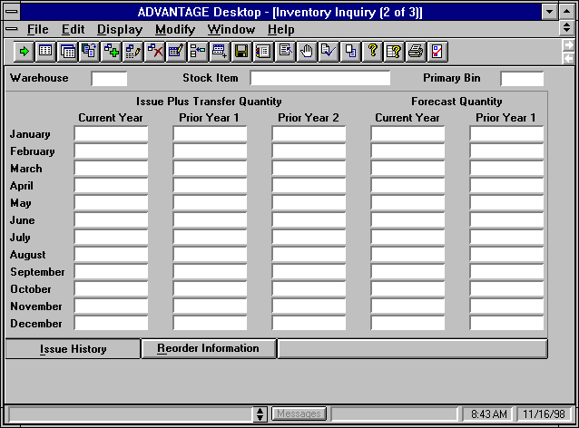

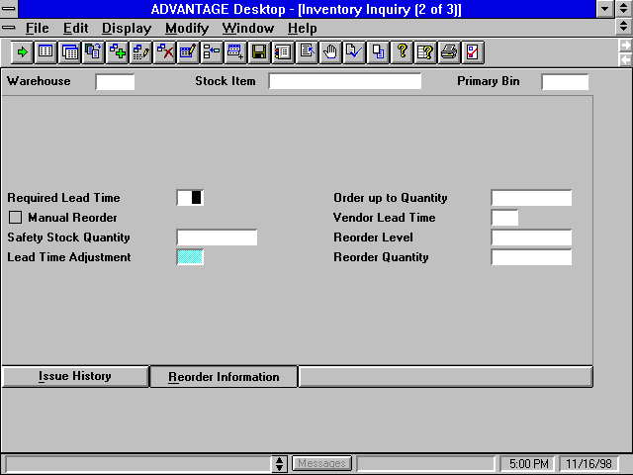
The reorder information tab on the INV2 table is updated to reflect the reorder quantity, reorder level, safety stock quantity fields etc.

Inventory Inquiry table (INV3)

The INV3 table is used to maintain non-system-generated information about stock items. Item account codes, price method options, and inventory control management parameters are set and /or modified using this screen. For the stock items, a technique called ‘smart numbering’ is used wherein all like items are displayed together to make the subsystem easier to use when ordering items.
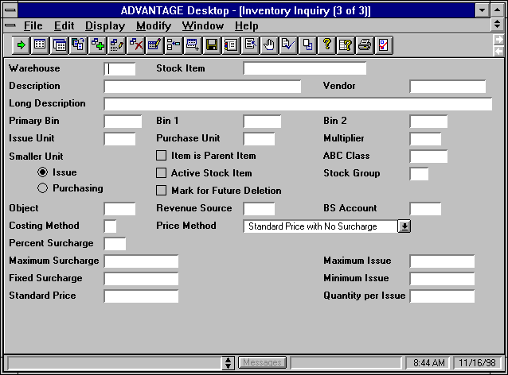

Adjustment Code table (ADJC)

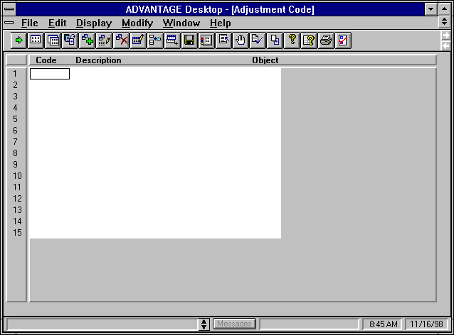
The ADJC table provides a list of valid adjustment codes with descriptions to define the reason for the adjustments to inventory. For each adjustment code, there is an object code to which the accounting entries are posted. The default adjustment code used by the inventory freeze program must have an entry in this table.

Return Code table (RETC)

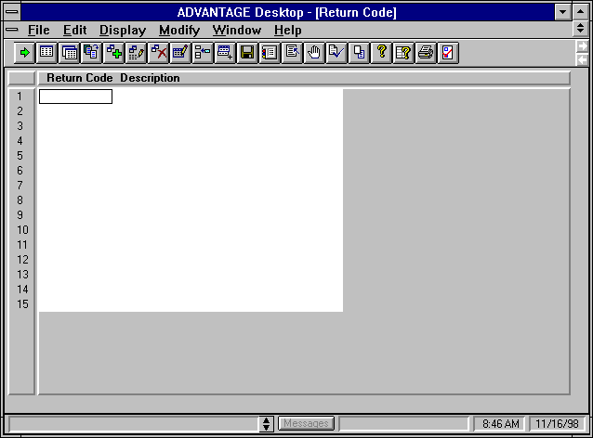
The RETC table is used to interpret valid return codes using the description defining why the stock item is returned to inventory.

Warehouse Group table (WHSG)

The WHSG table specifies the relationship between each central storage facility and its satellite storage facilities.
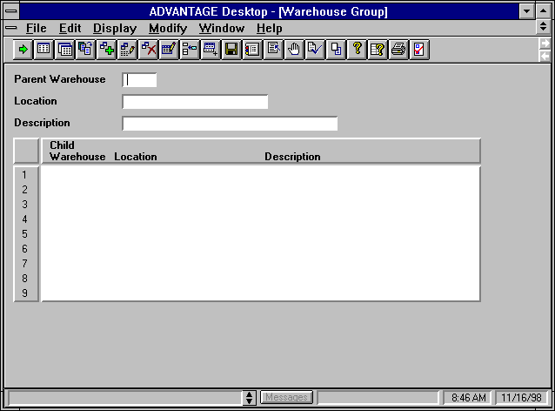

Item Group table (ITMG)

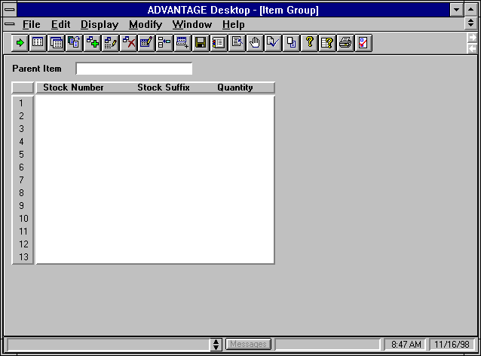
The ITMG table specifies relationships between inventory items. The relationship of parent/child allows the user to request one item (the parent) which consists of two or more stock items (the children).

Inventory Setup ‘Task Plan’

This Inventory setup ‘task plan’ describes the step-by-step procedure required to get started using the Inventory Control subsystem:

Task # | Task Description
T-1 | Finalize additional computer equipment installations including communication lines or circuits, terminals or PCs, and laser printers.
T-2 | Identify all consumable inventory system users including appropriate fiscal staff, warehouse managers and warehouse clerks.
T-3 | Identify number of agency storage facilities.
T-4 | Identify and classify a standardized inventory list. Current inventory stock must be re-numbered to the 11-digit commodity code.
T-5 | Update warehouse management master table (WHSE).
T-6 | Update master table (ABCP) ABC classification parameter table.
T-7 | Update reorder information on INV2.

Once the user maintained tables have been setup, users enter Inventory Adjustment (IA) documents. The Inventory Adjustment (IA) document allows the user to adjust the quantity or unit cost of an item. Since adjustments are classified by an Adjustment Code, the appropriate codes must be defined in Adjustment Code (ADJC) prior to Inventory Adjustment (IA) processing. Storage facilities and Inventory codes must also be defined in Warehouse Management (WHS2) and Inventory Inquiry (1 of 3) (INVN). The Inventory Adjustment document is shown in Figure 38.

Figure 38. Inventory Adjustment
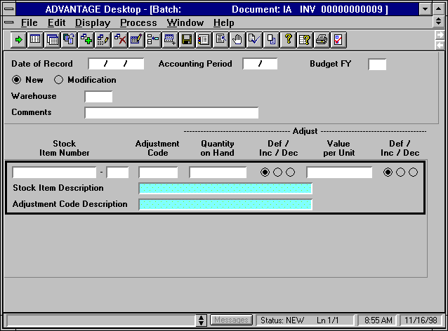

System Maintained Tables

The online mechanism for reviewing inventory reference data consists of the following tables:

- Open Stock Requisition Header Table- OSRH
- Open Stock Requisition Account Line Table- OSRL
- Open Stock Requisition Line Table- OSRC
- Open Stock Requisition Item Issues Table- OSRI
- Open Stock Transfer Receipt Header Table- OTRH
- Open Stock Transfer Receipt Line Table- OTRL
- Inventory Replenishment Table- IREP

Key Off-line Processes

Inventory control provides a series of offline programs to aid in the functionality of the system. These programs use data from the commodity ledger and master tables to perform the following functions:

- Calculate lead time. Calculates projected lead time required to requisition, order, and receive a stock item from a vendor and is also used to calculate safety stock.

- Calculate reorder levels. Calculates the safety stock for each stock item, the reorder level and reorder quantity for each stock item.

- Forecast demand calculation. Calculates demand forecasts for each stock item.

Key Inventory Reports

The Inventory Control subsystem includes various management and planning reports. These reports are identified by a report ID consisting of the letters IN followed by a two-digit number. The reports are normally run monthly or semi-monthly, although they may also be run on request.

Key reports include:

- ABC Analysis Report- IN10
- ABC Classification Report- IN20
- Forecasted Demand and Actual Item Usage History Report- IN30
- Inventory Management Report- IN40
- Inventory Price List by Stock Item Number Report- IN 50

Procurement Desktop Security

The MARS Materials Management system security features will be defined through several System Administration tasks in the Procurement Desktop application. The main security tasks in PD are Classes, Groups and Users. These Sys Admin functions provide the ability to set the following security features:
- User access to documents within and across agencies;
- User authority to create certain document types;
- User access to PD functionality;
- User approval authority;
- User access to System Administration tasks.

Building the right security model is critical to the successful implementation of MARS. The Commonwealth will need to develop a security plan that utilizes the flexibility inherent in the PD security model but provides the level of security necessary in the MARS environment. The security strategy to be implemented across the Commonwealth will be determined by Central Administration as outlined in the MARS System Security Approach and Plan. Security maintenance tasks will be divided between Agency and Central administration. The delegation of these tasks will be outlined in the MARS Central and Agency Security Administrators Guide.

Class
Classes are the basis of the security controls for an object in PD. As each object is created it is assigned a class depending on the group of the person creating it. Objects can have only one class and the class remains the same throughout the life of the object. The class of an object is one of the main determinants in setting user access to system documents. The Commonwealth must determine the classes that will be assigned to object types in PD.

Classes are created and maintained in the Class task in PD. Examples of PD classes are provided in Figure 39.

Figure 39. Class Code Examples
Class Code | Class Description
AGYREQ | Requisition in Agency
CORD | Central Purchase Order
AGYORD | Agency Purchase Order

The collection and maintenance of object class information will follow the system security deliverables mentioned above. Use Data Form PPD 11. Class Information to aid in collecting this information.

Group
Many of the security features of the Procurement Desktop application are directly related to the user’s group assignment. A group is a method of combining users by common security attributes such as document object class access and menu function availability. Groups can be set according to Agency, department or role within the organization. A user’s group determines the following items:
- The user’s access and edit authority for different documents with different object classes;
- The menu options available to the group’s users;
- The classes for the objects created by the group.

Groups are created and maintained in the Group task in PD system administration. Several attributes must be defined for each group including:
- Group ID – name and description for the group;
- Users – associates individual users with the group. This function can also be performed in the User task.
- Class Access – determines the group’s access authority to documents and objects. The group’s authorities are based upon two factors:
- The Owning Group is the group of the user who owns the document;
- The Object Class of the document is determined by who created the document.
The Group Class Access tab is shown in Figure 40.
- Menus – defines the menu access availability for the group. The Menus tab in the Group task is shown in Figure 41:
- Object Classes – defines the Classes for the Objects and documents created by the group. The Object Classes tab is shown in Figure 42:

Figure 40. Class Access Tab
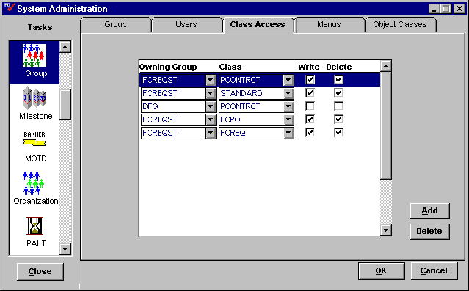
Figure 41. Menus Tab
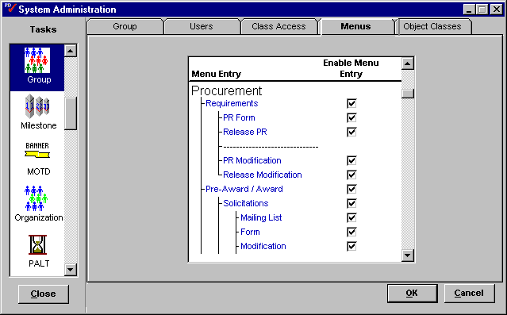

Figure 42. Object Classes Tab
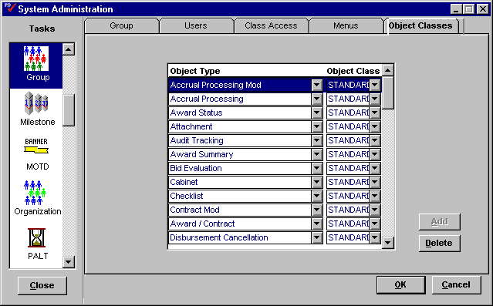
The setup and maintenance of Group security settings will be defined by the security deliverables mentioned above. Use Data Form PPD 12. Group Information to collect this information.

User
The PD application controls many aspects related to system access and workgroup authorities through the user profile. The Commonwealth must define the following characteristics pertaining to each user. The User task collects the information on each user such as:
- The basic attributes pertaining to the user’s profile;
- The primary and any secondary groups that the user will be assigned to;
- The Team(s) that a user will be assigned to (if any);
- The user’s class access, only if different from default class access provided by the Group task;
- The user’s approval authority;
- The user’s authority to buy a particular commodity;
- The user’s authority to perform organization maintenance or approve registered vendors (CRC personnel);
- The user’s status as a procurement card administrator;
- The user’s authority to assign Workload tasks to other users;
- The user’s access to System Administration tasks;
- The user’s default addresses for PR Requesting Office and Solicitation Issuing Office.
The creation and maintenance of user profiles is performed within the User task in PD System Administration as illustrated in Figure 43.

Figure 43. User Task
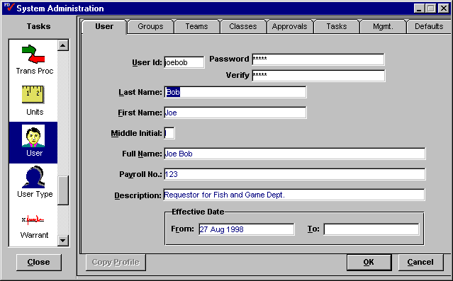
The setup and maintenance of user profiles will be defined by the security deliverables mentioned above. Use Data Form PPD 13. User Profile Information to collect this information.

Document Approval Setup
Kentucky has required that Procurement Desktop include automatic line level approval routing. The detailed designs of this function are provided by the Functional Design – Line Level Approval Routing and Functional Design – System Administration Approvals documents.

PD will automatically determine what approval authorities are required based upon the document type, the document sub-type, the total cost of the document, and the buying entity of the initiator of the approval route.

PD will also be used to approve Purchase Requests on the line item level by separating the lines into multiple PR documents and routing them to different users for approval. This separation will be based on the commodity code of the line item.

The setup and maintenance of this function is performed in the Approval and Auto Approval tasks in PD System Administration. Within these tasks the Commonwealth must define the rules to determine the approval path that the purchasing documents must take for approval and release.

Approval
In order to configure PD to control the approval process for procurement documents, the Commonwealth must prepare the basic attributes of the process. The Commonwealth must define the following:
- Type – defines the type of approvals necessary for approving documents;
- Authority – defines the levels of purchase authority needed for document approvals. These will be assigned to individual users in the User task (see Section 5.3 User);
- Template – defines an approval template by combining an approval type and an approval authority for use when manually routing documents for approval. These templates can be used when the Auto Approval Routing is not appropriate for the necessary approval path. These templates must then be manually routed for approval. See Section 3.7 Route for more information on routing documents.
- Acceptance – defines the user roles in acceptance. Acceptance is the process of reviewing a line item from an invoice or receiver to validate payment. The Commonwealth will not likely use this feature to validate payments.
This information will be managed in the Approval task in PD System Administration as illustrated in Figure 44.

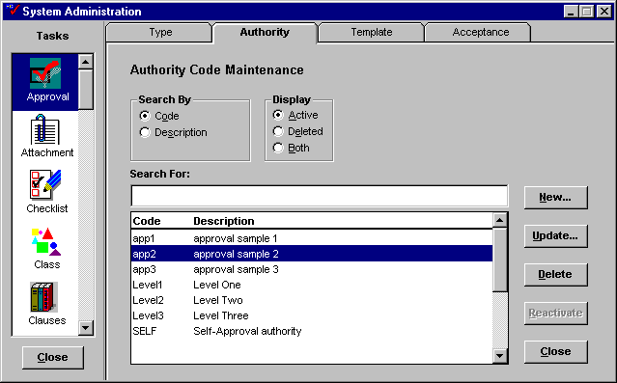
Figure 44. Approval Task

Since manually routing documents for approval will be specific to each document, approval template creation should be handled at the Agency level. Approval authorities will be dependent on Commonwealth business rules and will be defined by central administration.

Auto Approval
To facilitate the Auto Approval Routing process, administrators must setup the approval and routing information that will take a selected document from the desktop and route it for approval. The design of this task is detailed in the Functional Specification – System Administration Approvals document. The Commonwealth will be responsible for defining the following:
- Profiles – create, modify and delete approval profiles, which are used to determine the authorities required for an approval and in what order they are to be routed;
- Documents – identify the criteria for a document approval rule. The information on the document being routed for approval is compared to the criteria created in this task to determine which path to follow. These criteria include:
- Document type;
- Document sub-type;
- Cited authority;
- Document dollar value range.

The Auto Approvals Documents tab is illustrated in Figure 45.
- Document Template – create or modify a buying profile, which is a combination of a Buying Entity, approval profiles and authorized users. The Auto Approvals Document Template tab is illustrated in Figure 46.
- Commodities – identifies the criteria for a document at the line item level. This information determines if additional approvals are required as a result of information in the line item detail. For example, if a Purchase Request contains a request for a shredder, then an additional approval is required from the Division of Printing. The Auto Approvals Commodity tab is illustrated in Figure 47.
- Commodity Template – create or modify a buying profile to route the document for approval according to the commodity code information entered in the Commodity tab.
- Buyers – defines the buyers who will receive purchase requests based upon the commodity code of the items being requested. Buyers will be assigned responsibility for certain commodity groups based upon buying entity. The Auto Approval Buyers tab is illustrated in Figure 48.

Figure 45. Document Tab
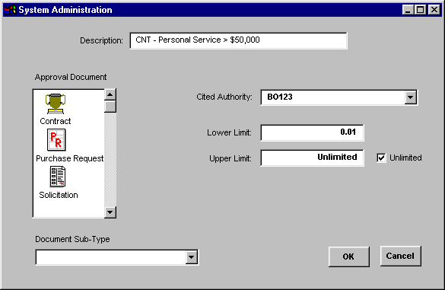

Figure 46. Document Template Tab
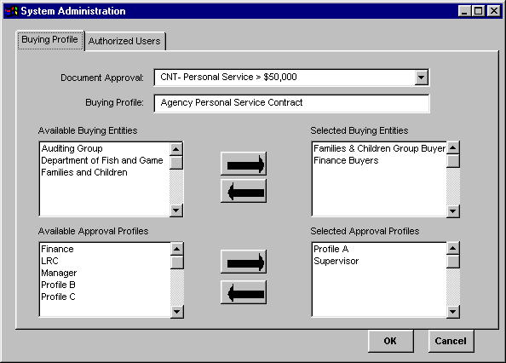

Figure 47. Commodity Tab
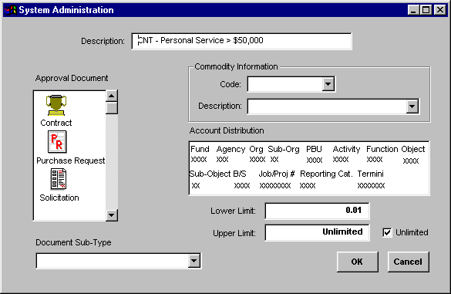

Figure 48. Buyers Tab
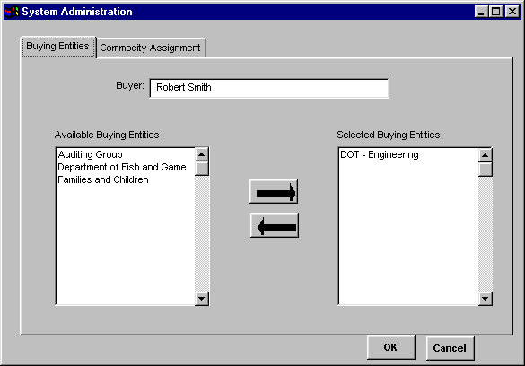

The information required in setting up the Approval structure of PD is quite involved, differing by document type, Agency and other criteria. Therefore the setup and maintenance of the Approval business rules will be assigned to a team of individuals familiar with all of the iterations contained in this process. Use the following forms to aid in collecting information for Auto Approvals:

- PPD 29. Identify Approval Profile;
- PPD 30. Identify Document Criteria;
- Error: Reference source not found;
- PPD 32. Identify Buying Profile for the Commodity Criteria;
- PPD 33. Commodity Buyer Information;
- PPD 34. Identify Commodity Criteria.

Authority Type
Users in the Commonwealth must cite the appropriate authority in order to allocate awards and funds to vendors. An authority type is the legal basis for purchasing rights. PD provides the ability for administrators to create authority types and associate them with particular groups to be accessed by users when creating procurement documents. These authority types will populate the Cited Authority drop-down boxes on PD procurement documents. The Commonwealth must define:
- Cited authority types;
- Group(s) associated with each authority type;
- Dollar limit for each group associated with the authority type.

Authority types can be added, modified and deleted in the Authority Type task in PD system administration, as illustrated in Figure 49.

Figure 49. Authority Type Task
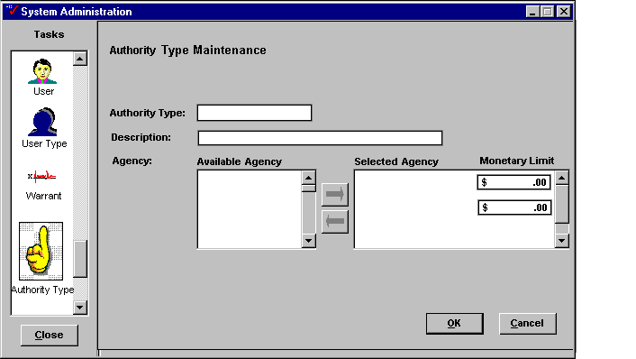

Since cited authority will affect purchases across the Commonwealth, authority type information should be collected and maintained by central administration. Use Data Form PPD 22. Cited Authority Types to aid in the collection of this information.

Team
In order to facilitate the Workload function of the system, PD allows users to be grouped into Teams who can share desktop cabinets. Documents placed in these cabinets can be accessed from the desktop of any member of the team. Administrators can create teams, assign team leaders and create shared cabinets and assign them to the team. These teams are created and maintained in the Team task in System Administration as shown in Figure 50. Team Task.

Since Team information will be specific to each Workgroup, this information should be gathered and maintained at the Agency level. Use Data Form PPD 17. Team Information to aid your collection efforts.

Figure 50. Team Task
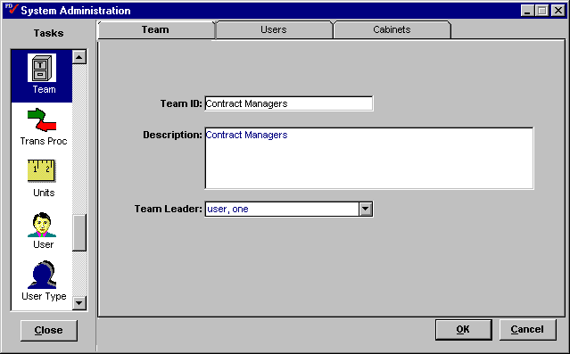

Warrant
The PD application provides the ability to define the levels of purchase authority that a user can exercise in terms of the types of awards available to be released and the dollar value limits for each award. These purchase authority profiles are called Warrants. Warrants are created and maintained in the Warrant task in PD System Administration.

The Commonwealth will not use the Warrant functionality in their operations so setup of this task is not necessary. However the functionality will remain in the baseline software if its use becomes necessary in the future.

Procurement Profile
The PD Application provides the ability to control user authority to release documents by dollar amount. . The Proc Profile task in PD System Administration allows system users to be assigned Warrants according to their procurement activity needs and manage their procurement profile.

The Commonwealth will not use the Procurement Profile functionality in their operations so setup of this task is not necessary. However, the functionality will remain in the baseline software if its use becomes necessary in the future.

Appendix A: Materials Management Data Forms

The Materials Management Data Forms are intended to aid in the collection of the information needed for the Setup and Usage of the Materials Management portion of MARS.
PPD 1. Attachment Templates
Attachment Title | File Name | OA Product | PD Module

Use this form to collect information on Attachment templates in PD Sys Admin.
PPD 2. Organization Maintenance
Address Type Description
Vendor Type Description
Contact Type Description
FOB Type Description
Region Description
Program Description

Use this form to collect data to populate tables in the Organization task in PD Sys Admin.
PPD 3. Procurement Type Information
Solicitation Type Code | Description
Contract Type Code | Description
Cancellation Reason | Description
Suspension Reason | Description

Use this form to collect information to populate the Procurement Type tables in PD Sys Admin.

PPD 4. Award Type Maintenance
Document Type | Sub Type | Description | Internal Award
 |  |  | ❒
 |  |  | ❒
 |  |  | ❒
 |  |  | ❒
 |  |  | ❒
 |  |  | ❒
 |  |  | ❒
 |  |  | ❒
 |  |  | ❒
 |  |  | ❒
 |  |  | ❒
 |  |  | ❒
 |  |  | ❒
 |  |  | ❒
 |  |  | ❒
 |  |  | ❒
 |  |  | ❒
 |  |  | ❒
 |  |  | ❒
 |  |  | ❒

Use this form to collect information for the Award Type task in PD Sys Admin.
PPD 5. Scheduling – A/P Reference Data
Hold Reason Code | Description
Override Reason Code | Description
Account Type Code | Description
Disbursements Code | Description | Lag Time
Use this form to collect information to populate the tables in the Scheduling task in PD Sys Admin.
PPD 6. Scheduling – Payment Terms Setup
Code | Description |  | DEFAULTS
Code |  |  | Inv/Pay Auth | Misc Quick Payment
 |  |  | ❑ | ❑
Discount Terms |  | Penalty Terms
Days | Percentage | Days | Percentage | $ Amount
Base Payment Days |  | Starting Date
Code | Description |  | DEFAULTS
Code |  |  | Inv/Pay Auth | Misc. Quick Payment
 |  |  | ❑ | ❑
Discount Terms |  | Penalty Terms
Days | Percentage | Days | Percentage | $ Amount
Base Payment Days |  | Starting Date

Use this form to collect payment terms information for the Schedule task in PD Sys Admin.
PPD 7. Shipping Information
Carrier Codes | Carrier Description
Ship Method Code | Method Description
Freight Payment Code | Payment Description
Discrepancy Code | Discrepancy Description
Not to Specs Code | Not to Specs Description

Use this form to collect information to populate the tables in the Shipping task in PD Sys Admin.
PPD 8. Manifest Route Template
Route Code | Route Description
Routing Stops
Route Code | Route Description
Routing Stops
Route Code | Route Description
Routing Stops

Use this form to collect information regarding Manifest Routes in PD Sys Admin.
PPD 9. Milestone Template
Template Title |  |  |  | Reminder Intervals
Group Association | All Groups   |  |  | 1: |  | 2: |  | 3:
Group Association |  |  |  | Type: Days  Weeks  Months 
Milestone |  | Action |  | Business Days |  | Dependency |  | Required 
Use this form to collect information to create Milestone plan templates in PD Sys Admin.
PPD 10. PALT Codes
PALT Number | Description | Lead Time (Days)

Use this information to collect data to populate the PALT (Procurement Action Lead Time) task in PD Sys Admin.

PPD 11. Class Information
Class Name | Class Description

Use this form to collect data on PD Security Classes for the Class task in Sys Admin.
PPD 12. Group Information
Group ID (Max 8 Characters)
Description (Max 60 Characters)
Class Access
Owning Group | Class |  |  | Write  ✓ |  | Delete  ✓
 |  |  |  | ❑ |  | ❑
 |  |  |  | ❑ |  | ❑
 |  |  |  | ❑ |  | ❑
 |  |  |  | ❑ |  | ❑
 |  |  |  | ❑ |  | ❑
 |  |  |  | ❑ |  | ❑
 |  |  |  | ❑ |  | ❑
 |  |  |  | ❑ |  | ❑
Menu Access
List menu items to activate.
Menu Option |  |  | Menu Option
Object Classes
Object Type | Class |  | Object Type |  | Class
Use this form to gather information to populate the Group task in PD Sys Admin.

PPD 13. User Profile Information
User ID  (Max 8 Characters) |  |  |  | Password  (Max 30 Characters)
Last Name  (Max 32 Characters) |  |  |  | First Name (Max 32 Char.) |  |  |  |  |  | M. I.
Full Name
Payroll Number
Copy From Profile
User’s Groups |  | Primary  ✓ |  |  | User’s Groups
 |  | ❑
User’s Teams
Team Name |  |  |  |  |  | Team Name
Class Access (only if different from User’s Group)
Owning Group |  |  | Class |  |  |  |  |  | Write  ✓ |  |  | Delete  ✓
 |  |  |  |  |  |  |  |  | ❑ |  |  | ❑
 |  |  |  |  |  |  |  |  | ❑ |  |  | ❑
 |  |  |  |  |  |  |  |  | ❑ |  |  | ❑
Approvals
Authority Code |  |  |  |  |  | Authority Code
Sys Admin Tasks |  |  |  |  |  | All Tasks 
Purchase Request  Requesting Office |  |  |  |  |  | Solicitation  Issuing Office

Use this form to gather information on PD User Profiles for the User task in PD Sys Admin.
PPD 14. User Profile - Management Information
Manager/Supervisor Name
User ID
Assigned Users
User ID | User Type

Use this form to assign workload management authority to a user in the User task in PD Sys Admin.

PPD 15. User Type Information
User Type | Description

Use this form to gather information for the User Types task in PD Sys Admin.

PPD 16. Checklist Templates
Template Title | Associated Module | Item # | Checklist Description

Use this form to collect information on Checklist templates in PD System Administration.

PPD 17. Team Information
Team Information
Team ID |  | Description
Team Leader |  | Cabinet Name
User Name |  | User Name
Team Information
Team ID |  | Description
Team Leader |  | Cabinet Name
User Name |  | User Name
Use this form to collect information on Procurement Teams for PD System Administration.
PPD 18. Warrant Information
Warrant Type |  | Description
Award Type | Contract Type |  | Dollar Value Limit | Unlimited
 |  |  |  | □
 |  |  |  | □
 |  |  |  | □
 |  |  |  | □
 |  |  |  | □
 |  |  |  | □
Warrant Type |  | Description
Award Type | Contract Type |  | Dollar Value Limit |  | Unlimited
 |  |  |  |  | □
 |  |  |  |  | □
 |  |  |  |  | □
 |  |  |  |  | □
 |  |  |  |  | □
 |  |  |  |  | □
Warrant Type |  | Description
Award Type | Contract Type |  | Dollar Value Limit | Unlimited
 |  |  |  | □
 |  |  |  | □
 |  |  |  | □
 |  |  |  | □
 |  |  |  | □
 |  |  |  | □

Use this form to setup Warrant information in PD system administration.

PPD 19. Procurement Profile Information
User Name | Employee Code
Warrant | Warrant Number
Issuing Organization | Issue Date | Expiration Date
 | Status
Comments
User Name | Employee Code
Warrant | Warrant Number
Issuing Organization | Issue Date | Expiration Date
 | Status
Comments

Use this form to collect information for the Procurement Profile task in PD Sys Admin.
PPD 20. Route Template
Route Name | Users

Use this form to collect information for the Route task in PD Sys Admin.
PPD 21. Clause Template Setup
Clause Template Name
Group Association | All □
Section | Clause Number |  | Required | Incorporate
 |  |  | □ | □ By Reference
 |  |  | □ | □ By Full Text
 |  |  | □ | □ By Reference
 |  |  | □ | □ By Full Text
 |  |  | □ | □ By Reference
 |  |  | □ | □ By Full Text
 |  |  | □ | □ By Reference
 |  |  | □ | □ By Full Text
 |  |  | □ | □ By Reference
 |  |  | □ | □ By Full Text
 |  |  | □ | □ By Reference
 |  |  | □ | □ By Full Text
 |  |  | □ | □ By Reference
 |  |  | □ | □ By Full Text
 |  |  | □ | □ By Reference
 |  |  | □ | □ By Full Text
 |  |  | □ | □ By Reference
 |  |  | □ | □ By Full Text
 |  |  | □ | □ By Reference
 |  |  | □ | □ By Full Text
 |  |  | □ | □ By Reference
 |  |  | □ | □ By Full Text
 |  |  | □ | □ By Reference
 |  |  | □ | □ By Full Text
 |  |  | □ | □ By Reference
 |  |  | □ | □ By Full Text
 |  |  | □ | □ By Reference
 |  |  | □ | □ By Full Text
 |  |  | □ | □ By Reference
 |  |  | □ | □ By Full Text
 |  |  | □ | □ By Reference
 |  |  | □ | □ By Full Text
 |  |  | □ | □ By Reference
 |  |  | □ | □ By Full Text
 |  |  | □ | □ By Reference
 |  |  | □ | □ By Full Text
 |  |  | □ | □ By Reference
 |  |  | □ | □ By Full Text
 |  |  | □ | □ By Reference
 |  |  | □ | □ By Full Text

Use this form to setup clause templates in PD system administration.

PPD 22. Cited Authority Types
Cited Authority Type
Authority Type Description
Group | All  | Dollar Limit
Cited Authority Type
Authority Type Description
Group | All  | Dollar Limit

Use this form to setup authority types in PD system administration.
PPD 23. Request for Audit Trail Trigger
Name of Requestor
Agency/Department
Phone Number
FAX
Requested Date
Title of Document
Field Name |  | Field Name
Signature

Use this form to indicate which data fields to track in the audit trail report.

PPD 24. Best Value Criteria
Identifier | Evaluation Criteria | Commodity Description

Use this form to collect information on evaluation criteria for PD system administration.

PPD 25. Evaluation Criteria Template
Template Title
Group Association | All Groups  
Identifier |  | Criterion

Use this form to collect information on best value criteria templates for PD system administration.

PPD 26. Accounting Template
Template Description
User Access
Fund |  |  | Percentage

Use this form to create accounting templates in the Accounting task in PD Sys Admin.
PPD 27. Fixed Asset Exception Information

Commodity Code | Agency | Dollar Amount

PPD 28. Procurement Card Setup
Administrator Name
Administrator ID (User task)
Cardholder Name
Card Number
Funding Strip |  | % split
Cardholder Name
Card Number
Funding Strip |  | % split
Cardholder Name
Card Number
Funding Strip |  | % split
Cardholder Name
Card Number
Funding Strip |  | % split
Cardholder Name
Card Number
Funding Strip |  | % split

Use this form to collect the information needed to setup procurement card administration in PD.

PPD 29. Identify Approval Profile
Approval Profile Description | Authority Codes

Use this form to setup Approval Profiles for the Auto Approval task in PD System Administration.

PPD 30. Identify Document Criteria
Document Approval Name | Document Type | Document Sub-Type | Cited Authority | Lower Limit | Upper Limit | Unlimited

Use this form to identify document criteria for the Auto Approval task in PD Sys Admin.

PPD 31. Identify Buying Profile for the Document Criteria
Buying Profile Description |  |  | Document Approval Description
Buying Entity | Approval Profile(s) | Authority Code |  | Authorized Users
Buying Entity | Approval Profile(s) | Authority Code |  | Authorized Users
Buying Entity | Approval Profile(s) | Authority Code |  | Authorized Users

Use this form to identify buying profiles for the Auto Approval task in PD Sys Admin.

PPD 32. Identify Buying Profile for the Commodity Criteria
Buying Profile Description |  |  | Commodity Approval Description
Buying Entity | Approval Profile(s) | Authority Code |  | Authorized Users
Buying Entity | Approval Profile(s) | Authority Code |  | Authorized Users
Buying Entity | Approval Profile(s) | Authority Code |  | Authorized Users

Use this form to identify commodity buying profiles in the Auto Approvals task in PD Sys Admin.

PPD 33. Commodity Buyer Information
Buyer Name
Buying Entity | Commodity Code | Commodity Description | Lower Limit | Upper Limit | Unlimited
Buying Entity | Commodity Code | Commodity Description | Lower Limit | Upper Limit | Unlimited

Use this form to assign commodity responsibility to buyers in PD Sys Admin.

PPD 34. Identify Commodity Criteria
Commodity Approval Name | Document Type | Document Sub-Type | Commodity Code | Account Code | Lower Limit | Upper Limit | Unlimited

Use this form to identify commodity criteria for the Auto Approval task in PD Sys Admin.

A non-matched invoice is an invoice that has been generated without reference to a previously existing PD document.
Team assignment can be performed in either the User task or the Team task in PD System Administration.

