Topic 5 working with lines tables

purpose

The purpose of this topic is to familiarize the user with the PD Lines tables.

objectives

During this topic you will learn how to:

- Create a Query using the Design View

- Select Fields

- Join Tables

- Set Criteria

- Save and Run the Queries

line item detail window
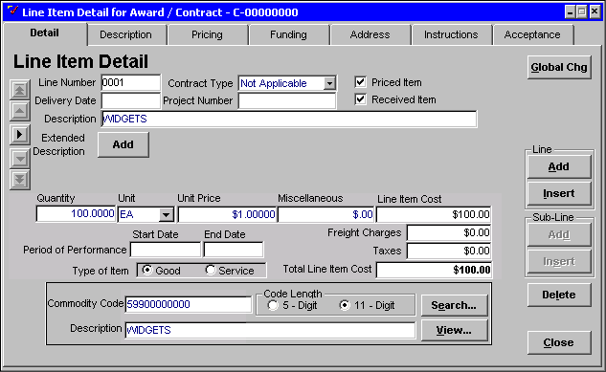

Lines Tables
The Line Tables includes information contained in the detail or commodity lines of the document. These tables include lines relating to released documents and to ALL versions of a document (original and modifications). There are not two separate tables for current and history lines.

line tables list
TABLE NAME
MREP.VW_PD_X_REQUISITION_ HIST_LN
MREP.VW_PD_X_SOLICITATION_ HIST_LN
MREP.VW_PD_X_CONTRACT_ HIST_LN
MREP.VW_PD_X_DELIVERY_ORD_ HIST_LN
MREP.VW_PD_X_PAYMENTS_ HIST_LN

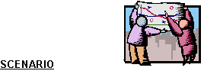
You have been asked to obtain the information on a particular fiscal year’s personal service contracts and memoranda of agreement for your agency. We will need a query to obtain the requested information.

New Table
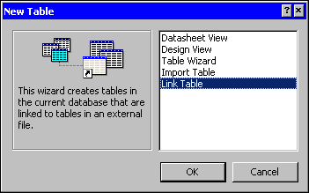

Adding Tables
Step 1 On the Table tab. Click on the <NEW> button.

Step 2 On the New Table window. Highlight Link Table.

Step 3 On the New Table window. Click the <OK> button. The Link window is displayed.

Table link
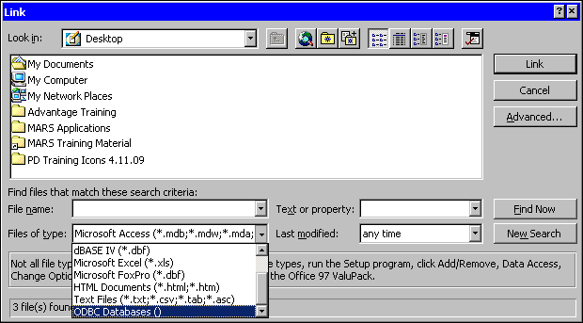

Step 4 On the Link window, in the FILES OF TYPE field. Select ODBC Databases(). The Select Data Source window is displayed.

Select data source
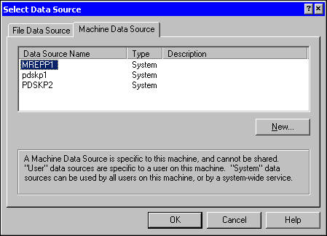

Step 5 On the Select Data Source window. Select the Machine Data Source tab.

Step 6 On the Machine Data Source tab. Select MREPP1.

Step 7 On the Select Data Source window. Click the <OK> button. The Oracle Logon window is displayed.

Oracle Logon
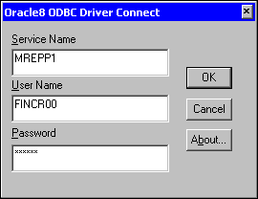

Step 8 On the Oracle Logon window in the USER ID field. Type Your USER ID.

Step 9 On the Oracle Logon window in the PASSWORD field. Type Your PASSWORD.

Step 10 On the Oracle Logon window. Click the <OK> button.

Link Tables
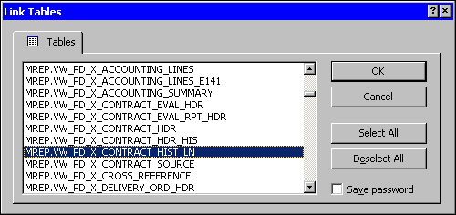

Since we already have the MREP.VW_PD_X_CONTRACT_HDR table, we only need to retrieve one table.

The Contract History Lines table contains the detail and commodity lines of the document. It contains all lines for the document both original and modifications.

Step 11 On the Link Tables window. Select MREP.VW_PD_X_CONTRACT_HIST_LN.

Step 12 On the Link Tables window. Click the <OK> button.

Select Unique Record Identifier
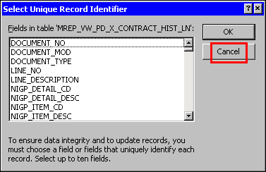

Step 13 On the Select Unique Identifier window. Click the <CANCEL> button.

The table will be added to the database and we are ready to create the necessary query.

Queries tab
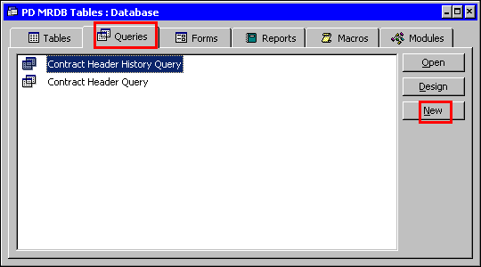

NEW QUERY
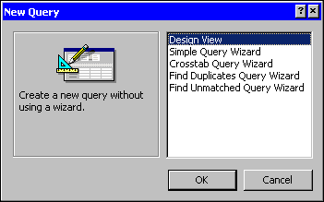

Creating a Query
Step 1 On the MRDB Database. Click on the Query tab.

Step 2 On the Queries tab. Click the <NEW> button.

Step 3 On the New Query window. The default is Design View. Leave As Is.

Step 4 Click the <OK> button. The Show Tables window is displayed.

Show table
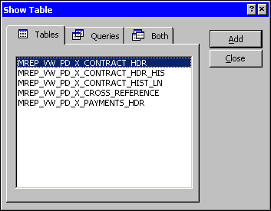

Step 5 On the Show Tables window. Highlight MREP_VW_PD_X_CONTRACT_HDR.

Step 6 On the Show Tables window. Click the <ADD> button.

Step 7 On the Show Tables window. Highlight MREP_VW_PD_X_CONTRACT_HIST_LN.

Step 8 On the Show Tables window. Click the <ADD> button.

Step 9 On the Show Tables window. Click the <CLOSE> button. The Query Design window is displayed.

Step 10 On the Toolbar. Click the <PROPERTIES> button. The Query Properties window is displayed.

PROPERTIES WINDOW
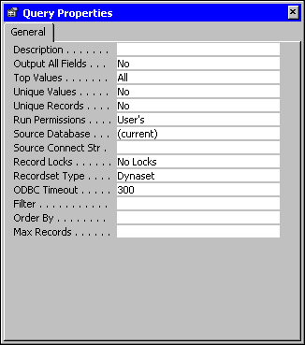

Step 11 In the ODBC TIMEOUT field. Highlight the defaulted 60. Type 300.

Step 12 On the Query Properties window. Click the 'X' in the upper right-hand corner. The Query Design window is displayed.

Design View
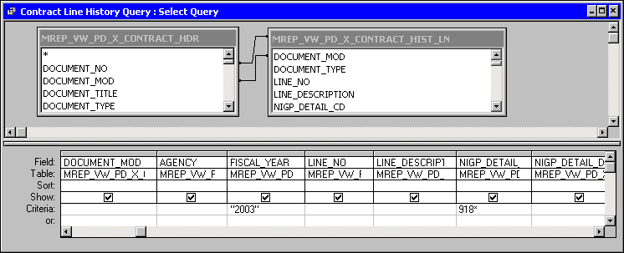

Step 28 On the Design View on the query in the MREP_VW_ PD_X_CONTRACT_HDR table. Highlight the DOCUMENT NO field hold your mouse button down and drag it to the DOCUMENT NO field in the MREP_VW_ PD_X_CONTRACT_HIST_LN table and release.

The Contract Header table contains only the current version of the document and the Contract History Lines table contains the lines for all version of the document; therefore, we will have to join the DOCUMENT MOD field to get the correct data.

NOTE: Remember from Topic 2 what would happen if we did not build a relationship on document mod.

Step 29 On the Design View on the query in the MREP_VW_ PD_X_CONTRACT_HDR table. Highlight the DOCUMENT MOD field hold your mouse button down and drag it to the DOCUMENT MOD field in the MREP_VW_ PD_X_CONTRACT_HIST_LN table and release.

Step 30 On the Table Field List window. From the MREP.VW_PD_X_CONTRACT_HDR table, highlight and double-click the following fields:

DOCUMENT_NO
DOCUMENT_MOD
AGENCY
FISCAL_YEAR
Step 31 On the Table Field List window. From the MREP.VW_PD_X_CONTRACT_HIST_LN table, highlight and double-click the following fields:

LINE_NO
LINE_DESCRIPTION
NIGP_DETAIL_CD
NIGP_DETAIL_DESC

NOTE: If you have access to multiple agencies, you can specify the agency code
you wish to query on the criteria line. Otherwise, leave blank to view all agencies you currently have security to.

Keep in mind that Master Agreements do not require an agency number and will not be displayed when an agency code is specified.

The Selection Criteria is always case sensitive.

Step 32 In the FISCAL_YEAR field. Type 2003.

Step 33 In the NIGP_DETAIL_CD field. Type 918* then Tab.

NOTE: Placing an asterisk at the end of a value tells MS Access to select all values that begin with the significant characters to the left of the asterisk. In this case, select all commodity codes that begin with ‘918’.

Step 34 Click the <SAVE> button. The Save As Dialog Box is displayed.

Save As
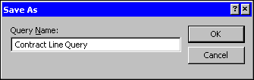

Step 35 In the QUERY NAME field. Type Contract Line Query.

Step 36 Click the <OK> button.

Step 37 On the Toolbar. Click the <RUN> button.

Query Results
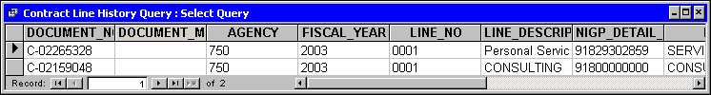

Step 38 On the Query Results window. Click the 'X' in the upper right-hand corner. The Query Results window closes.

Review Questions
What tables would you use to find the following information:

- What is the number of award contracts that will expire within the next six months for your agency?

- How many delivery orders were released on XYZ, Inc. this fiscal year?

- How many current contracts does buying entity 333333 have?

- How many kilowatts of electricity has your agency paid for this fiscal year?



In this topic we have learned how to:

- Create a Query using the Design View

- Select Fields

- Join Tables

- Set Criteria

- Save and Run the Queries



Are there any questions concerning the information covered in this topic?

