Topic 4 Working with header tables

purpose

The purpose of this topic is to familiarize the user with creating queries in Microsoft Access using the Design View. We will join tables in a query and run queries using various criteria.

objectives

During this topic you will learn how to:

- Create a Query using the Design View

- Select Fields

- Join Tables

- Set Criteria

- Save and Run Queries

Table relationship for this topic
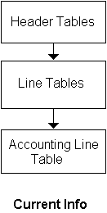

Header Tables
Header table information relates to the entire document. The Header Tables contain information from the Main tab or header of the document. These tables only include released documents and only the active or current version of the document.

NOTE: Active/Current version does not imply the document has not expired. It merely represents the latest version of the document.

For example on contracts, items such as EFFECTIVE DATE, EXPIRATION DATE, SUB-TYPE, and VENDOR are contained in the header tables.

These tables should be used when the user is concerned about current information and not any history of the document. For example, if the user is looking for all contracts his/her agency has with a particular vendor, wants the current amount of such contracts, and what amounts are expended on the them he/she should use the header tables.

There are five header tables: Requisition, Solicitation, Contract, Delivery Order, and Payments.

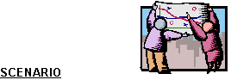
You have been asked to obtain information on a particular contract for your agency. We will first build one query to obtain the contract numbers for our agency. We will then build additional queries to obtain the requested information.

Query tab
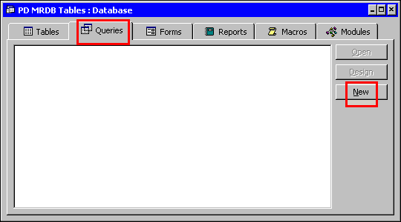

Creating a Query in the Design View
Step 1 On the MRDB Database. Click on the Query tab.

Step 2 On the Queries tab. Click the <NEW> button.

NEW QUERY
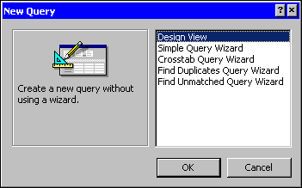

Step 3 On the New Query window. The default is Design View. Leave As Is.

Step 4 Click the <OK> button. The Show Tables window is displayed.

Show table
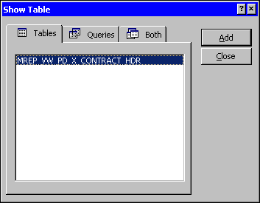

Step 5 On the Show Tables window. Highlight MREP_VW_PD_X_CONTRACT_HDR.

Step 6 On the Show Tables window. Click the <ADD> button.

Step 7 On the Show Tables window. Click the <CLOSE> button. The Query Design window is displayed.

We need to increase the time that it takes to run our query.

Step 8 On the Toolbar. Click the <PROPERTIES> button. The Query Properties window is displayed.

PROPERTIES WINDOW
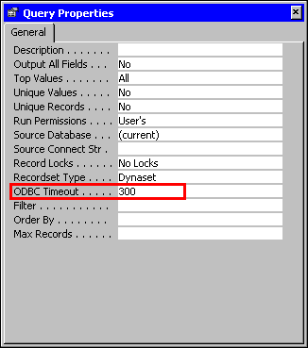

Step 9 In the ODBC TIMEOUT field. Highlight the defaulted 60. Type 300.

Step 10 On the Query Properties window. Click the 'X' in the upper right-hand corner. The Query Design window is displayed.

Design View
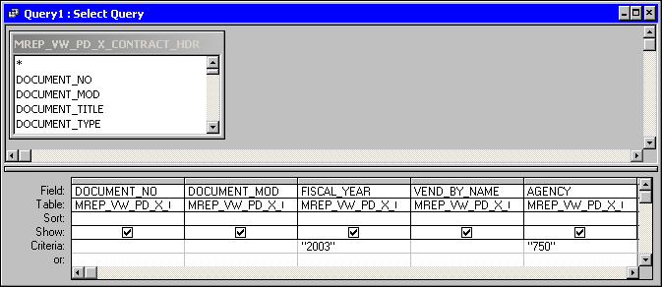

Step 11 On the Table Field List window. Highlight and double-click the following fields:

DOCUMENT_NO
DOCUMENT_MOD
AGENCY
FISCAL_YEAR
VEND_BY_NAME

Step 12 In the FISCAL_YEAR CRITERIA field. Type ☺☺☺☺.

NOTE: If you have access to multiple agencies, you can specify the agency code you wish to query on the criteria line. Otherwise, leave blank to view all agencies you currently have security to.

Keep in mind that Master Agreements do not require an agency number and will not be displayed when an agency code is specified.

The Selection Criteria is always case sensitive.

Step 13 Click the <SAVE> button. The Save As Dialog Box is displayed.

Save As
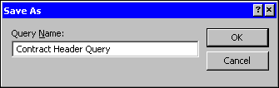

Step 14 In the QUERY NAME field. Type Contract Header Query.

Step 15 Click the <OK> button.

Step 16 On the Toolbar. Click the <RUN> button.

Query Results
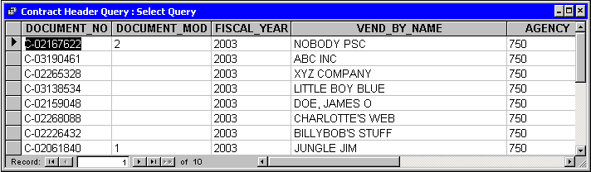

The DOCUMENT MOD field contains the number of the modification made to a particular document.

Step 17 Write down one of the contract numbers that has had a modification done on it. __-__ __ __ __ __ __ __ __ -__.

Step 18 On the Query Results window. Click the 'X' in the upper right-hand corner. The Query Results window closes.

We need to ensure that all the desired fields are on the query. In our case, we have now decided we need to know which document payments were made for this contract which requires adding more tables to our query. Let's go back and link to two additional tables and discuss table joins and relationships.

New Table
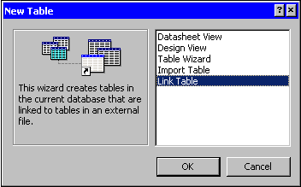

Adding Tables
Step 1 On the Table tab. Click on the <NEW> button.

Step 2 On the New Table window. Highlight Link Table.

Step 3 On the New Table window. Click the <OK> button. The Link window is displayed.

Table link
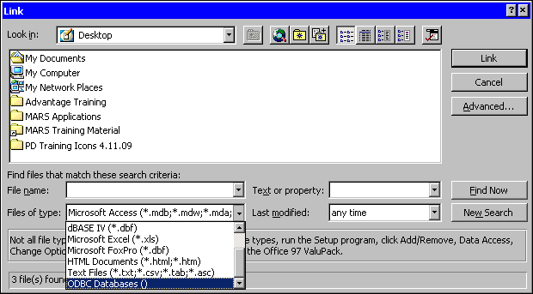

Step 4 On the Link window, in the FILES OF TYPE field. Select ODBC Databases(). The Select Data Source window is displayed.

Select data source
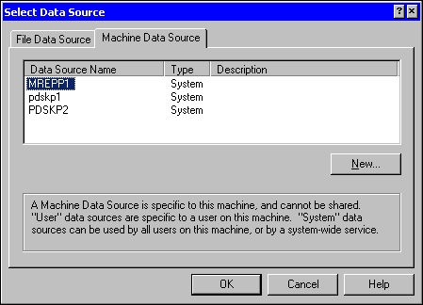

Step 5 On the Select Data Source window. Select the Machine Data Source tab.

Step 6 On the Machine Data Source tab. Select MREPP1.

Step 7 On the Select Data Source window. Click the <OK> button. The Oracle Logon window is displayed.

Oracle Logon
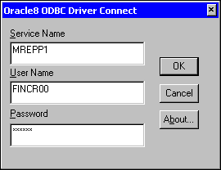

Step 8 On the Oracle Logon window in the USER ID field. Type Your USER ID.

Step 9 On the Oracle Logon window in the PASSWORD field. Type Your PASSWORD.

Step 10 On the Oracle Logon window. Click the <OK> button.

Link Tables
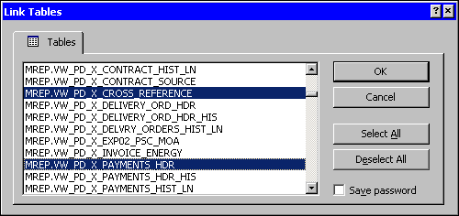

Step 11 On the Link Tables window. Select MREP.VW_PD_X_CROSS_REFERENCE and MREP.VW_PD_X_PAYMENTS_HDR.

The Cross Reference table contains Cradle to Grave information on documents. The Payments Header table contains information from the Main tab of Invoices and Miscellaneous Quick Payments for active or current version of those documents.

Step 12 On the Link Tables window. Click the <OK> button.

Select Unique Record Identifier
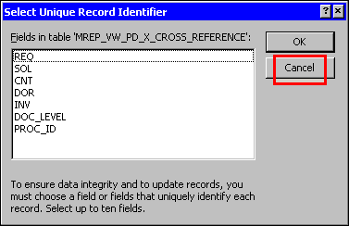

Cross_Reference Table Definitions
REQ represents Requisitions
SOL represents Solicitations
CNT represents Contracts/Master Agreements/Catalog Master
Agreements/Purchase Orders
DOR represents Delivery Orders/Catalog Delivery Orders
INV represents Invoices and Miscellaneous Quick Payments
DOC_LEVEL and PROC_ID are system identifiers

Step 13 On the Select Unique Identifier window. Click the <CANCEL> button.

NOTE: The Select Unique Record Identifier window appears for each table view selected. When the Select Unique Record Identifier window comes up for each table, it is important NOT to select any field, therefore, just click the <CANCEL> button.

Queries tab
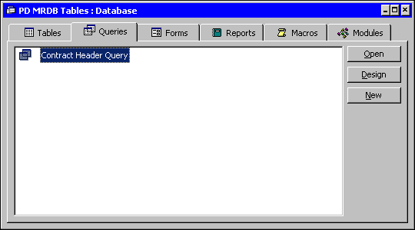

Step 14 Select the Queries tab.

Step 15 On the Queries tab. Highlight the Contract Header Query.

Step 16 On the Queries tab. Click the <DESIGN> button. The Query is displayed in the Design View.

Show Tables button
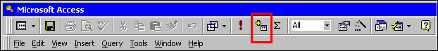

Step 17 On the Query Toolbar. Click the <SHOW TABLES> button.

Show table
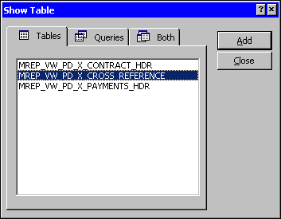

Step 18 On the Show Table window. Highlight the MREP_VW_PD_X_CROSS_REFERENCE table view.

Step 19 On the Show Table window. Click the <ADD> button.

Step 20 On the Show Table window. Highlight the MREP_VW_PD_X_PAYMENTS_HDR table view.

Step 21 On the Show Table window. Click the <ADD> button and then click the <CLOSE> button.

Step 22 Click the <SAVE> button.

NOTE: You can double-click when desired table is highlighted on the Show Table window.

You can create relationships in the Database window by selecting Tools then Relationships from the menu bar or clicking the Relationship button on the toolbar. When the Relationship window appears it is blank. You can add tables using the Show Tables button on the toolbar. To create a link between two tables, select the common field from one table and drag it over the common field in the other table, then drop it.

Creating a join
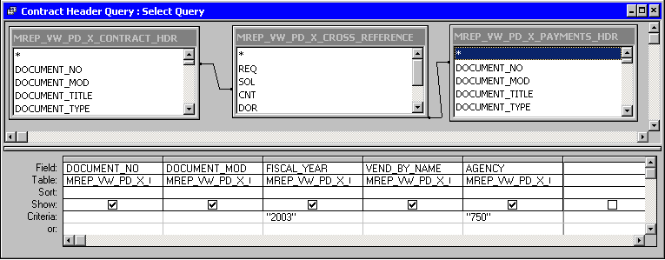

Since we want to see all payments against a contract we have to use the Cross_ Reference table. The Document Number on the Contract_HDR would be stored on the Cross_Reference table in the field CNT.

Step 23 On the Design View on the query in the MREP_VW_ PD_X_CONTRACT_HDR table. Highlight the DOCUMENT NO field hold your mouse button down and drag it to the CNT field in the MREP_VW_ PD_X_CROSS_REFERENCE table and release.

The Document Number on the Payments_HDR table would be stored on the Cross-Reference table in the field INV.

Step 24 On the Design View on the query in the MREP_VW_ PD_X_CROSS_REFERENCE table. Highlight the INV field hold your mouse button down and drag it to the DOCUMENT NO field in the MREP_VW_PD_X_PAYMENTS_HDR table and release.

NOTE: Select the CURRENT_FL field to avoid seeing duplicate lines.

Join properties window
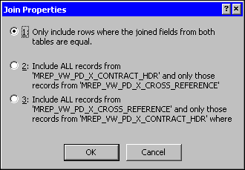

Step 25 Highlight the line created between the two tables and then double-click on it. The Join Properties window is displayed.

On the Join Properties window you have three options. Option number one is used when you want only the fields from both tables match. Option number two is used when you want all the records from the first table and only the joined fields from the second table. Option number three is used when you want all the records from the second table and only the joined fields from the first table.

Since we want certain fields from each table to match, we will keep the first selection and continue.

Step 26 Click the <OK> button.

We now need to add some additional fields.

We have decided that we want additional fields for our query from the Contract Header table in addition to the invoice number. We have linked to the appropriate table and have performed our join. Now we are ready to add the additional fields to our query.

adding fields
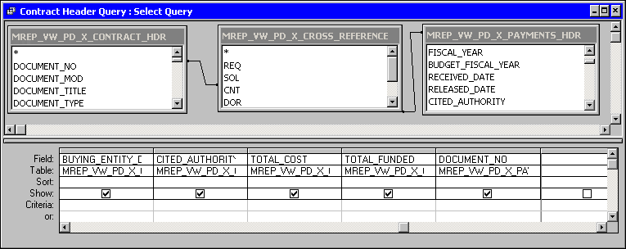

Adding Fields to a Query
Step 1 In the MREP_PD_X_CONTRACT_HDR table. Highlight and double-click on the following fields:

DOCUMENT_TITLE
SUBTYPE_DESC
BUYING_ENTITY_DESC
CITED_AUTHORITY_DESC

Step 2 In the MREP_PD_X_PAYMENTS_HDR table. Highlight and double-click on the following fields:

DOCUMENT_NO
TOTAL_COST

Step 3 In the DOCUMENT_NO for the Contract Header table. Type in Your Contract number from page 4-7 (Do not use Mod #).

Step 4 On the Design View of the query. Click the <SAVE> button.

Step 5 Click the <RUN> button.

Query results
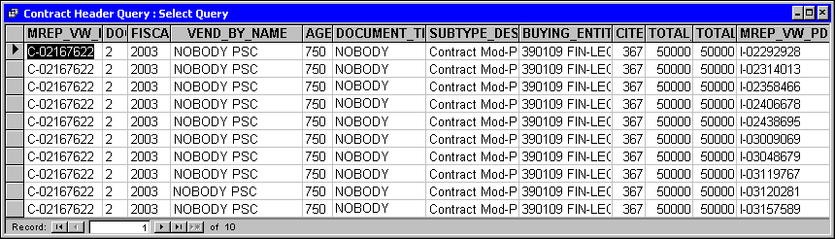

Step 6 On the Query Results window. Click the 'X' in the upper right-hand corner. The Query Results window closes.

Management has now asked that you provide information on the modifications that have occurred to a particular contract. You will have to create a new query to obtain this information. We will build an additional query. But before we can do this we must add the correct table into our database.

New Table
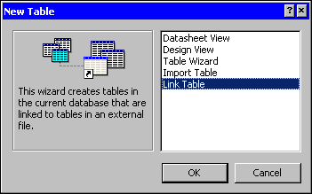

Step 1 On the Table tab. Click on the <NEW> button.

Step 2 On the New Table window. Highlight Link Table.

Step 3 On the New Table window. Click the <OK> button. The Link window is displayed.

Table link
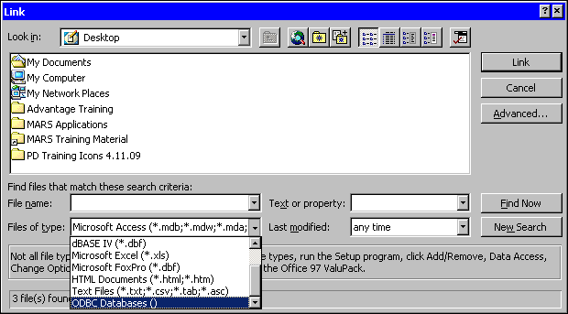

Step 4 On the Link window, in the FILES OF TYPE field. Select ODBC Databases(). The Select Data Source window is displayed.

Select data source
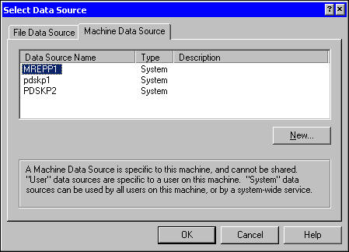

Step 5 On the Select Data Source window. Select the Machine Data Source tab.

Step 6 On the Machine Data Source tab. Select MREPP1.

Step 7 On the Select Data Source window. Click the <OK> button. The Oracle Logon window is displayed.

Oracle Logon
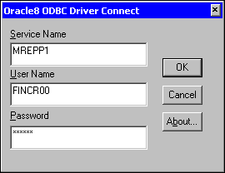

Step 8 On the Oracle Logon window in the USER ID field. Type Your USER ID.

Step 9 On the Oracle Logon window in the PASSWORD field. Type Your PASSWORD.

Step 10 On the Oracle Logon window. Click the <OK> button.

Link Tables
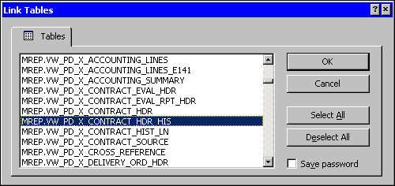

The Contract Header History table contains information from the Main tab of the document. It contains all versions of the document (original and modifications).

Step 11 On the Link Tables window. Select MREP.VW_PD_X_CONTRACT_HDR_HIS.

Step 12 On the Link Tables window. Click the <OK> button.

Select Unique Record Identifier
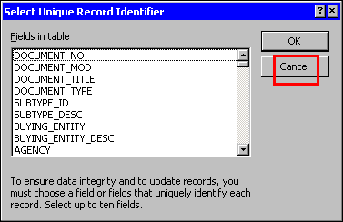

Step 13 On the Select Unique Identifier window. Click the <CANCEL> button.

Queries tab
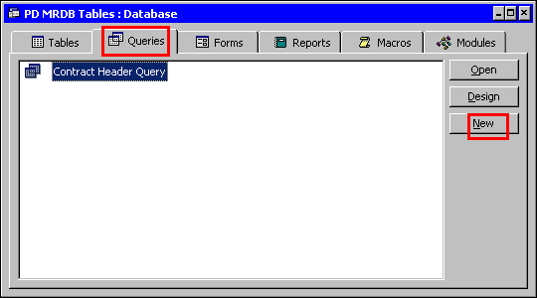

Step 14 On the MRDB Database. Click on the Query tab.

NEW QUERY
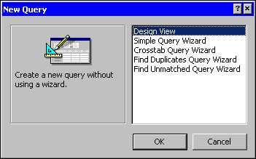

Step 15 On the Queries tab. Click the <NEW> button.

Step 16 On the New Query window. The default is Design View. Leave As Is.

Step 17 Click the <OK> button. The Show Tables window is displayed.

Show table
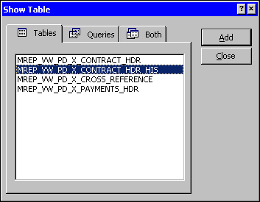

Step 18 On the Show Tables window. Highlight MREP_VW_PD_X_CONTRACT_HDR_HIS.

Step 19 On the Show Tables window. Click the <ADD> button.

Step 20 On the Show Tables window. Click the <CLOSE> button. The Query Design window is displayed.

We need to increase the time that it takes to run our query.

Step 21 On the Toolbar. Click the <PROPERTIES> button. The Query Properties window is displayed.

PROPERTIES WINDOW
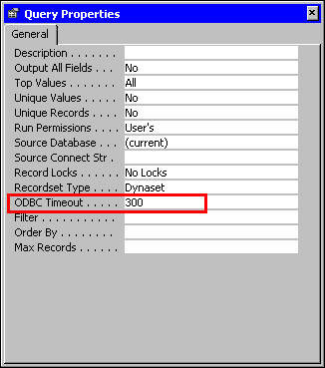

Step 22 In the ODBC TIMEOUT field. Highlight the defaulted 60. Type 300.

Step 23 On the Query Properties window. Click the 'X' in the upper right-hand corner. The Query Design window is displayed.

design View
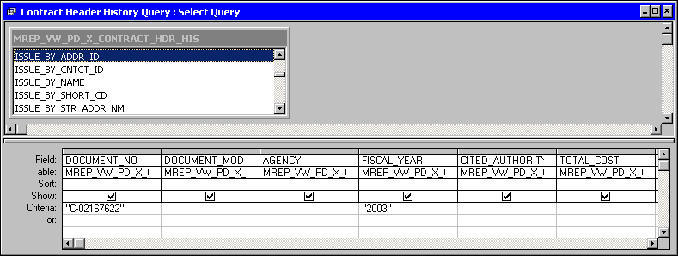

Step 24 On the Table Field List window. Highlight and double-click the following fields:

DOCUMENT_NO PRIOR_TOTAL_COST
DOCUMENT_MOD MOD_AMOUNT_COST
AGENCY TOTAL_FUNDED
FISCAL_YEAR PRIOR_TOTAL_FUNDED
CITED_AUTHORITY DESC MOD_AMOUNT_FUNDED
TOTAL_COST

NOTE: The amount fields that end in “cost” are extracted from the commodity line information. The amount fields that end in “funded” are extracted from the accounting line information. These fields are calculated fields.

Step 25 In the DOCUMENT_NO field. Type Your Contract Number from Page 4-7 (NOT THE MOD #).

NOTE: The selection criteria is always case sensitive.

Step 26 Click the <SAVE> button. The Save As Dialog Box is displayed.

Step 27 In the QUERY NAME field. Type Contract Header History Query.

Step 28 Click the <OK> button.

Step 29 On the Toolbar. Click the <RUN> button.

Query Results
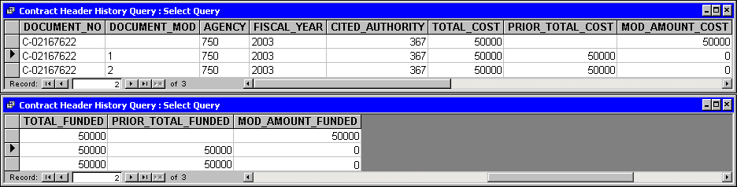

NOTE: Total Cost and Total Funded will always be the same for contracts; however, for MA or CMA documents there is not a requirement that funding be in place and therefore these fields could be different.

PRIOR_TOTAL_COST. Amount of commodity line before the mod being reported on

MOD_AMT_COST. The amount of modification on the mod being reported on

Step 30 On the Query Results window. Click the 'X' in the upper right-hand corner. The Query Results window closes.

To present an example of how a Master Agreement might look in the CONTRACT_HDR_HIST table, let’s make the following assumptions for a MA that has been modified two times:

- Original - established for $1000 with no funding lines
- Mod 1 - funding information added to document
- Mod 2 – Both commodity and funding were increased to $1500.
Use these fields for accurate document totals.
See table below:

Contract | Mod | Total Cost | Prior Total Cost | Mod Amount Cost | Total Funding | Prior Total Funding | Mod Amount Funding
M-02999999 |  | $1000.00 | $ 0.00 | $1000.00 | $ 0.00 | $ 0.00 | $ 0.00
M-02999999 | 1 | $1000.00 | $1000.00 | $ 0.00 | $1000.00 | $ 0.00 | $1000.00
M-02999999 | 2 | $1500.00 | $1000.00 | $ 500.00 | $1500.00 | $1000.00 | $ 500.00
You have been asked to obtain information on contract sub-types. We will have to link to the appropriate table and then build one query to obtain the sub-types information.

Before we begin the query, let’s discuss subtypes.

Sub Types are required on all award documents. They help to identify the type of award, i.e. fixed, capped, PSC, MOA, Rental, etc.

Sub Types also determine what Approval Templates can be used for the award.

In our query we are going to use the subtype to find out which award documents required a Proof of Necessity (PON). Therefore, we will set the PON REQUIRED field to “Y”.

standard subtypes

PON subtypes
NOTE: These subtypes are subject to change.

Now that you understand more about subtypes, we will continue with our query.

New table

Adding Tables
Step 1 On the Table tab. Click on the <NEW> button.

Step 2 On the New Table window. Highlight Link Table.

Step 3 On the New Table window. Click the <OK> button. The Link window is displayed.

Table link

Step 4 On the Link window, in the FILES OF TYPE field. Select ODBC Databases(). The Select Data Source window is displayed.

Select data source

Step 5 On the Select Data Source window. Select the Machine Data Source tab.

Step 6 On the Machine Data Source tab. Select MREPP1.

Step 7 On the Select Data Source window. Click the <OK> button. The Oracle Logon window is displayed.

Oracle Logon

Step 8 On the Oracle Logon window in the USER ID field. Type Your USER ID.

Step 9 On the Oracle Logon window in the PASSWORD field. Type Your PASSWORD.

Step 10 On the Oracle Logon window. Click the <OK> button.

Link Tables
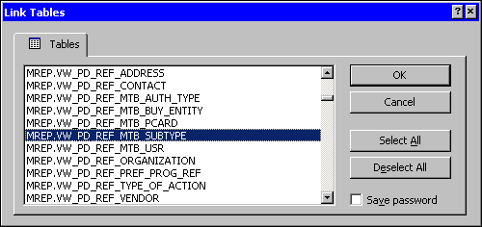

Step 11 On the Link Tables window. Select MREP.VW_PD_REF_MTB_SUBTYPE.

Step 12 On the Link Tables window. Click the <OK> button.

Select Unique Record Identifier
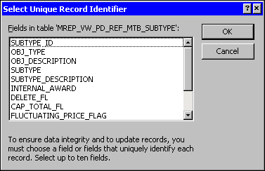

Step 13 On the Select Unique Identifier window. Click the <CANCEL> button.

NEW QUERY

Creating a Query in the Design View
Step 1 On the MRDB Database. Click on the Query tab.

Step 2 On the Queries tab. Click the <NEW> button.

Step 3 On the New Query window. The default is Design View. Leave As Is.

Step 4 Click the <OK> button. The Show Tables window is displayed.

Show table
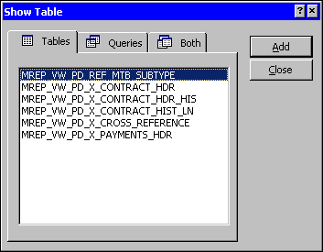

Step 5 On the Show Tables window. Highlight MREP_VW_PD_REF_MTB_SUBTYPE.

Step 6 On the Show Tables window. Click the <ADD> button.

Step 7 On the Show Tables window. Click the <CLOSE> button. The Query Design window is displayed.

We need to increase the time that it takes to run our query.

Step 8 On the Toolbar. Click the <PROPERTIES> button. The Query Properties window is displayed.

PROPERTIES WINDOW
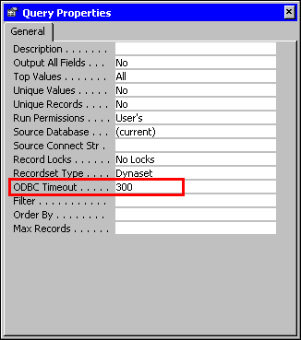

Step 9 In the ODBC TIMEOUT field. Highlight the defaulted 60. Type 300.

Step 10 On the Query Properties window. Click the 'X' in the upper right-hand corner. The Query Design window is displayed.

Design View
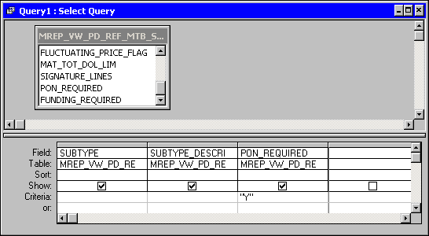

Step 11 On the Table Field List window. Highlight and double-click the following fields:

SUBTYPE
SUBTYPE_DESCRIPTION
PON_REQUIRED

Step 12 In the PON_REQUIRED field. Type Y.

NOTE: The selection criteria is always case sensitive.

Step 13 Click the <SAVE> button. The Save As Dialog Box is displayed.

Save As
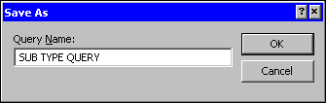

Step 14 In the QUERY NAME field. Type SUB TYPE QUERY.

Step 15 Click the <OK> button.

QUERY RESULTS
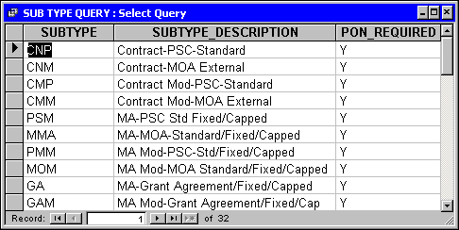

Step 16 On the Toolbar. Click the <RUN> button.

Step 17 On the Query window. Click the 'X' in the upper right-hand corner. The PD MRDB Tables Database window is displayed.

We have obtained information on contract sub-types. Now we will need to build another query to obtain the sub-types information for personal service contacts or MOA's.

Modifying an Existing Query
Step 1 On the Queries tab. Highlight the SUB TYPE QUERY and click the <DESIGN> button.

Show Tables button
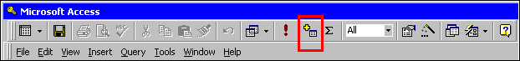

Step 2 On the Query Toolbar. Click the <SHOW TABLES> button. The Show Tables window is displayed.

Show table
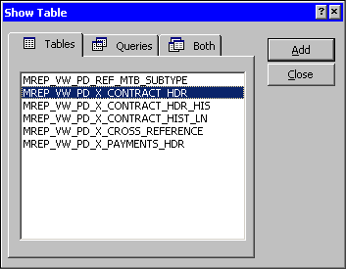

Step 3 On the Show Tables window. Highlight MREP_VW_PD_X_CONTRACT_HDR.

Step 4 On the Show Tables window. Click the <ADD> button.

Step 5 On the Show Tables window. Click the <CLOSE> button. The Query Design window is displayed.

Design View
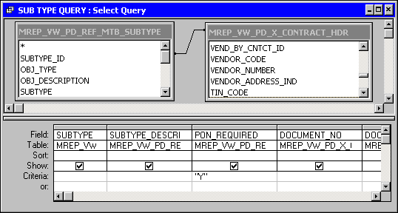

Step 6 On the Design View on the query in the MREP_VW_ PD_REF_MTB_SUBTYPE table. Highlight the SUBTYPE_ID field hold your mouse button down and drag it to the SUBTYPE_ID field in the MREP_VW_ PD_X_CONTRACT_HDR table and release.

Step 7 On the Table Field List window from the Contract HDR Highlight and double-click the following fields:

DOCUMENT_NO
DOCUMENT_MOD
DOCUMENT_TITLE
TOTAL_COST
VEND_BY_NAME

Step 8 Click the <SAVE> button.

Step 9 On the Toolbar. Click the <RUN> button.

QUERY RESULTS
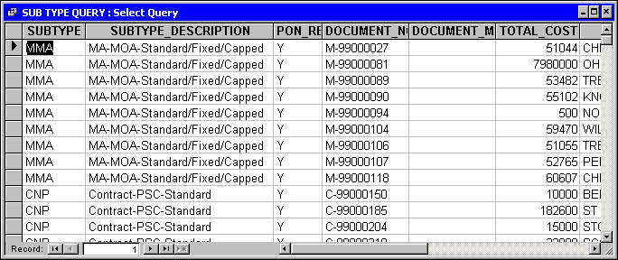

Step 10 On the Query window. Click the 'X' in the upper right-hand corner. The PD MRDB Tables Database window is displayed.



In this topic we have learned how to:

- Create a Query using the Design View

- Select Fields

- Join Tables

- Set Criteria

- Save and Run Queries



Are there any questions concerning the information covered in this topic?

