Topic 2 PD mRdb data model

purpose

The purpose of this topic is to familiarize the user with the PD MRDB Data Model for the document tables (PD_X_).

objectives

During this topic you will learn:

The PD MRDB Data Model

Table relationships
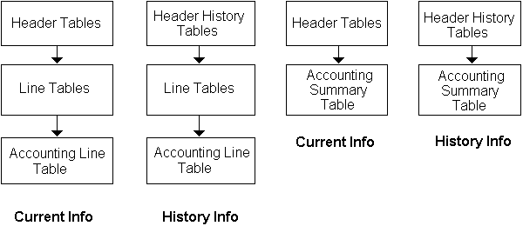

MRDB Structure and Naming Convention
Let’s take a look at the structure and naming convention of the MRDB. Becoming familiar with the MRDB structure and naming convention will assist you in identifying where to go to get the data you need for your report(s).

VIEW INFORMATION
TABLE NAME | Current/ All | DOCUMENTS
MREP.VW_PD_X_REQUISITION_HDR | Current | Purchase Requests
MREP.VW_PD_X_SOLICITATION_HDR | Current | Solicitations
MREP.VW_PD_X_CONTRACT_HDR | Current | Contracts, Master Agreements, Catalog Master Agreements, Purchase Orders
MREP.VW_PD_X_DELIVERY_ORD_HDR | Current | Delivery Orders, Catalog Delivery Orders
MREP.VW_PD_X_PAYMENTS_HDR | Current | Invoices, Miscellaneous Quick Pays
MREP.VW_PD_X_REQUISITION_HDR_HIS | All | Purchase Requests
MREP.VW_PD_X_SOLICITATION_HDR_HIS | All | Solicitations
MREP.VW_PD_X_CONTRACT_HDR_HIS | All | Contracts, Master Agreements, Catalog Master Agreements, Purchase Orders
MREP.VW_PD_X_DELIVERY_ORD_HDR_HIS | All | Delivery Orders, Catalog Delivery Orders
MREP.VW_PD_X_PAYMENTS_HDR_HIS | All | Invoices, Miscellaneous Quick Pays
MREP.VW_PD_X_REQUISITION_ HIST_LN | All | Purchase Requests
MREP.VW_PD_X_SOLICITATION_ HIST_LN | All | Solicitations
MREP.VW_PD_X_CONTRACT_ HIST_LN | All | Contracts, Master Agreements, Catalog Master Agreements, Purchase Orders
MREP.VW_PD_X_DELIVERY_ORD_ HIST_LN | All | Delivery Orders, Catalog Delivery Orders
MREP.VW_PD_X_PAYMENTS_ HIST_LN | All | Invoices, Miscellaneous Quick Pays
MREP.VW_ PD_X_ACCOUNTING_LINES | All | Information from the Funding tab
MREP.VW_PD_X_ACCOUNTING_SUMMARY | All | Information from the Funding Code Summary tab
MREP.VW_PD_X_CROSS_REFERENCE | N/A
MREP.VW_PD_X_PROCARD_ACCOUNTING | N/A | Procard Information
MREP.VW_PD_PON | N/A | Proof of Necessity
MREP.VW_PD_REF_VENDOR | N/A | Vendor Information
MREP.VW_PD_REF_MTB_SUBTYPE | N/A | Sub type information

HDR = Header
HIS and HIST= History
LN = Lines
ORD = Order

PD MRDB DATA MODEL
The PD MRDB Data Model is composed of 7 types of tables, Header, Header History, Cross Reference, Line, Accounting Lines, Accounting Summary, Reference tables. In the pages that follow, we will discuss each type of table.

Contract – Main Tab
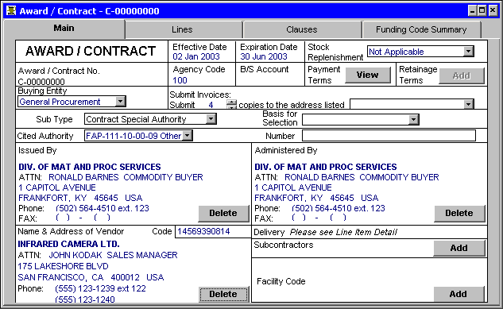

Header Tables
Header table information relates to the entire document. The Header Tables contain information from the Main tab or header of the document. These tables only include released documents and only the active or current version of the document.

NOTE: Active/Current version does not imply the document has not expired. It merely represents the latest version of the document.

Header table list
TABLE NAME | DOCUMENTS
MREP.VW_PD_X_REQUISITION_HDR | Purchase Requests
MREP.VW_PD_X_SOLICITATION_HDR | Solicitations
MREP.VW_PD_X_CONTRACT_HDR | Contracts, Master Agreements, Catalog Master Agreements, Purchase Orders
MREP.VW_PD_X_DELIVERY_ORD_HDR | Delivery Orders, Catalog Delivery Orders
MREP.VW_PD_X_PAYMENTS_HDR | Invoices, Miscellaneous Quick Pays

For example on contracts, items such as EFFECTIVE DATE, EXPIRATION DATE, SUB-TYPE, and VENDOR are contained in the header tables.

These tables should be used when the user is concerned about current information and not any history of the document. For example, if the user is looking for all contracts his/her agency has with a particular vendor or wants the current amount of such contracts. Furthermore if the user is interested in contract amounts then he/she should use the header tables.

Header History Tables
The Header History Tables contain information from the Main tab or header of the document. These tables only include released documents and include ALL versions of a document (original and all modifications).

Header history table list
TABLE NAME | DOCUMENTS
MREP.VW_PD_X_REQUISITION_HDR_HIS | Purchase Requests
MREP.VW_PD_X_SOLICITATION_HDR_HIS | Solicitations
MREP.VW_PD_X_CONTRACT_HDR_HIS | Contracts, Master Agreements, Catalog Master Agreements, Purchase Orders
MREP.VW_PD_X_DELIVERY_ORD_HDR_HIS | Delivery Orders, Catalog Delivery Orders
MREP.VW_PD_X_PAYMENTS_HDR_HIS | Invoices, Miscellaneous Quick Pays

Use these tables when you are concerned about tracking the history of a document. For example, if you want to know how much a contract amount on a given contract has changed over time, you want to use the header history tables.

line item detail window
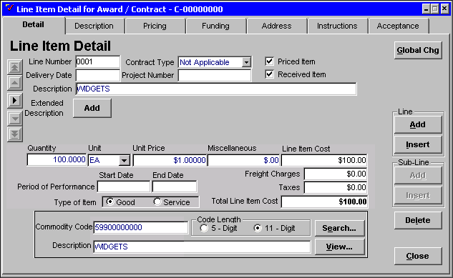

Lines Tables
The Line Tables includes information contained in the detail or commodity lines of the document. These tables include lines relating to released documents and to ALL versions of a document (original and modifications). There are not two separate tables for current and history lines. Although MQP documents do not contain line item detail information as described above, they may contain multiple records on this table to represent each of the lines that are on the document.

NOTE: To view lines for the current version of a document you will need to select those records where CURRENT_FL field has a value of 1.

line tables list
TABLE NAME | DOCUMENTS
MREP.VW_PD_X_REQUISITION_ HIST_LN | Purchase Requests
MREP.VW_PD_X_SOLICITATION_ HIST_LN | Solicitations
MREP.VW_PD_X_CONTRACT_ HIST_LN | Contracts, Master Agreements, Purchase Orders
MREP.VW_PD_X_DELIVERY_ORD_ HIST_LN | Delivery Orders, Catalog Delivery Orders
MREP.VW_PD_X_PAYMENTS_ HIST_LN | Invoices, Miscellaneous Quick Pays

contract - funding tab
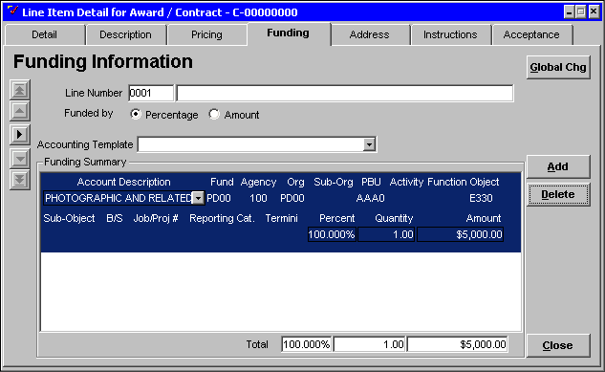

Accounting Lines Table
The Accounting Lines Table includes the accounting information that supports a detail/commodity line. This table includes lines relating to released documents and to ALL versions of a document (original and modifications). There is only one accounting lines table, which includes all document types, except for the following:

- CMAs, as they do not have a means for entering accounting lines.

- MAs and Solicitations, that do not require the entry of accounting information and therefore, may have no information on this table.

- Procard, which is secure information and not available to general users.

NOTE: To view lines for the current version of a document you will need to select those records where CURRENT_FL field has a value of 1.

Accounting line table list
TABLE NAME
MREP.VW_PD_X_ACCOUNTING_LINES

contract – funding code summary tab
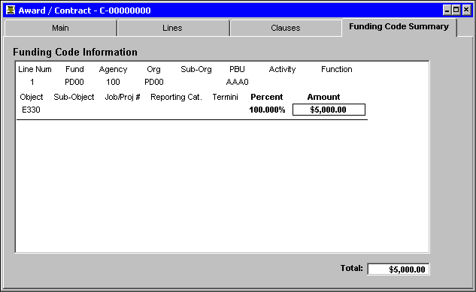

Accounting Summary Table
The Accounting Summary Table contains the accounting lines ‘rolled up’, or what is contained on the Funding Code Summary tab of a document. This table includes lines relating to released documents and to ALL versions of a document (original and modifications). There is only one accounting summary table, which includes all document types, except for the following:
- CMAs, as they do not have a means for entering accounting lines.

- MAs and Solicitations that do not require the entry of accounting information and therefore, may have no information on this table.

- Procard, which is secure information and not available to general users.

NOTE: To view lines for the current version of a document you will need to select those records where CURRENT_FL field has a value of 1.

Accounting summary table list
TABLE NAME
MREP.VW_PD_X_ACCOUNTING_SUMMARY

Cross-Reference Table
The Cross-Reference Table contains Cradle to Grave document numbers. The information in this table will allow you to identify the parent and/or child of any document.

Cradle to grave reporting
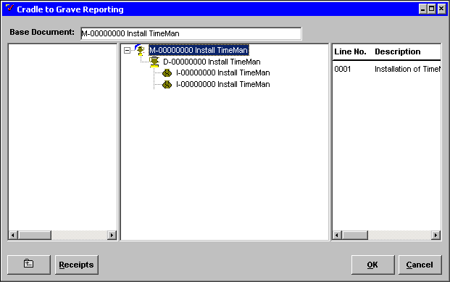

cross-reference table list
TABLE NAME
MREP.VW_PD_X_CROSS_REFERENCE

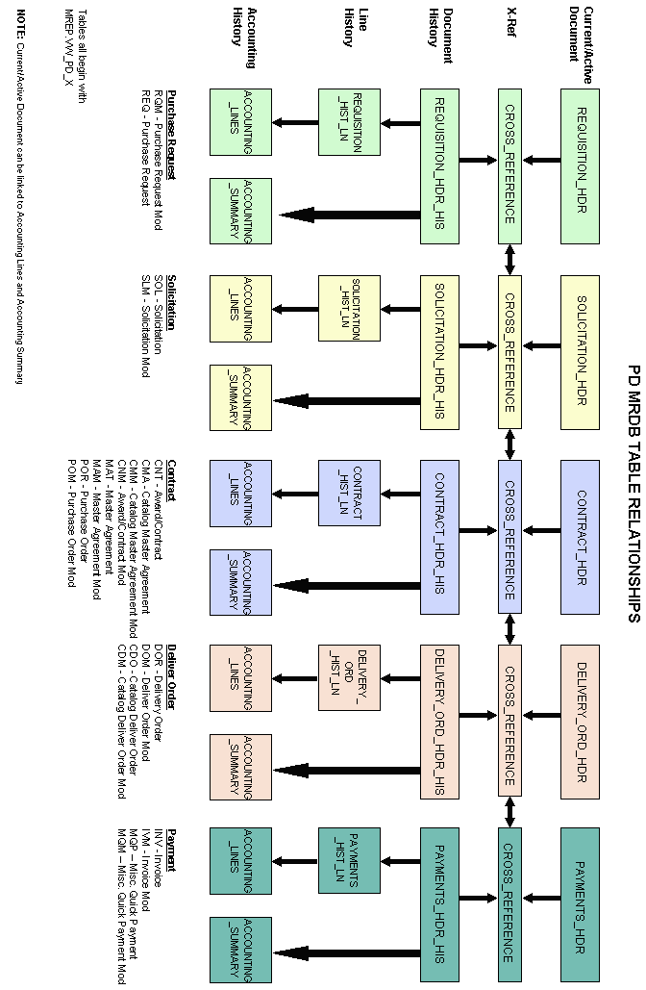

Relationship flowchart

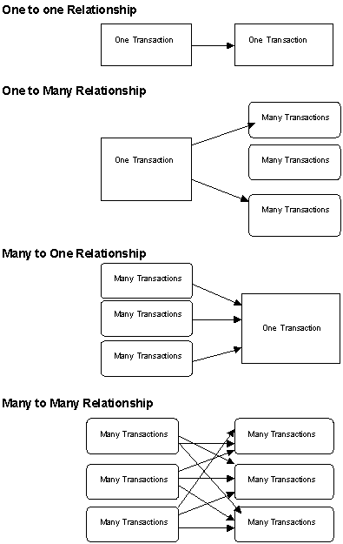

Joins and Relationships
There may be times you need to get information from more than one table. This can be achieved through running a query or queries that join tables. When you have a query with multiple-tables, MS Access automatically joins the tables on the common field names. If there are no common field names, the table is added to the query but remains unjoined. To join fields that contain identical information but have different field names highlight and drag the field from one table to the field with like information in the table to be joined.

Relationships established at the table level take precedence over those done at the query level. If there are relationships created between tables, the join lines are automatically displayed when you add related tables in the query Design view. There are four groups of relationships between tables:

- One to one - used to relate one record to one record between tables

- One to many - used to relate one record to many records between tables

- Many to one - (also called the lookup table relationship) used to related many records to a single record between tables

- Many to many - (the hardest to understand) a pair of one-to-many relationships between two tables

CAUTION: Join properties selected are extremely critical. The data extracted from the MRDB can be presented incorrectly if the join is not properly accomplished. To be sure that the data retrieved is correct, select a known value and then run the query with the join in place, using the known value criteria. If a numeric match is accomplished then the join is correct. If the numeric values do not match the join is incorrect and must be changed.

PD Data Relationship Examples

Contract_HDR records
Document_No | Document_Mod | Vendor_Code | Total_Cost
C-12345678 | 2 | 12345678900 | 2,000.00

Contract_Hist_Ln records
Document_No | Document_Mod | Current_Fl | Line_No | NIGP_Class_Code | Sub_Total_Line_Cost
C-12345678 |  | 0 | 0001 | 961 | 200.00
C-12345678 |  | 0 | 0002 | 906 | 1000.00
C-12345678 | 1 | 0 | 0001 | 961 | 200.00
C-12345678 | 1 | 0 | 0002 | 906 | 1100.00
C-12345678 | 2 | 1 | 0001 | 961 | 500.00
C-12345678 | 2 | 1 | 0002 | 906 | 1500.00

Object: Find all contracts for ABC Company (Vendor Number=12345678900) and the types of good/services they have contracted to us.

Option 1 – build a relationship on document number only

Option 2 – build a relationship on both document number and mod

Query: List commodity class and amount for all contract lines for vendor = 12345678900.

Option 1 Results:
NIGP_Class_Code | Sub_Total_Line_Cost
961 | 200.00
906 | 1000.00
961 | 200.00
906 | 1100.00
961 | 500.00
906 | 1500.00

Option 2 Results:
NIGP_Class_Code | Sub_Total_Line_Cost
961 | 500.00
906 | 1500.00

Review Questions:
On which table would you look to answer the following questions:

- How many widgets has the Commonwealth of Kentucky bought this year?

- How much is the contract with John Doe for?

- How much has the Commonwealth of Kentucky paid XYZ each month this fiscal year?

- How much has the Commonwealth of Kentucky paid XYZ Corporation on their contract for widgets?



In this topic we have learned:

The PD MRDB Data Model



Are there any questions concerning the information covered in this topic?

