Using Microsoft Access
MRDB views of tables and reports can be accessed directly through Access or Excel by setting up an ODBC driver on the desktop and linking to the views.

Steps:
- Click Start at the bottom left of the screen, select settings, control panel, then ODBC 32 icon.
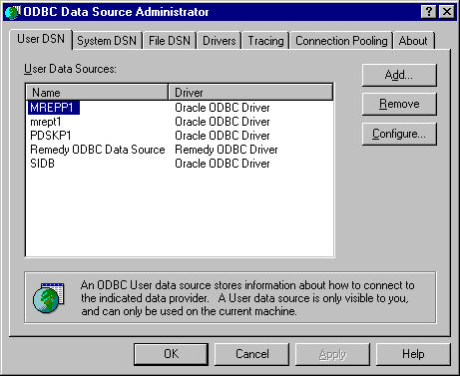
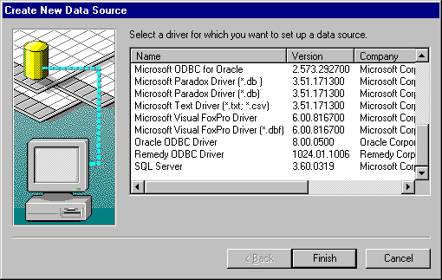
- Click the Add button, then Select the Oracle ODBC 8.0 driver and click Finish
- Type in mrepp1 in the Data Source Name and the Service Name and click OK.

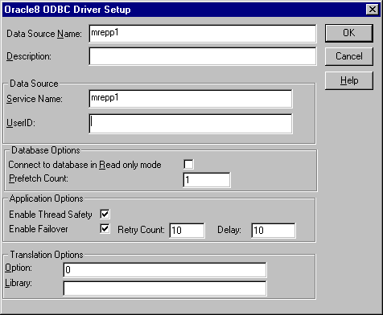
- Create a blank database in Access and chose File, get external data, link to table. Choose the ODBC file type to link.
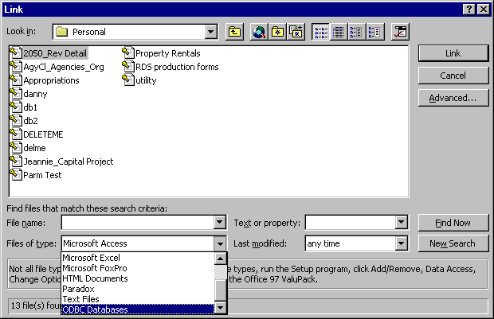
5. You are asked to chose your data source. Click the Machine Data Source Tab and select the driver you set up earlier.

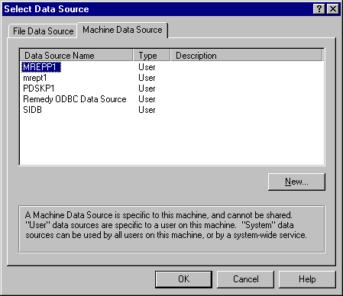
6. Sign on by entering your RACF ID and the word PASSWORD. Click on the views to link. When you click OK certain tables will ask you select a unique record identifier, just click OK without choosing any fields.

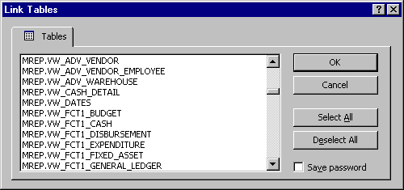

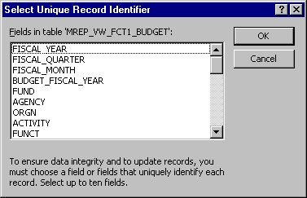
7. Now treat the view as if it were an Access table. Save the database, and next time you bring it up the links will still be there, but you have to log in to Oracle the first time you try to open it. If something changes to the underlying view you will have to delete the link and reestablish it.

