MARS
Release
Notes

MARS Release Number: 20031103

ADVANTAGE Version: 2.1.019
BRASS Version: 5.40.09.01
PD Version: 4.12.10

November 3, 2003

NOTE: This document is formatted for duplex reproduction, which is the Commonwealth of Kentucky standard. Blank pages are intentionally inserted throughout the document so that the document will reproduce correctly.

Table of Contents
Page
1 Introduction 5
1.1 Roadmap to Using the MARS Release Notes 5
1.2 Software Updated this Release 5
1.3 Release Schedule 6
1.4 Configuration Requirements 6
1.4.1 Agency Distribution Server 7
1.4.2 Client 7
1.5 MARS Confirmation IDs 8
1.6 Downloading the MARS Applications From the FTP Server 8
1.6.1 FTPing MARS Applications 9
1.6.2 FTPing MARS Common Contract Clauses 9
1.6.3 Web Access to the MARS Release Notes 10
1.7 Common Techniques 10
1.7.1 Locating Folders and Files 11
1.7.2 Copying a File 11
1.7.3 Copying the Contents of a Folder 11
1.7.4 Copying Folders 11
2 MARS Application Changes in This Release 13
2.1 ADVANTAGE 2000 Desktop 13
2.1.1 New for This Release 13
2.1.2 Corrections in This Release 14
2.2 BRASS 15
2.2.1 New for This Release 15
2.2.2 Corrections in This Release 16
2.3 Procurement Desktop 16
2.3.1 New for This Release 16
2.3.2 Corrections in This Release 16
3 Installing From an Agency Distribution Server 20
3.1 Setting up the Agency Distribution Server 20
3.1.1 Retrieving the Release Package from the MARS Central Distribution Server 20
3.1.1.1 Retrieving MARS Applications 21
3.1.1.2 Retrieving the MARS Release Notes [Optional] 21
3.1.1.3 Retrieving Document Direct [Optional] 21
3.1.1.4 Retrieving Internet Explorer Upgrades [Optional] 21
3.1.1.5 Retrieving Java Plug-Ins [Optional] 22
3.1.1.6 Retrieving Netscape Upgrades [Optional] 22
3.1.1.7 Retrieving Oracle [Optional] 22
3.1.1.8 Retrieving Seagate Info [Optional] 22
3.1.1.9 Retrieving WIN98 Upgrades [Optional] 23
3.1.1.10 Retrieving WINNT Upgrades [Optional] 23
3.1.2 Copying the Release Package from the MARS Distribution CDs 23
3.1.2.1 Copying From the MARS Applications & Miscellaneous CD 23
3.1.2.1.1 Copying MARS Applications 23
3.1.2.1.2 Copying MARS Release Notes [Optional] 23
3.1.2.1.3 Copying Document Direct [Optional] 23
3.1.2.1.4 Copying Internet Explorer Upgrades [Optional] 23
3.1.2.1.5 Copying Java Plug-Ins [Optional] 23
3.1.2.1.6 Copying Netscape Upgrades [Optional] 23
3.1.2.1.7 Copying WIN98 Upgrades [Optional] 24
3.1.2.1.8 Copying WINNT Upgrades [Optional] 24
3.1.2.2 Copying From the Oracle Client CD 24
3.1.2.3 Copying From the Seagate Info CD [Optional] 24
3.2 Installing Upgrades 24
3.2.1 Windows 98 25
3.2.2 Windows NT 25
3.2.3 Internet Explorer 25
3.2.4 Netscape 25
3.3 Installing the Supporting Software Environment 25
3.3.1 Installing Oracle 26
3.3.2 Installing Document Direct 29
3.3.3 Java Plug-Ins 31
3.3.4 Seagate Info 31
3.3.4.1 Normal Client Installation Instructions 33
3.3.4.2 Power User Installation Instructions 33
3.3.4.3 Finish Seagate Info Installation 34
3.3.4.4 Configuring ODBC Driver for Power Users 36
3.4 Installing MARS Applications 36
3.5 Synchronizing MARS Applications 41
3.5.1 Synchronizing ADVANTAGE Server 42
3.5.2 Synchronizing ADVANTAGE 42
3.5.3 Synchronizing BRASS 42
3.5.4 Synchronizing PD 42
3.5.5 Synchronizing Oracle Tnsnames 43
4 Installing Without an Agency Distribution Server 44
4.1 MARS CD ROM Distribution 44
4.1.1 CDs Distributed this Release 44
4.1.2 Current CDs Required for MARS 45
4.2 Installing Upgrades 45
4.2.1 Windows 98 45
4.2.2 Windows NT 45
4.2.3 Internet Explorer 45
4.2.4 Netscape 45
4.3 Installing the Supporting Software Environment 46
4.3.1 Installing Oracle 46
4.3.2 Installing Document Direct 49
4.3.3 Installing Java Plug-Ins 51
4.3.4 Installing Seagate Info 51
4.3.4.1 Normal Client Installation Instructions 53
4.3.4.2 Power User Installation Instructions 53
4.3.4.3 Finish Seagate Info Installation 54
4.4 Installing MARS Applications 55
4.5 Synchronizing MARS Applications 59
4.5.1 Synchronizing ADVANTAGE 60
4.5.2 Synchronizing BRASS 60
4.5.3 Synchronizing PD 60
4.5.4 Synchronizing Oracle Tnsnames 61
5 Troubleshooting Guide 62
5.1 ADVANTAGE Will Not Run 62
5.2 ADVANTAGE Connection Fails 63
5.3 ADVANTAGE Errors With a Reference to ND.DBG 64
5.4 BRASS Gives an Oracle Error Message on Startup 65
5.5 PD is not the Current Version 65
5.6 PD Gives an Oracle Error Message on Startup 65
5.7 PD Gives an Unique Constraint Message While Logging Into PD 65
5.8 PD Problems Validating or Routing Documents 66
5.9 PD HTTP Errors 66
5.10 Running Oracle Client from a Server 67
5.11 Running Oracle Net80 Client with Oracle 7.x Versions 67
5.12 Troubleshooting Oracle Connection Problems 67
5.13 Oracle Connection Problems in Novell Environments 69
5.14 Special Novell Considerations 70
5.15 MARS Setup.exe Program Error 71
5.16 One or More “Sync” Icons Will not Work 71

Introduction

This MARS Release Notes provides instructions for the installation and synchronization of the MARS applications for the following versions:

- ADVANTAGE Desktop 2.1.019.01
- BRASS 5.40.09.01
- PD 4.12.10

These versions must be installed. All prior versions are not supported, may not operate properly, and could cause damage to the production database. Direct your questions about installing this release of MARS to the Customer Resource Center (CRC) Help Desk at:

1-877-973-HELP {1-877-973-4357} OR, 564-9641

Roadmap to Using the MARS Release Notes

- READ ALL OF CHAPTER 1 for information pertaining specifically to the software in this release and the schedule to which you must adhere for this release.
- IF YOU WANT TO KNOW WHAT HAS CHANGED SINCE THE LAST RELEASE: Refer to Chapter 2 beginning on page 13.
- IF YOU HAVE AN AGENCY DISTRIBUTION SERVER: After reading Chapter 1, use Chapter 3 beginning on page 20 for installation instructions. Follow the checklist of instructions exactly.
- IF YOU DO NOT HAVE AN AGENCY DISTRIBUTION SERVER: After reading Chapter 1, use Chapter 4 beginning on page 44 for installation instructions. Follow the checklist of instructions exactly.
- IF YOU HAVE PROBLEMS: Refer to Chapter 5 beginning on page 62 for troubleshooting information. If this does not resolve your problem, call the CRC Help Desk.

Software Updated this Release

The following table indicates if software has been updated in this release (e.g., will need to be downloaded and installed or synchronized):

Software Updated This Release
MARS Applications |  |  | Supporting Software |  |  | Supporting Software Upgrades
√ | Download Checked Software |  | √ | Download Checked Software |  | √ | Download Checked Software
√ | ADVANTAGE Desktop |  |  | Document Direct |  |  | Internet Explorer
 | BRASS |  |  | Java Plug-ins |  |  | Netscape
√ | Procurement Desktop |  |  | Oracle |  |  | WIN98
 | Oracle Tnsnames |  |  | Seagate Info |  |  | WINNT

Release Schedule

This release of MARS will go into production at 08:00 am Eastern Standard Time on 11/03/2003. Agency System Administrators must have all software installed and synchronized with the production system by that time. Following is the schedule for this release.

MARS Release Schedule
Activity/Task | Start Date | Finish Date | Responsible
- Load Release Package to central distribution server |  | 11/02/2003 | MARS Central
- Download Release Package to agency distribution server |  | 11/03/2003 | Agency
- Distribute Release Package to regional agency servers (optional) | 10/28/2003 | 10/28/2003 | Agency
- Review MARS Release Notes and plan software distribution for agency | 10/28/2003 | 10/28/2003 | Agency
- Dry run installation in test environment (optional) | 10/28/2003 | 10/28/2003 | Agency
- Install and/or synchronize software on clients | 11/03/2003 | 11/03/2003 | Agency
- Go live in production |  | 11/03/2003

WARNING: You can NOT go live PRIOR to the Go Live date AND you MUST go live with updated client software on the Go Live date. This is a coordinated effort statewide. You may install and synchronize software on client computers at any time in the schedule, but none of these computers can be used for MARS production until the Go Live date.

Configuration Requirements

Each MARS application for this release require that the following supporting software minimum versions be installed and be operational on each client computer:

WARNING: Even if you are not planning to use the MicroSoft Internet Explorer as your Web browser, Internet Explorer version 4 (IE4), IE4 Service Pack 2, and the Java Plug-in must be loaded on each computer using PD. Windows needs the upgraded DLLs loaded with IE4 even for other Web browsers (e.g., Netscape) to support features in PD.

MARS Configuration Required by This Release
MARS Application | Support Software | Version
ADVANTAGE | Document Direct | 2.2
BRASS | Oracle Client | 8.0.5
MRDB | Oracle Client | 8.0.5
 | Seagate Info | 7
Procurement Desktop | Oracle Client | 8.0.5
 | Internet Explorer | 4.1, SP2
 | Netscape | 4.08
 | Java Plug-in | 1.1.1_002
PD Web | Internet Explorer¹ | 4.1, SP2
 | Netscape | 4.08
 | Java Plug-in | 1.1.1_002
Travel Web | Internet Explorer¹ | 4.1, SP2
 | Netscape | 4.08
Windows 98 Clients | N/A | N/A
Windows NT 4.0 Clients | WINNT Service Pack 4 (SP 3 is OK) | N/A
Windows 2000 | N/A | N/A
Windows XP | N/A | N/A

Agency Distribution Server

The agency distribution server will have a MARS_APPS folder with the following sub-folder structure for installing MARS applications (each application may also have additional sub-folders). If you do not have a MARS_APPS folder on your server, you must create one before conducting the installation steps in this MARS Release Notes. MARS requires approximately 123 MB on the server, excluding any other third-party software. Many of these folders are optional depending upon whether the administrator wishes to install third-party software from the agency distribution server or via some other media:

\\{local server name and path}\MARS_APPS
\ADVANTAGE
\Document Direct [Optional]
\Internet Explorer Upgrades [Optional]
\Java Activator [Optional]
\MARS
\MARS Release Notes [Optional]
\Netscape Upgrades [Optional]
\Oracle [Optional]
\Seagate Info [Optional]
\WIN98 Upgrades [Optional]
\WINNT Upgrades [Optional]

NOTE: Total space required on the server for loading all of the above installation packages is 1.2 GB.

Client

The client computers will have a MARS_APPS folder with the following sub-folder structure for installing MARS applications, depending upon which applications are installed. MARS requires approximately 149 MB on the client computer for the full installation of all MARS applications, excluding any other third-party software. The MARS setup software will create these folders automatically:

{local drive letter – C drive is default}:MARS_APPS
\ADVANTAGE
\BRASS
\Oracle Tnsnames
\PD

MARS Confirmation IDs

A set of user IDs and passwords have been established as an aid to the agency system administrators to test if an installation has been completed properly. These IDs will not allow any activity within the applications, but will allow you to access the system and databases.

MARS Confirmation Ids
Application | User ID | Password
ADVANTAGE | FINMARS | FINMARS1
BRASS | MAR | BRS
PD | MARS | PD
Seagate Info (Management Reporting Database) | MARS | <no password>

Ids and passwords are case sensitive. You should use all upper case for both the ID and password. For BRASS, select the Training database for testing your connection. The ID and password will only work in the Training and BudgetExec databases.

To log onto Seagate Info, select Programs from the Start menu and then select Seagate Info 7 and Info Desktop. At this point, the Connect to APS screen should be displayed. Seagate Info uses clustered servers; therefore, the correct method of logging onto Seagate Info is to address the cluster that will then connect you with the first available server. To do this, use the following setting on the Connect to APS screen:

User name: MARS
Password: <leave blank>
APS: kymarssa1

After the initial signon, you should use @MARS as the APS. The @MARS designates that you are logging onto the first available server in the MARS APS cluster.

NOTE: When logging onto ADVANTAGE for initial installations of a client computer, you will be requested to provide an email user id and password. Click Cancel to avoid changing email information on the client computer.

Downloading the MARS Applications From the FTP Server

The MARS project has established an FTP server from which the MARS Applications can be downloaded. This is an alternative to retrieving the package from the central distribution server for those Novell and remote users who do not have access to the kymarssi1 central distribution server. There are two files available on the FTP server:

- MARS Applications
- MARS Common Contract Clauses

FTPing MARS Applications

The MARS application FTP will download the standard set of MARS setup files that normally reside in the \\kymarssi1\mars_apps\MARS Setup\MARS folder or in the similar folder on the MARS Distribution CD. On the FTP server, these files have been compressed into a single self-extracting executable. When executed, the set of MARS setup files will be extracted and placed into the folder that you pick. Normally, this would be your MARS_APPS\MARS folder on your local server. The URL for the FTP is as follows:

ftp://www.state.ky.us/mars/MARS.exe

FTP or download this file to your local hard drive or server. Execute MARS.exe from wherever you stored it during the download to start the extraction process. The extraction will ask for the destination location for the MARS setup files. This should be your server MARS_APPS\MARS folder. You may place the files in a different location if you wish to stage them prior to setting up your server for a new release. If so, then before the go-live date, you must copy all of the files into the MARS_APPS\MARS folder on your server so that the client computers can sync to the latest version.

To install the MARS applications, refer to Chapters 3 or 4 as appropriate using the FTPed and extracted MARS setup files.

FTPing MARS Common Contract Clauses

NOTE: This option is intended ONLY for those agencies that do not have access to \\kymarssi1. If you elect to use this method, you MUST notify the MARS project so that you can be added to the email list to notify you when changes are made.

The MARS common contract terms, conditions, specifications, and clauses FTP will download the standard set of MARS common contract clauses that normally reside in the \\kymarssi1\mars_apps\MARS Setup\PD folder and subsequent sub-folders. These files are not distributed via normal distribution, but are maintained centrally and pointed to by the PD database for all PD users statewide. However, if your agency can not map the Q drive to the \\kymarssi1\mars_apps share, then you will need to install these clauses on your local server and map the Q drive to point to this local location for all of your PD users.

On the FTP server, these files have been compressed into a single self-extracting executable. When executed, the set of MARS standard contract clauses will be extracted and placed into the folder that you pick. Normally, this would be your MARS_APPS folder on your local server, but can be located anywhere on your server to which you can map the Q drive. The URL for the FTP is as follows:

ftp://www.state.ky.us/mars/MARSContractsClauses.exe

FTP or download this file to your local hard drive or server. Execute MARSContracts.exe from wherever you stored it during the download to start the extraction process. The extraction will ask for the destination location for the MARS contract clauses. This will typically be your server MARS_APPS folder.

NOTE: Standard contract clauses are maintained centrally by Purchasing and must not be changed without authorization. If you load these clauses onto your local server, then you must protect them from being altered by your end-users. Place these files into a location where MARS users have READ-ONLY access privileges and can not alter these files.

PD points to the common contract clauses through a centralize setting in the PD database. The assumption is that each PD user has the Q drive mapped to point to this location. If for some reason your organization can not use the Q drive, then you will have to modify the PD Desktop.ini file to point to your new location. The following sections in the MARS_APPS\PD\Desktop.ini file will have to be updated on each client computer:

[Reference_Bookshelf]
Bookname_URL=<your drive location>\MARS Setup\PD\Book_images\HTML\Ref_main.htm

[RTF_Lctn]
Basedir_RTF=<your drive location>\MARS Setup\PD\RTF_clauses

Where “<your drive location>” is the mapped destination location you gave when requested by the self-extract program. Please note that URL designation is not allowed here, it must be a drive letter.

Web Access to the MARS Release Notes

The current MARS Release Notes can be obtain from the MARS web site at the following URL:

http://www.state.ky.us/agencies/adm/mars/mars.htm

Go to this URL and scan downward under Planning Documents until you see the index for MARS Release Notes. Click on this index and Word will be launched with the latest MARS Release Notes. You can then print them locally.

Common Techniques

This section provides instructions for performing common techniques used throughout the installation. If you are a proficient Windows user and are familiar with using the File Explorer, then you will not have to read this section. If you are not fully comfortable with using Windows utilities, then this section covers the common techniques used and referenced throughout the remainder of this document. All of these techniques are performed using the Windows File Explorer.

Locating Folders and Files

Using the Windows File Explorer, in the left-hand pane, click on the plus sign beside a folder name to expand the folder and show sub-folders. Continue this until the desired folder has been found. For example, if you were instructed to copy the file ABC from C:\A\B\C, then you would expand the C: drive, expand the A folder, expand the B sub-folder, and click on the C folder. In the right-hand pane, a list of folders and files will appear. The file ABC will be listed in the right-hand pane.

Copying a File

Throughout the instructions, you will be asked to copy a file from one location to another. To copy a file, use the Windows File Explorer. In the left-hand pane, click on the plus sign beside a folder name to expand the folder and show sub-folders. Continue this until the folder that contains the file has been reached. In the right-hand pane, right click on the desired file and select Copy from the menu. Expand the folders and sub-folders again to locate the folder to which the file is to be copied. Right click on this folder and select Paste from the menu. This completes the file copy.

Copying the Contents of a Folder

In the instructions, you may be requested to copy the contents of a folder. This process is similar to copying individual files except you will be copying a group of files or all of the files within a folder. As above, expand folders to locate the desired folder. In the right pane, click on the first file in the folder. Scroll down to the last file in the folder and, while holding down the shift key, click on the last file in the folder. At this point, all files in the folder should be highlighted. Right click on any of the highlighted files and select Copy from the menu. Locate the target folder to where these files are to be copied. Right click on this folder and select Paste from the menu. This completes the folder content copy.

Copying Folders

You may be requested to copy a folder. This is similar to copying the contents of a folder except the whole folder is to be regenerated in a different location. Expand folders until the desired folder is located. In the left pane, right click on the folder and select Copy from the menu. Locate the folder under which this folder is to be copied. Right click on that folder and select Paste from the menu. The copied folder and its contents will become a sub-folder to this folder at this time.

MARS Application Changes in This Release

This chapter addresses the defects fixed and new enhancements provided in this release for each of the MARS applications.

ADVANTAGE 2000 Desktop

ADVANTAGE 2000 Desktop was upgraded for this release and requires synchronization of the ADVANTAGE 2000 Desktop application. The following sections outline any new features and corrections made to the ADVANTAGE software for this release.

New for This Release

New for this Release
Number | Enhancement Description
17763 | The following enhancements were applied to the Workflow component:  - Users are now able to "Track Work in Progress" from their worklists by right clicking on the work unit and selecting "Track Work Unit" or by using the menu option "Actions: Worklist: Track Work Unit"  .- Added the For Whom (WHOM) table to the Workflow Designer. Having this table along with the Security STAB) table that already existed will enable Workflow Administrators to appropriately assign workgroups and rules based on individual userid's Agency security restriction without the need to log onto both Workflow Designer and the ADVANTAGE application.
17765 | The following software modifications were applied to the Workflow:  - The Rule-based Notifications process has been modified to populate the Subject and Text fields so that the error message "ERROR**RECORD NOT FOUND" will only be generated for applicable notifications. - The Manual Routing Notification process has been modified to populate the 'Route by Worker' field on the Workflow Events (WEVT) table. - Workflow processing has been corrected so that the '<>' condition in the Designer remains after it is selected. Previously, when a user selected the '<>' condition code then selected the right-hand side of the condition, the condition code was reverted to "Is". This was happening when any of the preset values (Zero, Blank, In Range, In List) were selected for the right-hand side of the condition.
17766 | In order to accommodate dates greater than the year 2019, the pivot year has been changed from "20" to “40". Prior to implementing this modification, the application was defaulting the century to "19" if the coded year was "20" or greater. After this modification, the application will default the century to "19" if the coded year was "40" or greater.
17767 | The following enhancements were applied to the Security Administration:  - Modified the ability to override a batch or document to become dependent on either the Queue authority or Run Authority on the STAB table (I.e. a user may apply and remove overrides if the Queue or Run Action is set to "Y"). Previously, it was dependent upon a user's Run authority only.  - Processing has been altered to issue the warning message (*FG16 WARN: USERID MAY EXIST ON WHOM) when a security administrator deletes a user ID from the Security (STAB) table and that user ID exists in a 'U' record on the For Whom (WHOM) table.  - Processing has been modified to issue warning messages if a userid exits in the tables Workorder Workgroup (WKWG), Manager Workgroup (WMWG), Workorder ID E-mail ID (WWKE), and Extended Security (XSTB) while a security administrator is deleting that userid from the Security (STAB) table. In which case, the security administrator can manually delete that userid from these tables as well.  - Processing has been modified so that a security administrator only needs to blank out the first character  of the Security Group in order to delete the column without the need to blank out each field in that column.
17768 | The following enhancements were applied to the Desktop:  - The new print keyboard shortcut "CNTL+K" has been setup to print the active window. Users can still use the print keyboard shortcut "CNTL+SHIFT+P" to print the entire Desktop screen.  - Processing has been modified so that when a user selects the Print icon on the toolbar, the active window will be printed without the additional print dialog box appearing.  - Processing has been modified so that the Open Document keyboard shortcut 'Alt+O' leaves the focus on the selected document in the SUSF scroll window, which enables users to scroll up and down with the arrow keys. Previously, when the 'Alt+O' keyboard shortcut was used, the 'Open Document' button remained highlighted after the document was closed.  - Processing has been modified so that the user receives a warning message if the lines have not been selected but have been modified in a window containing header and a detail list box. Previously, if a user were to update multiple lines then focus on the header before processing the entry, the system was not popping a dialog box up asking whether the user wants to select all lines before proceeding.
17770 | The following baseline fixes were applied to the Desktop:  - Processing has been corrected so that fields with right justified data (e.g. amounts) will not appear truncated on windows with list boxes.  - Processing has been corrected so that a segmentation violation will not occur if a user added comments to a document and subsequently tried to copy the document while it was still open. Additionally, comments for documents are allowed to be saved now prior to saving the documents themselves.  - Processing has been corrected so that informational messages (e.g. "ALL LINES CHANGED") are not removed from the screen when then "Print" icon is used.  - Processing has been corrected so that active lines within a given document are now synchronized. Previously, when a user selected a line on the "Accounting" tab of a PV or CR document then switched over to the "Reference Document" tab, the same line appeared to be highlighted. However, the cursor was actually being incorrectly placed on the first line of the window. So, when the user started typing, the first line on the screen was then typed over.
17774 | The following baseline fixes were applied to the Desktop:  - Processing has been corrected to determine whether a batch needs to be generated or not when a user creates a new batch from within a document, and if so, bring up the 'new batch' window. Previously, when a user created a new batch from within a document, the error 'C010E' Missing Batch Number' would appear incorrectly on the batch header.  - Prior to the correction, if a user clicked on any line-level tab on the Payment Voucher (PV) document, the cursor would appear in the first field on the screen. Then, when the user began to type in this field, the cursor jumped to the view tab, and none of what he/she typed in was accepted onto the screen. Therefore, the user had to physically click in the first field before entering any information.  - Processing has been corrected so that the 'Go To Line' function (from the 'Edit' menu or via the 'CTRL-T' keyboard shortcut) accepts four-digit numbers (I.e. up to 9999) instead of just three-digit numbers (I.e. up to 999).
17776 | Processing has been modified so that the server programs will trap password expire warning messages and return them to the Desktop when the number of days until expiration reaches 4. Here is a copy of the message:  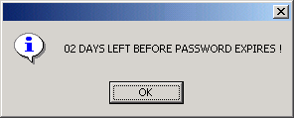

Corrections in This Release

Corrections in this Release
Number | Problem Description
12426 | The Desktop has been corrected so that the segmentation violation no longer occurs when a user sign on to the application, opens a document, minimizes it, then leaves it alone until the session times out.
17440 | The Desktop has been corrected so that a user can successfully reconnect to the application after being disconnected for a timeout condition without receiving the error message segmentation violation.
17448 | The Desktop has been corrected so that the 'Unapprove' action on all documents works whether or not the document contains detail lines without issuing the error message segmentation violation.
17563 | Modified the Desktop Common Codes (DKCC) and Desktop Codes Group (DKCG) tables in ADVANTAGE to not allow leading spaces in the Code Group field.
17753 | The Write-Off document (WO) processor was modified so that the Generate Billing Flag on the OREO table is correctly set to "N" when the WO document is processed against the Receivable document (RE).
17764 | The following software modifications were applied to Workflow: 2.1.019.01 ADVANTAGE  - The Approval-1 through Approval-5 conditions on the Workflow Condition Definition screen for Documents had the parameters: "A", "N", "Y" and "0". The parameter "N" is not a valid value for the Approval comparison for Documents and has been removed. The parameter "P" was missing and has been added.  - Workflow processing has been corrected for users who did not have either the "*ALL" or the document-specific (e.g. "JVM") Security Group on their security profiles so that their documents are properly routed.  - The Dialog Bar in the Worklist has been modified to display the correct total number of Work Units if that number was greater than twenty (e.g. '20 of 60 work unit(s) in "Documents"').  - Workflow processing has been modified to correctly display the Userid using the Address Selection in order to send e-mail messages in the application.
17769 | The following enhancements were applied to the Desktop:  - Processing has been enhanced to accommodate wrapping text and tabs when "Paste Special' is used to paste large multi-line narratives into text screens.  - Processing has been enhanced to remove leading spaces from the batch and document numbers when generating batches/documents. When leading spaces are found on the document number, the warning message "The document number contains leading spaces, which will be removed." will be issued. Note: Similar message will not be issued for a batch number with leading spaces.
17773 | The following baseline fixes were applied to the Desktop:  - Processing has been corrected so that documents upon editing do not lose inserted lines before and after (above and below) the original line.  - Processing has been altered so that if a document has comments then the title bar shows (the label will become visible only after the document has been saved and closed). Previously, it was unknown whether a document had comments associated with it unless the user actually selects 'view comments'.  - Processing has been corrected so that the Document Suspense (SUSF) window error message on the status bar is refreshed when clicking the 'refresh' button.  - Processing has been corrected so that: (1) Tabbing into the next line highlights the chosen line; (2) Entering data into a new line shifts the highlight to the new line; (3) Any time the header gets the focus, the line number is reset to the first line; and (4) When a user uses 'SHIFT+TAB' to enter the previous line, the previous line is highlighted. Previously, if a user is entering a multi-line multiple-tab document, the 'selected line' was not changing as the cursor changed lines. That caused confusion when a user switched tabs.
17775 | The Text Tables (COLT, CTXT, NOTE, RETX, RTXT, TXT) were modified to accommodate the WrapAround feature. This feature will allow the user to enter, view, and edit text as one unit in a scrolling text box. The text will be treated as one continuous block, which will allow the user to access all the text at once, move freely around the text, and making changes easier. It also allows the user to cut and paste a block of text from another application (e.g. MS-WORD). The maximum number of lines that the user can enter at a given time is 999.

BRASS

BRASS was not upgraded for this release and does not require synchronization

New for This Release

New for this Release
Number | Enhancement Description

Corrections in This Release

Corrections in this Release
Number | Problem Description

Procurement Desktop

PD was upgraded for this release and requires synchronization. The following sections outline any new features and corrections made to the PD software for this release.

New for This Release

New for this Release
Number | Enhancement Description

Corrections in This Release

Corrections in this Release
Number | Problem Description
17739 | Migration to PowerBuilder 8  - PD MARS was migrated from PowerBuilder 7 to PowerBuilder 8.  - SAR was migrated from PowerBuilder 7 to PowerBuilder 8 and a new SAR icon was added to incorporate PD’s checkmark logo.
17124 | Invoice Performance  - Changes were made to improve performance when releasing or validating invoices in cases where the user has access to the cited authority specified on the Catalog Master Agreement/Master Agreement, in which the award document has numerous invoices processed against it.
17317, 17611, 17644, UAT 11 | Find Match  - Changes were made to remove the ability to Find Match to multiple awards on both Invoice and Receiver documents.  - Aligned the Find Match functionality between the Main Tab and the Lines Tab on Invoices.  - For Payment Authorization Modifications and Invoice Modifications, the Find Match functionality has been disabled, on both the Main Tab and the Lines Tab when using either the Find Match button or the menu option.  - On an Invoice, it is now possible to Find Match to the same award twice without receiving an error message.
17328, UAT 6 | Solicitation Extended Descriptions  - Changes were made to ensure that changes to extended descriptions on Solicitation addendums are displaying and printing properly.
17382 | Payment Terms  - Modifications have been made to ensure that when an Invoice is generated directly from a Market Basket, the Payment Terms will be copied over from the Catalog Master Agreement to the Invoice.
17391, 17522 | Vendor Tracking Documents  - Changes were made to ensure that when Vendor Tracking Documents are  opened by selecting Procurement > Post Award > Vendor Tracking >  Review, the documents are read only and can no longer be edited.  - Vendor Tracking Documents that have been “Resolved” are no longer  editable.
17500 | Catalog Master Agreement (CMA) Authorized Vendors  - Changes have been made to the Authorized Vendors window of the CMA to prevent users from adding duplicate vendor numbers. If the vendor being added is already on the list of Authorized Vendors, a message is displayed to the user and the vendor is not added.  - The list of Authorized Vendors is now sorted alphabetically for both CMA and Catalog Delivery Order documents.
17515, 17516 | Password Security  - To ensure that passwords meet security standards, changes were made to check that new passwords are 7 characters and include at least one number, one letter and one special character.  - The new password must be different from the last 12 passwords used and will expire after 30 days.  - The lockout feature has now been enabled following three failed login attempts. The user will be informed they are locked out and will be requested to contact the Customer Resource Center to have the password reset.  - A “Reset Password” button has been added to the System Administration User Task. It will assign a new, randomly generated password that expires immediately to the user’s id. In addition, it will unlock the user’s account if necessary.  - Upon login using an expired password, users will be able to set a new password.
17591 | Release of Multiple Invoices from Master Agreement  - Changes were made to the process of releasing multiple Invoices off of a Master Agreement with a ceiling (not to exceed amount) so that the error message "The total dollar value exceeds the total remaining value under the Master Agreement ceiling by $0.00." is no longer received.
17592 (Part 1 only), 17706 | Master Agreement Usage Report  - The “Remaining Balance” field on the Master Agreement Usage Report will now display decimals accurately.  - The Master Agreement Usage Report will now correctly reflect $0.00 Invoices containing two or more negative lines.
17614, 17706, UAT 4 | Release Process and Master Agreement Ceilings  - Changes were made to the Invoice release process and the Delivery Order release process regarding calculations of usage against Master Agreement ceilings.  - The conformed copy Master Agreement ceiling will now be used in these calculations.
17613 | Bid Evaluation - Online Bid Response  - A text field under the title “Online Bid Version?” has been added to both the Optimized and Standard Bid Evaluation documents to display the Solicitation Number to which the Vendor has responded. If the Vendor submitted a manual bid the text will display “Hard Copy Bid”.  - This text field replaces the “Online Bid Indicator” check box on the Bid Evaluation main tab page.
17618 | Bid Evaluation Release  - Users will no longer be able to release a Bid Evaluation unless all online bids are loaded.  - Validation has also been added to prevent a Bid Evaluation/Bid Evaluation Modification from being released if it has been created from a Solicitation/Solicitation Modification that is no longer the most current Solicitation/Solicitation Modification.  - An appropriate message box will now appear if a user attempts to release a Bid Evaluation without any vendors.
17619, UAT 2,  UAT 7 (Part 2) | Printing of Online Bids from Bid Evaluations  - “Print” and “Print All” buttons have been added to the Bid Evaluation document to allow the printing of Online and Hard Copy Bid Information, and a report has been created to display this information.  - The Bid Evaluation printout has been modified to include additional vendor information.  - The email address shown in the new vendor information field now reflects the email address of the primary contact for the vendor.  - A new field entitled “Online Response To:” has been added to the Bid Evaluation printout to display the Solicitation Number associated with the vendor’s bid. If the vendor has been added manually, “N/A (Hard Copy Bid)” will be displayed.
17634 | Duplicate PCARDs  - Changes were made to the System Administration PCARD Task to prevent a user from entering an existing Procurement Card Number under another Admin Id.
17648 | Online Bid Response Line Sorting  - Changes have been made to ensure that lines on Online Bid Responses will be sorted correctly, regardless of the source of the Online Bid (Solicitation, Solicitation Modification) and of the “Award By” type (Group, Group All, Line Item). Lines will be sorted first by Group and then by line number within the Group.
17690 | Proof of Necessity (PON) Tab Printing  - Changes have been made to allow for the PON Tab information to print from the File > Print menu option independently from the award.  - The printed PON header information is similar to the Clauses header printout and includes a reference to the Document Number.
17692 | Inserting and Adding Lines on Solicitation Modification  - Corrections were made so that lines inserted or added to a Solicitation Modification are placed into the group of the selected line.  - On inserted or added lines, the default unit of measurement has been changed from ‘Acre’ to ‘Each’.  - Changes have been made to ensure that no error will occur when a user attempts to add lines to a Solicitation Modification that does not have any current lines.
17713 | Vendor Search  - Changes have been made to prevent error messages being received when selecting a vendor in the following instances:  - from File > ProCard Search, clicking on the Add button in the Find Match window, searching for and selecting a vendor;  - from Procurement > Post Award > Vendor Tracking Record > Create New or Review option, clicking the Add button in the Find match window, searching for and selecting a vendor.
17732 | Fixed Asset Exception Rules  - Changes were made to ensure that the Fixed Asset Exception Rules are fully implemented. Upon viewing the Invoices Funding Summary Tab, all lines marked as a Fixed Asset (as determined by the rules mentioned above) will have their funding split out. Lines not marked as a Fixed Asset will have the funding lines rolled up but will be grouped by Vendor Invoice Number.
17736 | Copying Miscellaneous Quick Payment (MQP) Document  - Changes were made to ensure that edits to the “Free Form” vendor in the “Remit To Address” field are not transferred from a copied MQP back to the original MQP document.
17758 | Date-Time Display on EP Website Home Page  - The date and time is now displayed on the EP Website home page.
UAT Issues | Issues found during User Acceptance Testing
UAT 1 | Password Changes  - Modifications have been made to ensure that when users change their passwords (through the System Administration User Task, Preferences or upon expiration at login) the changes are accepted and do not cause errors during later processing.
UAT 7 (Part 1) | Bid Evaluation “Response Submitted” Time  - Changes were made to ensure that the “Response Submitted” time on the Vendor’s web version of the Record of Online Bid printout matches the “Response Submitted” time on the Bid Evaluation printout.
UAT 9 | Optimized Bid Evaluation  - On Optimized Bid Evaluations, ensured that contact information is initially populated for manually added vendors.  - Changes have been made to ensure that the value for the “Taxes & Discounts/Markups” field and the resulting “Total Cost” field is now saving and displaying correctly.

Installing From an Agency Distribution Server

This chapter is for those agencies that have an agency distribution server to be used for installing the MARS applications. If your agency or site does not have access to a local agency distribution server and/or you have received MARS CDs for installation, you should skip to Chapter 4. If you are setting up your agency distribution server for installing client computers, the following instructions tell you how to:

- Retrieve the MARS release package from the central distribution server, and;
- Install MARS, or;
- Synchronize MARS.

The following table provides a guideline to the instructions for installing and synchronizing the distributed software.

If you are… | Then, follow these instructions…
Setting up the agency distribution server for distribution, DO ONE OF THE FOLLOWING…
Retrieve the release package from the MARS Central Distribution server. | Go to Section 3.1.1.
OR…Copy the release package from the MARS distribution CDs. | Go to Section 3.1.2.
Performing initial installs or installing new computers…
Retrieve the release package using one of the methods above. | See Setting up the agency distribution server for distribution above.
Install upgrades. | Go to Section 3.2.
Install the supporting software environment. | Go to Section .
Install the MARS applications. | Go to Section 3.4
Performing synchronization after initial installations…
Retrieve the release package using one of the methods above. | See Setting up the agency distribution server for distribution above.
Install upgrades if required by the particular release. | Go to Section 3.2, if required.
Synchronize client computers with ADVANTAGE and Setup.exe installed on the computer. | Go to Section 3.5.

Setting up the Agency Distribution Server

This section discusses how to load the distribution software to the agency distribution server so that client computer can be installed from the agency distribution server. There are two methods: download the release package from the MARS central distribution server; or, copy the release package from the MARS Distribution CDs onto your distribution server.

Retrieving the Release Package from the MARS Central Distribution Server

These instructions are for retrieving the MARS Release Package from the central distribution server. If you have received the MARS Distribution CDs and wish to set up your agency distribution server using those CDs, then skip this section and go to section 3.1.2, Copying the Release Package from the MARS Distribution CDs.

Most supporting software will not be updated for each release. Instructions are provided for retrieving the whole MARS release package in case the agency must rebuild or create a new agency distribution server. The table provided in section 1.2 indicates if software has been updated for this release. To ensure that all steps are completed in the proper sequence, it is recommended that the check box to the left of each instruction be checked as the step is completed successfully. Please perform the following steps:
- Log onto the network and locate the \\kymarssi1\Mars_apps folder. The \\kymarssi1 server can be located by using the File Explorer, double clicking on Network Neighborhood, double clicking on Entire Network, and expanding kyeantd. It might facilitate installation to map a drive letter to the \\kymarssi1\Mars_apps folder.

Retrieving MARS Applications

NOTE: If you are retrieving the new release for setup prior to the go-live date, then you should get it from the \\kymarssi1\Mars_apps\MARS Setup\New Release xxxxx\MARS folder, where “xxxxx” is the new release number. After the go-live date, you should retrieve the package from \\kymarssi1\Mars_apps\MARS Setup\MARS since the New Release folder is deleted once the system goes live.
- To copy the MARS setup software to your local server, copy the \\kymarssi1\Mars_apps\MARS Setup\New Release\MARS folder to your local server, MARS_APPS folder.

Retrieving the MARS Release Notes [Optional]

NOTE: If you are retrieving the new release MARS Release Notes prior to the go-live date, then you should get it from the \\kymarssi1\Mars_apps\MARS Setup\New Release xxxxx\MARS Release Notes folder, where “xxxxx” is the new release number. After the go-live date, you should retrieve the package from \\kymarssi1\Mars_apps\MARS Setup\MARS Release Notes.

- To copy the MARS setup software to your local server, copy the \\kymarssi1\Mars_apps\MARS Setup\New Release\MARS Release Notes folder to your local server, MARS_APPS folder.

Retrieving Document Direct [Optional]
- Copy the \\kymarssi1\Mars_apps\MARS Setup \Document Direct folder to your local server, MARS_APPS folder.

Retrieving Internet Explorer Upgrades [Optional]
- Copy the \\kymarssi1\Mars_apps\MARS Setup \Internet Explorer Upgrades folder to your local server, MARS_APPS folder.

Retrieving Java Plug-Ins [Optional]
- Copy the \\kymarssi1\Mars_apps\MARS Setup \Java Activator folder to your local server, MARS_APPS folder.

Retrieving Netscape Upgrades [Optional]
- Coyp the \\kymarssi1\Mars_apps\MARS Setup \Netscape Upgrades folder to your local server, MARS_APPS folder.

Retrieving Oracle [Optional]
WARNING: This requires copying 218 MB over the network that could take a long time depending upon your network connection speed. Oracle will also require 498 MB of space on your server when the installation package is installed.
- Copy the \\kymarssi1\Mars_apps\MARS Setup\Oracle folder to your local server, MARS_APPS folder.
- On your local server, double click on MARS_APPS\Oracle\Install\Setup.exe to uncompress the Oracle installation software. During the installation process, you must provide the server name in the path where there are question marks. The default location is to install the Oracle installation package in MARS_APPS\Oracle folder on your local server.
- After the installation is complete, on your local server, click on the MARS_APPS\Oracle\Install folder and press the Delete key to delete the folder and all contents.
- Empty the Recycle Bin.

Retrieving Seagate Info [Optional]
WARNING: This requires copying 448 MB over the network that could take a very long time depending upon your network connection speed. Seagate Info will also require 579 MB of space on your server when the installation package is installed.
- Copy the \\kymarssi1\Mars_apps\MARS Setup\Seagate Info folder to your local server, MARS_APPS folder.
- On your local server, double click on MARS_APPS\Seagate Info\Install\Setup.exe to uncompress the Seagate Info installation software. During the installation process, you must provide the server name in the path where there are question marks. The default location is to install the Seagate installation package in MARS_APPS\Seagate Info folder on your local server.
- On your local server, click on the MARS_APPS\Seagate Info\Install folder and press the Delete key to delete the folder and all contents.
- Empty the Recycle Bin.
.

Retrieving WIN98 Upgrades [Optional]
- Copy the \\kymarssi1\Mars_apps\MARS Setup\WIN98 Upgrades folder to your local server, MARS_APPS folder.

Retrieving WINNT Upgrades [Optional]
- Copy the \\kymarssi1\Mars_apps\MARS Setup\WINNT Upgrades folder to your local server, MARS_APPS folder.

Copying the Release Package from the MARS Distribution CDs

Even though you have an agency server, you may also request MARS Distribution CDs and copy the release package onto your agency distribution server from the CDs. This section addresses how to copy the MARS applications and supporting software from the MARS Distribution CDs to your agency distribution server.

Copying From the MARS Applications & Miscellaneous CD

The following setup applications should be copied from the MARS Distribution CD marked as MARS Applications & Miscellaneous.

Copying MARS Applications
- Copy the MARS Setup\MARS folder to your local server, MARS_APPS folder.

Copying MARS Release Notes [Optional]
- Coyp the MARS Setup \MARS Release Notes folder to your local server, MARS_APPS folder.

Copying Document Direct [Optional]
- Copy the MARS Setup\Document Direct folder to your local server, MARS_APPS folder.

Copying Internet Explorer Upgrades [Optional]
- Copy the MARS Setup \Internet Explorer Upgrades folder to your local server, MARS_APPS folder.

Copying Java Plug-Ins [Optional]
- Copy the MARS Setup \Java Activator folder to your local server, MARS_APPS folder.

Copying Netscape Upgrades [Optional]
- Copy the MARS Setup \Netscape Upgrades folder to your local server, MARS_APPS folder.

Copying WIN98 Upgrades [Optional]
- Copy the MARS Setup\WIN98 Upgrades folder to your local server, MARS_APPS folder.

Copying WINNT Upgrades [Optional]
- Copy the MARS Setup\WINNT Upgrades folder to your local server, MARS_APPS folder.

Copying From the Oracle Client CD

The following setup applications should be copied from the MARS Distribution CD marked as Oracle Client. When you insert the Oracle Client CD into the drive, it will automatically run the Oracle install program.
- When the Oracle Products Autorun menu appears, close the window to exit the setup program before performing the following steps.
- On your local server, click on the MARS_APPS folder to highlight.
- Skip this step if you already have a MARS_APPS\Oracle folder on your local server. On the File Explorer menu bar on your local server, click File and select New and Folder from the menus. Name the new folder Oracle.
- On the client computer, click on the CD drive to expand and show the contents of the CD.
- Copy each folder on the CD to your local server, MARS_APPS\Oracle folder.

Copying From the Seagate Info CD [Optional]

The following setup applications should be copied from the MARS Distribution CD marked as Seagate Info.
- On your local server, click on the MARS_APPS folder to highlight.
- Skip this step if you already have a MARS_APPS\Seagate Info folder on your local server. On the File Explorer menu bar on your local server, click File and select New and Folder from the menus. Name the new folder Seagate Info.
- Select all folders and files on the CD and copy them to your local server, MARS_APPS\Seagate Info folder.

Installing Upgrades

This Chapter provides information on upgrades to operating systems and other supporting software necessary for this release. To obtain copies of previous upgrades, download from the MARS Central Distribution server or contact the Customer Resource Center (CRC) Help Desk.

Windows 98

No upgrade to Windows 98 is required for this release. Refer to section 1.4 required software versions.

Windows NT

The upgrade should have been applied with Release 19990607 and no additional upgrade to Windows NT is required for this release. Refer to section 1.4 required software versions. To install this upgrade, perform the follow step:
- Using the File Explorer on your agency server, double click on MARS_APPS\WINNT Upgrades\NT4-sp4\I386\Update\Update.exe. This is a self-extracting installation package. Accept any defaults.

Internet Explorer

The upgrade should have been applied with Release 19990607 and no additional upgrade is required for this release. Refer to section 1.4 required software versions. To install this upgrade, perform the follow step:
- For WIN98 ONLY: Using the File Explorer on your agency server, double click on MARS_APPS\Internet Explorer Upgrades\SP2 Setup95\ie4setup.exe. This is a self-extracting installation package. Accept any defaults.
- For WINNT ONLY: Using the File Explorer on your agency server, double click on MARS_APPS\Internet Explorer Upgrades\SP2 SetupNT\ie4setup.exe. This is a self-extracting installation package. Accept any defaults.

Netscape

This upgrade is required to support the Web travel applications and should have been installed with MARS Release 19990607. To install the upgrade to version 4.08, perform the following steps:
- Using the File Explorer on your agency server, double click on MARS_APPS\Netscape Upgrades\n32e408.exe. This is a self-extracting installation package. Accept any defaults.

Installing the Supporting Software Environment

For initial installations of MARS, you should first install the supporting software environment on the client computer. Load the setup software on your agency distribution server. You can download the setup software from the central distribution server (see section 3.1, Setting up the Agency Distribution Server) or copy from the MARS distribution CDs onto your agency distribution server. Alternately, you can load the software directly from the MARS distribution CDs onto the client computers.

These instructions are for installing the following supporting software:

- Oracle
- Document Direct
- Java Plug-ins
- Seagate Info

It is assumed that the agencies have already installed either the MS Internet Explorer or the Netscape browser. If not, then one of these browsers will have to be installed if the client computer is to access any of the Web applications. If the version of the browser that is loaded is not the correct version needed by MARS, refer to section 3.2 for upgrading instructions.

Installing Oracle
- On the local agency distribution server, click on the MARS_APPS\Oracle\WIN32\Autorun folder and double click on the Autorun.exe file and the following screen will appear.
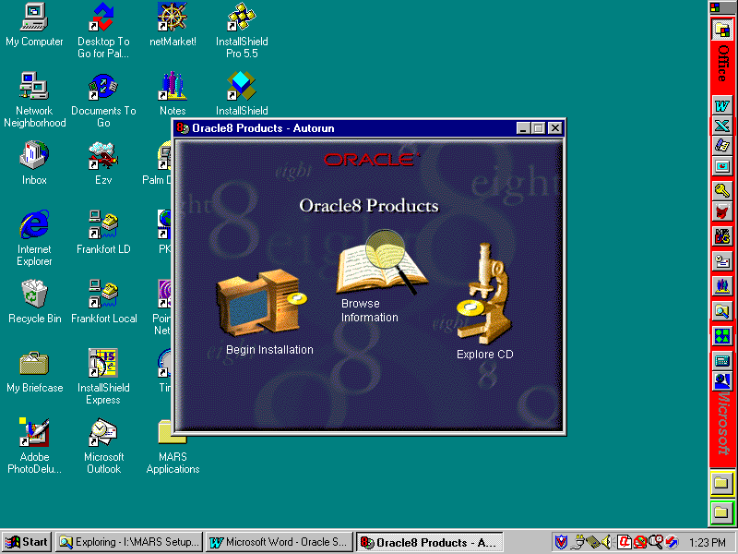
- Click on the Begin Installation icon and the Oracle Installation Settings dialog will appear with any previously defined Oracle parameters. It is advisable to keep the default values. However, you can change the installation Location field.
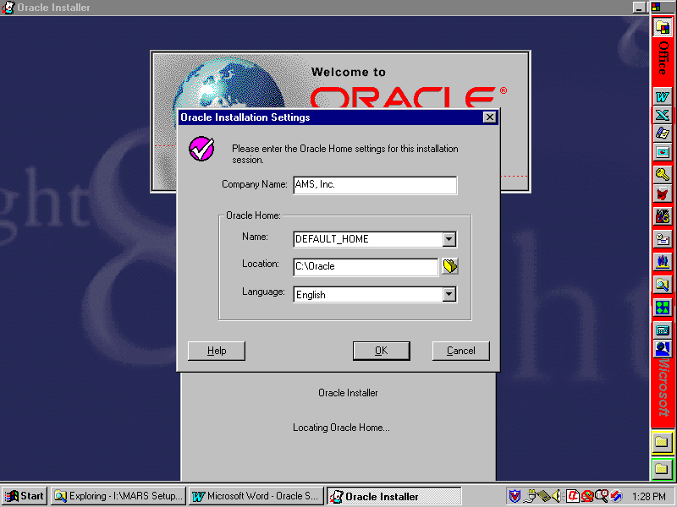
- Click OK and the following installation type dialog will appear.
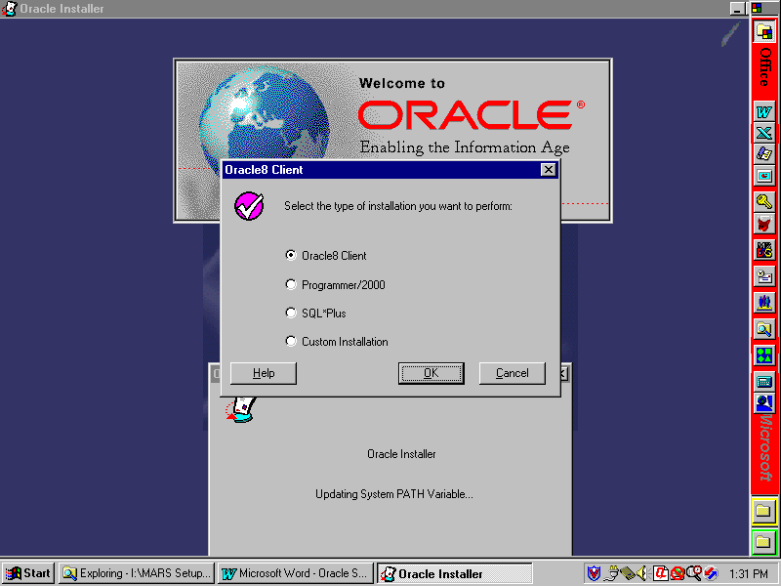
- Click on the Oracle Client selection and then click OK. The following Client Configuration dialog will appear. Select Application User and click on OK.
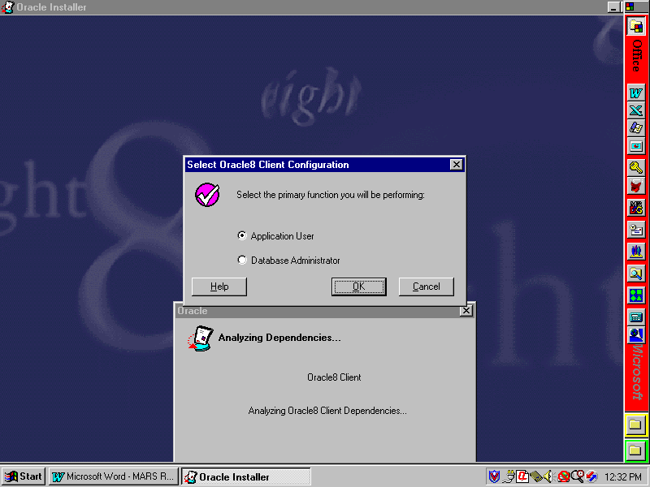
- In the following dialog screen, you are asked whether or not to load the Oracle documentation on your computer. Documentation is not required for MARS operations; however, if you feel that documentation is required for your particular installation, follow the instructions for installing documentation. For standard MARS installations, click on CD-ROM and click OK.
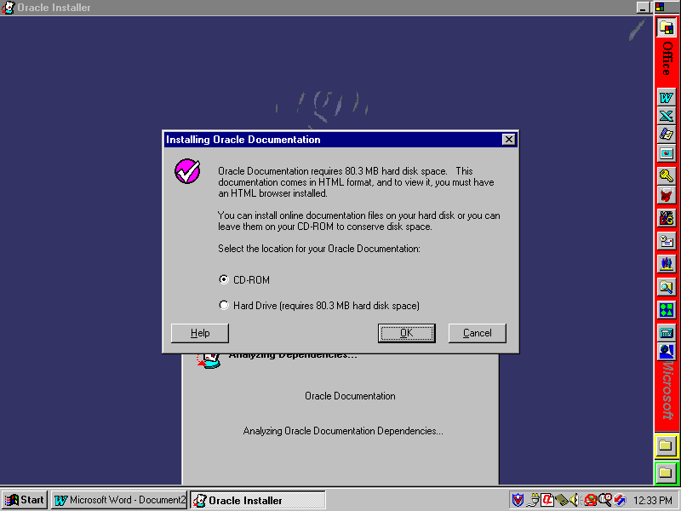
- At this point, Oracle files will be copied to the client computer and Oracle products registered. When the installation is complete, the following screen will appear. Click No to avoid reviewing documentation.
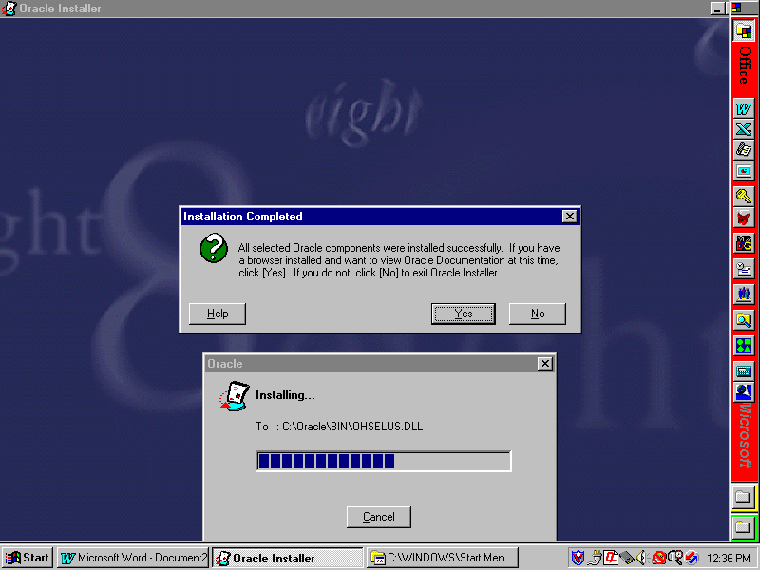
- You may be asked if you have a browser installed and if you want to view Oracle documentation at this time. If you get this message, click No to continue.
- You may be told to reboot the computer at this time. Do not reboot at this time since other installations also require rebooting. Wait until all installs are completed.
- Close the Oracle window. Oracle client installation is complete, but continue to the next steps for MARS-specific Oracle installation.
- MARS applications using Oracle require a customized file (tnsnames.ora) that defines databases, etc. for MARS. This file must be copied into an Oracle folder to replace the one distributed with Oracle. NOTE: If your agency also uses Oracle, you will have to merge your tnsnames.ora file with the MARS tnsnames.ora file before copying it to the client computers.
- If you do NOT have an agency-specific tnsnames.ora file, select to install Oracle Tnsnames when installing the MARS Applications. If this is a re-install of Oracle, then open the MARS Applications folder and double click on the Tnsnames Sync icon.
- If you have an agency-specific tnsnames.ora file, your Oracle DBA will need to merge a copy of the MARS tnsnames.ora file with the agency tnsnames.ora file. After these files have been merged, then it should be copied into the Oracle home folder (wherever you installed Oracle) \Net80\Admin folder.
- This completes the installation of Oracle on the client computer.

Installing Document Direct
- Using File Explorer on the local agency distribution server, click on the MARS_APPS\Document Direct folder.
- Double click on the Setup.exe file and accept all default settings or perform your own custom installation.
- After the installation completes, run Document Direct by either double clicking on the Document Direct icon in the Document Direct folder, or by clicking on Start, Programs, Document Direct, and Document Direct 2.2.
- From the menu bar, select Options and Configure Document Servers, and the Document Servers screen will appear with three sample document servers. Click on each in turn and click Remove to delete all three sample servers.
- Click New to configure a new server and the New Document Server screen will appear.
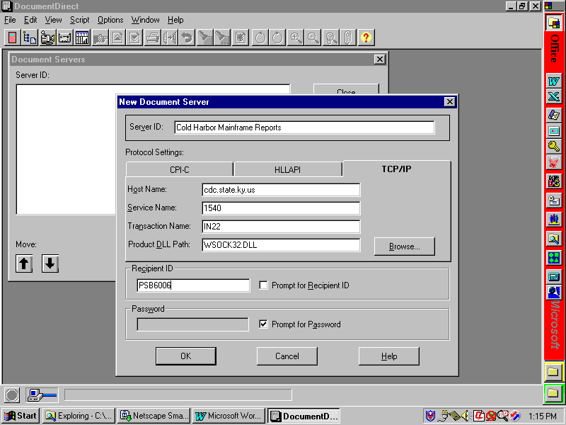
- In the Server ID field, enter Cold Harbor Mainframe Reports.
- Click on the TCP/IP tab and enter cdc.state.ky.us in the Host Name field.
- In the Service Name field, enter 1540.
- In the Transaction Name field, enter IN22.
- In the Product DLL Path field, enter WSOCK32.DLL. If another value has defaulted in this area, leave it as it appears and do not change.
- In the Recipient ID field, enter your mainframe user ID.
- Click on the Prompt for Password checkbox to select this option.
- Click OK and Close to complete this phase.
- From menu bar, click Options and select Customize Explorer from the menu and the following screen will appear.
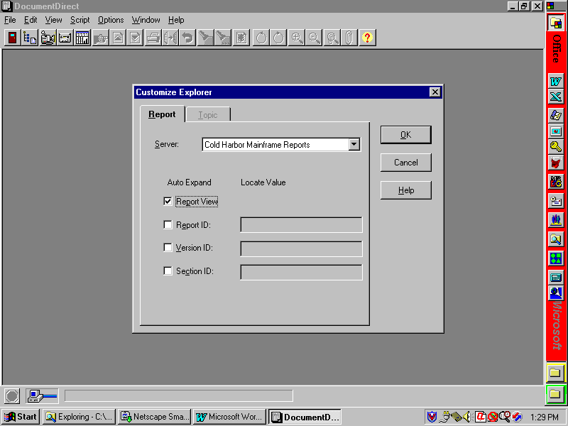
- Under the Auto Expand column, click the Report View checkbox to select. All of the other checkboxes should not be checked.
- Click OK to close and save these settings.
- Exit Document Direct and this completes the installation process. When viewing reports, you may wish to set the font to 8 pt so that the reports will better fit the screen.

Java Plug-Ins
- On the local agency distribution server, double click on the MARS_APPS\Java Activator\plugin-111-win32.exe file. Accept all default settings or perform your own custom installation. This will update environment variable settings, etc. that will require rebooting the client computer before they will take effect. Do not reboot at this time. Wait until all software has been installed.

Seagate Info
- On the local agency distribution server, double click the MARS_APPS\Seagate Info\Setup.exe file and the Seagate Info main menu screen will appear.
- Select Install (WIN32) from the menu to start the installation process.
- Seagate Info checks your currently installed ODBC DLLs to see if they need to be updated. If not, skip this step. If so, then the following screen will appear. Selecting No will cause the setup to exit; therefore, if you get this screen, select Yes. After the ODBC DLLs have been updated, you will automatically exit the setup program and be told to reboot the computer for changes to take affect. Reboot the computer and re-run the Seagate Info Setup.exe program.
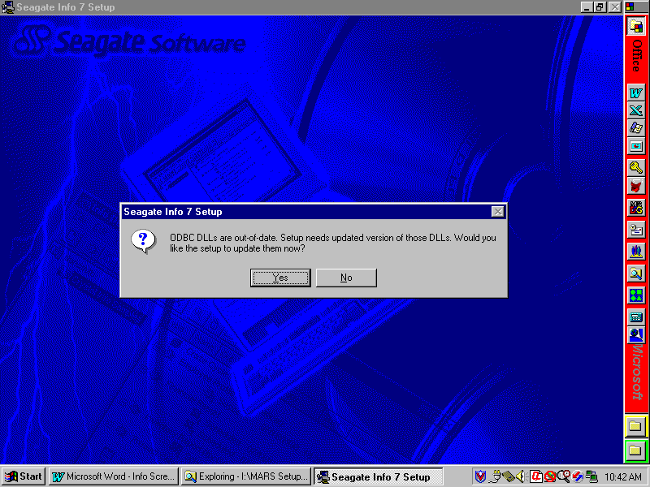
- If the ODBC DLLs are okay, or after they have been loaded and you have rebooted the computer and returned to the setup process, click Next on the Welcome screen and I Accept o the License Agreement screen and the following installation options dialog will be presented.
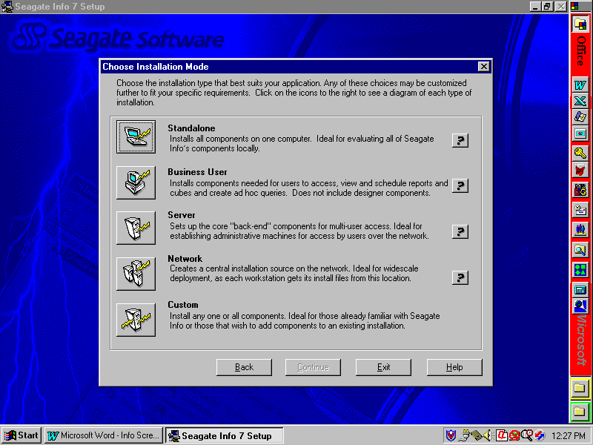
- Seagate Info provides a number of predefined options for installing the system. Click on the Business User option and the Business User dialog screen will appear.
- If you are installing a normal Seagate Info user (one who will only run reports and queries), then skip to section 3.3.4.1, Normal Client Installation Instructions below.
- If you are installing a Seagate Info power user (one who will develop reports), then skip to section 3.3.4.2, Power User Installation Instructions below. NOTE: There are licensing issues with loading power user applications. Only those people specifically identified should be given these components.

Normal Client Installation Instructions
- On the Business User dialog screen, you can change the installation location. It is recommended that you accept the default value already preloaded. If you want to install in a custom location, click Set Location and specify your custom path.
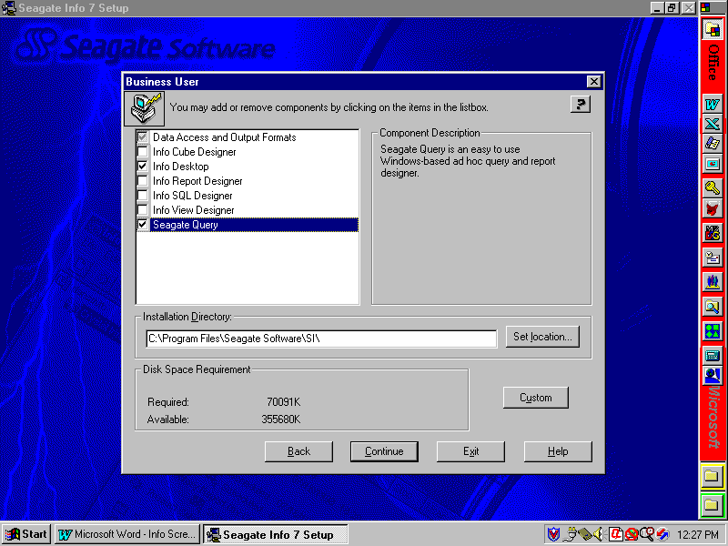
- Make sure that the following components have been selected (checkboxes checked):
- Data Access and Output Formats {leave grayed—do not click}
- Info Desktop
- Seagate Query [optional]
- Skip to section 3.3.4.3, Finish Seagate Info Installation to complete the installation process.

Power User Installation Instructions

There are a limited number of Seagate Info development licenses provided statewide for power users; therefore, this installation must only be performed for those individuals in your agency who have been specifically identified to receive this level of access.
- On the Business User dialog screen, you can change the installation location. It is recommended that you accept the default value already preloaded. If you want to install in a custom location, click Set Location and specify your custom path.
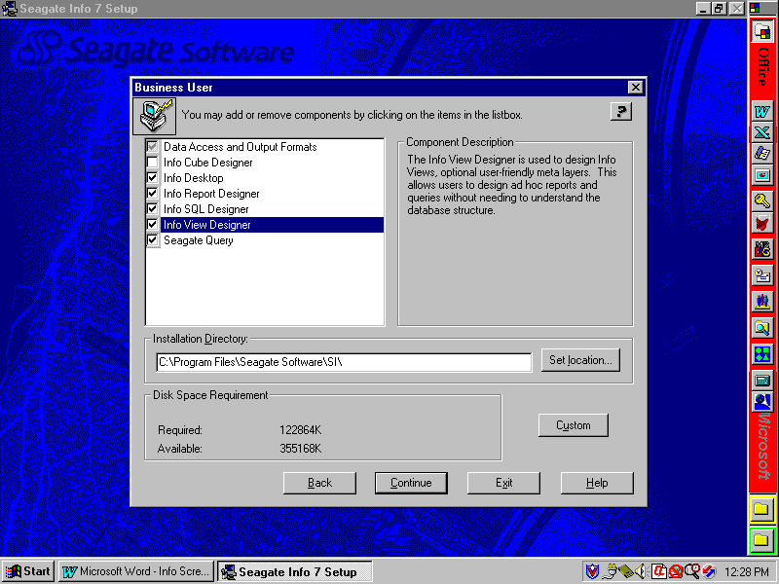
- Make sure that the following components have been selected (checkboxes checked):
- Data Access and Output Formats
- Info Desktop
- Info Report Designer
- Info SQL Designer
- Info View Designer
- Seagate Query
- Continue with section 3.3.4.3, Finish Seagate Info Installation to complete the installation process.

Finish Seagate Info Installation
- Click Continue and the Info APS Name dialog box will appear as shown below. Enter the following into the Info APS field: KYMARSSA2 and click Continue to begin the file copying process.
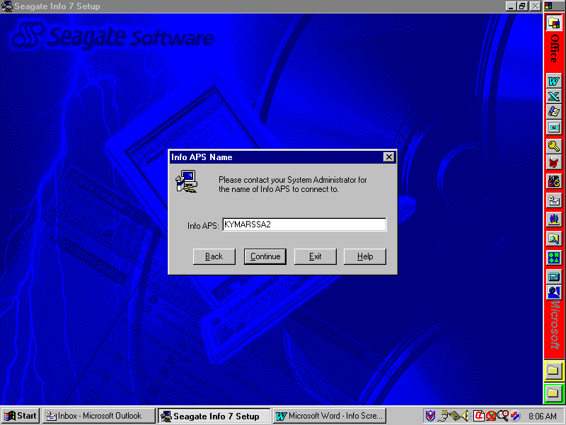
- You may get the Borland Database Engine Location dialog screen. If so, accept the default values and click Next.
- After the files have been copied and installed, the Info Configuration Manager dialog box shown below will appear. Click on the TCP/IP checkbox to make this selection. All other checkboxes should not be checked.

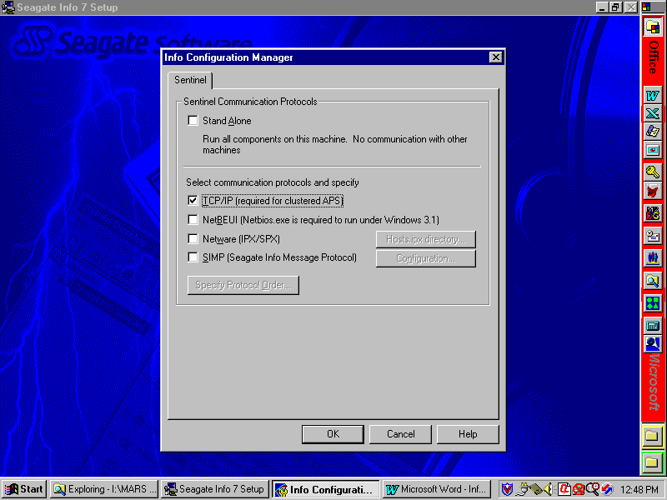
- Click OK and the Choose Program Group dialog box will appear as shown below. Select the default group or enter a custom group and click Next to continue.
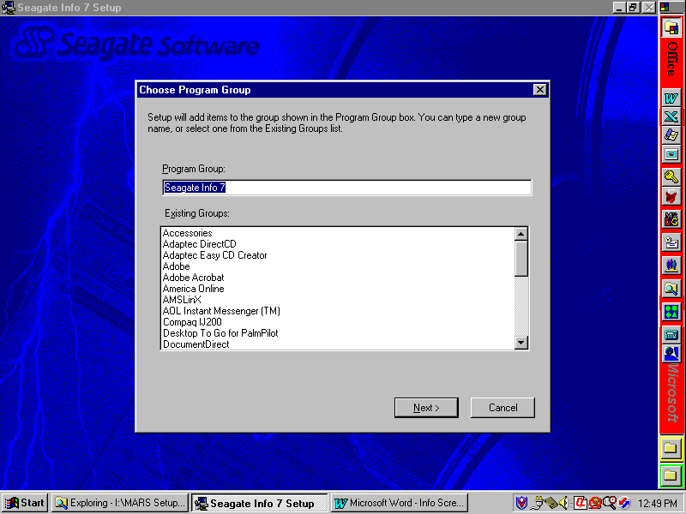
- There may be other dialog boxes telling you to reboot the computer, etc. Click on the appropriate response to cause the desired process. The installation of Seagate Info is complete at this time. If you are installing a power user, then proceed to section 3.3.4.4 for instructions on configuring ODBC drivers.

Configuring ODBC Driver for Power Users

For power users (those with the designer options chosen), the Oracle ODBC driver must be configured to point to the Management Reporting Database. To do this, perform the following steps:

- Click the Windows Start button and select Settings and Control Panel.
- Double click on the ODBC (32 bit) icon and select the User DSN tab.
- In the Name column, click on CROR8 to highlight and click the Configure button to the right.
- In the Server Name field, type MREPP1 and click Apply.
- Click the OK button until you exit the ODBC Data Source Administrator window.
- Exit the control panel. You may be instructed to reboot the computer before these changes will take place.

Installing MARS Applications

This section addresses installing the MARS applications. If MARS has already been installed and you are using standard MARS synchronization procedures with an agency distribution server, skip to section 3.5. If you are performing initial installs on a client computer, then you need to perform the installation procedures in this chapter. These instructions are for installation of the MARS ADVANTAGE Desktop, BRASS, and PD components on the client computers and ADVANTAGE Desktop on the agency distribution server.

NOTE: Make sure that you have write access to the server if installing the ADVANTAGE Server component. ADVANTAGE Server component only needs to be install once on the server for each release, not for each client computer install.
- On the local server, double click on MARS_APPS\MARS\Setup.exe and you will receive a warning screen. Click Yes to continue.
- The following dialog box allows you to specify where to install the MARS applications on the client computer. NOTE: It is highly recommended that you use the default settings or, at minimum, only change the installation drive letter. This is to aid in debugging any future problems you might have with running MARS. The path entered here will have the \MARS_APPS folder appended to the end. If you are installing ADVANTAGE Server, you should select the default since the Setup needs a location on the local computer in which to unpack files, etc.
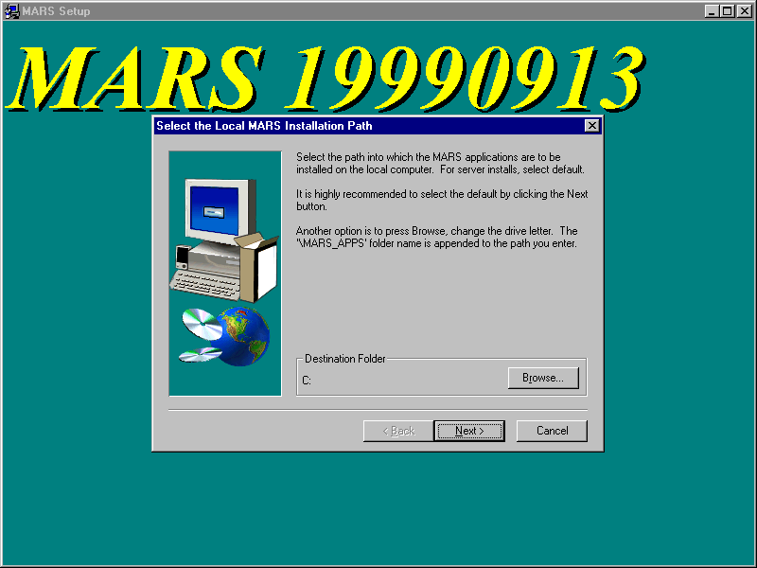
- If you wish to change the client computer installation path, click Browse and the following dialog box will appear. Select or specify the folder path into which you want the client software to be installed. When you are finished, click OK to return to the previous dialog box.
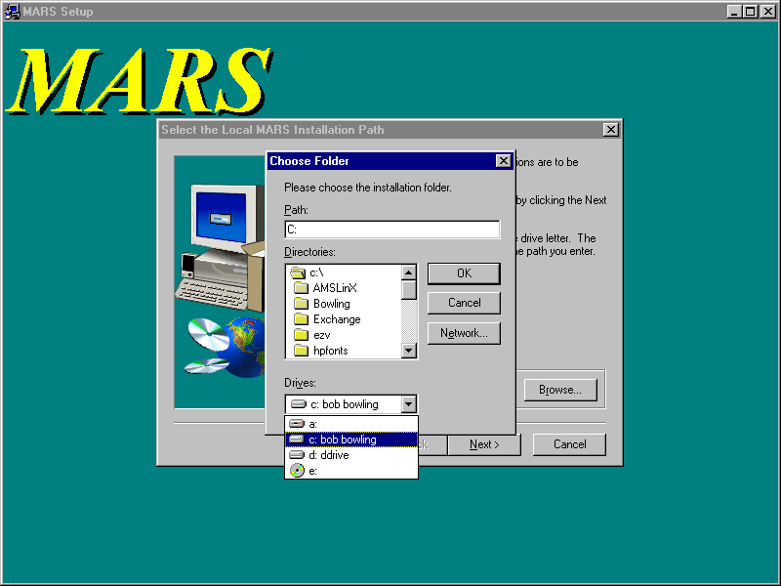
- Click Next and the following dialog will appear. Since you are installing from an agency distribution server, click on Agency Server-Based Installation.
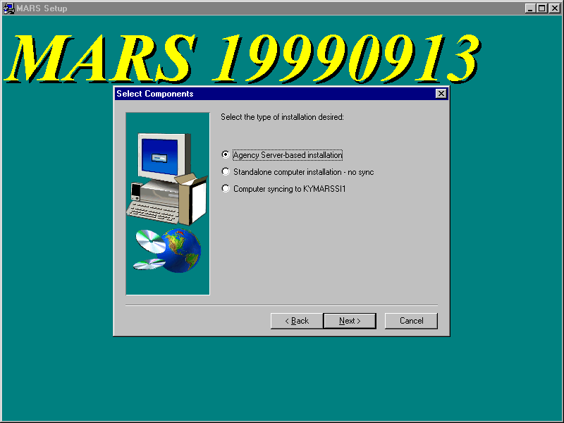
- Click Next and the following dialog will appear. This dialog is asking you for your agency distribution server path into which you will install the ADVANTAGE Server application and where the Setup.exe for MARS is stored. When providing this path, it should be the fully qualified server designation path rather than a mapped drive letter, unless your agency has standardized mapped drive letters to the server. The Browse button can be used or the path can be typed directly into the field. Typically, replace the question mark with your server name and any additional path information and the path should be similar to the following:
\\dismarsnt\appsdata {where “dismarsnt” is the server name}
NOTE: The path entered here will have the \MARS_APPS folder appended to the end and is used for all synchronization processes.
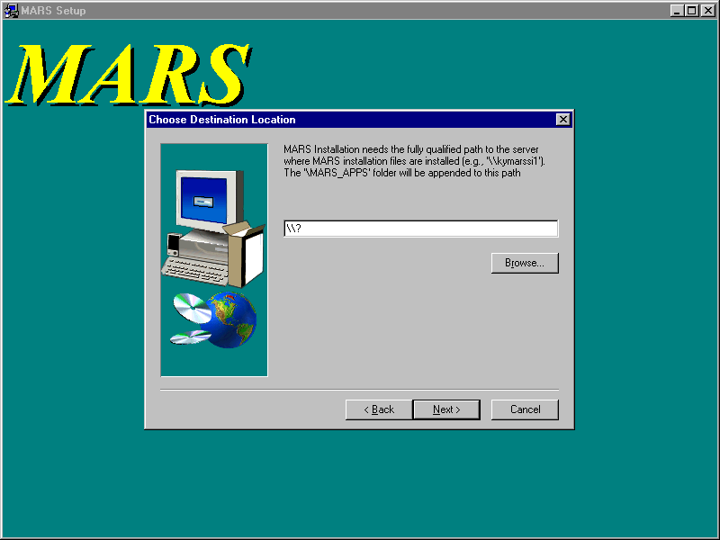
- After entering the server path, click Next and the following screen will appear. Click on the applications to be installed (indicated by a checkmark in the associated box).
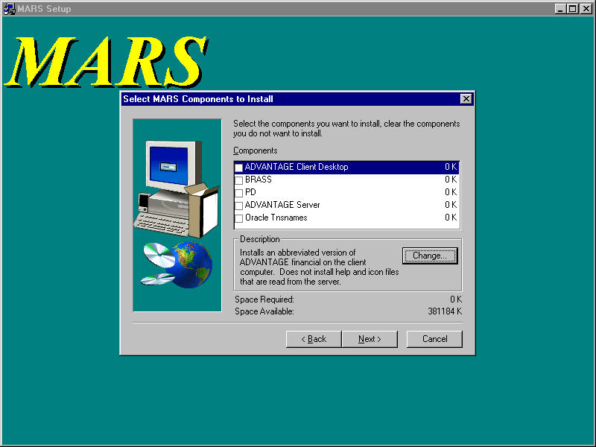
NOTE: If installing a new release of ADVANTAGE, you must install the ADVANTAGE Server to your agency server. Those client computers that already have ADVANTAGE Client Desktop installed do not have to be re-installed since they will sync automatically with the agency distribution server. For those client computers that do not already have ADVANTAGE installed, you will need to install the ADVANTAGE Client Desktop. If you change the location of ADVANTAGE on the server, you must reinstall ADVANTAGE on all client computers so that they will sync properly with the new location.
- After selecting all applications to be installed, click Next. You should not select to install Oracle Tnsnames if you already use Oracle at your agency. Talk to the Oracle DBA about how to merge and distribute tnsnames.ora separately. If you have selected to update the Oracle Tnsnames, the following screen will appear. Enter the Oracle home folder for where you have installed Oracle on the client computer. The default given is read from your computer’s registry. Click Next to continue.

NOTE: If you have not installed Oracle prior to trying to install Tnsnames, you will get a message from the install software telling you that you must install Oracle first and the install of Tnsnames will be aborted. Refer to section 3.3.1.
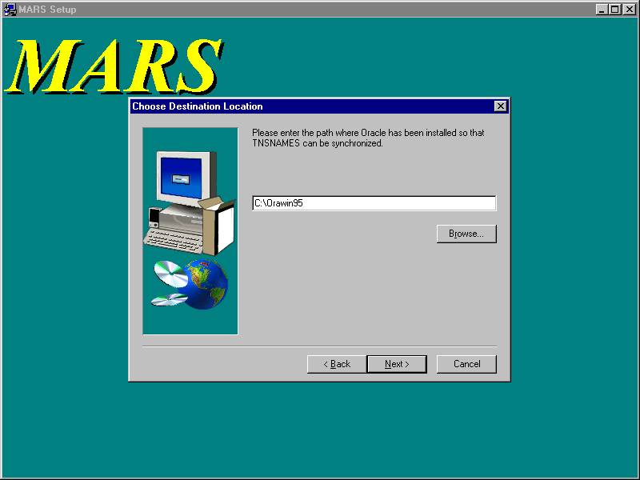

- At this point, MARS files will be copied to the appropriate locations, ini and bat files updated with the information you provided, and a MARS Application folder placed on the client desktop with icons for the MARS applications that were installed.
- For new installations of ADVANTAGE Desktop on client computers running WIN98: The ADVANTAGE and ADVANTAGE Workflow icons may need to be adjusted for a more desirable operation. These icons execute a minimized batch command file; however, the MS DOS window does not automatically close upon exiting ADVANTAGE and the computer may not have assigned enough memory to the MS DOS window. To correct these problems, perform the following steps:
- Double click on the MARS Applications folder on the desktop to open and the following screen should appear. Not all icons will be present if you have not done a full install.
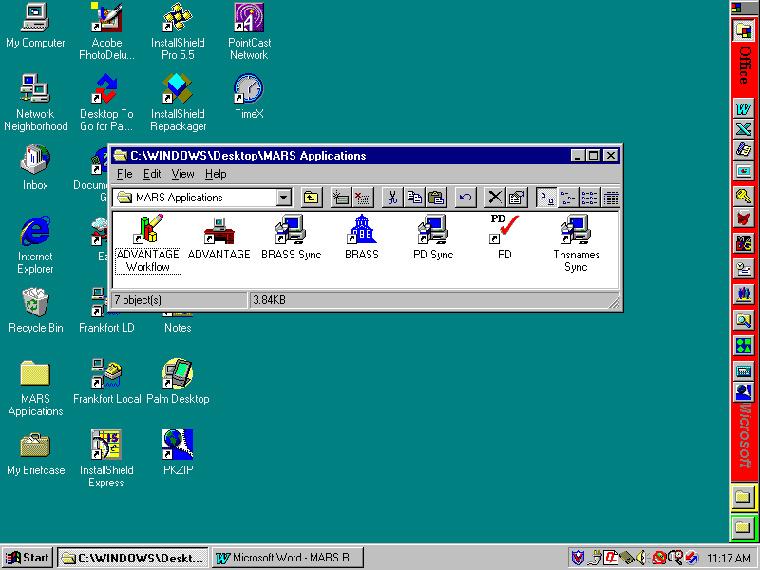
- Right click on the ADVANTAGE Workflow icon and select Properties from the menu.
- Click on the Program tab and click on the Close on exit checkbox.
- Click on the Memory tab and verify that the Initial environment is set to 4096. If not (e.g., set to Auto), then click on the Initial environment field, scroll down, and select 4096 from the pick list.
- Click Apply and click OK to close.
- Right click on the ADVANTAGE icon and select Properties from the menu.
- Click on the Program tab and click on the Close on exit checkbox.
- Click on the Memory tab and verify that the Initial environment is set to 4096. If not (e.g., set to Auto), then click on the Initial environment field, scroll down, and select 4096 from the pick list.
- Click on Apply and click on OK to close.
- For WIN98 Only: You must reboot the computer before the Sync icons will work.
- This completes the MARS applications installation.

Synchronizing MARS Applications

This chapter addresses how to synchronize previously installed MARS applications with new releases. Agencies may decide not to use the standard MARS synchronization and substitute other methods (e.g., use distribution software to push changes to client computers). With a standard MARS installation, a MARS Applications folder is placed on the client computer desktop with icons as shown in the following screen:

If you are providing other methods for synchronizing MARS software, then you should remove the BRASS Sync, PD Sync, and Tnsnames Sync icons from the MARS Applications folder. Otherwise, the following sections provide instructions on how to synchronize MARS software.

Synchronizing ADVANTAGE Server

The MARS installation software will create an ADVANTAGE Server Install icon whenever the ADVANTAGE Server installation is performed. This icon can be used to perform future ADVANTAGE Server installations without having to go through the detailed entry and selection of information. When ADVANTAGE Server is installed, the icon will record the information entered during the installation and use these data for future installations. Note that this icon is only for the MARS System Administrators and should not be installed on end-user client computers.

Synchronizing ADVANTAGE

ADVANTAGE has its own automated synchronization tool built into the process of running ADVANTAGE. System Administrators can not disable or bypass this process. It is transparent to the end user and does not require any special knowledge on their part. The process occurs automatically every time that ADVANTAGE is executed.

For the ADVANTAGE synchronization to work properly, you need to install the new ADVANTAGE Server component on your local agency distribution server. Download the MARS release package as instructed in section 3.1.1.1 and run the setup program to select this component. ADVANTAGE should be installed into the same server location referenced when the desktop clients were initially installed. If ADVANTAGE is moved to a different location on the agency distribution server, the client computers will fail to synchronize and will have to be re-installed or manually changed.

After installing the new version of ADVANTAGE on the agency distribution server, all client computers will automatically synchronize to the new version whenever ADVANTAGE is run. If multiple releases have occurred since the last synchronization on a given client computer, the client will automatically upgrade to the newest version.

Synchronizing BRASS

When a new release of MARS is loaded on the agency distribution server, client computers can synchronize to the new version by double clicking on the BRASS Sync icon in the MARS Applications folder. Download the MARS release package as instructed in section 3.1.1.1. You do not need to load BRASS on the distribution server. The client computers will synchronize with the MARS setup program. When BRASS Sync is run, the new version of BRASS will automatically load into the same location where it was originally installed. This synchronization load will not ask the end user any questions.

Synchronizing PD

With this release PD has its own automated synchronization tool built into the process of running PD. System Administrators can not disable or bypass this process. It is transparent to the end user and does not require any special knowledge on their part. The process occurs automatically every time that PD is executed.

For the PD synchronization to work properly, you need to install the new ADVANTAGE Server component on your local agency distribution server. Download the MARS release package as instructed in section 3.1.1.1 and run the setup program to select this component. ADVANTAGE should be installed into the same server location referenced when the desktop clients were initially installed. If PD is moved to a different location on the agency distribution server, the client computers will fail to synchronize and will have to be re-installed or manually changed.

After installing the new version of PD on the agency distribution server, all client computers will automatically synchronize to the new version whenever PD is run. If multiple releases have occurred since the last synchronization on a given client computer, the client will automatically upgrade to the newest version.

Synchronizing Oracle Tnsnames

When a new release of MARS is loaded on the agency distribution server, client computers can synchronize to the new version by double clicking on the Tnsnames Sync icon in the MARS Applications folder. Download the MARS release package as instructed in section 3.1.1.1. You do not need to load Tnsnames on the distribution server. The client computers will synchronize with the MARS setup program. When Tnsnames Sync is run, the new version of Oracle tnsnames.ora will automatically load into the Oracle home directory based on the original installation of MARS on the client computer. This synchronization load will not ask the end user any questions.

Installing Without an Agency Distribution Server

This chapter is for those agencies that do not have an agency distribution server from which to distribute software to the client computers. These installation procedures are for standalone computers not connected to an agency distribution server. Please follow the instructions below to install or synchronize the latest version of MARS applications and supporting software environment.

The following table provides a guideline to the instructions for installing the distributed software on a standalone, non-networked computer.

If you are… | Then, follow these instructions…
Performing initial installs or installing new computers…
Install upgrades. | Go to Section 4.2.
Install the supporting software environment. | Go to Section 4.2.1.
Install the MARS applications. | Go to Section 4.4.
Performing subsequent installs after initial installation…
Install upgrades if required by the particular release. | Go to Section 4.2, if required.
Install the MARS applications. | Go to Section 4.4.

MARS CD ROM Distribution

MARS and associated third-party software are distributed to agencies on a set of MARS Distribution CDs as follows:

- Seagate Info
- Oracle Client
- MARS Applications & Miscellaneous

The Seagate Info and Oracle Client CDs are distributed to all agencies for initial installation of client computers. These two CDs will not be shipped with every release. Subsequent synchronization of client computers to the latest release of MARS will not require these CDs. They should be saved in case a new installation is required. When new releases of these products are received, a new set of CDs will be distributed.

The MARS Applications & Miscellaneous CD will generally contain the MARS Setup\MARS folder. However, from time to time, other software upgrades, etc. may be shipped on the MARS Applications CD. In these instances, the MARS Setup folder will contain addition sub-folders.

CDs Distributed this Release

Not all sites were issued CDs for this release. If your site receives MARS CDs, the following should have been in your release package:

- <Oracle Client >
- <Seagate Info>
- MARS Applications & Miscellaneous

Current CDs Required for MARS

The following set of CDs constitutes the complete and current set to support this release of MARS:

- Seagate Info {Shipped with MARS Release 19990607}
- Oracle Client {Shipped with MARS Release 19990607}
- MARS Applications & Miscellaneous {Shipped with MARS Release <19990614>}

Installing Upgrades

This Chapter provides information on upgrades to operating systems and other supporting software necessary for this release. All other supporting software upgrades are addressed in the Prerequisites section for each MARS component and are not distributed with this release. To obtain copies of previous upgrades, contact the Customer Resource Center (CRC) Help Desk.

Windows 98

No upgrade to Windows 98 is required for this release. Refer to section 1.4 required software versions.

Windows NT

The upgrade should have been applied with Release 19990607 and no additional upgrade is required for this release. Refer to section 1.4 required software versions. To install this upgrade, perform the follow step:
- Using the File Explorer on your agency server, double click on MARS Setup\WINNT Upgrades\NT4-sp4\I386\Update\Update.exe. This is a self-extracting installation package. Accept any defaults.

Internet Explorer

The upgrade should have been applied with Release 19990607 and no additional upgrade is required for this release. Refer to section 1.4 required software versions. To install this upgrade, perform the follow step:
- For WIN98 ONLY: Using the File Explorer on your agency server, double click on MARS Setup\Internet Explorer Upgrades\SP2 Setup95\ie4setup.exe. This is a self-extracting installation package. Accept any defaults.
- For WINNT ONLY: Using the File Explorer on your agency server, double click on MARS Setup\Internet Explorer Upgrades\SP2 SetupNT\ie4setup.exe. This is a self-extracting installation package. Accept any defaults.

Netscape

The upgrade should have been applied with Release 19990607 and no additional upgrade is required for this release. Refer to section 1.4 required software versions. To install this upgrade, perform the follow step:
- Using the File Explorer on your agency server, double click on MARS Setup\Netscape Upgrades\n32e408.exe. This is a self-extracting installation package. Accept any defaults.

Installing the Supporting Software Environment

For initial installations of MARS, you should first install the supporting software environment on the client computer. Use the MARS distribution CDs and the following instructions to load the supporting software onto your computer.

These instructions are for installing the following supporting software:

- Oracle
- Document Direct
- Java Plug-ins
- Seagate Info

It is assumed that the agencies have already installed either the MS Internet Explorer or the Netscape browser. If not, then one of these browsers will have to be installed if the client computer is to access any of the Web applications.

Installing Oracle
- Insert the Oracle Client CD into your CD drive and it should start the Oracle installation process automatically. If not, using the file explorer, click on the CD ROM drive in which the Oracle installation CD is loaded to open the MARS Setup\Oracle\WIN32\Autorun folder and double click on the Autorun.exe file.
- Click on the Begin Installation icon and the Oracle Installation Settings dialog will appear with any previously defined Oracle parameters. It is advisable to keep the default values. However, you can change the installation Location field (e.g., place Oracle under the MARS_APPS folder).
- Click OK and the following installation type dialog will appear.
- Click on the Oracle Client selection and then click OK. The following Client Configuration dialog will appear. Select Application User and click on OK.
- In the following dialog screen, you are asked whether or not to load the Oracle documentation on your computer. Documentation is not required for MARS operations; however, if you feel that documentation is required for your particular installation, follow the instructions for installing documentation. For standard MARS installations, click on CD-ROM and click OK.
- At this point, Oracle files will be copied to the client computer and Oracle products registered. When the installation is complete, the following screen will appear. Click No to avoid reviewing documentation.
- You may be asked if you have a browser installed and if you want to view Oracle documentation at this time. If you get this message, click No to continue.
- You may be told to reboot the computer at this time. Do not reboot at this time since other installations also require rebooting. Wait until all installs are completed.
- Close the Oracle window. Oracle client installation is complete, but continue to the next steps for MARS-specific Oracle installation.
- MARS applications using Oracle require a customized file (tnsnames.ora) that defines databases, etc. for MARS. This file must be copied into an Oracle folder to replace the one distributed with Oracle. NOTE: If your agency also uses Oracle, you will have to merge your tnsnames.ora file with the MARS tnsnames.ora file before copying it to the client computers.
- If you do NOT have an agency-specific tnsnames.ora file, select to install Oracle Tnsnames when installing the MARS Applications. If this is a re-install of Oracle, then open the MARS Applications folder and double click on the Tnsnames Sync icon.
- If you have an agency-specific tnsnames.ora file, your Oracle DBA will need to merge a copy of the MARS tnsnames.ora file with the agency tnsnames.ora file. After these files have been merged, then it should be copied into the Oracle home folder (wherever you installed Oracle) \Net80\Admin folder.
- This completes the installation of Oracle on the client computer.

Installing Document Direct
- Insert the MARS Application & Miscellaneous CD into the drive and double click on the MARS Setup\Document Direct\Setup.exe file. Accept all default settings or perform your own custom installation.
- After the installation completes, run Document Direct by either double clicking on the Document Direct icon in the Document Direct folder, or by clicking on Start, Programs, Document Direct, and Document Direct 2.2.
- From the menu bar, select Options and Configure Document Servers, and the Document Servers screen will appear with three sample document servers. Click on each in turn and click Remove to delete all three sample servers.
- Click New to configure a new server and the New Document Server screen will appear.
- In the Server ID field, enter Cold Harbor Mainframe Reports.
- Click on the TCP/IP tab and enter cdc.state.ky.us in the Host Name field.
- In the Service Name field, enter 1540.
- In the Transaction Name field, enter IN22.
- In the Product DLL Path field, enter WSOCK32.DLL. If another value has defaulted in this area, leave it as it appears and do not change.
- In the Recipient ID field, enter your mainframe user ID.
- Click on the Prompt for Password checkbox to select this option.
- Click OK and Close to complete this phase.
- From menu bar, click Options and select Customize Explorer from the menu and the following screen will appear.
- Under the Auto Expand column, click the Report View checkbox to select. All of the other checkboxes should not be checked.
- Click OK to close and save these settings.
- Exit Document Direct and this completes the installation process. When viewing reports, you may wish to set the font to 8 pt so that the reports will better fit the screen.

Installing Java Plug-Ins
- Insert the MARS Applications & Miscellaneous CD into your CD drive and double click on the MARS_APPS\MARS Setup\Java Activator\plugin-111-win32.exe file. Accept all default settings or perform your own custom installation. This will update environment variable settings, etc. that will require rebooting the client computer before they will take effect.

Installing Seagate Info
- Insert the Seagate Info CD into your CD drive and it will automatically start the setup process. If not, using the file explorer, click on the CD ROM drive in which the Seagate Info installation CD is loaded and double click on the Setup.exe file.
- The Seagate Info main menu screen will appear. Select Install (WIN32) from the menu to start the installation process.
- Seagate Info checks your currently installed ODBC DLLs to see if they need to be updated. If not, skip this step. If so, then the following screen will appear. Selecting No will cause the setup to exit; therefore, if you get this screen, select Yes. After the ODBC DLLs have been updated, you will automatically exit the setup program and be told to reboot the computer for changes to take affect. Reboot the computer and re-run the Seagate Info Setup.exe program.
- If the ODBC DLLs are okay, or after they have been loaded and you have rebooted the computer and returned to the setup process, click Next on the Welcome screen and I Accept o the License Agreement screen and the following installation options dialog will be presented.
- Seagate Info provides a number of predefined options for installing the system. Click on the Business User option and the Business User dialog screen will appear.
- If you are installing a normal Seagate Info user (one who will only run reports and queries), then skip to section 4.3.4.1 below.
- If you are installing a Seagate Info power user (one who will develop reports), then skip to section 4.3.4.2 below. NOTE: There are licensing issues with loading power user applications. Only those people specifically identified should be given these components.

Normal Client Installation Instructions
- On the Business User dialog screen, you can change the installation location. It is recommended that you accept the default value already preloaded. If you want to install in a custom location, click Set Location and specify your custom path.
- Make sure that the following components have been selected (checkboxes checked):
- Data Access and Output Formats
- Info Desktop
- Seagate Query [optional]
- Skip to section 4.3.4.3 to complete the installation process.

Power User Installation Instructions

There are a limited number of Seagate Info development licenses provided statewide for power users; therefore, this installation must only be performed for those individuals in your agency who have been specifically identified to receive this level of access.
- On the Business User dialog screen, you can change the installation location. It is recommended that you accept the default value already preloaded. If you want to install in a custom location, click Set Location and specify your custom path.
- Make sure that the following components have been selected (checkboxes checked):
- Data Access and Output Formats
- Info Desktop
- Info Report Designer
- Info SQL Designer
- Info View Designer
- Seagate Query
- Skip to section 4.3.4.3 to complete the installation process.

Finish Seagate Info Installation
- Click Continue and the Info APS Name dialog box will appear as shown below. Enter the following into the Info APS field: KYMARSSA2 and click Continue to begin the file copying process.
- After the files have been copied and installed, the Info Configuration Manager dialog box shown below will appear. Click on the TCP/IP checkbox to make this selection. All other checkboxes should not be checked.

- Click OK and the Choose Program Group dialog box will appear as shown below. Select the default group or enter a custom group.
- There may be other dialog boxes telling you to reboot the computer, etc. Click on the appropriate response to cause the desired process. The installation of Seagate Info is complete at this time.

Installing MARS Applications

When installing from the MARS Distribution CDs, it is assumed that you do not have access to an agency distribution server. You will either install MARS from the CD or synchronize the MARS applications to the MARS Central Distribution server. The choice is a matter of the time it takes to do the synchronization over a low speed line versus the time it takes for the MARS Distribution CD to be mailed to your location. Re-installing MARS from the CD will take 6 to 10 minutes depending upon the speed of your CD drive. Synchronizing MARS with the MARS Central Distribution server over a 56KB line will take approximately 70 minutes for BRASS, 100 minutes for PD, and 90 minutes for ADVANTAGE.
- Insert the MARS Applications & Miscellaneous CD into your CD drive and double click on MARS Setup\MARS\Setup.exe and a warning screen will appear warning that changes in folder names will result in MARS applications not working. Click Yes to continue and the following screen will appear. This dialog box allows you to specify where to install the MARS applications on the client computer. NOTE: It is highly recommended that you use the default settings or, at minimum, only change the installation drive letter. This is to aid in debugging any future problems you might have with running MARS. The path entered here will have the \MARS_APPS folder appended to the end.
- If you wish to change the client computer installation path, click Browse and the following dialog box will appear. Select or specify the folder path into which you want the client software to be installed. When you are finished, click OK to return to the previous dialog box.
- Click Next and the following dialog box will appear. This dialog is requesting the type of installation desired. Since your agency does not have a distribution server, at this point, you must decide if you are installing a standalone computer (Standalone computer installation – no sync ) that does not synchronize (e.g., purely installed from CD each time) or if you want to synchronize with the MARS Central Distribution server (Computer syncing to KYMARSSI1). Make the appropriate selection and click Next to continue.
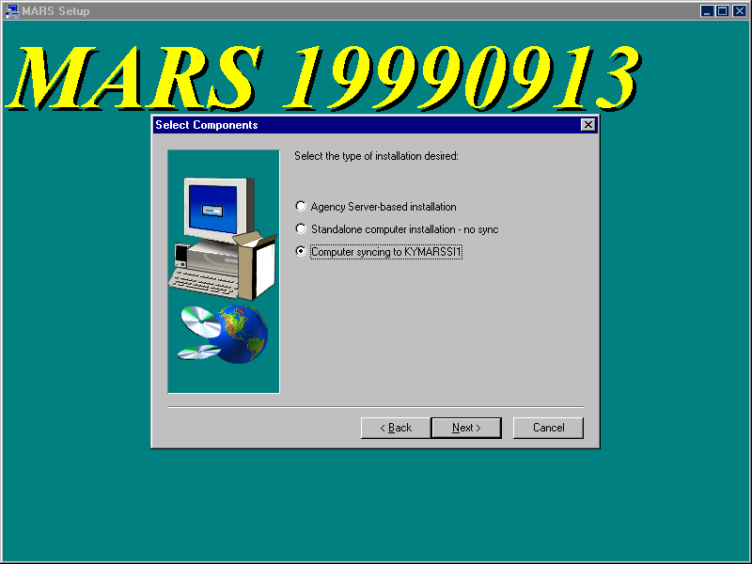
- Once you have made a decision on the previous screen, the following dialog screen will appear. Click on the MARS components to be installed (indicated by a checkmark in the associated checkbox). For Standalone installations, regardless of whether or not you are synchronizing with the MARS Central Distribution server, the ADVANTAGE Server files will always be installed if you pick either of the ADVANTAGE selections. You should not pick both selections.
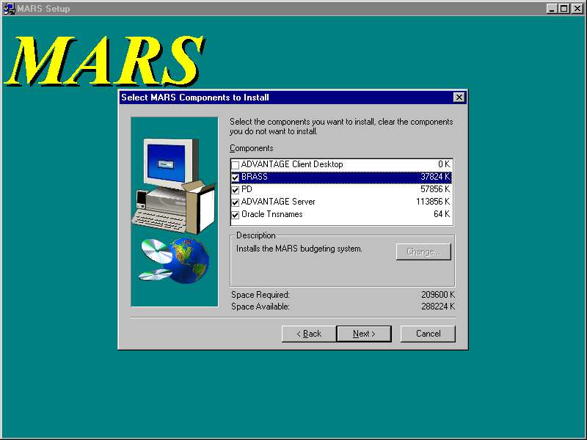
- At this point, MARS files will be copied to the appropriate locations, ini and bat files updated with the information you provided, and a MARS Application folder placed on the client desktop with icons for the MARS applications that were installed.
- For initial installations on computers running WIN98: The ADVANTAGE and ADVANTAGE Workflow icons may need to be adjusted for a more desirable operation. These icons execute a minimized batch command file; however, the MS DOS window does not automatically close upon exiting ADVANTAGE and the computer may not have assigned enough memory to the MS DOS window. To correct these problems, perform the following steps:
- Double click on the MARS Applications folder on the desktop to open and the following screen should appear. Not all icons will be present if you have not done a full install.
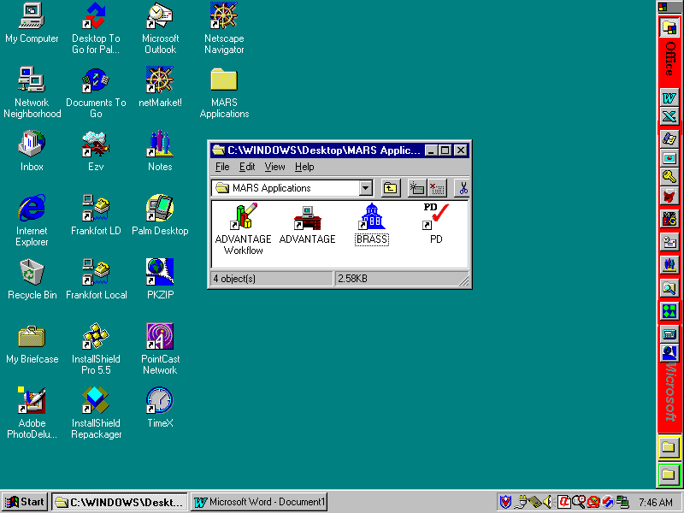
NOTE: If you chose to synchronize with the MARS Central Distribution server, your MARS Application Folder will have Sync icons for BRASS, PE, and Tnsnames.
- Right click on the ADVANTAGE Workflow icon and select Properties from the menu.
- Click on the Program tab and click on the Close on exit checkbox.
- Click on the Memory tab and verify that the Initial environment is set to 4096. If not (e.g., set to Auto), then click on the Initial environment field, scroll down, and select 4096 from the pick list.
- Click Apply and click OK to close.
- Right click on the ADVANTAGE icon and select Properties from the menu.
- Click on the Program tab and click on the Close on exit checkbox.
- Click on the Memory tab and verify that the Initial environment is set to 4096. If not (e.g., set to Auto), then click on the Initial environment field, scroll down, and select 4096 from the pick list.
- Click on Apply and click on OK to close.
- For WIN98 Only: You must reboot the computer before the Sync icons will work.
- This completes the MARS applications installation.

Synchronizing MARS Applications

This chapter addresses how to synchronize previously installed MARS applications with new releases for those agencies that have chosen to synchronize with the MARS Central Distribution server. MARS Applications folder is placed on the client computer desktop with icons as shown in the following screen:

The following sections provide instructions on how to synchronize MARS software.

Synchronizing ADVANTAGE

ADVANTAGE has its own automated synchronization tool built into the process of running ADVANTAGE. System Administrators can not disable or bypass this process. It is transparent to the end user and does not require any special knowledge on their part. The process occurs automatically every time that ADVANTAGE is executed. If multiple releases have occurred since the last synchronization on a given client computer, the client will automatically upgrade to the newest version.

Synchronizing BRASS

You can synchronize to the new version by double clicking on the BRASS Sync icon in the MARS Applications folder. The client computer will synchronize with the MARS setup program stored on the MARS Central Distribution server. When BRASS Sync is run, the new version of BRASS will automatically load into the same location where it was originally installed. This synchronization load will not ask any questions.

Synchronizing PD

PD has its own automated synchronization tool built into the process of running PD. System Administrators can not disable or bypass this process. It is transparent to the end user and does not require any special knowledge on their part. The process occurs automatically every time that PD is executed. If multiple releases have occurred since the last synchronization on a given client computer, the client will automatically upgrade to the newest version.

You can synchronize to the new version by double clicking on the PD icon in the MARS Applications folder. The client computer will synchronize with the MARS setup program stored on the MARS Central Distribution server. When PD is run, the new version of PD will automatically load into the same location where it was originally installed. This synchronization load will not ask any questions.

Synchronizing Oracle Tnsnames

You can synchronize to the new version by double clicking on the Tnsnames Sync icon in the MARS Applications folder. The client computer will synchronize with the MARS setup program stored on the MARS Central Distribution server. When Tnsnames Sync is run, the new version of tnsnames.ora will automatically load into the same location where it was originally installed. This synchronization load will not ask any questions.

Troubleshooting Guide

The information in this guide is based on past problems encountered for which corrective actions have been determined. Your exact problem may not be listed, but this guide should help point you in the right direction for isolating and correcting your specific installation problem.

ADVANTAGE Will Not Run

You have double clicked on the ADVANTAGE or ADVANTAGE Workflow icons and either nothing happens or you get a message that a file can not be found. Typically, this is caused by the batch file \MARS_APPS\ADVANTAGE\bin\runprog.bat not pointing to the local drive where ADVANTAGE is installed and/or to the agency distribution server location where ADVANTAGE is installed on the server.

Using the File Explorer, right click on \MARS_APPS\ADVANTAGE\bin\runprog.bat and select Edit from the menu. Check that the SET AD_LDRIVE command is set equal to the drive onto which ADVANTAGE was installed on the client computer. The default setting is:

SET AD_LDRIVE=C

Note that the drive letter (e.g., “C”) is not followed by a colon (“:”). If it is, then remove the colon.

In the following SET commands, the paths may be in DOS short path notation for your actual installations. For those agencies with Novell version 3.11, long paths are not supported and you will have to use short path notation. Check that the SET AD_RDRIVE command is set equal to the distribution server path where ADVANTAGE is installed. This path is used by the client ADVANTAGE Desktop application to synchronize with the latest version. The path setting should be similar to the following:

SET AD_RDRIVE=\\kymarssi1\MARS_APPS

where in the place of “kymarssi1” you would have substituted you local distribution server name and path.

Check that the SET AD_LHOME command is set equal to the distribution server path plus the ADVANTAGE folder where ADVANTAGE is installed. The path setting should be similar to the following:

SET AD_LHOME=\\kymarssi1\MARS_APPS\ADVANTAGE

where in the place of “kymarssi1” you would have substituted you local distribution server name and path.

If either of these settings was incorrect, correct the problem and try to run ADVANTAGE again. If not, check the network connection between the client computer and that server location. Verify that the user has access rights to read from the server location. You can also review the MARS_APPS\ADVANTAGE\system\advsync.log file for errors that occurred during the attempt to make the connection. If there are any errors recorded, correct those errors and try to connect again.

If a problem can not be found, then review the other troubleshooting topics, specifically section 5.2 to check the relative network addressing between your distribution server and the mainframe.

ADVANTAGE Connection Fails

The receipt of the Connection Failed error box or an error message says that “the host specified by the name [null] could not be found,” then there is a likely problem with the network connection between the client desktop and the ADVANTAGE server application. The problem is that the client computer cannot resolve the path to the mainframe (e.g., cdc.state.ky.us). This is caused by the client either inheriting domain settings from the agency server or having them coded into the client computer setup. Either way, the client has some other domain root for which state.ky.us is not in the upward portion. Since the domain search starts at the root and searches upward, it can not find the reference to cdc from ADVANTAGE. To test to see if this is the case, open a DOS window and issue the following command:

Ping cdc.state.ky.us

If the ping returns an “unknown host” message, then there is a network problem preventing access to the mainframe. This will have to be resolved by the agency network people or DIS. If the ping returns a “reply from <IP address>” message, then the client computer does have access to the mainframe and the problem is in the domain search being conducted by the client computer.

Typically, ADVANTAGE references the mainframe in the ADVANTAGE\system\Ad.ini file with the address of CDC on the following command:

HOST_ADDRESS = CDC

Since this is not a fully qualified name (e.g., cdc.state.ky.us), when an agency appends a prefix to state.ky.us (e.g., KYTC.state.ky.us), the CDC name referenced in the AD.INI file can not be resolved. The DNS searches up from the starting point (e.g., KYTC.state.ky.us). Since the partial name CDC is now below your domain root, the upward search will not find it. This problem can be resolved in one of three ways:

- Change the ADVANTAGE host address to be a fully qualified name
- Change your root domain to state.ky.us, or;
- Add a domain suffix search to each computer

Edit the ADVANTAGE\system\Ad.ini file, locate the HOST_ADDRESS command, and change it to the following:

HOST_ADDRESS=CDC.STATE.KY.US

After making the change, try running ADVANTAGE. If the change works, place the changed file on the agency server (if the agency is using a distribution server) so that client computers will sync to the changed AD.INI file. If this does not resolve the problem, try changing the domain search.

Changing the domain requires a change to each client computer. To change the root domain, perform the following steps:

- From the Control Panel select Network and click on the Configuration tab.

- For WINNT: Select the Protocols tab, click on the TCP/IP Protocol, and click Properties.

- For the WIN98: Select the Configuration tab, click on the TCP/IP adapter bound to your network card, and click Properties.

Although there are some differences in the screens at this point between WINNT and WIN98, they are close enough so that the labels will be similar. In the domain suffix search order field (at the bottom of the either screen), add state.ky.us. Apply the change, exit the Control Panel and reboot the computer. This should resolve the problem.

If the problem is still not resolved, go back to the TCP/IP properties screen, remove the suffix you just added and now enter state.ky.us into the Domain field at the top of the screen. Apply the change, exit, and reboot. After the reboot, if you still can not get into ADVANTAGE, you may have to hard code the mainframe IP address. Before doing this, contact the CRC Help Desk.

If there is still a problem, check the ADVSync log for additional help. The log is located in the \MARS_APPS\ADVANTAGE\system\Advsync.log file. Edit this file to see if there are any error messages and check one of the other troubleshooting topics below.

ADVANTAGE Errors With a Reference to ND.DBG

If you are getting the message “Error messages have been saved to the log file (nd.dbg)”, determine how email is installed for the client computer and check the ADVANTAGE email protocol. For example, if the Outlook mailbox is installed locally rather than on the server, then the following command in the ADVANTAGE\system\Ad.ini file would cause errors and ADVANTAGE will not start.

EmailProtocol = MAPI

If this is the case, you can try the following:

- On Internet Explorer, go to Tools/Internet Options, and in the Programs Tab, the E-mail option needs to be set to Microsoft Outlook. In some cases this E-mail option is defaulted to Outlook Express.
- In the MARS_APPS\ADVANTAGE\System folder, if there is a “userID.INI” file (userID being the ID of the user trying to log on), then you need to verify that this file is not blank. If this file is blank, you can copy what is in a different “userID.INI” file into it (the content of every userID.INI file is the same, so copying from one to the other should not cause any problems).
- In the MARS_APPS\ADVANTAGE\System folder, the ADVSYNC.log file may also provide some useful system messages.

In case none of the above resolves your problem, you may comment out the EmailProtocol command from the ADVANTAGE\system\Ad.ini file by placing a semicolon (“;”) in front of the command. This will disable the email protocol and should allow ADVANTAGE to execute. Please be aware that the ADVANTAGE Workflow functionality will be disabled once this command is commented out.

BRASS Gives an Oracle Error Message on Startup

The most likely source for this error is that the Oracle tnsnames.ora file is not the current or correct file. Compare the dates of the Oracle \Net80\Admin\tnsnames.ora file to that in the MARS_APPS\Oracle Tnsnames folder to ensure that both are the same.

If your agency also uses Oracle, then there is a likelihood that the tnsnames.ora file distributed with MARS will have to be merged with the tnsnames.ora file used by your agency. If this merger has not taken place, then this could be the source of this error. Likewise, if the agency has changed the tnsnames.ora file and not included MARS changes, then this would also cause this error. Examine the Oracle \Net80\Admin\tnsnames.ora file to ensure that the MARS information is included and exactly as distributed with MARS.

Another source of Oracle problems is not having the Oracle \bin folder on the path environment variable. This would also cause a problem is there are more than one Oracle paths to different locations or if the path is incorrect. Verify that the folder is on the path variable and that it is correct.

If the tnsnames.ora file is correct, then contact your Oracle DBA to continue debugging the problem.

PD is not the Current Version

When attempting to execute PD you receive a message that you are not running the current version of PD, you will have to re-install PD from the current release package on that client computer. Most likely, that computer was overlooked during the installation of the new release.

PD Gives an Oracle Error Message on Startup

The most likely source for this error is that the Oracle tnsnames.ora file is not the current or correct file. Compare the dates of the Oracle \Net80\Admin\tnsnames.ora file to that in the MARS_APPS\Oracle Tnsnames folder to ensure that both are the same.

If your agency also uses Oracle, then there is a likelihood that the tnsnames.ora file distributed with MARS will have to be merged with the tnsnames.ora file used by your agency. If this merger has not taken place, then this could be the source of this error. Likewise, if the agency has changed the tnsnames.ora file and not included MARS changes, then this would also cause this error. Examine the Oracle \Net80\Admin\tnsnames.ora file to ensure that the MARS information is included and exactly as distributed with MARS.

Another source of Oracle problems is not having the Oracle \bin folder on the path environment variable. This would also cause a problem is there are more than one Oracle paths to different locations or if the path is incorrect. Verify that the folder is on the path variable and that it is correct.

If the tnsnames.ora file is correct, then contact your Oracle DBA to continue debugging the problem.

PD Gives an Unique Constraint Message While Logging Into PD

The symptom is that an error message is received after you enter the user id and password. The error message is as follows:

Error: ORA-00001: unique constraint (PD.X_DSK_LOGINS) violated

This is generally caused by someone who is installing PD and has performed multiple installs on this computer. This does not happen every time multiple installs are done, only on some rare circumstances when the prior unique identifier assigned to the computer when you logged on for the first time has now been duplicated by another computer.

To correct this situation, go to the MARS_APPS\PD folder and edit the desktop.ini file. Under the [MACHINE] group, there will be an ID command similar to the following:

ID=xx where “xx” is a number

Delete this whole command line. Exit the editor and save the file. You should now be able to successfully log into PD.

PD Problems Validating or Routing Documents

PD communicates with ADVANTAGE and routes documents through the set of PD Web servers. Even if you are not using PD Web applications, PD desktop still uses the Web servers. Therefore, it is imperative that the Web browsers be brought up to at least the level referenced in section 1.4.

This involves installing the Java plug-ins and upgrading the Microsoft Internet Explorer (IE). If your agency plans to use Netscape instead of IE, you still must upgrade to the proper version and service pack for IE. The reason is that Windows requires upgraded DLLs that come with the IE upgrade. Even if you are using Netscape, Windows is using parts of IE.

Another problem encountered is the reference to the PD Web servers in the PD Desktop.ini file. Most client computers were corrected during the sync performed for Release 19990709; however, if a client computer were missed, there could still be a reference to a single PD Web server rather than to the cluster of Web servers. Whereas this will still work, if the single Web server being addressed is taken down, then the client computer will not be able to communicate with ADVANTAGE or route documents until the Web server is brought back on line.

The correct method of addressing the PD Web servers is by the address PDWEB.STATE.KY.US. This method will allow the first available Web server on the cluster to process the client computer requests. If one server is down, the other will pick up the load until it is brought back on line; thus, uninterrupted service.

The PD Web server address is in the MARS_APPS\PD\Desktop.ini file under the [Server] group in the following command:

ServerName=PDWEB.STATE.KY.US

Be careful to set the correct ServerName variable since there are two in the file. There is one under the [Database] group that should not be changed.

PD HTTP Errors

PD communicates through the PD Web servers. At times, HTTP error messages may be received by the end-user. The one of the following messages will usually appear at the end of the error message:

uf_parse_into_ds with Error -1

Indicates the connection between the database and web server has been interrupted. The solution is to call the CRC Help Desk and request that a PD technical representative "unload the web server servlets." Make sure to indicate if the users being affected are in transportation, other sections of the Commonwealth, or both.

The operation timed out.

Indicates that the web server response time for the action has exceeded the default settings for allowable web response time to the client PC. The solution is to add a parameter to the user's desktop.ini file labeled "Timeout=". This parameter should be placed under the section titled "[Server]." The default value of this parameter is 300 seconds. Try setting the value to 450 or 600. This will increase the amount of time the server-related actions will take before the action stops trying to execute.

Could not connect to server.

Indicates that the client PC could not connect to the web server over the network. Could mean that the web server is down, there are network issues, or the data on the document may have gotten corrupted and cannot be passed through to the server. Try pinging the appropriate web server in a DOS prompt. If that receives a reply, run a web browser and enter the web server name into the URL line and see if there is a reply. If either of these fail, contact the agency network administrator to discover where the network connection problems are occurring. If both of these get a reply, contact the CRC and request assistance from a PD technical resource.

Running Oracle Client from a Server

The Net80 Oracle client software can be installed and run from a server rather than being installed on each client computer. However, this type of installation is more complex and requires manually adjusting the client computer registry. If your agency is running the client software from the server, then any previous version (e.g., SQL*NET) of Oracle client software must be removed from the registry. Then the Net80 Oracle client must be registered on each client computer and the registry modified to point to the server location for Oracle. Since Oracle must be able to find its \bin folder, you must ensure that this is on the DOS path environment variable.

Running Oracle Net80 Client with Oracle 7.x Versions

Versions of Oracle prior to version 8.x use the SQL*NET client software. However, Oracle version 8.x uses the Net80 client software. Net80 is fully backward compatible with SQL*NET (in accordance with Oracle corporation literature) and can be used by applications to access 7.x and 8.x versions of the Oracle database. When installing Net80, first remove SQL*NET from the computer, especially remove it from the registry. Then install the Net80 client.

Troubleshooting Oracle Connection Problems

The symptom of these problems is the inability to access neither BRASS nor PD. BRASS will issue an Oracle error message screen while PD will simply issue an error message about an “invalid user name or password.” The fact that you can not get into either application is an indication that there is something wrong with how Oracle is setup. The following steps will help you determine where to look for correcting the problem.

- Verify that the correct confirmation user ID and password are being used. Both should be in all upper case.
- To confirm that Net80 is operational on the client computer, open a DOS window and, from the C:\> promt, enter the following command:
Tnsping80 pdskp1
If Net80 is properly operating, you should receive confirmation of the IP address to the production database and a message similar to the following:
OK (100 msec)
- If the “OK” message is received, go to step 5.
- If an message is received that tnsping80 is not a valid program, then the problem is most likely with the DOS PATH statement. Open a DOS window and enter PATH. This will display the current path settings. If the Oracle path to the Orawin95\Bin folder is not on your path statement (e.g., where Orawin95 should be the home directory of where you installed Oracle), then you must resolve the path problem and reboot the computer (for WIN98 only). If this does not resolve the problem, continue with the next step.
- Try logging into PD. If there is a 5 to 10 second pause before the error message is returned, then the database was actually being accessed and the problem is most likely that the user name and password is wrong. You have successfully installed PD and the problem has been resolved. If the message “invalid user name or password” returns almost immediately, then the problem is most likely involves the tnsnames.ora file and you need to continue to Step 6.
- Verify that the tnsnames.ora file is the correct file. With the File Explorer, look into the home directory of Oracle (the folder name that you gave to install Oracle) and open the Net80\Admin folder. Verify that the tnsnames.ora file is the same file as the one distributed with MARS (found in the MARS_APPS\Oracle Tnsnames folder). If your agency uses Oracle already, you will need to verify with your Oracle DBA that the contents of the tnsnames.ora file distributed with MARS has been correctly merged with your existing tnsnames.ora file.
- If the tnsnames.ora file is correct, verify that this is the actual Oracle installation being used. You can do this by verifying the location in the registry; however, since this could lead to more serious problems, you can use the MARS setup program to verify the registered location for Oracle. Rerun the MARS setup program and select to install the Oracle Tnsnames component.
- If Oracle has not been installed and registered properly, you will receive an error message telling you that Oracle has not been installed. If you receive this message, proceed to install Oracle. Else, continue with the following.
- If Oracle has been installed, you will receive a dialog box displaying the path where Oracle has been registered in the registry. If this is not the location you verified above for the correct tnsnames.ora file, then Oracle has not been installed properly or has been installed into two or more locations. This situation has to be resolved and the tnsnames.ora file moved to the Oracle location actually being used.

If the above do not resolve the problem, refer to the other troubleshooting sections or call the CRC Help Desk.

Oracle Connection Problems in Novell Environments

If you are operating a Novell network, sometimes Oracle will not install properly if the Novell Netware client software is running at the time you install Oracle. These problems do not happen for every Netware client, but can cause sporadic problems. Generally, the client issues a connection error when the user tries to run BRASS or PD. The error generally instructs you to fax Oracle Corporation the error message. There can be other error messages as well depending upon which Oracle DLLs failed to install because of conflicts with Netware.

To correct these problems, you must first remove Oracle from the affected computer and re-install Oracle without the Netware client software operating. To remove Oracle from the computer, DO NOT USE THE WINDOWS REMOVE SOFTWARE UTILITY. This will not properly remove Oracle and will led to a number of other problems. Instead, take the following steps to remove Oracle from the client computer:

- For WIN98 clients, delete the Orawin95 folder. For WINNT clients, delete the Orant folder. If Oracle was not installed in a standard location, determine where it was installed and delete the folder from the client computer. If you can not determine where Oracle is installed on the computer, see steps below for locating the Oracle registry key. When you click on the ORACLE software key, the ORACLE_HOME variable will show you where Oracle is installed.
- From the Start menu select Run, enter regedit, and click OK.
- Expand HKEY_LOCAL_MACHINE by clicking on the plus sign (“+”).
- Under HKEY_LOCAL_MACHINE, expand SOFTWARE by clicking on the plus sign (“+”).
- Under SOFTWARE, click on ORACLE and press the Delete key to totally delete the Oracle key from the registry.
- Close regedit.

Disable the Netware software from being loaded during the boot process and reboot the computer. It is best to perform a cold boot by shutting down the computer and turning off the power for a few seconds and then powering back up.

After the computer reboots, make sure that there is no Netware software running on the computer. Install Oracle using the Oracle distribution CD. Re-enable the Netware client software disabled above and reboot the computer.

If there is still a problem, go through the guidelines in section 5.12 to make sure that there is not another problem caused by the re-install. If you still can not find the problem, execute BRASS and try to connect to a database. BRASS will issue a full Oracle error message. Record the five-digit Oracle error code and call this code into the CRC Help Desk. An Oracle DBA will be able to look this code up in the Oracle error code database and get a precise explanation of what is wrong.

Special Novell Considerations

Novell Netware presents some interesting problems for the MARS client environment. To troubleshoot these problems, the MARS System Administrator needs to understand some of the nuisances of Novell in regards to assumptions made in the MARS NT domain environment.

The first problem is that Novell users can not connect to Windows NT domains unless special software is purchased and the later versions of Novell installed. However, many of the Commonwealth’s agencies that use Novell are operating older 3.x and 4.x version of Novell that are not compatible with the NT domain environment. Therefore, NT-Novell connectivity is not a practical solution.

The MARS System Administrators who operate in the Novell environment already know of the problems faced in just trying to download a copy of the latest release package. This was overcome by providing the package on a Web FTP server accessible through standard Web technology independent of Novell-NT issues. However, some of these administrators may not be aware that PD references common contract clauses that are stored on the kymarssi1 NT domain server. This means that your users who are creating contracts through PD can not access these common clauses. To overcome this problem, these clauses must be installed on your Novell server and the Q: drive letter mapped to this location. How to do this is discussed in detail in Section 1.6.2 and will not be covered here.

What is not covered in Section 1.6.2 is that PD accesses these common contract clauses using DOS short name notation. Most Novell administrators have install long names when they setup their Novell servers. The long names option in Novell allows the use of long filenames and folder names like is found in Windows environments. However, this Novell option was for Mac compatibility and not implemented for Microsoft Windows file naming compatibility. Microsoft compatibility is not present until the later versions of Novell (e.g., version 5.x).

Therefore, when PD sends a request to the file management system to access a file, the requested file in DOS short name notation might look like the following:

Q:\MARSSe~1\PD\Book_I~1\HTML\Ref_ma~1.htm

In an NT server environment, NT file management can resolve that the short name notation above is exactly the same as the following long name notation:

Q:\MARS Setup\PD\Book_Images\HTML\Ref_main.htm

However, earlier versions of Novell can not make this connection. To overcome this problem, you will have to use DOS short name convention and rename the contract clause folders and subfolders. Some files may also have to be renamed, but wait until your users specifically encounter them before doing so. It would also be advisable to maintain a list of these files and folders that have to be renamed since when a new release of the clauses is issued, you will have to go through the renaming process again.

One possible solution to a lot of the problems encountered using Novell with the Commonwealth standard NT domains is to create a domain server for your agency. For small locations, a single workstation can be set up as both a NT domain server and an NT workstation. Larger offices may wish to dedicate a machine solely to being the NT domain server. You do not have to maintain user files on this server (e.g., continue to do this on your Novell server), only user security. Then a trust can be established between this domain server and the MARS domain servers.

Users in the office would log onto both the Novel server and NT domain server. This would give them and you access to all of the MARS NT servers. You will then be able to map the Q: drive to the MARS kymarssi1 server location for common contract clauses and your users would be able to access these clauses without you having to load them on your Novell server. MARS System Administrators would be able to copy the new release package directly from the kymarssi1 distribution folders onto their Novell servers.

MARS Setup.exe Program Error
When executing the MARS Setup.exe program, an error message appears that says that there was an error copying files or there was an error during the move data process. This problem is generally caused by one of the following:
- You are trying to install the ADVANTAGE Server component and you do not have write access rights to the server location where ADVANTAGE is being installed.
- You are running the Setup.exe file from the Network Neighborhood to select the server. You will need to map a drive letter to the server first. Network Neighborhood does not provide the proper path for the setup.exe program to execute.

One or More “Sync” Icons Will not Work

BRASS, PD, and Tnsnames all have a Sync icon in the MARS Application folder. If one or more of these do not work, right click on the icon, select Properties from the menu, and click on the Shortcut tab. A screen similar to the following will appear.

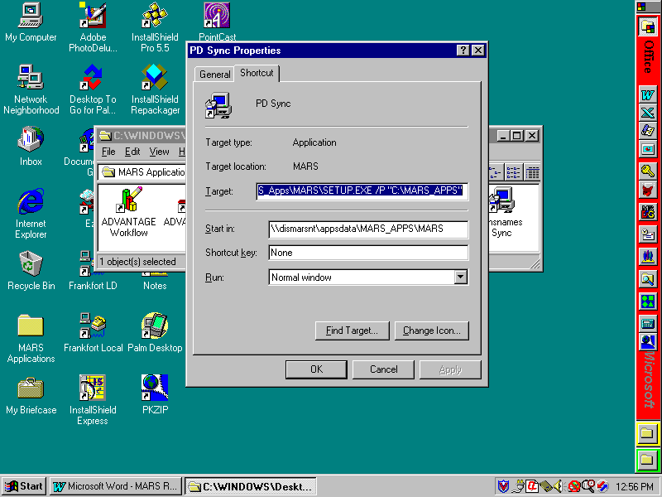

Make sure that the Target path is the correct location of the MARS Setup.exe file on the local agency synchronization server. If not, correct the problem. This could be caused if the MARS_APPS folder was relocated on the agency server. Also, if the Target path is correct, make sure that the Start in path is also correct. This should be the same path as in the Target path.

The synchronization icons are created when the MARS application is initially installed. The way that synchronization works is that the shortcut passes parameters to the MARS setup.exe program to tell which synchronization to do and provide the original installation path.

DLLs from Internet Explorer are required by Windows even if you are using Netscape or another Web browser.

