MARS
Release
Notes

MARS Release Number: 20020529

ADVANTAGE Version: 2.1.017
BRASS Version: 5.40.05.11
PD Version: 4.9.42

May 29, 2002

NOTE: This document is formatted for duplex reproduction, which is the Commonwealth of Kentucky standard. Blank pages are intentionally inserted throughout the document so that the document will reproduce correctly.

Table of Contents
Page
1 Introduction 5
1.1 Roadmap to Using the MARS Release Notes 5
1.2 Software Updated this Release 5
1.3 Release Schedule 6
1.4 Configuration Requirements 6
1.4.1 Agency Distribution Server 7
1.4.2 Client 8
1.5 MARS Confirmation IDs 8
1.6 Downloading the MARS Applications From the FTP Server 9
1.6.1 FTPing MARS Applications 9
1.6.2 FTPing MARS Common Contract Clauses 9
1.6.3 Web Access to the MARS Release Notes 10
1.7 Common Techniques 10
1.7.1 Locating Folders and Files 11
1.7.2 Copying a File 11
1.7.3 Copying the Contents of a Folder 11
1.7.4 Copying Folders 11
2 MARS Application Changes in This Release 13
2.1 ADVANTAGE 2000 Desktop 13
2.2 BRASS 13
2.3 Procurement Desktop 13
2.3.1 Corrections in This Release – 4.9.42 13
2.3.2 New for This Release – 4.9.40 13
2.3.3 Corrections in This Release - 4.9.40 22
3 Installing From an Agency Distribution Server 25
3.1 Setting up the Agency Distribution Server 26
3.1.1 Retrieving the Release Package from the MARS Central Distribution Server 26
3.1.1.1 Retrieving MARS Applications 26
3.1.1.2 Retrieving the MARS Release Notes [Optional] 27
3.1.1.3 Retrieving Document Direct [Optional] 27
3.1.1.4 Retrieving Internet Explorer Upgrades [Optional] 27
3.1.1.5 Retrieving Java Plug-Ins [Optional] 27
3.1.1.6 Retrieving Netscape Upgrades [Optional] 27
3.1.1.7 Retrieving Oracle [Optional] 27
3.1.1.8 Retrieving Seagate Info [Optional] 28
3.1.1.9 Retrieving WIN95 Upgrades [Optional] 28
3.1.1.10 Retrieving WIN98 Upgrades [Optional] 28
3.1.1.11 Retrieving WINNT Upgrades [Optional] 28
3.1.2 Copying the Release Package from the MARS Distribution CDs 29
3.1.2.1 Copying From the MARS Applications & Miscellaneous CD 29
3.1.2.1.1 Copying MARS Applications 29
3.1.2.1.2 Copying MARS Release Notes [Optional] 29
3.1.2.1.3 Copying Document Direct [Optional] 29
3.1.2.1.4 Copying Internet Explorer Upgrades [Optional] 29
3.1.2.1.5 Copying Java Plug-Ins [Optional] 29
3.1.2.1.6 Copying Netscape Upgrades [Optional] 29
3.1.2.1.7 Copying WIN95 Upgrades [Optional] 29
3.1.2.1.8 Copying WIN98 Upgrades [Optional] 29
3.1.2.1.9 Copying WINNT Upgrades [Optional] 30
3.1.2.2 Copying From the Oracle Client CD 30
3.1.2.3 Copying From the Seagate Info CD [Optional] 30
3.2 Installing Upgrades 30
3.2.1 Windows 95 30
3.2.2 Windows 98 31
3.2.3 Windows NT 31
3.2.4 Internet Explorer 31
3.2.5 Netscape 31
3.3 Installing the Supporting Software Environment 31
3.3.1 Installing Oracle 32
3.3.2 Installing Document Direct 35
3.3.3 Java Plug-Ins 37
3.3.4 Seagate Info 37
3.3.4.1 Normal Client Installation Instructions 39
3.3.4.2 Power User Installation Instructions 39
3.3.4.3 Finish Seagate Info Installation 40
3.3.4.4 Configuring ODBC Driver for Power Users 42
3.4 Installing MARS Applications 42
3.5 Synchronizing MARS Applications 47
3.5.1 Synchronizing ADVANTAGE Server 48
3.5.2 Synchronizing ADVANTAGE 48
3.5.3 Synchronizing BRASS 48
3.5.4 Synchronizing PD 48
3.5.5 Synchronizing Oracle Tnsnames 49
4 Installing Without an Agency Distribution Server 50
4.1 MARS CD ROM Distribution 50
4.1.1 CDs Distributed this Release 50
4.1.2 Current CDs Required for MARS 51
4.2 Installing Upgrades 51
4.2.1 Windows 95 51
4.2.2 Windows 98 51
4.2.3 Windows NT 51
4.2.4 Internet Explorer 51
4.2.5 Netscape 52
4.3 Installing the Supporting Software Environment 52
4.3.1 Installing Oracle 52
4.3.2 Installing Document Direct 56
4.3.3 Installing Java Plug-Ins 57
4.3.4 Installing Seagate Info 57
4.3.4.1 Normal Client Installation Instructions 59
4.3.4.2 Power User Installation Instructions 60
4.3.4.3 Finish Seagate Info Installation 60
4.4 Installing MARS Applications 62
4.5 Synchronizing MARS Applications 66
4.5.1 Synchronizing ADVANTAGE 66
4.5.2 Synchronizing BRASS 66
4.5.3 Synchronizing PD 67
4.5.4 Synchronizing Oracle Tnsnames 67
5 Troubleshooting Guide 68
5.1 ADVANTAGE Will Not Run 68
5.2 ADVANTAGE Connection Fails 69
5.3 ADVANTAGE Errors With a Reference to ND.DBG 70
5.4 BRASS Gives an Oracle Error Message on Startup 70
5.5 PD is not the Current Version 71
5.6 PD Gives an Oracle Error Message on Startup 71
5.7 PD Gives an Unique Constraint Message While Logging Into PD 71
5.8 PD Problems Validating or Routing Documents 72
5.9 PD HTTP Errors 72
5.10 Running Oracle Client from a Server 73
5.11 Running Oracle Net80 Client with Oracle 7.x Versions 73
5.12 Troubleshooting Oracle Connection Problems 73
5.13 Oracle Connection Problems in Novell Environments 74
5.14 Special Novell Considerations 75
5.15 MARS Setup.exe Program Error 76
5.16 One or More “Sync” Icons Will not Work 77

Introduction

This MARS Release Notes provides instructions for the installation and synchronization of the MARS applications for the following versions:

- ADVANTAGE Desktop 2.1.017
- BRASS 5.40.05.11
- PD 4.9.42

With the MARS Release 20011015, the operating system, Windows 2000, was approved and certified for MARS installation and support. The current release notes do not encompass details regarding Windows 2000. With the next release, specific information will be included in these notes.

These versions must be installed. All prior versions are not supported, may not operate properly, and could cause damage to the production database. Direct your questions about installing this release of MARS to the Customer Resource Center (CRC) Help Desk at:

1-877-973-HELP {1-877-973-4357} OR, 564-9641

Roadmap to Using the MARS Release Notes

- READ ALL OF CHAPTER 1 for information pertaining specifically to the software in this release and the schedule to which you must adhere for this release.
- IF YOU WANT TO KNOW WHAT HAS CHANGED SINCE THE LAST RELEASE: Refer to Chapter 2 beginning on page 13.
- IF YOU HAVE AN AGENCY DISTRIBUTION SERVER: After reading Chapter 1, use Chapter 3 beginning on page 25 for installation instructions. Follow the checklist of instructions exactly.
- IF YOU DO NOT HAVE AN AGENCY DISTRIBUTION SERVER: After reading Chapter 1, use Chapter 4 beginning on page 50 for installation instructions. Follow the checklist of instructions exactly.
- IF YOU HAVE PROBLEMS: Refer to Chapter 5 beginning on page 68 for troubleshooting information. If this does not resolve your problem, call the CRC Help Desk.

Software Updated this Release

The following table indicates if software has been updated in this release (e.g., will need to be downloaded and installed or synchronized):

Software Updated This Release
MARS Applications |  |  | Supporting Software |  |  | Supporting Software Upgrades
 | Download Checked Software |  |  | Download Checked Software |  |  | Download Checked Software
 | ADVANTAGE Desktop |  |  | Document Direct |  |  | Internet Explorer
 | BRASS |  |  | Java Plug-ins |  |  | Netscape
 | Procurement Desktop |  |  | Oracle |  |  | WIN95
 | Oracle Tnsnames |  |  | Seagate Info |  |  | WIN98
 |  |  |  |  |  |  | WINNT

Release Schedule

This release of MARS will go into production at 08:00 am Eastern Standard Time on 05/29/2002. Agency System Administrators must have all software installed and synchronized with the production system by that time. Following is the schedule for this release.

MARS Release Schedule
Activity/Task | Start Date | Finish Date | Responsible
- Load Release Package to central distribution server |  | 05/29/2002 | MARS Central
- Download Release Package to agency distribution server |  | 05/28/2002 | Agency
- Distribute Release Package to regional agency servers (optional) | 05/28/2002 | 05/28/2002 | Agency
- Review MARS Release Notes and plan software distribution for agency | 05/28/2002 | 05/28/2002 | Agency
- Dry run installation in test environment (optional) | 05/28/2002 | 05/28/2002 | Agency
- Install and/or synchronize software on clients | 05/29/2002 | 05/29/2002 | Agency
- Go live in production |  | 05/29/2002

WARNING: You can NOT go live PRIOR to the Go Live date AND you MUST go live with updated client software on the Go Live date. This is a coordinated effort statewide. You may install and synchronize software on client computers at any time in the schedule, but none of these computers can be used for MARS production until the Go Live date.

Configuration Requirements

Each MARS application for this release require that the following supporting software minimum versions be installed and be operational on each client computer:

MARS Configuration & Support Software - May 16, 2002
MARS Application | Support Software | Version(s)
ADVANTAGE | Document Direct | 2.1
BRASS | Oracle Client | 8.0.5, 8.1.6, 8.1.7
MRDB | Oracle Client | 8.0.5, 8.1.6, 8.1.7
 | Seagate Info | 7.5.2.0
Procurement Desktop Client | Oracle Client | 8.0.5, 8.1.6, 8.1.7
PD eProcurement (external) Web/  Internal Web Servers | Internet Explorer | 5.0 +
 | Netscape | 6.0 +
Supported MARS Client Platforms - May 16, 2002
Operating System | Notes
Windows 95 Clients | WIN95 Service Pack 1
Windows 98 Clients | N/A
Windows NT 4.0 Clients | WINNT Service Pack 4 (SP 3 is OK)
Windows 2000 | N/A
Windows XP | N/A

Agency Distribution Server

The agency distribution server will have a MARS_APPS folder with the following sub-folder structure for installing MARS applications (each application may also have additional sub-folders). If you do not have a MARS_APPS folder on your server, you must create one before conducting the installation steps in this MARS Release Notes. MARS requires approximately 123 MB on the server, excluding any other third-party software. Many of these folders are optional depending upon whether the administrator wishes to install third-party software from the agency distribution server or via some other media:

\\{local server name and path}\MARS_APPS
\ADVANTAGE
\Document Direct [Optional]
\Internet Explorer Upgrades [Optional]
\Java Activator [Optional]
\MARS
\MARS Release Notes [Optional]
\Netscape Upgrades [Optional]
\Oracle [Optional]
\Seagate Info [Optional]
\WIN95 Upgrades [Optional]
\WIN98 Upgrades [Optional]
\WINNT Upgrades [Optional]

NOTE: Total space required on the server for loading all of the above installation packages is 1.2 GB.

Client

The client computers will have a MARS_APPS folder with the following sub-folder structure for installing MARS applications, depending upon which applications are installed. MARS requires approximately 149 MB on the client computer for the full installation of all MARS applications, excluding any other third-party software. The MARS setup software will create these folders automatically:

{local drive letter – C drive is default}:MARS_APPS
\ADVANTAGE
\BRASS
\Oracle Tnsnames
\PD

MARS Confirmation IDs

A set of user IDs and passwords have been established as an aid to the agency system administrators to test if an installation has been completed properly. These IDs will not allow any activity within the applications, but will allow you to access the system and databases.

MARS Confirmation Ids
Application | User ID | Password
ADVANTAGE | finmars | advant12
BRASS | MAR | BRS
PD | MARS | PD
Seagate Info (Management Reporting Database) | MARS | <no password>

Ids and passwords are case sensitive. You should use all upper case for both the ID and password. For BRASS, select the Training database for testing your connection. The ID and password will only work in the Training and BudgetExec databases.

To log onto Seagate Info, select Programs from the Start menu and then select Seagate Info 7 and Info Desktop. At this point, the Connect to APS screen should be displayed. Seagate Info uses clustered servers; therefore, the correct method of logging onto Seagate Info is to address the cluster that will then connect you with the first available server. To do this, use the following setting on the Connect to APS screen:

User name: MARS
Password: <leave blank>
APS: kymarssa1

After the initial signon, you should use @MARS as the APS. The @MARS designates that you are logging onto the first available server in the MARS APS cluster.

NOTE: When logging onto ADVANTAGE for initial installations of a client computer, you will be requested to provide an email user id and password. Click Cancel to avoid changing email information on the client computer.

Downloading the MARS Applications From the FTP Server

The MARS project has established an FTP server from which the MARS Applications can be downloaded. This is an alternative to retrieving the package from the central distribution server for those Novell and remote users who do not have access to the kymarssi1 central distribution server. There are two files available on the FTP server:

- MARS Applications
- MARS Common Contract Clauses

FTPing MARS Applications

The MARS application FTP will download the standard set of MARS setup files that normally reside in the \\kymarssi1\mars_apps\MARS Setup\MARS folder or in the similar folder on the MARS Distribution CD. On the FTP server, these files have been compressed into a single self-extracting executable. When executed, the set of MARS setup files will be extracted and placed into the folder that you pick. Normally, this would be your MARS_APPS\MARS folder on your local server. The URL for the FTP is as follows:

ftp://www.state.ky.us/mars/MARS.exe

FTP or download this file to your local hard drive or server. Execute MARS.exe from wherever you stored it during the download to start the extraction process. The extraction will ask for the destination location for the MARS setup files. This should be your server MARS_APPS\MARS folder. You may place the files in a different location if you wish to stage them prior to setting up your server for a new release. If so, then before the go-live date, you must copy all of the files into the MARS_APPS\MARS folder on your server so that the client computers can sync to the latest version.

To install the MARS applications, refer to Chapters 3 or 4 as appropriate using the FTPed and extracted MARS setup files.

FTPing MARS Common Contract Clauses

NOTE: This option is intended ONLY for those agencies that do not have access to \\kymarssi1. If you elect to use this method, you MUST notify the MARS project so that you can be added to the email list to notify you when changes are made.

The MARS common contract terms, conditions, specifications, and clauses FTP will download the standard set of MARS common contract clauses that normally reside in the \\kymarssi1\mars_apps\MARS Setup\PD folder and subsequent sub-folders. These files are not distributed via normal distribution, but are maintained centrally and pointed to by the PD database for all PD users statewide. However, if your agency can not map the Q drive to the \\kymarssi1\mars_apps share, then you will need to install these clauses on your local server and map the Q drive to point to this local location for all of your PD users.

On the FTP server, these files have been compressed into a single self-extracting executable. When executed, the set of MARS standard contract clauses will be extracted and placed into the folder that you pick. Normally, this would be your MARS_APPS folder on your local server, but can be located anywhere on your server to which you can map the Q drive. The URL for the FTP is as follows:

ftp://www.state.ky.us/mars/MARSContractsClauses.exe

FTP or download this file to your local hard drive or server. Execute MARSContractsClauses.exe from wherever you stored it during the download to start the extraction process. The extraction will ask for the destination location for the MARS contract clauses. This will typically be your server MARS_APPS folder.

NOTE: Standard contract clauses are maintained centrally by Purchasing and must not be changed without authorization. If you load these clauses onto your local server, then you must protect them from being altered by your end-users. Place these files into a location where MARS users have READ-ONLY access privileges and can not alter these files.

PD points to the common contract clauses through a centralize setting in the PD database. The assumption is that each PD user has the Q drive mapped to point to this location. If for some reason your organization can not use the Q drive, then you will have to modify the PD Desktop.ini file to point to your new location. The following sections in the MARS_APPS\PD\Desktop.ini file will have to be updated on each client computer:

[Reference_Bookshelf]
Bookname_URL=<your drive location>\MARS Setup\PD\Book_images\HTML\Ref_main.htm

[RTF_Lctn]
Basedir_RTF=<your drive location>\MARS Setup\PD\RTF_clauses

Where “<your drive location>” is the mapped destination location you gave when requested by the self-extract program. Please note that URL designation is not allowed here, it must be a drive letter.

Web Access to the MARS Release Notes

The current MARS Release Notes can be obtain from the MARS web site at the following URL:

http://www.state.ky.us/agencies/adm/mars/mars.htm

Go to this URL and scan downward under Planning Documents until you see the index for MARS Release Notes. Click on this index and Word will be launched with the latest MARS Release Notes. You can then print them locally.

Common Techniques

This section provides instructions for performing common techniques used throughout the installation. If you are a proficient Windows user and are familiar with using the File Explorer, then you will not have to read this section. If you are not fully comfortable with using Windows utilities, then this section covers the common techniques used and referenced throughout the remainder of this document. All of these techniques are performed using the Windows File Explorer.

Locating Folders and Files

Using the Windows File Explorer, in the left-hand pane, click on the plus sign beside a folder name to expand the folder and show sub-folders. Continue this until the desired folder has been found. For example, if you were instructed to copy the file ABC from C:\A\B\C, then you would expand the C: drive, expand the A folder, expand the B sub-folder, and click on the C folder. In the right-hand pane, a list of folders and files will appear. The file ABC will be listed in the right-hand pane.

Copying a File

Throughout the instructions, you will be asked to copy a file from one location to another. To copy a file, use the Windows File Explorer. In the left-hand pane, click on the plus sign beside a folder name to expand the folder and show sub-folders. Continue this until the folder that contains the file has been reached. In the right-hand pane, right click on the desired file and select Copy from the menu. Expand the folders and sub-folders again to locate the folder to which the file is to be copied. Right click on this folder and select Paste from the menu. This completes the file copy.

Copying the Contents of a Folder

In the instructions, you may be requested to copy the contents of a folder. This process is similar to copying individual files except you will be copying a group of files or all of the files within a folder. As above, expand folders to locate the desired folder. In the right pane, click on the first file in the folder. Scroll down to the last file in the folder and, while holding down the shift key, click on the last file in the folder. At this point, all files in the folder should be highlighted. Right click on any of the highlighted files and select Copy from the menu. Locate the target folder to where these files are to be copied. Right click on this folder and select Paste from the menu. This completes the folder content copy.

Copying Folders

You may be requested to copy a folder. This is similar to copying the contents of a folder except the whole folder is to be regenerated in a different location. Expand folders until the desired folder is located. In the left pane, right click on the folder and select Copy from the menu. Locate the folder under which this folder is to be copied. Right click on that folder and select Paste from the menu. The copied folder and its contents will become a sub-folder to this folder at this time.

MARS Application Changes in This Release

This chapter addresses the defects fixed and new enhancements provided in this release for each of the MARS applications.

ADVANTAGE 2000 Desktop

ADVANTAGE 2000 Desktop was not upgraded for this release.

BRASS

BRASS was not upgraded for this release and does not require synchronization.

Procurement Desktop

PD was upgraded for this release and does require synchronization. The following sections outline any new features and corrections made to the PD software for this release.

Corrections in This Release – 4.9.42

Corrections in this Release
Number | Problem Description
 | System Administration - PCard. Search by card number.
 | System Administration - Prod/Svcs. Adding new code on the detail tab.
 | Invoice Modifications. Approval/Release.
 | Print and Print Preview of Miscellaneous Quick Pay documents with vendor information.
 | Find Match of Invoices from a Master Agreement document. If the Master Agreement has been marked All for Authorized Agencies. Ensure that any buyer, regardless of what agencies (buying entities) they belong to, can create a find match Invoice off the Master Agreement in question.
 | Creating Invoices off Contracts/Contract modifications (with and without using a Receiver) has been reverted back to the original functionality found in 4.8.

PD was upgraded for this release and does require synchronization. The following sections outline any new features and corrections made to the PD software for this release.

New for This Release – 4.9.40

New for this Release
Number | Enhancement Description
11917, 12008, 12253, 17359, 12169, 12921, 12922, 12923, 12925, 12926, 12942, 13113, 13349, 13589, 16939, 17010, 17011, 17012, 17013, 17015, 17017, 17018, 17019, 17020, 17021, 17022, 17023, 17036, 17037, 17038, 17039, 17040, 17041, 17042, 17043, 17046, 17068, 17081, 17095, 17131, 17148, 17195, 17225, 17275, 17403. | What’s new in PD 4.9:  PD Catalog  ENH 300, 305, 306, 307, 309, 311, 366  Catalog Master Agreements (CMA) in PD  Catalog lines, previously stored in Requisite, are available for catalog searches in 4.9.  NOTE: The catalog lines imported from Requisite will have a blank commodity code. Upon being added to a Market Basket the user has to update the commodity code to a valid one before being able to generate the Market Basket.  In time, the buyers can create modification documents for the Catalog Master Agreements with the Requisite lines, update the commodity code on each line and release the Catalog Master Agreements mod. At this point, these lines will become available for catalog searches and when added to a Market Basket there is no need to update the commodity code anymore.  It should also be noted that all the existing released Solicitations that are still open have had the “SOLTODOC” process run, therefore viewing these Solicitations on the Web will not show commodity category on the MS Word document.
Market Basket:

When clicking on the Add to Basket button on the Catalog Line Item Search page, the line items chosen are transferred to the Market Basket document. This becomes visible when the Return To Market Basket button is clicked and the Catalog Line Item Search page is closed.

Upon adding stand alone lines to a Market Basket the following information is not defaulted; Supplier, Sup. Part Number and Catalog MA No., on the Description Line Item Detail tab.
Catalog Search:

A catalog search may now be performed within the PD application.

Sorting functionality is available on the Catalog Line Item Search page. By clicking on a column header once, the displayed results will be sorted in ascending order of that column’s values. Clicking on the same column header again sorts the displayed results in descending order of that column’s values. A tiny arrow on the column header indicates the sorting order of that column’s data.

Only the current, active, released and un-expired Catalog Master Agreement (Modification) documents are available for searching on the Catalog Line Item Search page.

The Catalog Line Item Search functionality enables buyers to search for all lines of specific catalogues using ‘C-12345678’ or all lines in all catalogs using ‘C-‘. Additionally a buyer can search based on description and supplier part number.
Catalog Master Agreement Display / Main Tab Changes:

Information on the Catalog Master Agreement (Modification) Lines Summary Tab and the Catalog Master Agreement (Modification) Line Item Detail Tab is displayed in a clean and crisp manner. This includes the values being displayed in their full length.

The layout of the Master Agreement (Modification) document and the Catalog Master Agreement (Modification) document are synchronized to enhance the ease of the use of the application.

The Effective Date, Expiration Date, Vendor and Authorized Agencies displays are populated once the Catalog Master Agreement (Modification) document is opened or created.

Catalog Master Agreement (Modification) document no longer has an Extended Description Tab or a Catalog Tab. These tabs were removed since the information displayed on them was redundant. Extended description information is now available at the line item level.

Only cited authorities that the current user has access to, are listed in the Cited Authority field of a document.
Catalog Master Agreement - Main Tab Renewal Periods:

The default number of “renewal periods” has been changed from 5 to 4 on the main tab of Catalog Master Agreements (Modifications).
Catalog Master Agreement Line Item Menu:

The “Lines” menu has been modified to remove the “Default Lines” and the “Attach Lines” options for Catalog Master Agreements (Modification),
Catalog Master Agreement – Line Item Pictures:

Pictures can be attached to individual line items for Catalog Master Agreements (Modifications). The pictures must be one of three file formats: .jpg, .jpeg or .gif. On the Line Item Tab there are two buttons associated with pictures. The first button will be labeled either “Add” if there is no picture attached to this line item, or “Delete” if there is a picture. The second button is “View”, which allows the user to view the picture associated with the line item. NOTE: This second button will be disabled if there is no picture.
Catalog Master Agreement – Performance:

Changes were made to improve the performance when saving a Catalog Master Agreement document that has extended description text.
Catalog Master Agreement - Line Item Filtering:

On the Catalog Master Agreement (Modification) documents, the Lines Tab allows filtering the line item summaries based on either the Supplier Part Number or the Description. When users filter the lines, the Lines Menu functionality will be disabled.
Additional changes:
- Searching of line items will be permitted by both supplier part number and by description.
- A reset button will remove the filter, displaying all the line items and clear the search criteria entered by the user.
Catalog Master Agreement - Line Import / Export:

From the Catalog Master Agreement (CMA) document, the buyer can click on the “Export” button to create an Excel spreadsheet to send to the vendor. Once the Excel spreadsheet has been returned, the buyer clicks the “Import” button on the CMA to import the additional information. Instead of using the export/import functionality the buyer also has the option of entering lines manually on the CMA.
Catalog Master Agreement Line Validation:

On the Catalog Master Agreement (CMA) or the CMA modification (CMM) Lines Summary tab page, there is a Validate button, which when pressed will cycle through each line checking specific fields for valid values as shown in the table below:

Field
Validation

Supplier Part Number
Can't be null, or blank, and must be unique within the CMA (Max – 35 Characters)

Description
Can't be null or blank (Max – 100 Characters – NO SPECIAL CHARACTERS)

Delivery Days
Can't be null or blank, or a negative number (NOTE: 0 (Zero) is acceptable)

Commodity Code
Can't be null or blank, or invalid (Max – 11 digits)

Unit of Issue (Unit of Measure)
Can't be null or 0 (Zero)

Unit Price
Can't be null (0 and negative IS allowed)

An error message will appear if any errors are detected. A User is not required to press this button but they can do so to check if the lines they have entered are correct, especially if they have entered a large number of lines, prior to attempting to release a CMA/CMM. This same validation occurs when attempting to release a CMA or when choosing the Validate menu option. In order to perform the validation, the CMA/CMM must first be saved, just as is the case when Importing or Exporting lines to a CMA/CMM.
Attaching Catalog Lines to a Catalog Delivery Order:

Catalog lines can be added to a Catalog Delivery Order (CDO). To complete this task follow these steps:
- Open a CDO and click the Lines tab
- Select Lines → Attach… from the menu
- This will trigger the Catalog Line Item Search window to open and display filtered search results based on the CMA number (C-XXXXXXXX) that CDO was created from.
- The User can search through the displayed lines, select lines as necessary and click the Add to CDO button
- When the User clicks the Return to CDO button any newly added lines will now appear along with any existing lines on the CDO
Catalog Master Agreement from Bid Evaluation:

A Catalog Master Agreement (CMA) is created off a Bid Evaluation and not a Solicitation. In addition, a CMA cannot be created from a Bid Evaluation (BVL) through the Procurement menu option. With the CMA export button removed from the BVL main tab, a User must instead follow these steps to create a CMA off a BVL:

- Open an issued BVL
- On the Main tab click the Award button
- Choose Catalog Master Agreement from the Line Item Selection Award Type dropdown list.
- Move any lines from the Source box to the Award box by highlighting lines and clicking the appropriate arrow.
- Click the OK button

The CMA will be created. The Information appearing on the Main tab of the CMA as well as line item information will be copied over directly from the BVL or Bid Evaluation modification (BVM).

A User may not be able to create a CMA off a BVL because they do not have the appropriate security privileges. If this problem occurs, they should contact their System Administrator.
Catalog Master Agreement from Purchase Request:

The ability to create a Catalog Master Agreement from a Purchase Request (PR), once the PR has been approved and released has been added.
Invoice from Catalog Master Agreements not allowed:

Invoices and Payment Authorizations cannot be created from a Catalog Master Agreement (Modification.
Catalog Master Agreement Copy From:

"Copy From" (from the file menu) was adapted for the new lines tab on Catalog Master Agreement (Modificdation) documents.
Catalog Master Agreement Printing:

The buyer now has three different printable reports for Catalog Master Agreements (Modifications):
- A report showing only the header information
- A report showing the header and all line information
- A report showing only the lines that have been modified or deleted

When the buyer is about to print a large Catalog Master Agreements they will be notified regarding the number of lines contained within the report , and asked if they want to continue.
Catalog Master Agreement - Approval through menu:

In PD, users can now use the menu option Procurement -> Pre Award/Award -> Award -> Release Award for Catalog Master Agreements. This works the same as the checkbox on the toolbar, and keeps functionality consistent with other types of awards. Similarly for Catalog Master Agreement Modifications, the menu option Post Award -> Process Modification -> Release is available.

Successful validation message:
Similar to other types of awards, the user can now Validate a Catalog Master Agreement (Modification) through the appropriate menu options and receive a useful message if the validation was successful.
Catalog Master Agreement - Saving of Commodity Code:

A Commodity Code is now required for each line item that is included in a Catalog Master Agreement (CMA) or CMA modification (CMM). This information will be saved along with the other data for each line item. To add a Commodity Code for a line item follow these steps:
- Open a CMA or CMM and click Lines tab
- Double-click on a line which will open it in Line Item Details
- Click either the 5 or 11 digit radio button in the Code Length area
- Type in a number string in the Commodity Code Field or alphanumeric string in the Description Field
- Click Search button
- Choose one Commodity Code from the list provided
The Commodity Code area in Line Item Details will be populated with the code selected by the User
Catalog Master Agreement Modification - Implementation:

Catalog Master Agreement Modification (CMM) can now be created from a Catalog Master Agreement (CMA). Only one draft CMM can exist from a CMA. Once it is released, a new CMM can be created off the original CMA. When a CMM is created:
- Information from the main tab of the CMA will be placed in the “PRIOR” tab on a CMM and is read-only
- All line item information will be copied over from the CMA to the CMM including: Supplier Part Number, Picture, NIGP code and other line item details. This data can be changed for each line item as necessary.
Delivery Days/Date:

The display of a ‘delivery date’ value has been changed to ‘delivery days’ on the Bid Evaluation (Modification), Master Agreement (Modification) and Catalog Master Agreement (Modification) documents. The validation of these documents was modified accordingly.

When creating a document off another one with the document displaying different delivery values – date/days – the new document’s field is displayed empty.
Catalog Master Agreement - Supporting Multiple Vendors:

All locations for a particular vendor can be added on the Catalog Master Agreement (Modification) document’s Authorized Vendors window as authorized vendors. The Catalog Delivery Order document created from the Market Basket document displays the vendor from the Catalog Master Agreement document. The user then has the ability to change the vendor on the Catalog Delivery Order document to a different location – one from the list of authorized vendors entered on the Catalog Master Agreement document.
Catalog Master Agreement Modification – Deleting a Vendor:

The vendor can be deleted on the Catalog Master Agreement (Modification) document and the Master Agreement (Modification) document using the Delete button.
17275, 17403, 13589 | Reports:  The "MA Usage" Report has been corrected to display accurate numbers.  The "Master Agreement / Contract Activity" and the "Master Agreement / Contract Expiration" Reports have been updated to ensure they can be generated for a Catalog Master Agreement document.
17171, 17314, 17358, 17383, 17337 | Tolerances:  There have been significant changes to the ‘over tolerance limits’ to include more document chains. Over Tolerance Limits will now be enforced for Delivery Orders, Catalog Delivery Orders and their modifications. In addition, tolerance limits will now be enforced on Invoices and Payment Authorizations created off Master Agreements regardless of the Master Agreement sub type. As well, tolerance limits will now be enforced on Invoices created off Payment Authorizations directly. In addition, invoice documents that were generated from a Market Basket now enforce tolerance correctly. Tolerance checks are now performed correctly on Invoice documents when a line item has a negative unit price value.  There are additional restrictive rules for enforcing tolerance limits for Delivery Orders and Catalog Delivery Orders (and their modifications) that take into account the originating Master Agreement, or Catalog Master Agreement’s tolerance limits.  Changes have been made to the read-only status of the tolerance limit fields on the pricing tab, depending on the type of document and its subtype.  Changes have been made to restrict the user from switching a line item from a Unit Price/Quantity line to a Miscellaneous Cost line, depending on the type of document, and the originating document.  Changes have been made to the tolerance error messages to be more consistent and informative.  The ability to use the “Global Change” button on the pricing tab to modify tolerance values has been removed.  Tolerance checks will not be enforced when editing unsaved Delivery Orders and Catalog Delivery Orders (and their modifications). However, tolerances will be enforced when these documents are being released.
17063, 17161, 17242, 12984, 12061, 16961, 13580, 12984, 16961, 13663, 12000, 11961, 16943, 13662, 17380 | ENH 287:  The Vendor Request Form (VRF), the Vendor Request Modification (VRM) , the Vendor Information/Maintenance Window and the Employee Maintenance Window have been reformatted. Changes are:  - Vendor Code is no longer editable. It is built using the Tax Identification Number (or Social Security Number) and the short code. For “International / Non-profit” vendors, the vendor code is system generated.  - Once released, the VRF / VRM document will disappear from the desktop.  - The VRF/VRM release process has been modified to transmit the vendor’s data to Advantage directly during the approval.  - The VRF/VRM documents have been changed so that multiple contacts are allowed, with one being marked as the primary contact.  - The Vendor Information/Maintenance Window has been modified to allow for one bank account only.  - The “Pending Vendor Report” has been replaced by the “Web Vendor Requests” report. This new report contains the list of all requests made by the Vendors thru the EP Web site. From that report, you can view (and edit if it’s a new vendor), release or deny a request. Once a Web request has been released or denied, notification e-mail will be sent to the vendor (if an e-mail address was provided).  - Vendors now have an “Authentication Code” to be used when login in the EP Web Site and a “Bid Authorization Code” to be used when submitting formal online bid response. These codes can be reset with the new buttons on the Vendor Maintenance Window. The vendors themselves can also change them thru the EP Web site.  - New fields have been added in the database to keep track of the user ids of the persons who made a changed to vendor’s data. The timestamp is also added.  - On the VRF/VRM document, the following fields have been added:  - Remit-To Address  - E-mail  - Commodity Categories  - Discount Terms  - On the Vendor Information/Maintenance Window, the following fields have been removed:  - Tax Exemption Code  - Merchant ID  - County  - Duns Code  - Establishment Code  - Business Form Code  - Shipping Payment Method  - Geographic Region  - Address Type  - In the “Account Type” drop down list, a blank option has been added, in case user wants to go from EFT type to Check type.
17254 | EP - Browse Bid Opportunities:  On the EP website, users now search for Bid Opportunities by Issuing Office, instead of by Cabinets. The retrieval times and the filtering capabilities have been drastically improved. Some information for inactive or cancelled solicitations is no longer displayed.
EP - Browse Bid Opportunities Commodity Categories:

In addition to being able to search by Issuing Office, users on the EP website can also search Bid Opportunities by Commodity Category. The Commodity Category is now a mandatory field that the buyer must set in PD at the Solicitation document level before releasing it.
EP - Catalog Search:

On the EP Website, users can now search for line item information on all released, active Catalog Master Agreements. The ability to sort results by any column has been added.
EP - Online Bidding:

On the EP Website, registered vendors are able to submit a bid for a released, active solicitation. As well, they are able to make modifications to their bid up until the closing date and time of that solicitation. Bid responses are now multi-page forms. Online bid responses can be "saved as draft" or "formally submitted"; only the latter will be loaded by the Bid Evaluation's "internet load" button.

Vendors are able to add up to 4 files as attachments to their bid response, each up to 4 Mb in size.
EP - Online Bidding - Standard Bid Evaluation:

Bid evaluations in PD have been modified to show the Bid Response contact information on the main tab page, as well the Internet Load button now retrieves the bid responses submitted against all the versions of the selected solicitation.

In addition, documents attached to the Bid Response can now be opened and viewed directly from PD (without having to be saved to the computer first).
EP - General Website:

Users accessing the EP Website need to have “cookies” and “javascript” enabled. If they do not, then they will experience significant problems, especially with vendor information and on-line bidding. A warning message will appear to those users who do not have cookies enabled.

Users accessing the EP Website to register as a new vendor, update their existing vendor information, or creating an on-line bid response require Microsoft Internet Explorer 5.0 (or higher) or Netscape Navigator 6.1 (or higher). An error message will appear to those users who do not meet this requirement and will be unable to access those areas.
12984, 13579, 16961, 17242, 17162 | EP - Vendor Information:  Significant changes have been made to the layout and process flow for a vendor to register on the EP Website. There is now only one page that the vendor must complete to register, and similarly, only one page to complete if a vendor wishes to change their information. . A new component, Commodity Category, allows vendors to associate their records with specific commodity categories; when a solicitation is released, all vendors matching that commodity category will be sent an email alerting them to a potential bid opportunity.  Vendors are now able to register and respond on line on a 24/7 basis.
16794, 17013, 17120, 17139, 17160, 17206 | EP - View Awards:  On the EP Website, the View Awards section has been improved with added sorting, and the retrievals are faster. The data is refreshed every 6 hours. Vendors are informed on the View Awards results page that the refreshes happen at noon and 6 pm daily. (as well as 6 a.m. and midnight)
16880, 16842, 13648 | Optimized Bid Evaluation:  The new alternative Bid Evaluation object is optimized to minimize processing utilization and resource allocation requirements. In order to achieve this, the new object supports a subset of the most important functional features of the current Bid Evaluation object. The optimized bid evaluation can accept online bids with vendor attachments and add and delete lines. It also supports the “formula one” (detailed evaluation) spreadsheet; Freight Charges; the Evaluate functionality and displays key lines detail information. NOTE: Optimized Bid Eval. is intended to be used for large bid evaluations that contain many lines or multiple vendors. Since it is much quicker than the original bid evaluation it can also be used for simple bid evaluations. It is also compatible with the standard bid evaluation. It is possible to switch to the standard bid evaluation if a user needs the extra functionality.  Users are able to set their account preference in order to default opening Bid Evaluation documents using the Standard Bid Evaluation, the Optimized Bid Evaluation or being prompted each time.
Bid Evaluation - Save of Extended Description:

When creating a Bid Evaluation from a Solicitation document, and adding (or changing) the extended description, the additional marking text, the hazardous material text, the tagging instructions and the packaging instructions are now saving for all line items.
17009 | ENH344:  Approval Template Maintenance task has a new Groups tab. The Approval Creation window logic is updated to reflect this change. The delete functionality is also updated in Group Maintenance task to reflect this change.  Users do not have access to all approval templates, only the ones that they were specifically granted access to.
17095 | ENH300:  The “Delivery days” values are displayed on Bid Evaluation/Bid Evaluation Mod, Master Agreements/Master Agreement Mod and Catalog Master Agreements/Catalog Master Agreement Mod documents. When creating a document off another one with the document displaying different delivery values – date/days – the new document’s field is displayed empty.
17165 | ENH351:  The Routing Templates can now be filtered based upon the Approval Template selected when attaching an Approval Sheet.

Corrections in This Release - 4.9.40

Corrections in this Release
Number | Problem Description
1183 | Fix delivery order as the catalog delivery order was fixed with an indicator that shows which lines came from a Master Agreement and if any are added the user can not check the checkbox for the reference to the MA.
3215 | When establishing the funding amount per funding strip the miscellaneous amount is also taken into account where applicable. Also funding information for the source line is now shown after completing a global change of funding.
12253 | The Market Basket document no longer saves automatically. If we answer “No” to the question “Would you like to save?”, the document will not be saved.
12264 | In System Administration, User Task. Upon selecting search by last name the user_id list will be sorted by last name then first name. Upon selecting search by first name the user_id list will be sorted by first name then last name.  When entering a character for the First Name or Last Name search, the user can proceed to the actual search without problems.
12515, HD002173 | Printing more than one copy at a time now works for the  Miscellaneous Quick Payment documents and Contract Modification documents.
12946 | New rules have been made for working with Team Cabinets:  1) You cannot drag/drop a document from a folder in which you are not the owner and it is not a team cabinet.  2) You cannot Delete or Cancel a document in a Team Cabinet.
13162, 13201 | When generating a Market Basket, a redundant question was removed and the hourglass was added while the document is being generated.
13175, 13187 | The appropriate extended description button name is now set for both the Market Basket and the Solicitation Modification documents.
13182 | Global Change Button is disabled on the Cradle to Grave Report if the document is opened read only.
13322 | The Route Template order will always be kept for actual routing.
13354 | The “Pending Receipt” report results are now sorted by “Expected Rcpt Date” and “Award Line” (Document Number and Line code).
13382 | The correct value is now displayed as the vendor number on awards, payments and the Address tab of Vendor Maintenance and Vendor Update documents. Some documents were amended so the field is now populated when a new vendor is selected from the Vendor Search window.
13522 | The search functionality as been modified so that when creating a Delivery Order document, the search can also be done by Document Title and Issuing Office.
13598 | An error message is no longer appearing when we try to delete a funding strip on a MA that was generated from a Purchase Request->Solicitation->Bid Evaluation->Master Agreement chain.
13667 | Invoice documents generated from a Market Basket document have a reference to the Catalog Master Agreement that was listed on the Market Basket document.
16794 | EP Web site - View Awards section:  Awards are only listed if a Bid Evaluation document was created off the Solicitation document. (Awards are displayed in the results list for a specified amount of time. The View Awards functionality now displays all awards regardless of cabinet/division or issuing office. No delivery orders or award modification documents are displayed to the user. Open but not yet awarded solicitations are not listed, instead an appropriate message is displayed.)
16800,  HD004862 | A user who is on a routing sheet puts a document into the team cabinet; then someone else goes, pulls it out and modifies it; then routes it. It is routed correctly. The person the document is routed to can also route it and it routes correctly.
16996 | A Market Basket document no longer needs funding information for the approval process.
17084 | When a document is released, copied or modified, its last updated timestamp value reflects the current server time and not the machine time.
17088 | The MA/Contract Expiration Report no longer displays Cancelled contracts.
17092 | Updating Pcards with 16 digits Pcard numbers no longer results in an error message.
17105 | Can only receive against a document through Find Match in PD if the user has access to this document.
17107, 16801 | Can only invoice against a document through Find Match in PD if the user has access to this document.
17135 | “Invoice Address Type” is now the only address type that can be selected in the Invoice address search window.
17145 | It is no longer possible to release a Bid Evaluation document if it was created off a Solicitation document for which the closing date and time hasn’t passed yet.
17201, 17400 | The appropriate name (Add or Open) is now set for the “Extended Description” button on the Master Agreement Mod, the Contract Mod and the Bid Eval documents.  The "Open" button is no longer disabled on the Master Agreement Mod document when there is text in the extended description field.  The extended description field can now contain 4,000 characters instead of 3,500.
17252 | For the following document type, it is no longer possible to create a second modification document if there is already a draft modification document:  - Payment Authorization  - Invoice  - Purchase Request  - Solicitation  - Bid Evaluation  - Catalog Master Agreement.
17271 | When a user selects the approval template and attaches to their document, the order of the approvals is correct (The order on the routing sheet is the same as on the approval sheet).
17369 | If the associated Master Agreement document is active and not expired, the Delivery Order documents will now approve successfully even when there is another Master Agreement expired (or cancelled) created off the same Solicitation document.
17385 | Validating a Catalog Delivery Order created from a catalog that had more than 1000 Catalog Delivery Orders off it is done correctly without errors.
17387 | When creating a Delivery Order from a Master Agreement, PD no longer Shuts down when we hit Cancel on the line selection window.
17389 | If the net result of an invoice is $0.00, only the negative line referencing the contract is counted toward the Master Agreement ceiling to restore the availability of funds.
17413 | Enter key to cancel Find Match on an Invoice document works correctly.
17438 | Master Agreement Modification document is created and processed correctly.
17453 | When an invoice is generated from a Payment Authorization, the invoice no longer shows twice on the “Cradle to Grave” report.
17458 | The supplier part number will now show up on the Catalog Delivery Order and Catalog Delivery Order Modification documents.
UAT Issues | Issues found during User Acceptance Testing
UAT 10 | The groups selected into the Selected box on the Route tab of the Route System Administration task are now listed in ascending order.
UAT 15 | Searching for a Master Agreement document when creating a Delivery Order document, searching by Issuing Office or Month Issued are both performed correctly. Also, the date and list of organizations are shown correctly in the search criteria.
UAT 46 | Upon the validation and approval of an invoice, the existence of a buying entity is checked. If none chosen, an appropriate error message is displayed and the process is not concluded.
UAT 56 | Lines of a Solicitation Modification document cannot be deleted if they existed on the source document. This is true for a line deletion attempted using the button or the menu functionality. In such a case the user is advised of this fact.
UAT 61 | A message was added to remind users to check for online bids before they approve a Bid Evaluation, if the solicitation has the “electronic bids permitted” checkbox checked. They have the option to ignore the message and continue with the approval or they can cancel the approval process and then return to the Bid Evaluation to check for online bids
UAT 78 | Upon the validation and approval of an invoice, the existence of a cited authority is checked. If none chosen, an appropriate error message is displayed and the process is not concluded.
UAT 86 | The Vendor Code is now being displayed on the main tab of the Bid Evaluation document.
UAT 92 | When a Payment Authorization document is approved, the Recurring Payment information remains intact (The number of payments does not increase).
UAT 93 | When an Invoice document is generated off a Payment Authorization document that was created off a Contract document, the partial pay flag is carried along the document chain.
UAT 94 | Deletion of an invoice no longer deletes corresponding Invoice and Payment documents.
OTHER | On the Lines tab of Catalog Master Agreement (and its modification), the “Default lines” menu option is grayed out in an un-checked state.
OTHER | On Invoices, beside the Terms button the field now reads "Payment Terms" like every other PD document.

Installing From an Agency Distribution Server

This chapter is for those agencies that have an agency distribution server to be used for installing the MARS applications. If your agency or site does not have access to a local agency distribution server and/or you have received MARS CDs for installation, you should skip to Chapter 4. If you are setting up your agency distribution server for installing client computers, the following instructions tell you how to:

- Retrieve the MARS release package from the central distribution server, and;
- Install MARS, or;
- Synchronize MARS.

The following table provides a guideline to the instructions for installing and synchronizing the distributed software.

If you are… | Then, follow these instructions…
Setting up the agency distribution server for distribution, DO ONE OF THE FOLLOWING…
Retrieve the release package from the MARS Central Distribution server. | Go to Section 3.1.1.
OR…Copy the release package from the MARS distribution CDs. | Go to Section 3.1.2.
Performing initial installs or installing new computers…
Retrieve the release package using one of the methods above. | See Setting up the agency distribution server for distribution above.
Install upgrades. | Go to Section 3.2.
Install the supporting software environment. | Go to Section .
Install the MARS applications. | Go to Section 3.4
Performing synchronization after initial installations…
Retrieve the release package using one of the methods above. | See Setting up the agency distribution server for distribution above.
Install upgrades if required by the particular release. | Go to Section 3.2, if required.
Synchronize client computers with ADVANTAGE and Setup.exe installed on the computer. | Go to Section 3.5.

Setting up the Agency Distribution Server

This section discusses how to load the distribution software to the agency distribution server so that client computer can be installed from the agency distribution server. There are two methods: download the release package from the MARS central distribution server; or, copy the release package from the MARS Distribution CDs onto your distribution server.

Retrieving the Release Package from the MARS Central Distribution Server

These instructions are for retrieving the MARS Release Package from the central distribution server. If you have received the MARS Distribution CDs and wish to set up your agency distribution server using those CDs, then skip this section and go to section 3.1.2, Copying the Release Package from the MARS Distribution CDs.

Most supporting software will not be updated for each release. Instructions are provided for retrieving the whole MARS release package in case the agency must rebuild or create a new agency distribution server. The table provided in section 1.2 indicates if software has been updated for this release. To ensure that all steps are completed in the proper sequence, it is recommended that the check box to the left of each instruction be checked as the step is completed successfully. Please perform the following steps:
- Log onto the network and locate the \\kymarssi1\Mars_apps folder. The \\kymarssi1 server can be located by using the File Explorer, double clicking on Network Neighborhood, double clicking on Entire Network, and expanding kyeantd. It might facilitate installation to map a drive letter to the \\kymarssi1\Mars_apps folder.

Retrieving MARS Applications

NOTE: If you are retrieving the new release for setup prior to the go-live date, then you should get it from the \\kymarssi1\Mars_apps\MARS Setup\New Release xxxxx\MARS folder, where “xxxxx” is the new release number. After the go-live date, you should retrieve the package from \\kymarssi1\Mars_apps\MARS Setup\MARS since the New Release folder is deleted once the system goes live.
- To copy the MARS setup software to your local server, copy the \\kymarssi1\Mars_apps\MARS Setup\New Release\MARS folder to your local server, MARS_APPS folder.

Retrieving the MARS Release Notes [Optional]

NOTE: If you are retrieving the new release MARS Release Notes prior to the go-live date, then you should get it from the \\kymarssi1\Mars_apps\MARS Setup\New Release xxxxx\MARS Release Notes folder, where “xxxxx” is the new release number. After the go-live date, you should retrieve the package from \\kymarssi1\Mars_apps\MARS Setup\MARS Release Notes.

- To copy the MARS setup software to your local server, copy the \\kymarssi1\Mars_apps\MARS Setup\New Release\MARS Release Notes folder to your local server, MARS_APPS folder.

Retrieving Document Direct [Optional]
- Copy the \\kymarssi1\Mars_apps\MARS Setup \Document Direct folder to your local server, MARS_APPS folder.

Retrieving Internet Explorer Upgrades [Optional]
- Copy the \\kymarssi1\Mars_apps\MARS Setup \Internet Explorer Upgrades folder to your local server, MARS_APPS folder.

Retrieving Java Plug-Ins [Optional]
- Copy the \\kymarssi1\Mars_apps\MARS Setup \Java Activator folder to your local server, MARS_APPS folder.

Retrieving Netscape Upgrades [Optional]
- Coyp the \\kymarssi1\Mars_apps\MARS Setup \Netscape Upgrades folder to your local server, MARS_APPS folder.

Retrieving Oracle [Optional]
WARNING: This requires copying 218 MB over the network that could take a long time depending upon your network connection speed. Oracle will also require 498 MB of space on your server when the installation package is installed.
- Copy the \\kymarssi1\Mars_apps\MARS Setup\Oracle folder to your local server, MARS_APPS folder.
- On your local server, double click on MARS_APPS\Oracle\Install\Setup.exe to uncompress the Oracle installation software. During the installation process, you must provide the server name in the path where there are question marks. The default location is to install the Oracle installation package in MARS_APPS\Oracle folder on your local server.
- After the installation is complete, on your local server, click on the MARS_APPS\Oracle\Install folder and press the Delete key to delete the folder and all contents.
- Empty the Recycle Bin.

Retrieving Seagate Info [Optional]
WARNING: This requires copying 448 MB over the network that could take a very long time depending upon your network connection speed. Seagate Info will also require 579 MB of space on your server when the installation package is installed.
- Copy the \\kymarssi1\Mars_apps\MARS Setup\Seagate Info folder to your local server, MARS_APPS folder.
- On your local server, double click on MARS_APPS\Seagate Info\Install\Setup.exe to uncompress the Seagate Info installation software. During the installation process, you must provide the server name in the path where there are question marks. The default location is to install the Seagate installation package in MARS_APPS\Seagate Info folder on your local server.
- On your local server, click on the MARS_APPS\Seagate Info\Install folder and press the Delete key to delete the folder and all contents.
- Empty the Recycle Bin.

Retrieving WIN95 Upgrades [Optional]
- Copy the \\kymarssi1\Mars_apps\MARS Setup\WIN95 Upgrades folder to your local server, MARS_APPS folder.

Retrieving WIN98 Upgrades [Optional]
- Copy the \\kymarssi1\Mars_apps\MARS Setup\WIN98 Upgrades folder to your local server, MARS_APPS folder.

Retrieving WINNT Upgrades [Optional]
- Copy the \\kymarssi1\Mars_apps\MARS Setup\WINNT Upgrades folder to your local server, MARS_APPS folder.

Copying the Release Package from the MARS Distribution CDs

Even though you have an agency server, you may also request MARS Distribution CDs and copy the release package onto your agency distribution server from the CDs. This section addresses how to copy the MARS applications and supporting software from the MARS Distribution CDs to your agency distribution server.

Copying From the MARS Applications & Miscellaneous CD

The following setup applications should be copied from the MARS Distribution CD marked as MARS Applications & Miscellaneous.

Copying MARS Applications
- Copy the MARS Setup\MARS folder to your local server, MARS_APPS folder.

Copying MARS Release Notes [Optional]
- Coyp the MARS Setup \MARS Release Notes folder to your local server, MARS_APPS folder.

Copying Document Direct [Optional]
- Copy the MARS Setup\Document Direct folder to your local server, MARS_APPS folder.

Copying Internet Explorer Upgrades [Optional]
- Copy the MARS Setup \Internet Explorer Upgrades folder to your local server, MARS_APPS folder.

Copying Java Plug-Ins [Optional]
- Copy the MARS Setup \Java Activator folder to your local server, MARS_APPS folder.

Copying Netscape Upgrades [Optional]
- Copy the MARS Setup \Netscape Upgrades folder to your local server, MARS_APPS folder.

Copying WIN95 Upgrades [Optional]
- Copy the MARS Setup\WIN95 Upgrades folder to your local server, MARS_APPS folder.

Copying WIN98 Upgrades [Optional]
- Copy the MARS Setup\WIN98 Upgrades folder to your local server, MARS_APPS folder.

Copying WINNT Upgrades [Optional]
- Copy the MARS Setup\WINNT Upgrades folder to your local server, MARS_APPS folder.

Copying From the Oracle Client CD

The following setup applications should be copied from the MARS Distribution CD marked as Oracle Client. When you insert the Oracle Client CD into the drive, it will automatically run the Oracle install program.
- When the Oracle Products Autorun menu appears, close the window to exit the setup program before performing the following steps.
- On your local server, click on the MARS_APPS folder to highlight.
- Skip this step if you already have a MARS_APPS\Oracle folder on your local server. On the File Explorer menu bar on your local server, click File and select New and Folder from the menus. Name the new folder Oracle.
- On the client computer, click on the CD drive to expand and show the contents of the CD.
- Copy each folder on the CD to your local server, MARS_APPS\Oracle folder.

Copying From the Seagate Info CD [Optional]

The following setup applications should be copied from the MARS Distribution CD marked as Seagate Info.
- On your local server, click on the MARS_APPS folder to highlight.
- Skip this step if you already have a MARS_APPS\Seagate Info folder on your local server. On the File Explorer menu bar on your local server, click File and select New and Folder from the menus. Name the new folder Seagate Info.
- Select all folders and files on the CD and copy them to your local server, MARS_APPS\Seagate Info folder.

Installing Upgrades

This Chapter provides information on upgrades to operating systems and other supporting software necessary for this release. To obtain copies of previous upgrades, download from the MARS Central Distribution server or contact the Customer Resource Center (CRC) Help Desk.

Windows 95

The upgrade should have been applied with Release 19990607 and no additional upgrade to Windows 95 is required for this release. Refer to section 1.4 required software versions. To install this upgrade, perform the follow step:
- Using the File Explorer on your agency server, double click on MARS_APPS\WIN95 Upgrades\ServicePack1.exe and accept any defaults.

Windows 98

No upgrade to Windows 98 is required for this release. Refer to section 1.4 required software versions.

Windows NT

The upgrade should have been applied with Release 19990607 and no additional upgrade to Windows NT is required for this release. Refer to section 1.4 required software versions. To install this upgrade, perform the follow step:
- Using the File Explorer on your agency server, double click on MARS_APPS\WINNT Upgrades\NT4-sp4\I386\Update\Update.exe. This is a self-extracting installation package. Accept any defaults.

Internet Explorer

The upgrade should have been applied with Release 19990607 and no additional upgrade is required for this release. Refer to section 1.4 required software versions. To install this upgrade, perform the follow step:
- For WIN95/98 ONLY: Using the File Explorer on your agency server, double click on MARS_APPS\Internet Explorer Upgrades\SP2 Setup95\ie4setup.exe. This is a self-extracting installation package. Accept any defaults.
- For WINNT ONLY: Using the File Explorer on your agency server, double click on MARS_APPS\Internet Explorer Upgrades\SP2 SetupNT\ie4setup.exe. This is a self-extracting installation package. Accept any defaults.

Netscape

This upgrade is required to support the Web travel applications and should have been installed with MARS Release 19990607. To install the upgrade to version 4.08, perform the following steps:
- Using the File Explorer on your agency server, double click on MARS_APPS\Netscape Upgrades\n32e408.exe. This is a self-extracting installation package. Accept any defaults.

Installing the Supporting Software Environment

For initial installations of MARS, you should first install the supporting software environment on the client computer. Load the setup software on your agency distribution server. You can download the setup software from the central distribution server (see section 3.1, Setting up the Agency Distribution Server) or copy from the MARS distribution CDs onto your agency distribution server. Alternately, you can load the software directly from the MARS distribution CDs onto the client computers.

These instructions are for installing the following supporting software:

- Oracle
- Document Direct
- Java Plug-ins
- Seagate Info

It is assumed that the agencies have already installed either the MS Internet Explorer or the Netscape browser. If not, then one of these browsers will have to be installed if the client computer is to access any of the Web applications. If the version of the browser that is loaded is not the correct version needed by MARS, refer to section 3.2 for upgrading instructions.

Installing Oracle
- On the local agency distribution server, click on the MARS_APPS\Oracle\WIN32\Autorun folder and double click on the Autorun.exe file and the following screen will appear.
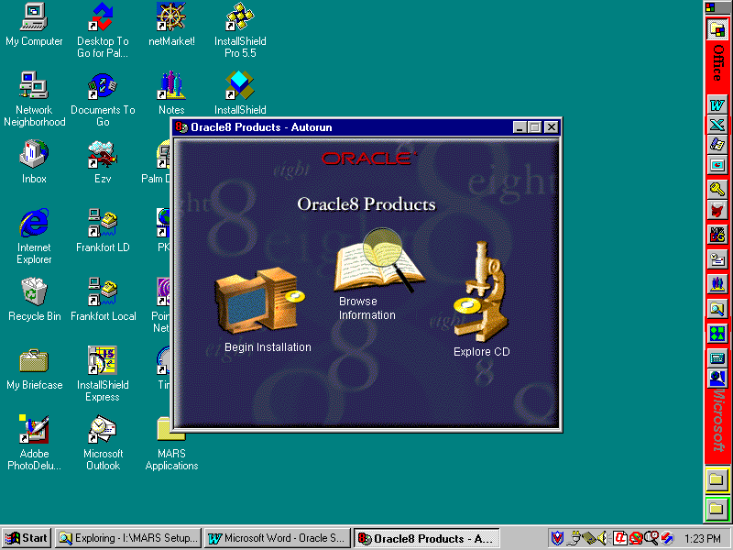
- Click on the Begin Installation icon and the Oracle Installation Settings dialog will appear with any previously defined Oracle parameters. It is advisable to keep the default values. However, you can change the installation Location field.
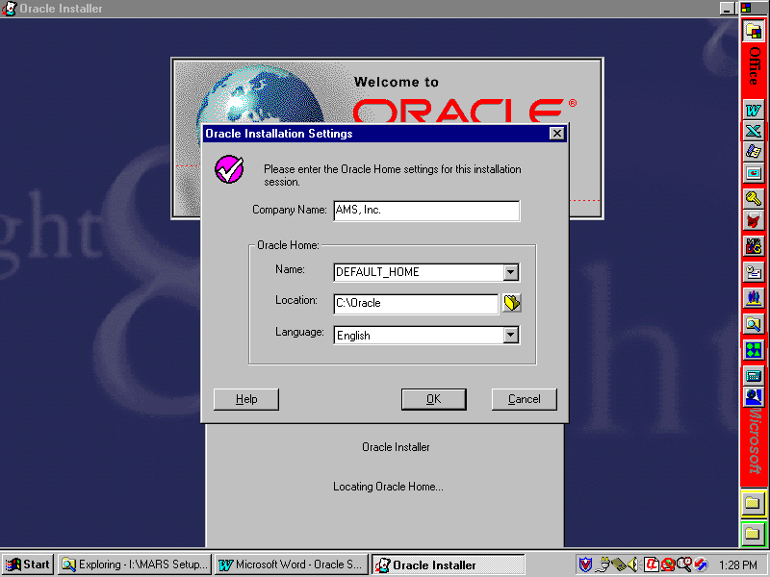
- Click OK and the following installation type dialog will appear.
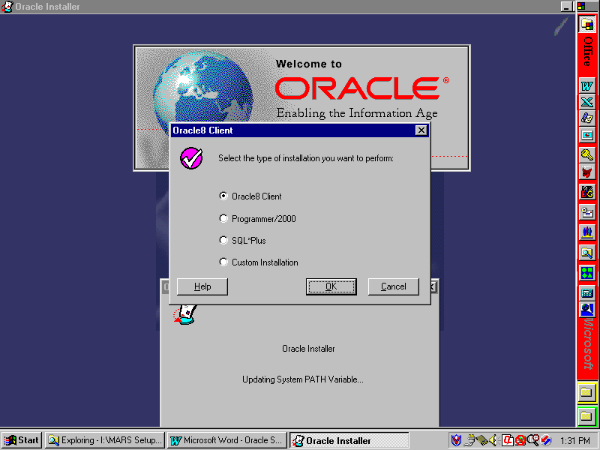
- Click on the Oracle Client selection and then click OK. The following Client Configuration dialog will appear. Select Application User and click on OK.
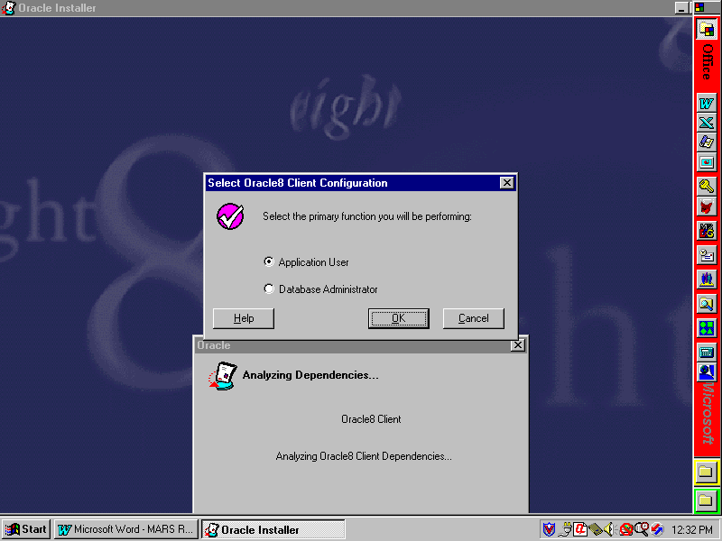
- In the following dialog screen, you are asked whether or not to load the Oracle documentation on your computer. Documentation is not required for MARS operations; however, if you feel that documentation is required for your particular installation, follow the instructions for installing documentation. For standard MARS installations, click on CD-ROM and click OK.
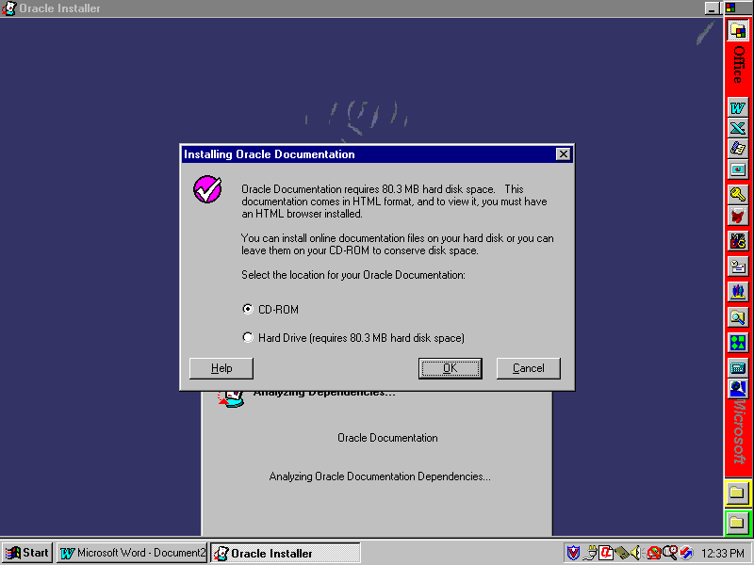
- At this point, Oracle files will be copied to the client computer and Oracle products registered. When the installation is complete, the following screen will appear. Click No to avoid reviewing documentation.
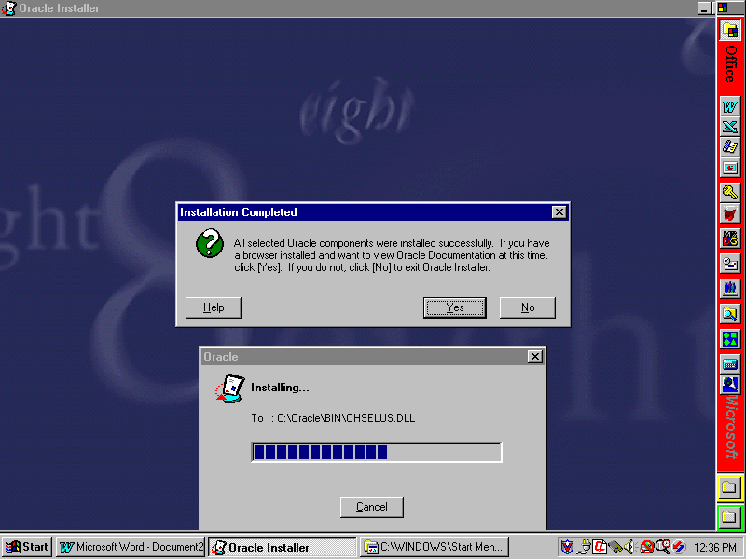
- You may be asked if you have a browser installed and if you want to view Oracle documentation at this time. If you get this message, click No to continue.
- You may be told to reboot the computer at this time. Do not reboot at this time since other installations also require rebooting. Wait until all installs are completed.
- Close the Oracle window. Oracle client installation is complete, but continue to the next steps for MARS-specific Oracle installation.
- MARS applications using Oracle require a customized file (tnsnames.ora) that defines databases, etc. for MARS. This file must be copied into an Oracle folder to replace the one distributed with Oracle. NOTE: If your agency also uses Oracle, you will have to merge your tnsnames.ora file with the MARS tnsnames.ora file before copying it to the client computers.
- If you do NOT have an agency-specific tnsnames.ora file, select to install Oracle Tnsnames when installing the MARS Applications. If this is a re-install of Oracle, then open the MARS Applications folder and double click on the Tnsnames Sync icon.
- If you have an agency-specific tnsnames.ora file, your Oracle DBA will need to merge a copy of the MARS tnsnames.ora file with the agency tnsnames.ora file. After these files have been merged, then it should be copied into the Oracle home folder (wherever you installed Oracle) \Net80\Admin folder.
- This completes the installation of Oracle on the client computer.

Installing Document Direct
- Using File Explorer on the local agency distribution server, click on the MARS_APPS\Document Direct folder.
- Double click on the Setup.exe file and accept all default settings or perform your own custom installation.
- After the installation completes, run Document Direct by either double clicking on the Document Direct icon in the Document Direct folder, or by clicking on Start, Programs, Document Direct, and Document Direct 2.1.
- From the menu bar, select Options and Configure Document Servers, and the Document Servers screen will appear with three sample document servers. Click on each in turn and click Remove to delete all three sample servers.
- Click New to configure a new server and the New Document Server screen will appear.
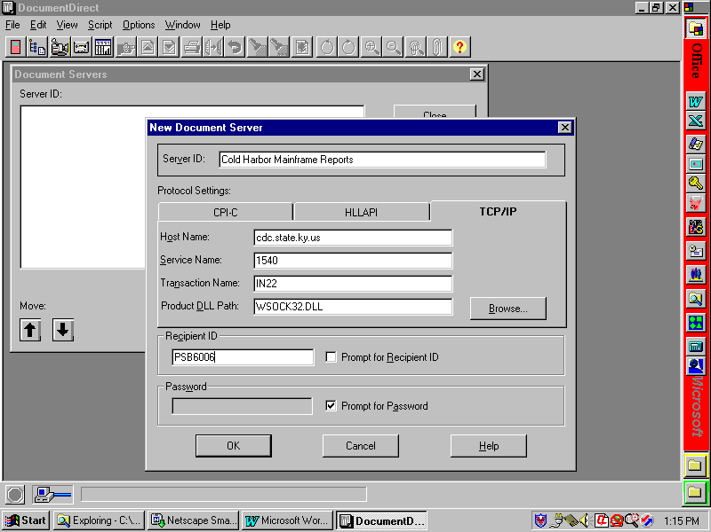
- In the Server ID field, enter Cold Harbor Mainframe Reports.
- Click on the TCP/IP tab and enter cdc.state.ky.us in the Host Name field.
- In the Service Name field, enter 1540.
- In the Transaction Name field, enter IN22.
- In the Product DLL Path field, enter WSOCK32.DLL. If another value has defaulted in this area, leave it as it appears and do not change.
- In the Recipient ID field, enter your mainframe user ID.
- Click on the Prompt for Password checkbox to select this option.
- Click OK and Close to complete this phase.
- From menu bar, click Options and select Customize Explorer from the menu and the following screen will appear.
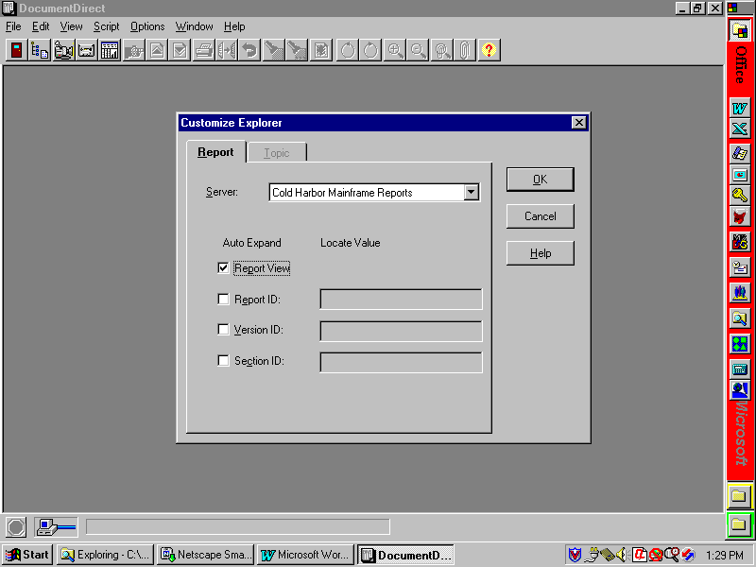
- Under the Auto Expand column, click the Report View checkbox to select. All of the other checkboxes should not be checked.
- Click OK to close and save these settings.
- Exit Document Direct and this completes the installation process. When viewing reports, you may wish to set the font to 8 pt so that the reports will better fit the screen.

Java Plug-Ins
- On the local agency distribution server, double click on the MARS_APPS\Java Activator\plugin-111-win32.exe file. Accept all default settings or perform your own custom installation. This will update environment variable settings, etc. that will require rebooting the client computer before they will take effect. Do not reboot at this time. Wait until all software has been installed.

Seagate Info
- On the local agency distribution server, double click the MARS_APPS\Seagate Info\Setup.exe file and the Seagate Info main menu screen will appear.
- Select Install (WIN32) from the menu to start the installation process.
- Seagate Info checks your currently installed ODBC DLLs to see if they need to be updated. If not, skip this step. If so, then the following screen will appear. Selecting No will cause the setup to exit; therefore, if you get this screen, select Yes. After the ODBC DLLs have been updated, you will automatically exit the setup program and be told to reboot the computer for changes to take affect. Reboot the computer and re-run the Seagate Info Setup.exe program.
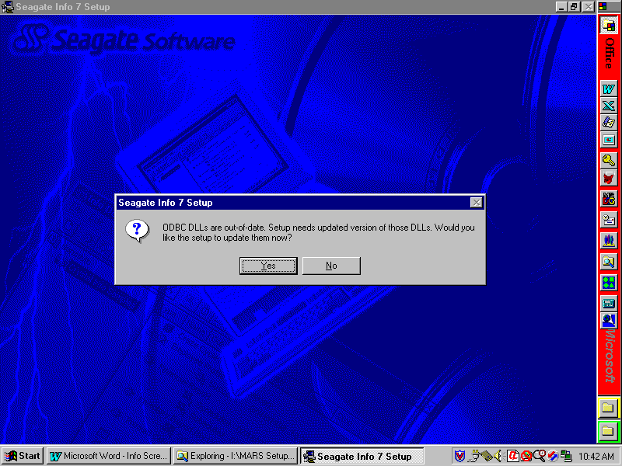
- If the ODBC DLLs are okay, or after they have been loaded and you have rebooted the computer and returned to the setup process, click Next on the Welcome screen and I Accept o the License Agreement screen and the following installation options dialog will be presented.
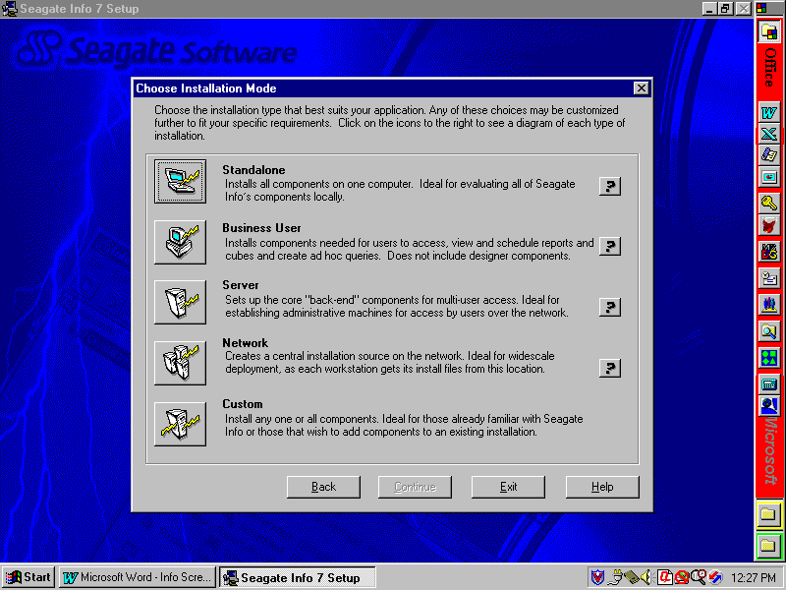
- Seagate Info provides a number of predefined options for installing the system. Click on the Business User option and the Business User dialog screen will appear.
- If you are installing a normal Seagate Info user (one who will only run reports and queries), then skip to section 3.3.4.1, Normal Client Installation Instructions below.
- If you are installing a Seagate Info power user (one who will develop reports), then skip to section 3.3.4.2, Power User Installation Instructions below. NOTE: There are licensing issues with loading power user applications. Only those people specifically identified should be given these components.

Normal Client Installation Instructions
- On the Business User dialog screen, you can change the installation location. It is recommended that you accept the default value already preloaded. If you want to install in a custom location, click Set Location and specify your custom path.
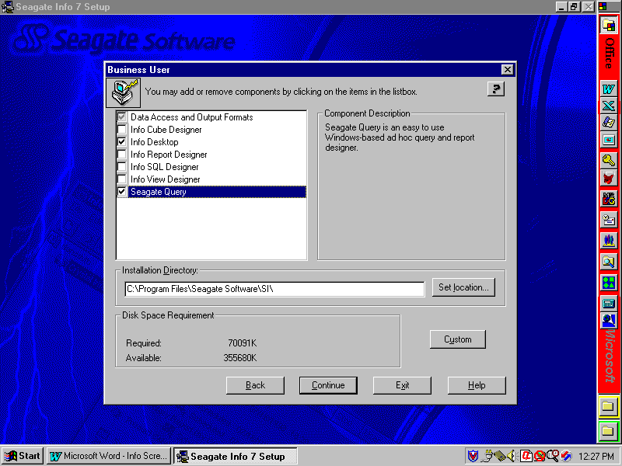
- Make sure that the following components have been selected (checkboxes checked):
- Data Access and Output Formats {leave grayed—do not click}
- Info Desktop
- Seagate Query [optional]
- Skip to section 3.3.4.3, Finish Seagate Info Installation to complete the installation process.

Power User Installation Instructions

There are a limited number of Seagate Info development licenses provided statewide for power users; therefore, this installation must only be performed for those individuals in your agency who have been specifically identified to receive this level of access.
- On the Business User dialog screen, you can change the installation location. It is recommended that you accept the default value already preloaded. If you want to install in a custom location, click Set Location and specify your custom path.
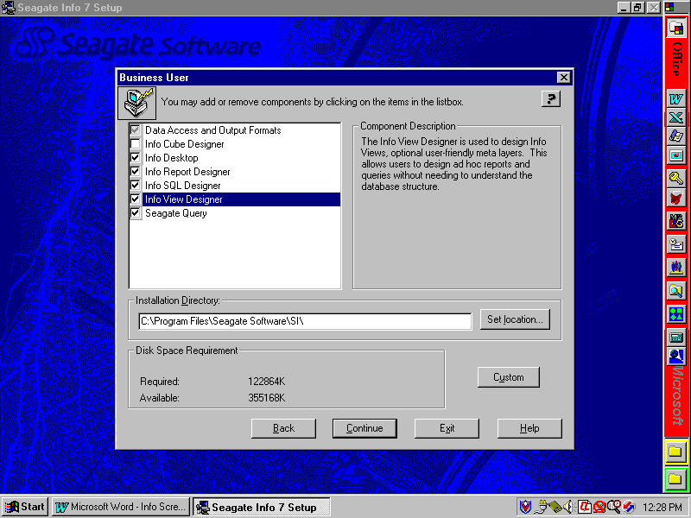
- Make sure that the following components have been selected (checkboxes checked):
- Data Access and Output Formats
- Info Desktop
- Info Report Designer
- Info SQL Designer
- Info View Designer
- Seagate Query
- Continue with section 3.3.4.3, Finish Seagate Info Installation to complete the installation process.

Finish Seagate Info Installation
- Click Continue and the Info APS Name dialog box will appear as shown below. Enter the following into the Info APS field: KYMARSSA2 and click Continue to begin the file copying process.
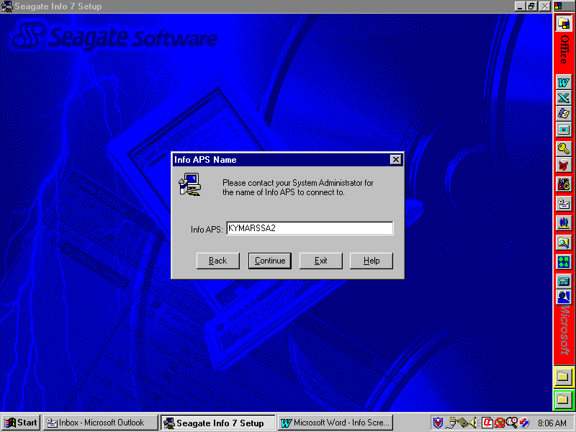
- You may get the Borland Database Engine Location dialog screen. If so, accept the default values and click Next.
- After the files have been copied and installed, the Info Configuration Manager dialog box shown below will appear. Click on the TCP/IP checkbox to make this selection. All other checkboxes should not be checked.

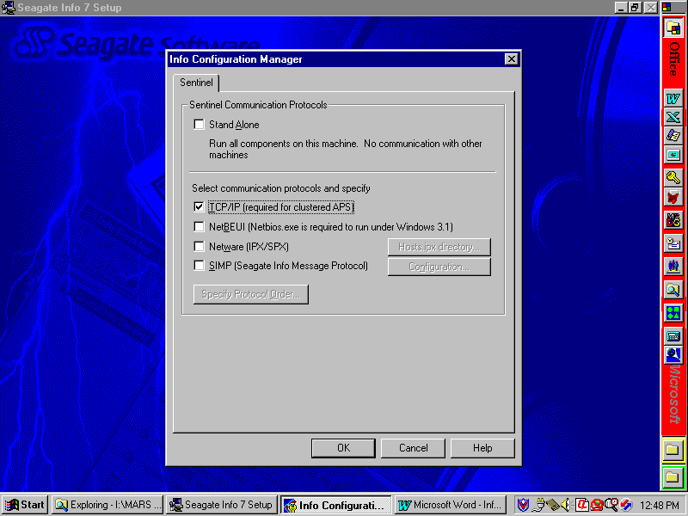
- Click OK and the Choose Program Group dialog box will appear as shown below. Select the default group or enter a custom group and click Next to continue.
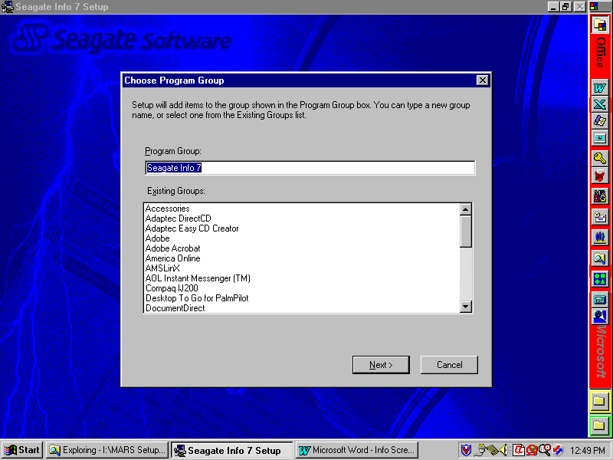
- There may be other dialog boxes telling you to reboot the computer, etc. Click on the appropriate response to cause the desired process. The installation of Seagate Info is complete at this time. If you are installing a power user, then proceed to section 3.3.4.4 for instructions on configuring ODBC drivers.

Configuring ODBC Driver for Power Users

For power users (those with the designer options chosen), the Oracle ODBC driver must be configured to point to the Management Reporting Database. To do this, perform the following steps:

- Click the Windows Start button and select Settings and Control Panel.
- Double click on the ODBC (32 bit) icon and select the User DSN tab.
- In the Name column, click on CROR8 to highlight and click the Configure button to the right.
- In the Server Name field, type MREPP1 and click Apply.
- Click the OK button until you exit the ODBC Data Source Administrator window.
- Exit the control panel. You may be instructed to reboot the computer before these changes will take place.

Installing MARS Applications

This section addresses installing the MARS applications. If MARS has already been installed and you are using standard MARS synchronization procedures with an agency distribution server, skip to section 3.5. If you are performing initial installs on a client computer, then you need to perform the installation procedures in this chapter. These instructions are for installation of the MARS ADVANTAGE Desktop, BRASS, and PD components on the client computers and ADVANTAGE Desktop on the agency distribution server.

NOTE: Make sure that you have write access to the server if installing the ADVANTAGE Server component. ADVANTAGE Server component only needs to be install once on the server for each release, not for each client computer install.
- On the local server, double click on MARS_APPS\MARS\Setup.exe and you will receive a warning screen. Click Yes to continue.
- The following dialog box allows you to specify where to install the MARS applications on the client computer. NOTE: It is highly recommended that you use the default settings or, at minimum, only change the installation drive letter. This is to aid in debugging any future problems you might have with running MARS. The path entered here will have the \MARS_APPS folder appended to the end. If you are installing ADVANTAGE Server, you should select the default since the Setup needs a location on the local computer in which to unpack files, etc.
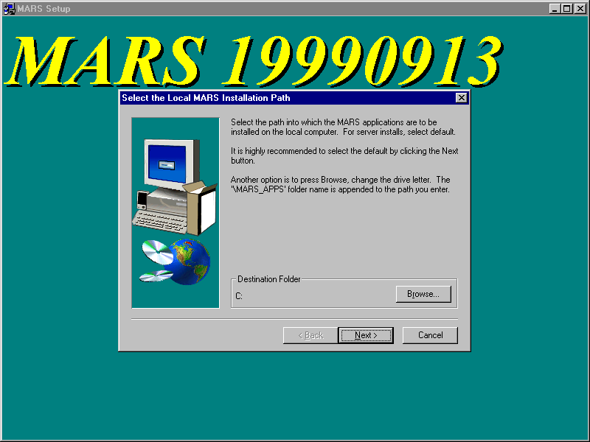
- If you wish to change the client computer installation path, click Browse and the following dialog box will appear. Select or specify the folder path into which you want the client software to be installed. When you are finished, click OK to return to the previous dialog box.
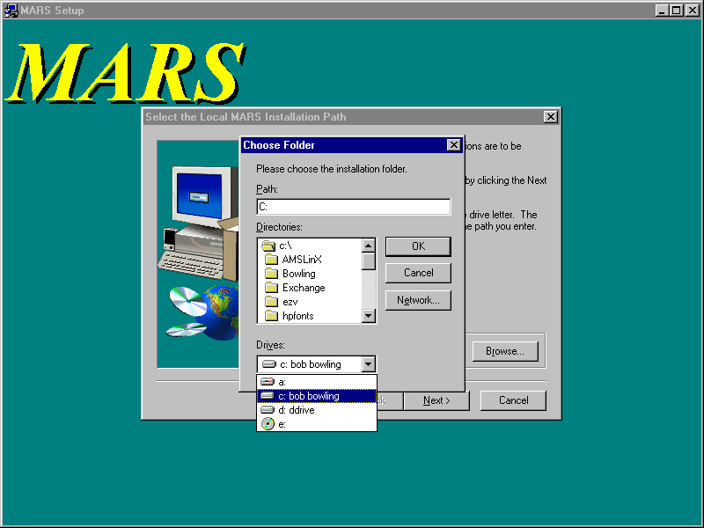
- Click Next and the following dialog will appear. Since you are installing from an agency distribution server, click on Agency Server-Based Installation.
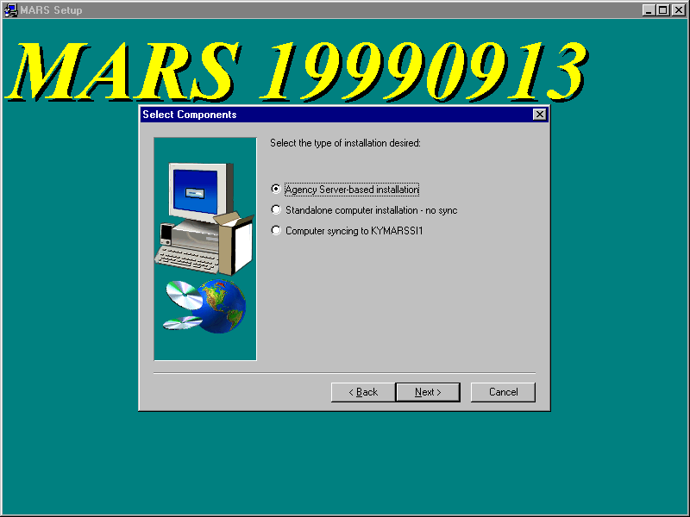
- Click Next and the following dialog will appear. This dialog is asking you for your agency distribution server path into which you will install the ADVANTAGE Server application and where the Setup.exe for MARS is stored. When providing this path, it should be the fully qualified server designation path rather than a mapped drive letter, unless your agency has standardized mapped drive letters to the server. The Browse button can be used or the path can be typed directly into the field. Typically, replace the question mark with your server name and any additional path information and the path should be similar to the following:
\\dismarsnt\appsdata {where “dismarsnt” is the server name}
NOTE: The path entered here will have the \MARS_APPS folder appended to the end and is used for all synchronization processes.
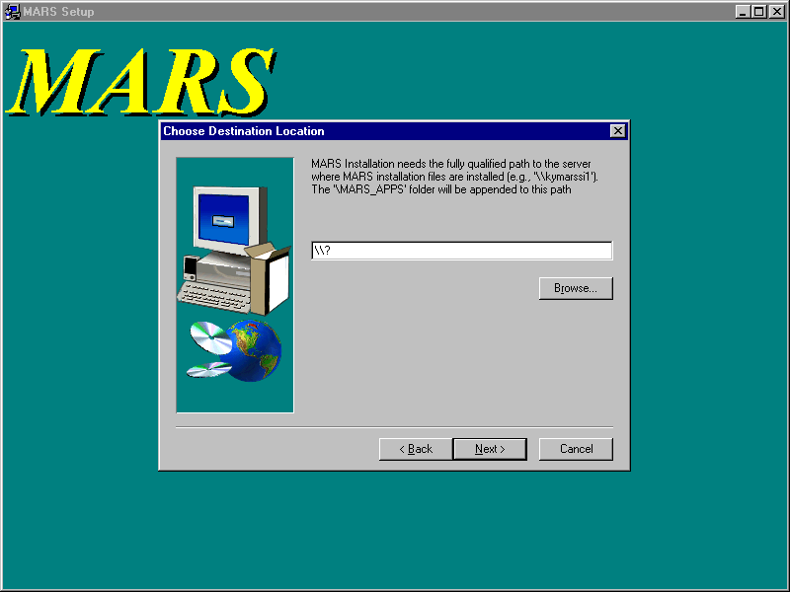
- After entering the server path, click Next and the following screen will appear. Click on the applications to be installed (indicated by a checkmark in the associated box).
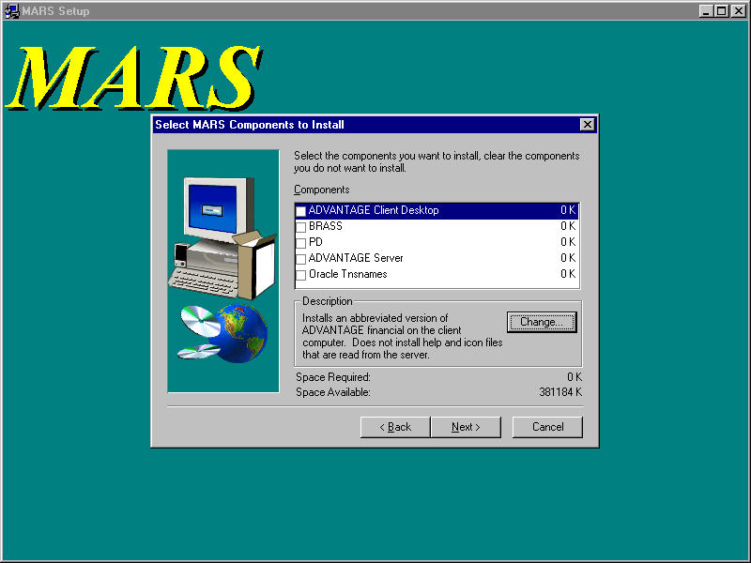
NOTE: If installing a new release of ADVANTAGE, you must install the ADVANTAGE Server to your agency server. Those client computers that already have ADVANTAGE Client Desktop installed do not have to be re-installed since they will sync automatically with the agency distribution server. For those client computers that do not already have ADVANTAGE installed, you will need to install the ADVANTAGE Client Desktop. If you change the location of ADVANTAGE on the server, you must reinstall ADVANTAGE on all client computers so that they will sync properly with the new location.
- After selecting all applications to be installed, click Next. You should not select to install Oracle Tnsnames if you already use Oracle at your agency. Talk to the Oracle DBA about how to merge and distribute tnsnames.ora separately. If you have selected to update the Oracle Tnsnames, the following screen will appear. Enter the Oracle home folder for where you have installed Oracle on the client computer. The default given is read from your computer’s registry. Click Next to continue.

NOTE: If you have not installed Oracle prior to trying to install Tnsnames, you will get a message from the install software telling you that you must install Oracle first and the install of Tnsnames will be aborted. Refer to section 3.3.1.
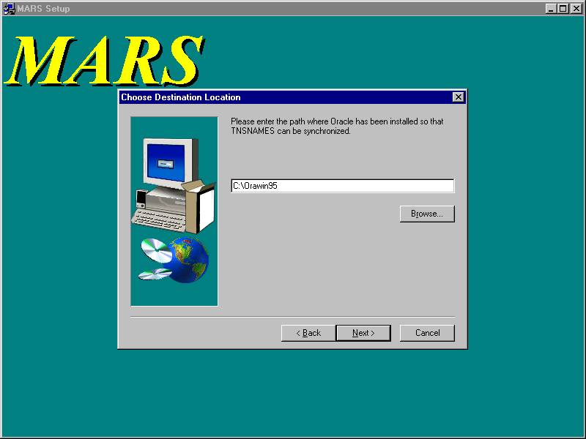

- At this point, MARS files will be copied to the appropriate locations, ini and bat files updated with the information you provided, and a MARS Application folder placed on the client desktop with icons for the MARS applications that were installed.
- For new installations of ADVANTAGE Desktop on client computers running WIN95 or WIN98: The ADVANTAGE and ADVANTAGE Workflow icons may need to be adjusted for a more desirable operation. These icons execute a minimized batch command file; however, the MS DOS window does not automatically close upon exiting ADVANTAGE and the computer may not have assigned enough memory to the MS DOS window. To correct these problems, perform the following steps:
- Double click on the MARS Applications folder on the desktop to open and the following screen should appear. Not all icons will be present if you have not done a full install.
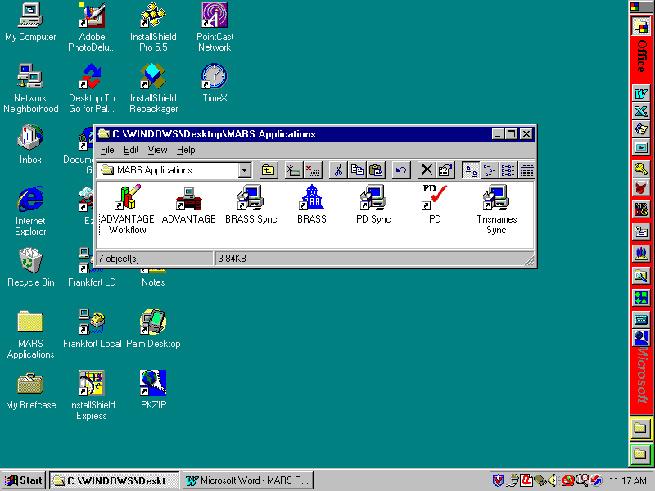
- Right click on the ADVANTAGE Workflow icon and select Properties from the menu.
- Click on the Program tab and click on the Close on exit checkbox.
- Click on the Memory tab and verify that the Initial environment is set to 4096. If not (e.g., set to Auto), then click on the Initial environment field, scroll down, and select 4096 from the pick list.
- Click Apply and click OK to close.
- Right click on the ADVANTAGE icon and select Properties from the menu.
- Click on the Program tab and click on the Close on exit checkbox.
- Click on the Memory tab and verify that the Initial environment is set to 4096. If not (e.g., set to Auto), then click on the Initial environment field, scroll down, and select 4096 from the pick list.
- Click on Apply and click on OK to close.
- For WIN98 Only: You must reboot the computer before the Sync icons will work.
- This completes the MARS applications installation.

Synchronizing MARS Applications

This chapter addresses how to synchronize previously installed MARS applications with new releases. Agencies may decide not to use the standard MARS synchronization and substitute other methods (e.g., use distribution software to push changes to client computers). With a standard MARS installation, a MARS Applications folder is placed on the client computer desktop with icons as shown in the following screen:

If you are providing other methods for synchronizing MARS software, then you should remove the BRASS Sync, PD Sync, and Tnsnames Sync icons from the MARS Applications folder. Otherwise, the following sections provide instructions on how to synchronize MARS software.

Synchronizing ADVANTAGE Server

The MARS installation software will create an ADVANTAGE Server Install icon whenever the ADVANTAGE Server installation is performed. This icon can be used to perform future ADVANTAGE Server installations without having to go through the detailed entry and selection of information. When ADVANTAGE Server is installed, the icon will record the information entered during the installation and use these data for future installations. Note that this icon is only for the MARS System Administrators and should not be installed on end-user client computers.

Synchronizing ADVANTAGE

ADVANTAGE has its own automated synchronization tool built into the process of running ADVANTAGE. System Administrators can not disable or bypass this process. It is transparent to the end user and does not require any special knowledge on their part. The process occurs automatically every time that ADVANTAGE is executed.

For the ADVANTAGE synchronization to work properly, you need to install the new ADVANTAGE Server component on your local agency distribution server. Download the MARS release package as instructed in section 3.1.1.1 and run the setup program to select this component. ADVANTAGE should be installed into the same server location referenced when the desktop clients were initially installed. If ADVANTAGE is moved to a different location on the agency distribution server, the client computers will fail to synchronize and will have to be re-installed or manually changed.

After installing the new version of ADVANTAGE on the agency distribution server, all client computers will automatically synchronize to the new version whenever ADVANTAGE is run. If multiple releases have occurred since the last synchronization on a given client computer, the client will automatically upgrade to the newest version.

Synchronizing BRASS

When a new release of MARS is loaded on the agency distribution server, client computers can synchronize to the new version by double clicking on the BRASS Sync icon in the MARS Applications folder. Download the MARS release package as instructed in section 3.1.1.1. You do not need to load BRASS on the distribution server. The client computers will synchronize with the MARS setup program. When BRASS Sync is run, the new version of BRASS will automatically load into the same location where it was originally installed. This synchronization load will not ask the end user any questions.

Synchronizing PD

When a new release of MARS is loaded on the agency distribution server, client computers can synchronize to the new version by double clicking on the PD Sync icon in the MARS Applications folder. Download the MARS release package as instructed in section 3.1.1.1. You do not need to load PD on the distribution server. The client computers will synchronize with the MARS setup program. When PD Sync is run, the new version of PD will automatically load into the same location where it was originally installed. This synchronization load will not ask the end user any questions.

Synchronizing Oracle Tnsnames

When a new release of MARS is loaded on the agency distribution server, client computers can synchronize to the new version by double clicking on the Tnsnames Sync icon in the MARS Applications folder. Download the MARS release package as instructed in section 3.1.1.1. You do not need to load Tnsnames on the distribution server. The client computers will synchronize with the MARS setup program. When Tnsnames Sync is run, the new version of Oracle tnsnames.ora will automatically load into the Oracle home directory based on the original installation of MARS on the client computer. This synchronization load will not ask the end user any questions.

Installing Without an Agency Distribution Server

This chapter is for those agencies that do not have an agency distribution server from which to distribute software to the client computers. These installation procedures are for standalone computers not connected to an agency distribution server. Please follow the instructions below to install or synchronize the latest version of MARS applications and supporting software environment.

The following table provides a guideline to the instructions for installing the distributed software on a standalone, non-networked computer.

If you are… | Then, follow these instructions…
Performing initial installs or installing new computers…
Install upgrades. | Go to Section 4.2.
Install the supporting software environment. | Go to Section 4.2.1.
Install the MARS applications. | Go to Section 4.4.
Performing subsequent installs after initial installation…
Install upgrades if required by the particular release. | Go to Section 4.2, if required.
Install the MARS applications. | Go to Section 4.4.

MARS CD ROM Distribution

MARS and associated third-party software are distributed to agencies on a set of MARS Distribution CDs as follows:

- Seagate Info
- Oracle Client
- MARS Applications & Miscellaneous

The Seagate Info and Oracle Client CDs are distributed to all agencies for initial installation of client computers. These two CDs will not be shipped with every release. Subsequent synchronization of client computers to the latest release of MARS will not require these CDs. They should be saved in case a new installation is required. When new releases of these products are received, a new set of CDs will be distributed.

The MARS Applications & Miscellaneous CD will generally contain the MARS Setup\MARS folder. However, from time to time, other software upgrades, etc. may be shipped on the MARS Applications CD. In these instances, the MARS Setup folder will contain addition sub-folders.

CDs Distributed this Release

Not all sites were issued CDs for this release. If your site receives MARS CDs, the following should have been in your release package:

- <Oracle Client >
- <Seagate Info>
- MARS Applications & Miscellaneous

Current CDs Required for MARS

The following set of CDs constitutes the complete and current set to support this release of MARS:

- Seagate Info {Shipped with MARS Release 19990607}
- Oracle Client {Shipped with MARS Release 19990607}
- MARS Applications & Miscellaneous {Shipped with MARS Release <19990614>}

Installing Upgrades

This Chapter provides information on upgrades to operating systems and other supporting software necessary for this release. All other supporting software upgrades are addressed in the Prerequisites section for each MARS component and are not distributed with this release. To obtain copies of previous upgrades, contact the Customer Resource Center (CRC) Help Desk.

Windows 95

The upgrade should have been applied with Release 19990607 and no additional upgrade is required for this release. Refer to section 1.4 required software versions. To install this upgrade, perform the follow step:
- Using the File Explorer on the MARS Distribution CD, double click on MARS Setup\WIN95 Upgrades\ServicePack1.exe and accept any defaults.

Windows 98

No upgrade to Windows 98 is required for this release. Refer to section 1.4 required software versions.

Windows NT

The upgrade should have been applied with Release 19990607 and no additional upgrade is required for this release. Refer to section 1.4 required software versions. To install this upgrade, perform the follow step:
- Using the File Explorer on your agency server, double click on MARS Setup\WINNT Upgrades\NT4-sp4\I386\Update\Update.exe. This is a self-extracting installation package. Accept any defaults.

Internet Explorer

The upgrade should have been applied with Release 19990607 and no additional upgrade is required for this release. Refer to section 1.4 required software versions. To install this upgrade, perform the follow step:
- For WIN95/98 ONLY: Using the File Explorer on your agency server, double click on MARS Setup\Internet Explorer Upgrades\SP2 Setup95\ie4setup.exe. This is a self-extracting installation package. Accept any defaults.
- For WINNT ONLY: Using the File Explorer on your agency server, double click on MARS Setup\Internet Explorer Upgrades\SP2 SetupNT\ie4setup.exe. This is a self-extracting installation package. Accept any defaults.

Netscape

The upgrade should have been applied with Release 19990607 and no additional upgrade is required for this release. Refer to section 1.4 required software versions. To install this upgrade, perform the follow step:
- Using the File Explorer on your agency server, double click on MARS Setup\Netscape Upgrades\n32e408.exe. This is a self-extracting installation package. Accept any defaults.

Installing the Supporting Software Environment

For initial installations of MARS, you should first install the supporting software environment on the client computer. Use the MARS distribution CDs and the following instructions to load the supporting software onto your computer.

These instructions are for installing the following supporting software:

- Oracle
- Document Direct
- Java Plug-ins
- Seagate Info

It is assumed that the agencies have already installed either the MS Internet Explorer or the Netscape browser. If not, then one of these browsers will have to be installed if the client computer is to access any of the Web applications.

Installing Oracle
- Insert the Oracle Client CD into your CD drive and it should start the Oracle installation process automatically. If not, using the file explorer, click on the CD ROM drive in which the Oracle installation CD is loaded to open the MARS Setup\Oracle\WIN32\Autorun folder and double click on the Autorun.exe file.
- Click on the Begin Installation icon and the Oracle Installation Settings dialog will appear with any previously defined Oracle parameters. It is advisable to keep the default values. However, you can change the installation Location field (e.g., place Oracle under the MARS_APPS folder).
- Click OK and the following installation type dialog will appear.
- Click on the Oracle Client selection and then click OK. The following Client Configuration dialog will appear. Select Application User and click on OK.
- In the following dialog screen, you are asked whether or not to load the Oracle documentation on your computer. Documentation is not required for MARS operations; however, if you feel that documentation is required for your particular installation, follow the instructions for installing documentation. For standard MARS installations, click on CD-ROM and click OK.
- At this point, Oracle files will be copied to the client computer and Oracle products registered. When the installation is complete, the following screen will appear. Click No to avoid reviewing documentation.
- You may be asked if you have a browser installed and if you want to view Oracle documentation at this time. If you get this message, click No to continue.
- You may be told to reboot the computer at this time. Do not reboot at this time since other installations also require rebooting. Wait until all installs are completed.
- Close the Oracle window. Oracle client installation is complete, but continue to the next steps for MARS-specific Oracle installation.
- MARS applications using Oracle require a customized file (tnsnames.ora) that defines databases, etc. for MARS. This file must be copied into an Oracle folder to replace the one distributed with Oracle. NOTE: If your agency also uses Oracle, you will have to merge your tnsnames.ora file with the MARS tnsnames.ora file before copying it to the client computers.
- If you do NOT have an agency-specific tnsnames.ora file, select to install Oracle Tnsnames when installing the MARS Applications. If this is a re-install of Oracle, then open the MARS Applications folder and double click on the Tnsnames Sync icon.
- If you have an agency-specific tnsnames.ora file, your Oracle DBA will need to merge a copy of the MARS tnsnames.ora file with the agency tnsnames.ora file. After these files have been merged, then it should be copied into the Oracle home folder (wherever you installed Oracle) \Net80\Admin folder.
- This completes the installation of Oracle on the client computer.

Installing Document Direct
- Insert the MARS Application & Miscellaneous CD into the drive and double click on the MARS Setup\Document Direct\Setup.exe file. Accept all default settings or perform your own custom installation.
- After the installation completes, run Document Direct by either double clicking on the Document Direct icon in the Document Direct folder, or by clicking on Start, Programs, Document Direct, and Document Direct 2.1.
- From the menu bar, select Options and Configure Document Servers, and the Document Servers screen will appear with three sample document servers. Click on each in turn and click Remove to delete all three sample servers.
- Click New to configure a new server and the New Document Server screen will appear.
- In the Server ID field, enter Cold Harbor Mainframe Reports.
- Click on the TCP/IP tab and enter cdc.state.ky.us in the Host Name field.
- In the Service Name field, enter 1540.
- In the Transaction Name field, enter IN22.
- In the Product DLL Path field, enter WSOCK32.DLL. If another value has defaulted in this area, leave it as it appears and do not change.
- In the Recipient ID field, enter your mainframe user ID.
- Click on the Prompt for Password checkbox to select this option.
- Click OK and Close to complete this phase.
- From menu bar, click Options and select Customize Explorer from the menu and the following screen will appear.
- Under the Auto Expand column, click the Report View checkbox to select. All of the other checkboxes should not be checked.
- Click OK to close and save these settings.
- Exit Document Direct and this completes the installation process. When viewing reports, you may wish to set the font to 8 pt so that the reports will better fit the screen.

Installing Java Plug-Ins
- Insert the MARS Applications & Miscellaneous CD into your CD drive and double click on the MARS_APPS\MARS Setup\Java Activator\plugin-111-win32.exe file. Accept all default settings or perform your own custom installation. This will update environment variable settings, etc. that will require rebooting the client computer before they will take effect.

Installing Seagate Info
- Insert the Seagate Info CD into your CD drive and it will automatically start the setup process. If not, using the file explorer, click on the CD ROM drive in which the Seagate Info installation CD is loaded and double click on the Setup.exe file.
- The Seagate Info main menu screen will appear. Select Install (WIN32) from the menu to start the installation process.
- Seagate Info checks your currently installed ODBC DLLs to see if they need to be updated. If not, skip this step. If so, then the following screen will appear. Selecting No will cause the setup to exit; therefore, if you get this screen, select Yes. After the ODBC DLLs have been updated, you will automatically exit the setup program and be told to reboot the computer for changes to take affect. Reboot the computer and re-run the Seagate Info Setup.exe program.
- If the ODBC DLLs are okay, or after they have been loaded and you have rebooted the computer and returned to the setup process, click Next on the Welcome screen and I Accept o the License Agreement screen and the following installation options dialog will be presented.
- Seagate Info provides a number of predefined options for installing the system. Click on the Business User option and the Business User dialog screen will appear.
- If you are installing a normal Seagate Info user (one who will only run reports and queries), then skip to section 4.3.4.1 below.
- If you are installing a Seagate Info power user (one who will develop reports), then skip to section 4.3.4.2 below. NOTE: There are licensing issues with loading power user applications. Only those people specifically identified should be given these components.

Normal Client Installation Instructions
- On the Business User dialog screen, you can change the installation location. It is recommended that you accept the default value already preloaded. If you want to install in a custom location, click Set Location and specify your custom path.
- Make sure that the following components have been selected (checkboxes checked):
- Data Access and Output Formats
- Info Desktop
- Seagate Query [optional]
- Skip to section 4.3.4.3 to complete the installation process.

Power User Installation Instructions

There are a limited number of Seagate Info development licenses provided statewide for power users; therefore, this installation must only be performed for those individuals in your agency who have been specifically identified to receive this level of access.
- On the Business User dialog screen, you can change the installation location. It is recommended that you accept the default value already preloaded. If you want to install in a custom location, click Set Location and specify your custom path.
- Make sure that the following components have been selected (checkboxes checked):
- Data Access and Output Formats
- Info Desktop
- Info Report Designer
- Info SQL Designer
- Info View Designer
- Seagate Query
- Skip to section 4.3.4.3 to complete the installation process.

Finish Seagate Info Installation
- Click Continue and the Info APS Name dialog box will appear as shown below. Enter the following into the Info APS field: KYMARSSA2 and click Continue to begin the file copying process.
- After the files have been copied and installed, the Info Configuration Manager dialog box shown below will appear. Click on the TCP/IP checkbox to make this selection. All other checkboxes should not be checked.

- Click OK and the Choose Program Group dialog box will appear as shown below. Select the default group or enter a custom group.
- There may be other dialog boxes telling you to reboot the computer, etc. Click on the appropriate response to cause the desired process. The installation of Seagate Info is complete at this time.

Installing MARS Applications

When installing from the MARS Distribution CDs, it is assumed that you do not have access to an agency distribution server. You will either install MARS from the CD or synchronize the MARS applications to the MARS Central Distribution server. The choice is a matter of the time it takes to do the synchronization over a low speed line versus the time it takes for the MARS Distribution CD to be mailed to your location. Re-installing MARS from the CD will take 6 to 10 minutes depending upon the speed of your CD drive. Synchronizing MARS with the MARS Central Distribution server over a 56KB line will take approximately 70 minutes for BRASS, 100 minutes for PD, and 90 minutes for ADVANTAGE.
- Insert the MARS Applications & Miscellaneous CD into your CD drive and double click on MARS Setup\MARS\Setup.exe and a warning screen will appear warning that changes in folder names will result in MARS applications not working. Click Yes to continue and the following screen will appear. This dialog box allows you to specify where to install the MARS applications on the client computer. NOTE: It is highly recommended that you use the default settings or, at minimum, only change the installation drive letter. This is to aid in debugging any future problems you might have with running MARS. The path entered here will have the \MARS_APPS folder appended to the end.
- If you wish to change the client computer installation path, click Browse and the following dialog box will appear. Select or specify the folder path into which you want the client software to be installed. When you are finished, click OK to return to the previous dialog box.
- Click Next and the following dialog box will appear. This dialog is requesting the type of installation desired. Since your agency does not have a distribution server, at this point, you must decide if you are installing a standalone computer (Standalone computer installation – no sync ) that does not synchronize (e.g., purely installed from CD each time) or if you want to synchronize with the MARS Central Distribution server (Computer syncing to KYMARSSI1). Make the appropriate selection and click Next to continue.
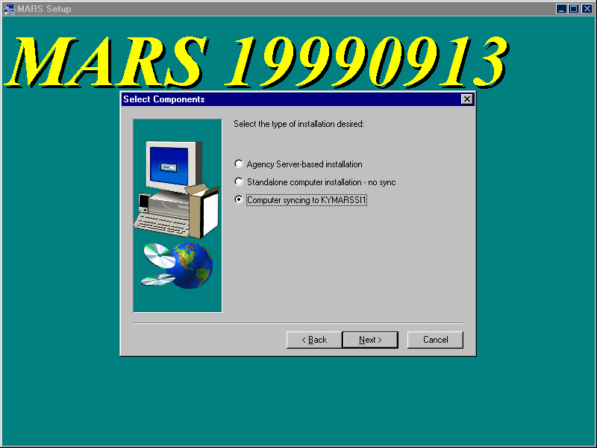
- Once you have made a decision on the previous screen, the following dialog screen will appear. Click on the MARS components to be installed (indicated by a checkmark in the associated checkbox). For Standalone installations, regardless of whether or not you are synchronizing with the MARS Central Distribution server, the ADVANTAGE Server files will always be installed if you pick either of the ADVANTAGE selections. You should not pick both selections.
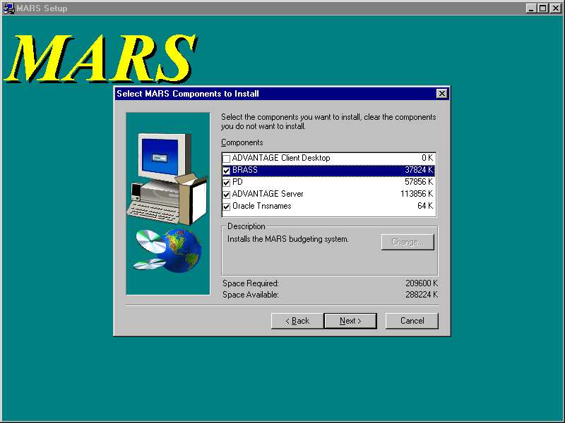
- At this point, MARS files will be copied to the appropriate locations, ini and bat files updated with the information you provided, and a MARS Application folder placed on the client desktop with icons for the MARS applications that were installed.
- For initial installations on computers running WIN95 or WIN98: The ADVANTAGE and ADVANTAGE Workflow icons may need to be adjusted for a more desirable operation. These icons execute a minimized batch command file; however, the MS DOS window does not automatically close upon exiting ADVANTAGE and the computer may not have assigned enough memory to the MS DOS window. To correct these problems, perform the following steps:
- Double click on the MARS Applications folder on the desktop to open and the following screen should appear. Not all icons will be present if you have not done a full install.
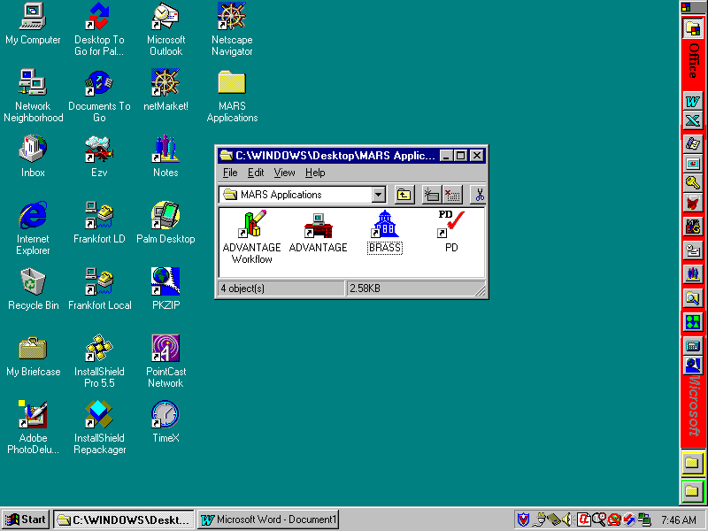
NOTE: If you chose to synchronize with the MARS Central Distribution server, your MARS Application Folder will have Sync icons for BRASS, PE, and Tnsnames.
- Right click on the ADVANTAGE Workflow icon and select Properties from the menu.
- Click on the Program tab and click on the Close on exit checkbox.
- Click on the Memory tab and verify that the Initial environment is set to 4096. If not (e.g., set to Auto), then click on the Initial environment field, scroll down, and select 4096 from the pick list.
- Click Apply and click OK to close.
- Right click on the ADVANTAGE icon and select Properties from the menu.
- Click on the Program tab and click on the Close on exit checkbox.
- Click on the Memory tab and verify that the Initial environment is set to 4096. If not (e.g., set to Auto), then click on the Initial environment field, scroll down, and select 4096 from the pick list.
- Click on Apply and click on OK to close.
- For WIN98 Only: You must reboot the computer before the Sync icons will work.
- This completes the MARS applications installation.

Synchronizing MARS Applications

This chapter addresses how to synchronize previously installed MARS applications with new releases for those agencies that have chosen to synchronize with the MARS Central Distribution server. MARS Applications folder is placed on the client computer desktop with icons as shown in the following screen:

The following sections provide instructions on how to synchronize MARS software.

Synchronizing ADVANTAGE

ADVANTAGE has its own automated synchronization tool built into the process of running ADVANTAGE. System Administrators can not disable or bypass this process. It is transparent to the end user and does not require any special knowledge on their part. The process occurs automatically every time that ADVANTAGE is executed. If multiple releases have occurred since the last synchronization on a given client computer, the client will automatically upgrade to the newest version.

Synchronizing BRASS

You can synchronize to the new version by double clicking on the BRASS Sync icon in the MARS Applications folder. The client computer will synchronize with the MARS setup program stored on the MARS Central Distribution server. When BRASS Sync is run, the new version of BRASS will automatically load into the same location where it was originally installed. This synchronization load will not ask any questions.

Synchronizing PD

You can synchronize to the new version by double clicking on the PD Sync icon in the MARS Applications folder. The client computer will synchronize with the MARS setup program stored on the MARS Central Distribution server. When PD Sync is run, the new version of PD will automatically load into the same location where it was originally installed. This synchronization load will not ask any questions.

Synchronizing Oracle Tnsnames

You can synchronize to the new version by double clicking on the Tnsnames Sync icon in the MARS Applications folder. The client computer will synchronize with the MARS setup program stored on the MARS Central Distribution server. When Tnsnames Sync is run, the new version of tnsnames.ora will automatically load into the same location where it was originally installed. This synchronization load will not ask any questions.

Troubleshooting Guide

The information in this guide is based on past problems encountered for which corrective actions have been determined. Your exact problem may not be listed, but this guide should help point you in the right direction for isolating and correcting your specific installation problem.

ADVANTAGE Will Not Run

You have double clicked on the ADVANTAGE or ADVANTAGE Workflow icons and either nothing happens or you get a message that a file can not be found. Typically, this is caused by the batch file \MARS_APPS\ADVANTAGE\bin\runprog.bat not pointing to the local drive where ADVANTAGE is installed and/or to the agency distribution server location where ADVANTAGE is installed on the server.

Using the File Explorer, right click on \MARS_APPS\ADVANTAGE\bin\runprog.bat and select Edit from the menu. Check that the SET AD_LDRIVE command is set equal to the drive onto which ADVANTAGE was installed on the client computer. The default setting is:

SET AD_LDRIVE=C

Note that the drive letter (e.g., “C”) is not followed by a colon (“:”). If it is, then remove the colon.

In the following SET commands, the paths may be in DOS short path notation for your actual installations. For those agencies with Novell version 3.11, long paths are not supported and you will have to use short path notation. Check that the SET AD_RDRIVE command is set equal to the distribution server path where ADVANTAGE is installed. This path is used by the client ADVANTAGE Desktop application to synchronize with the latest version. The path setting should be similar to the following:

SET AD_RDRIVE=\\kymarssi1\MARS_APPS

where in the place of “kymarssi1” you would have substituted you local distribution server name and path.

Check that the SET AD_LHOME command is set equal to the distribution server path plus the ADVANTAGE folder where ADVANTAGE is installed. The path setting should be similar to the following:

SET AD_LHOME=\\kymarssi1\MARS_APPS\ADVANTAGE

where in the place of “kymarssi1” you would have substituted you local distribution server name and path.

If either of these settings was incorrect, correct the problem and try to run ADVANTAGE again. If not, check the network connection between the client computer and that server location. Verify that the user has access rights to read from the server location. You can also review the MARS_APPS\ADVANTAGE\system\advsync.log file for errors that occurred during the attempt to make the connection. If there are any errors recorded, correct those errors and try to connect again.

If a problem can not be found, then review the other troubleshooting topics, specifically section 5.2 to check the relative network addressing between your distribution server and the mainframe.

ADVANTAGE Connection Fails

The receipt of the Connection Failed error box or an error message says that “the host specified by the name [null] could not be found,” then there is a likely problem with the network connection between the client desktop and the ADVANTAGE server application. The problem is that the client computer cannot resolve the path to the mainframe (e.g., cdc.state.ky.us). This is caused by the client either inheriting domain settings from the agency server or having them coded into the client computer setup. Either way, the client has some other domain root for which state.ky.us is not in the upward portion. Since the domain search starts at the root and searches upward, it can not find the reference to cdc from ADVANTAGE. To test to see if this is the case, open a DOS window and issue the following command:

Ping cdc.state.ky.us

If the ping returns an “unknown host” message, then there is a network problem preventing access to the mainframe. This will have to be resolved by the agency network people or DIS. If the ping returns a “reply from <IP address>” message, then the client computer does have access to the mainframe and the problem is in the domain search being conducted by the client computer.

Typically, ADVANTAGE references the mainframe in the ADVANTAGE\system\Ad.ini file with the address of CDC on the following command:

HOST_ADDRESS = CDC

Since this is not a fully qualified name (e.g., cdc.state.ky.us), when an agency appends a prefix to state.ky.us (e.g., KYTC.state.ky.us), the CDC name referenced in the AD.INI file can not be resolved. The DNS searches up from the starting point (e.g., KYTC.state.ky.us). Since the partial name CDC is now below your domain root, the upward search will not find it. This problem can be resolved in one of three ways:

- Change the ADVANTAGE host address to be a fully qualified name
- Change your root domain to state.ky.us, or;
- Add a domain suffix search to each computer

Edit the ADVANTAGE\system\Ad.ini file, locate the HOST_ADDRESS command, and change it to the following:

HOST_ADDRESS=CDC.STATE.KY.US

After making the change, try running ADVANTAGE. If the change works, place the changed file on the agency server (if the agency is using a distribution server) so that client computers will sync to the changed AD.INI file. If this does not resolve the problem, try changing the domain search.

Changing the domain requires a change to each client computer. To change the root domain, perform the following steps:

- From the Control Panel select Network and click on the Configuration tab.

- For WINNT: Select the Protocols tab, click on the TCP/IP Protocol, and click Properties.

- For the WIN95/98: Select the Configuration tab, click on the TCP/IP adapter bound to your network card, and click Properties.

Although there are some differences in the screens at this point between WINNT and WIN95/98, they are close enough so that the labels will be similar. In the domain suffix search order field (at the bottom of the either screen), add state.ky.us. Apply the change, exit the Control Panel and reboot the computer. This should resolve the problem.

If the problem is still not resolved, go back to the TCP/IP properties screen, remove the suffix you just added and now enter state.ky.us into the Domain field at the top of the screen. Apply the change, exit, and reboot. After the reboot, if you still can not get into ADVANTAGE, you may have to hard code the mainframe IP address. Before doing this, contact the CRC Help Desk.

If there is still a problem, check the ADVSync log for additional help. The log is located in the \MARS_APPS\ADVANTAGE\system\Advsync.log file. Edit this file to see if there are any error messages and check one of the other troubleshooting topics below.

ADVANTAGE Errors With a Reference to ND.DBG

If you are getting the message “Error messages have been saved to the log file (nd.dbg)”), determine how email is installed for the client computer and check the ADVANTAGE email protocol. For example, if the Outlook mailbox is installed locally rather than on the server, then the following command in the ADVANTAGE\system\Ad.ini file would cause errors and ADVANTAGE will not start.

EmailProtocol = MAPI

If this is the case, comment out the above command by placing a semicolon (“;”) in front of the command. This will disable the email protocol and should allow ADVANTAGE to execute.

BRASS Gives an Oracle Error Message on Startup

The most likely source for this error is that the Oracle tnsnames.ora file is not the current or correct file. Compare the dates of the Oracle \Net80\Admin\tnsnames.ora file to that in the MARS_APPS\Oracle Tnsnames folder to ensure that both are the same.

If your agency also uses Oracle, then there is a likelihood that the tnsnames.ora file distributed with MARS will have to be merged with the tnsnames.ora file used by your agency. If this merger has not taken place, then this could be the source of this error. Likewise, if the agency has changed the tnsnames.ora file and not included MARS changes, then this would also cause this error. Examine the Oracle \Net80\Admin\tnsnames.ora file to ensure that the MARS information is included and exactly as distributed with MARS.

Another source of Oracle problems is not having the Oracle \bin folder on the path environment variable. This would also cause a problem is there are more than one Oracle paths to different locations or if the path is incorrect. Verify that the folder is on the path variable and that it is correct.

If the tnsnames.ora file is correct, then contact your Oracle DBA to continue debugging the problem.

PD is not the Current Version

When attempting to execute PD you receive a message that you are not running the current version of PD, you will have to re-install PD from the current release package on that client computer. Most likely, that computer was overlooked during the installation of the new release.

PD Gives an Oracle Error Message on Startup

The most likely source for this error is that the Oracle tnsnames.ora file is not the current or correct file. Compare the dates of the Oracle \Net80\Admin\tnsnames.ora file to that in the MARS_APPS\Oracle Tnsnames folder to ensure that both are the same.

If your agency also uses Oracle, then there is a likelihood that the tnsnames.ora file distributed with MARS will have to be merged with the tnsnames.ora file used by your agency. If this merger has not taken place, then this could be the source of this error. Likewise, if the agency has changed the tnsnames.ora file and not included MARS changes, then this would also cause this error. Examine the Oracle \Net80\Admin\tnsnames.ora file to ensure that the MARS information is included and exactly as distributed with MARS.

Another source of Oracle problems is not having the Oracle \bin folder on the path environment variable. This would also cause a problem is there are more than one Oracle paths to different locations or if the path is incorrect. Verify that the folder is on the path variable and that it is correct.

If the tnsnames.ora file is correct, then contact your Oracle DBA to continue debugging the problem.

PD Gives an Unique Constraint Message While Logging Into PD

The symptom is that an error message is received after you enter the user id and password. The error message is as follows:

Error: ORA-00001: unique constraint (PD.X_DSK_LOGINS) violated

This is generally caused by someone who is installing PD and has performed multiple installs on this computer. This does not happen every time multiple installs are done, only on some rare circumstances when the prior unique identifier assigned to the computer when you logged on for the first time has now been duplicated by another computer.

To correct this situation, go to the MARS_APPS\PD folder and edit the desktop.ini file. Under the [MACHINE] group, there will be an ID command similar to the following:

ID=xx where “xx” is a number

Delete this whole command line. Exit the editor and save the file. You should now be able to successfully log into PD.

PD Problems Validating or Routing Documents

PD communicates with ADVANTAGE and routes documents through the set of PD Web servers. Even if you are not using PD Web applications, PD desktop still uses the Web servers. Therefore, it is imperative that the Web browsers be brought up to at least the level referenced in section 1.4.

This involves installing the Java plug-ins and upgrading the Microsoft Internet Explorer (IE). If your agency plans to use Netscape instead of IE, you still must upgrade to the proper version and service pack for IE. The reason is that Windows requires upgraded DLLs that come with the IE upgrade. Even if you are using Netscape, Windows is using parts of IE.

Another problem encountered is the reference to the PD Web servers in the PD Desktop.ini file. Most client computers were corrected during the sync performed for Release 19990709; however, if a client computer were missed, there could still be a reference to a single PD Web server rather than to the cluster of Web servers. Whereas this will still work, if the single Web server being addressed is taken down, then the client computer will not be able to communicate with ADVANTAGE or route documents until the Web server is brought back on line.

The correct method of addressing the PD Web servers is by the address PDWEB.STATE.KY.US. This method will allow the first available Web server on the cluster to process the client computer requests. If one server is down, the other will pick up the load until it is brought back on line; thus, uninterrupted service.

The PD Web server address is in the MARS_APPS\PD\Desktop.ini file under the [Server] group in the following command:

ServerName=PDWEB.STATE.KY.US

Be careful to set the correct ServerName variable since there are two in the file. There is one under the [Database] group that should not be changed.

PD HTTP Errors

PD communicates through the PD Web servers. At times, HTTP error messages may be received by the end-user. The one of the following messages will usually appear at the end of the error message:

uf_parse_into_ds with Error -1

Indicates the connection between the database and web server has been interrupted. The solution is to call the CRC Help Desk and request that a PD technical representative "unload the web server servlets." Make sure to indicate if the users being affected are in transportation, other sections of the Commonwealth, or both.

The operation timed out.

Indicates that the web server response time for the action has exceeded the default settings for allowable web response time to the client PC. The solution is to add a parameter to the user's desktop.ini file labeled "Timeout=". This parameter should be placed under the section titled "[Server]." The default value of this parameter is 300 seconds. Try setting the value to 450 or 600. This will increase the amount of time the server-related actions will take before the action stops trying to execute.

Could not connect to server.

Indicates that the client PC could not connect to the web server over the network. Could mean that the web server is down, there are network issues, or the data on the document may have gotten corrupted and cannot be passed through to the server. Try pinging the appropriate web server in a DOS prompt. If that receives a reply, run a web browser and enter the web server name into the URL line and see if there is a reply. If either of these fail, contact the agency network administrator to discover where the network connection problems are occurring. If both of these get a reply, contact the CRC and request assistance from a PD technical resource.

Running Oracle Client from a Server

The Net80 Oracle client software can be installed and run from a server rather than being installed on each client computer. However, this type of installation is more complex and requires manually adjusting the client computer registry. If your agency is running the client software from the server, then any previous version (e.g., SQL*NET) of Oracle client software must be removed from the registry. Then the Net80 Oracle client must be registered on each client computer and the registry modified to point to the server location for Oracle. Since Oracle must be able to find its \bin folder, you must ensure that this is on the DOS path environment variable.

Running Oracle Net80 Client with Oracle 7.x Versions

Versions of Oracle prior to version 8.x use the SQL*NET client software. However, Oracle version 8.x uses the Net80 client software. Net80 is fully backward compatible with SQL*NET (in accordance with Oracle corporation literature) and can be used by applications to access 7.x and 8.x versions of the Oracle database. When installing Net80, first remove SQL*NET from the computer, especially remove it from the registry. Then install the Net80 client.

Troubleshooting Oracle Connection Problems

The symptom of these problems is the inability to access neither BRASS nor PD. BRASS will issue an Oracle error message screen while PD will simply issue an error message about an “invalid user name or password.” The fact that you can not get into either application is an indication that there is something wrong with how Oracle is setup. The following steps will help you determine where to look for correcting the problem.

- Verify that the correct confirmation user ID and password are being used. Both should be in all upper case.
- To confirm that Net80 is operational on the client computer, open a DOS window and, from the C:\> promt, enter the following command:
Tnsping80 pdskp1
If Net80 is properly operating, you should receive confirmation of the IP address to the production database and a message similar to the following:
OK (100 msec)
- If the “OK” message is received, go to step 5.
- If an message is received that tnsping80 is not a valid program, then the problem is most likely with the DOS PATH statement. Open a DOS window and enter PATH. This will display the current path settings. If the Oracle path to the Orawin95\Bin folder is not on your path statement (e.g., where Orawin95 should be the home directory of where you installed Oracle), then you must resolve the path problem and reboot the computer (for WIN95/98 only). If this does not resolve the problem, continue with the next step.
- Try logging into PD. If there is a 5 to 10 second pause before the error message is returned, then the database was actually being accessed and the problem is most likely that the user name and password is wrong. You have successfully installed PD and the problem has been resolved. If the message “invalid user name or password” returns almost immediately, then the problem is most likely involves the tnsnames.ora file and you need to continue to Step 6.
- Verify that the tnsnames.ora file is the correct file. With the File Explorer, look into the home directory of Oracle (the folder name that you gave to install Oracle) and open the Net80\Admin folder. Verify that the tnsnames.ora file is the same file as the one distributed with MARS (found in the MARS_APPS\Oracle Tnsnames folder). If your agency uses Oracle already, you will need to verify with your Oracle DBA that the contents of the tnsnames.ora file distributed with MARS has been correctly merged with your existing tnsnames.ora file.
- If the tnsnames.ora file is correct, verify that this is the actual Oracle installation being used. You can do this by verifying the location in the registry; however, since this could lead to more serious problems, you can use the MARS setup program to verify the registered location for Oracle. Rerun the MARS setup program and select to install the Oracle Tnsnames component.
- If Oracle has not been installed and registered properly, you will receive an error message telling you that Oracle has not been installed. If you receive this message, proceed to install Oracle. Else, continue with the following.
- If Oracle has been installed, you will receive a dialog box displaying the path where Oracle has been registered in the registry. If this is not the location you verified above for the correct tnsnames.ora file, then Oracle has not been installed properly or has been installed into two or more locations. This situation has to be resolved and the tnsnames.ora file moved to the Oracle location actually being used.

If the above do not resolve the problem, refer to the other troubleshooting sections or call the CRC Help Desk.

Oracle Connection Problems in Novell Environments

If you are operating a Novell network, sometimes Oracle will not install properly if the Novell Netware client software is running at the time you install Oracle. These problems do not happen for every Netware client, but can cause sporadic problems. Generally, the client issues a connection error when the user tries to run BRASS or PD. The error generally instructs you to fax Oracle Corporation the error message. There can be other error messages as well depending upon which Oracle DLLs failed to install because of conflicts with Netware.

To correct these problems, you must first remove Oracle from the affected computer and re-install Oracle without the Netware client software operating. To remove Oracle from the computer, DO NOT USE THE WINDOWS REMOVE SOFTWARE UTILITY. This will not properly remove Oracle and will led to a number of other problems. Instead, take the following steps to remove Oracle from the client computer:

- For WIN95/98 clients, delete the Orawin95 folder. For WINNT clients, delete the Orant folder. If Oracle was not installed in a standard location, determine where it was installed and delete the folder from the client computer. If you can not determine where Oracle is installed on the computer, see steps below for locating the Oracle registry key. When you click on the ORACLE software key, the ORACLE_HOME variable will show you where Oracle is installed.
- From the Start menu select Run, enter regedit, and click OK.
- Expand HKEY_LOCAL_MACHINE by clicking on the plus sign (“+”).
- Under HKEY_LOCAL_MACHINE, expand SOFTWARE by clicking on the plus sign (“+”).
- Under SOFTWARE, click on ORACLE and press the Delete key to totally delete the Oracle key from the registry.
- Close regedit.

Disable the Netware software from being loaded during the boot process and reboot the computer. It is best to perform a cold boot by shutting down the computer and turning off the power for a few seconds and then powering back up.

After the computer reboots, make sure that there is no Netware software running on the computer. Install Oracle using the Oracle distribution CD. Re-enable the Netware client software disabled above and reboot the computer.

If there is still a problem, go through the guidelines in section 5.12 to make sure that there is not another problem caused by the re-install. If you still can not find the problem, execute BRASS and try to connect to a database. BRASS will issue a full Oracle error message. Record the five-digit Oracle error code and call this code into the CRC Help Desk. An Oracle DBA will be able to look this code up in the Oracle error code database and get a precise explanation of what is wrong.

Special Novell Considerations

Novell Netware presents some interesting problems for the MARS client environment. To troubleshoot these problems, the MARS System Administrator needs to understand some of the nuisances of Novell in regards to assumptions made in the MARS NT domain environment.

The first problem is that Novell users can not connect to Windows NT domains unless special software is purchased and the later versions of Novell installed. However, many of the Commonwealth’s agencies that use Novell are operating older 3.x and 4.x version of Novell that are not compatible with the NT domain environment. Therefore, NT-Novell connectivity is not a practical solution.

The MARS System Administrators who operate in the Novell environment already know of the problems faced in just trying to download a copy of the latest release package. This was overcome by providing the package on a Web FTP server accessible through standard Web technology independent of Novell-NT issues. However, some of these administrators may not be aware that PD references common contract clauses that are stored on the kymarssi1 NT domain server. This means that your users who are creating contracts through PD can not access these common clauses. To overcome this problem, these clauses must be installed on your Novell server and the Q: drive letter mapped to this location. How to do this is discussed in detail in Section 1.6.2 and will not be covered here.

What is not covered in Section 1.6.2 is that PD accesses these common contract clauses using DOS short name notation. Most Novell administrators have install long names when they setup their Novell servers. The long names option in Novell allows the use of long filenames and folder names like is found in Windows environments. However, this Novell option was for Mac compatibility and not implemented for Microsoft Windows file naming compatibility. Microsoft compatibility is not present until the later versions of Novell (e.g., version 5.x).

Therefore, when PD sends a request to the file management system to access a file, the requested file in DOS short name notation might look like the following:

Q:\MARSSe~1\PD\Book_I~1\HTML\Ref_ma~1.htm

In an NT server environment, NT file management can resolve that the short name notation above is exactly the same as the following long name notation:

Q:\MARS Setup\PD\Book_Images\HTML\Ref_main.htm

However, earlier versions of Novell can not make this connection. To overcome this problem, you will have to use DOS short name convention and rename the contract clause folders and subfolders. Some files may also have to be renamed, but wait until your users specifically encounter them before doing so. It would also be advisable to maintain a list of these files and folders that have to be renamed since when a new release of the clauses is issued, you will have to go through the renaming process again.

One possible solution to a lot of the problems encountered using Novell with the Commonwealth standard NT domains is to create a domain server for your agency. For small locations, a single workstation can be set up as both a NT domain server and an NT workstation. Larger offices may wish to dedicate a machine solely to being the NT domain server. You do not have to maintain user files on this server (e.g., continue to do this on your Novell server), only user security. Then a trust can be established between this domain server and the MARS domain servers.

Users in the office would log onto both the Novel server and NT domain server. This would give them and you access to all of the MARS NT servers. You will then be able to map the Q: drive to the MARS kymarssi1 server location for common contract clauses and your users would be able to access these clauses without you having to load them on your Novell server. MARS System Administrators would be able to copy the new release package directly from the kymarssi1 distribution folders onto their Novell servers.

MARS Setup.exe Program Error
When executing the MARS Setup.exe program, an error message appears that says that there was an error copying files or there was an error during the move data process. This problem is generally caused by one of the following:
- You are trying to install the ADVANTAGE Server component and you do not have write access rights to the server location where ADVANTAGE is being installed.
- You are running the Setup.exe file from the Network Neighborhood to select the server. You will need to map a drive letter to the server first. Network Neighborhood does not provide the proper path for the setup.exe program to execute.

One or More “Sync” Icons Will not Work

BRASS, PD, and Tnsnames all have a Sync icon in the MARS Application folder. If one or more of these do not work, right click on the icon, select Properties from the menu, and click on the Shortcut tab. A screen similar to the following will appear.

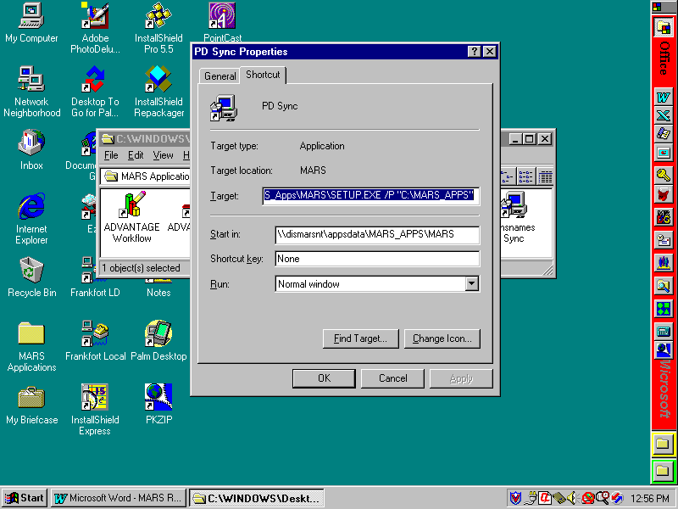

Make sure that the Target path is the correct location of the MARS Setup.exe file on the local agency synchronization server. If not, correct the problem. This could be caused if the MARS_APPS folder was relocated on the agency server. Also, if the Target path is correct, make sure that the Start in path is also correct. This should be the same path as in the Target path.

The synchronization icons are created when the MARS application is initially installed. The way that synchronization works is that the shortcut passes parameters to the MARS setup.exe program to tell which synchronization to do and provide the original installation path.

DLLs from Internet Explorer are required by Windows even if you are using Netscape or another Web browser.

