The Simplified Administrative Services Project Update



MARS and the Year 2000

Wondering how MARS will handle the Year 2000? The Year 2000 is a very important milestone for all of us, but especially with respect to our financial technology and systems. If you haven’t already read it, we have posted a MARS Year 2000 Readiness Disclosure statement on our project website at: http://www.state.ky.us/agencies/adm/mars/Y2K_Readiness.doc.

You may be interested to know that the MARS applications were year 2000 compliant “out-of-the-box”. In fact, the MARS project team has taken many steps to ensure the Y2K readiness of MARS. This includes:

Year 2000 Step | Result
Specified Year 2000 Compliance in the MARS Request for Proposal (RFP) | The first step in our Y2K “due diligence” was a requirement from respondent vendors for Year 2000 compliance.
RFP response from vendor | The RFP response from our vendor, American Management Systems (AMS), stated that the MARS applications were compliant “out-of-the-box”.
System Test Plan and Process | A portion of the MARS Project included a formal system test plan. This plan outlined how MARS System Testing would verify Year 2000 compliance, especially given the fact that our first year of operation would include both fiscal and calendar year 2000.
User Acceptance Test Plan and Process | A second round of testing for MARS allowed the project team to operate the system with actual dates in the year 2000. In fact, project team members had to constantly remind themselves of the actual date, given that MARS and our desktops were set to dates beyond January 1, 2000. This second round of testing helped to ensure Year 2000 compliancy, especially given the amount of customizing we did.
MARS Hardware Assessed by GOT | All of the hardware (servers, mainframe, etc.) is located at 101 Cold Harbor Drive within the Governor’s Office for Technology. This hardware is supported by the GOT and has been assessed for Year 2000 compliance.
How can I make sure that my desktop date is properly set to comply with the Year 2000?


Great question! MARS Year 2000 compliancy has several components. Because MARS is a client server system, you can infer that there are server components as well as client (or desktop) pieces that make up the system. If the software has been certified as compliant, and the hardware has been also assessed for compliance, what about each user’s desktop?

The date format on your desktop must be set up to support a 4-digit year under Windows 95, 98, or NT. This is done in the regional settings section of the control panel under windows.

Here are three easy steps to verify that your desktop is set up properly to support MARS (or any other windows application) for the year 2000.
- Step 1

Click the Windows Start button.
Choose Settings . . . and then Control Panel as seen below.
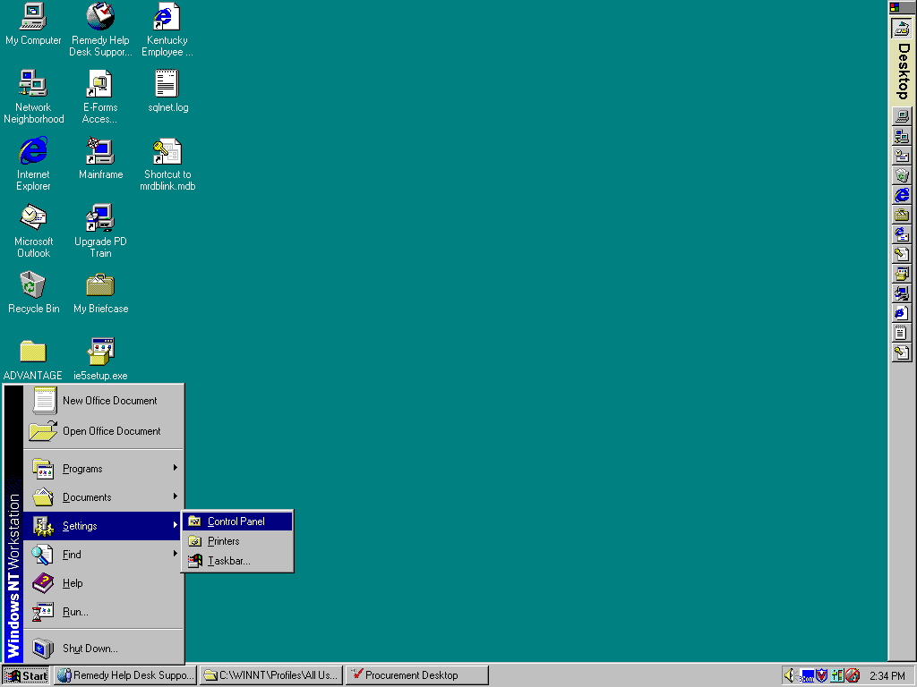

Choose Start, Settings and Control Panel from your desktop

- Step 2

You should now see the Control Panel Window with many icons displayed as below.
Now double-click the Regional Settings icon. This is the icon that looks like a globe of the world.

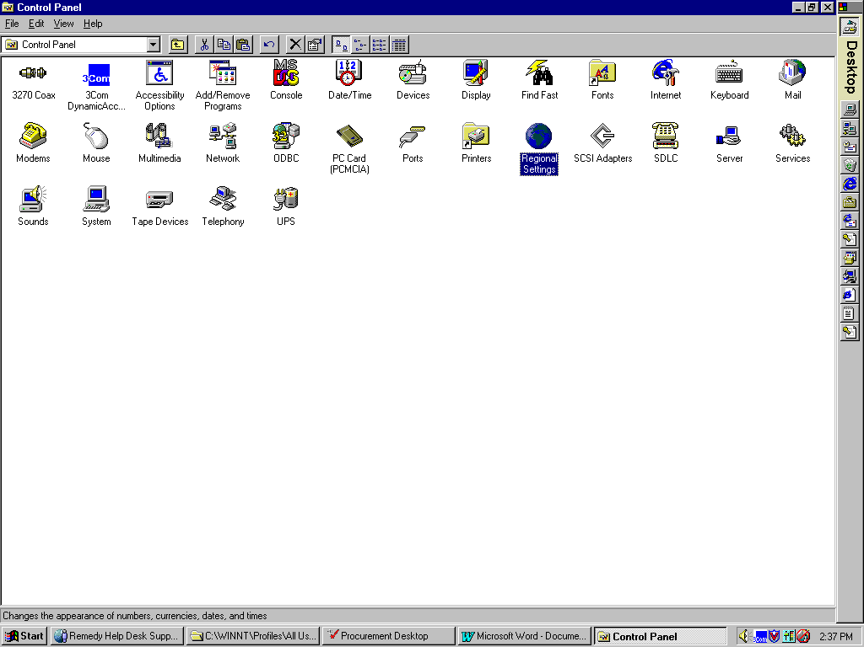

Double-click the Regional Settings icon under the Control Panel

Step 3

Under the Regional Settings window, you should now notice a Date Tab. Click the Date Tab to show options for the display of dates on your computer. You should now notice two boxes: One for the display of Short Date and one for Long Date.

- IMPORTANT

Make sure that your Short Date style is set to display month, day, and year as mm/dd/yyyy in support of a 4-digit year. This permits windows to read the year 2000 as a valid date range.
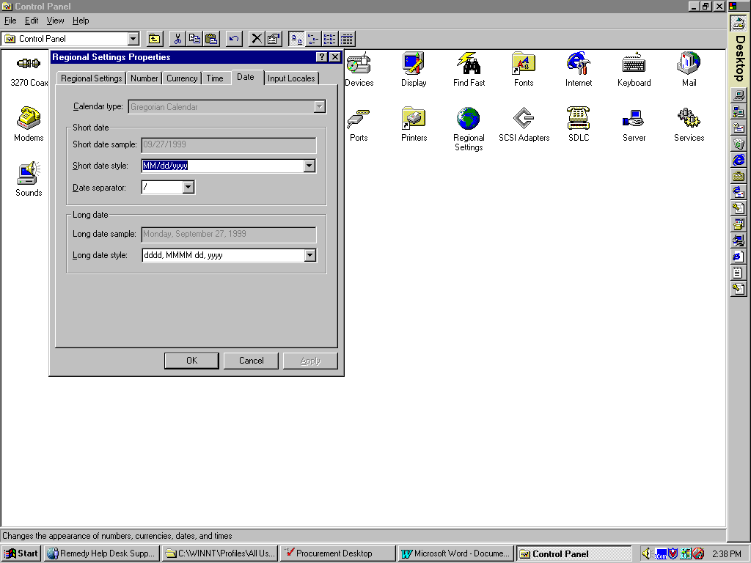

Change the Short date style to MM/dd/yyyy

If the Short Date style is set to MM/dd/yy, you need to change it to display MM/dd/yyyy in support of a 4-digit year. To do this, select MM/dd/yyyy in the drop down box.

If the Short Date style is already set to MM/dd/yyyy, you do not need to change anything.

Click the OK button to save your changes. Your desktop will now support the Year 2000. If you do not have the authority to make these changes on your desktop, you should contact your MARS System Administrator to assist in setting the date format.
If you have questions regarding MARS readiness for the Year 2000, please contact Chris Clark via email or phone (502-564-7236).

