Topic 6 working with forms

purpose

The purpose of this topic is to familiarize the user with creating forms using the Wizard. This topic will not cover all the functionality of the form, but will provide an overview of this useful tool. We will build forms from the queries we did in Topic 3.

objectives

During this topic you will learn:

Creating a Form using the Wizard

In the previous topic we completed a total of two queries, one using the Wizard and the other in the Design View. However, in this topic we will only use the Wizard. This is because when building forms the Wizard is the easiest way to accomplish the mission. The Design View is more complex when developing forms.


Your co-workers have come to you ask for an easier way to look up information on a particular vendor. They find the query datasheet view too confusing. We will use the Qry_Vendor Payment Information to accomplish this task.

Form tab
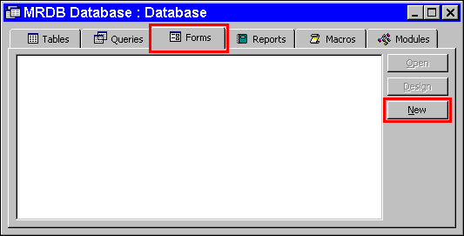

Creating a Form with the Wizard
Step 1 On the MRDB Database. Highlight the Forms tab.

Step 2 On the Forms tab. Click the <NEW> button. The New Form window is displayed.

New form wizard
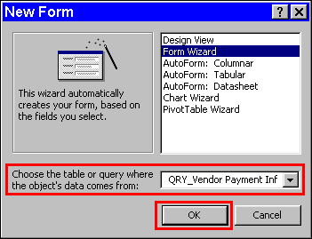

Step 3 On the New Form window. Highlight Form Wizard.

Step 4 In the CHOOSE TABLE OR QUERY WHERE THE OBJECT'S DATA COMES FROM: field. Select Qry_Vendor Payment Information from the drop down box.

Step 5 On the New Form window. Click the <OK> button. The Form Wizard window is displayed.

Available fields
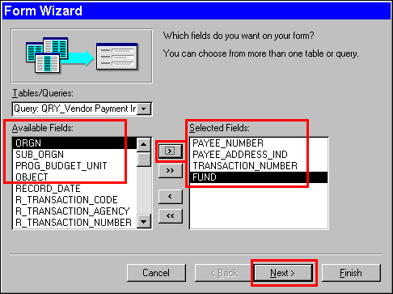

Step 6 On the Form Wizard window. Select the following fields:

TRANSACTION_NUMBER
FUND
ORGN
PROG_BUDGET_UNIT
OBJECT
RECORD_DATE
R_TRANSACTION_NUMBER
LINE_AMOUNT
NAME

Step 7 On the Form Wizard window. Click the <NEXT> button. The Layout Option window is displayed.

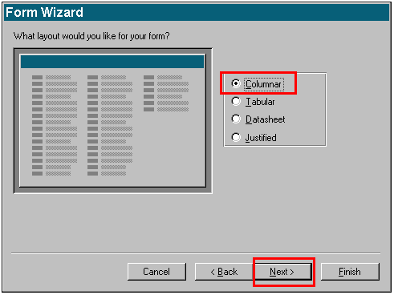Layout option

Step 8 On the Form Wizard Layout Option window. The default is Columnar. Leave As Is.

Step 9 On the Form Wizard Layout Option window. Click the <NEXT> button. The Style Option window is displayed.

Style option
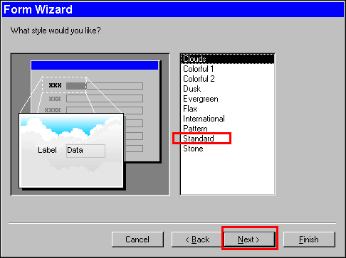

Step 10 On the Form Wizard Style Option window. The first time default is Clouds, then afterwards it is whatever was chosen last. Highlight Standard.

Step 11 On the Form Wizard Style Option window. Click the <NEXT> button. The Title Option window is displayed.

Title Option
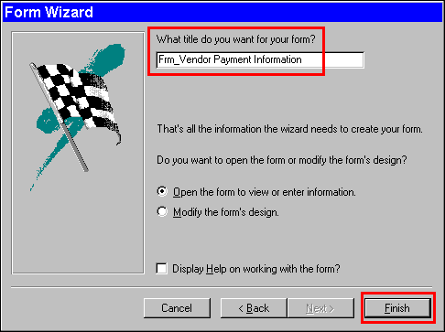

Step 12 On the Form Wizard Title Option window. Type Frm_Vendor Payment Information.

Step 13 On the Form Wizard Title Option window. Click the <FINISH> button.

Parameter Value
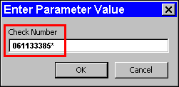

Step 14 On the Enter Parameter Value window. Enter vendor number 061133385*.

Vendor Payment Information Form
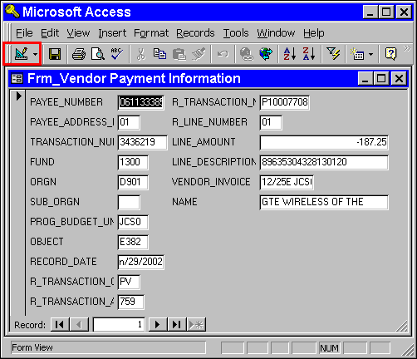

You may want to change the appearance of your form to make it more user- friendly.

Step 15 On the Form toolbar. Click the <VIEW> button from the drop down box. Select Design View. The form opens in the Design View.

Form in Design view
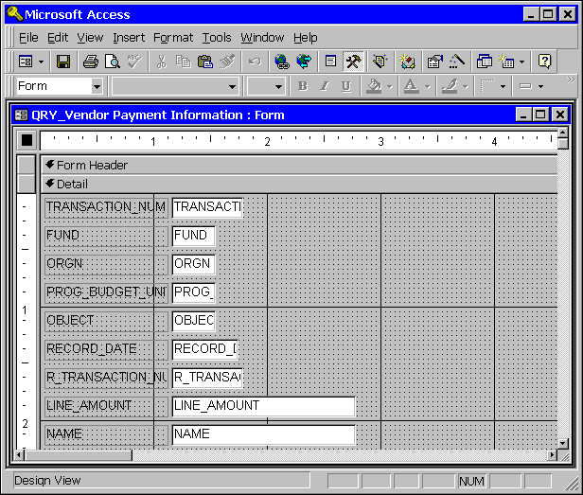

In the Design View you can change the appearance of the form by adding colors, move and arrange the fields, change the field labels to more meaningful words, and add commands to make the form more user friendly. We will not be going over these features, however, the Governor's Office of Technology offers classes in Microsoft Access that will cover them.

Step 16 Click the 'X' in the upper right-hand corner when finish with the form.



In this topic we have learned how to:

Create a Form using the Wizard



Are there any questions concerning the information covered in this topic?

