Topic 4 working with fct tables

purpose

The purpose of this topic is to familiarize the user with building queries using the Design View and the MRDB FCT table views. We will use the FCT1 Expenditure and FCT2 Revenue tables. We will join tables in a query and run queries using various criteria.

objectives

During this topic you will learn:

- Create a Query using the Design View

- How to Select Fields

- Setting Criteria

- Joining tables

- Export Data to MS Excel

- Saving and Running Queries


The Fiscal Officer has requested that you provide him with the total amount paid to Verizon Wireless. He would like it broken down by fiscal year, fund and PBU. We will create the queries to obtain the necessary information. Then in Topic 5 create a report to present the information in an organized fashion.

Mrdb database
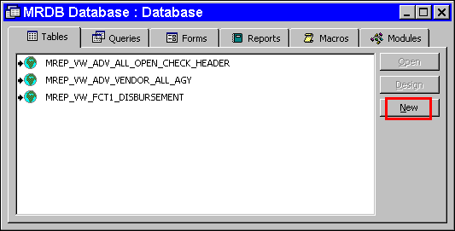

Linking FCT Tables
We are going to link the table views that we will need to accomplish our mission. We will link a FCT1 and FCT2 table view. We will also link a reference table before the topic is complete.

Step 1 On the Tables tab. Click the <NEW> button.

New table
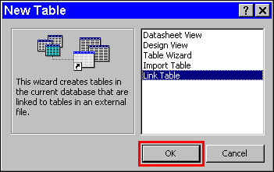

Step 2 On the New Table window. Highlight Link Table.

Step 3 Click the <OK> button.

Link tables
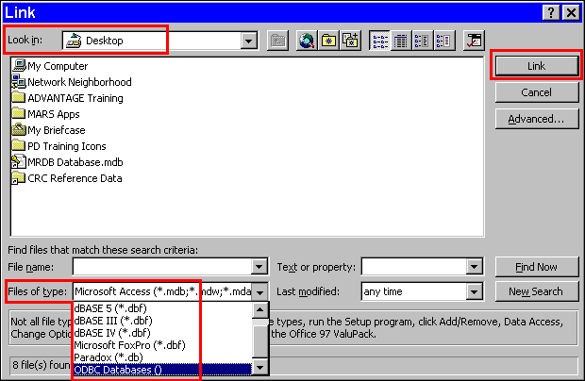

Step 4 In the FILES OF TYPE field. Select ODBC Databases(). The Select Data Source window is displayed.

Select data source
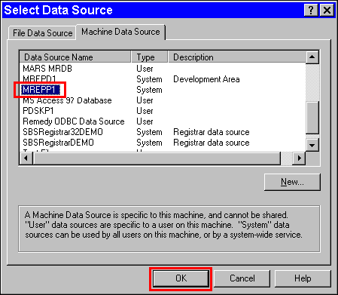

Step 5 On the Select Data Source window. Select the Machine Data Source tab.

Step 6 On the Machine Data Source tab. Highlight MREPP1.

NOTE: If your machine does not have MREPP1 to choose, go to Topic 1 and follow the steps to Add Data Source or contact your system administrator.

Step 7 On the Select Data Source window. Click the <OK> button. The Oracle Logon window is displayed.

ORACLE LOGON
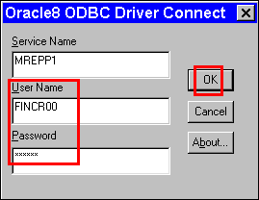

Step 8 On the Oracle Logon window in the USER ID field. Type Your USER ID.

Step 9 On the Oracle Logon window in the PASSWORD field. Type Your PASSWORD.

Step 10 On the Oracle Logon window. Click the <OK> button. The Link Tables window is displayed.

Expenditure and revenue FCT1 Tables
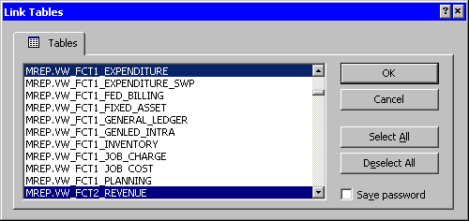

Step 11 On the Link Tables window. Highlight MREP.VW_FCT1_EXPENDITURE.

Step 12 On the Link Tables window. Highlight MREP.VW_FCT2_REVENUE.

NOTE: You can highlight all the desired table views before clicking the <OK> button.

Step 13 On the Link Tables window. Click the <OK> button. The Select Unique Record Identifier window is displayed.

Select Unique Record Identifier
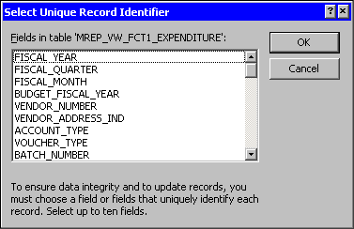

Step 14 On the Select Unique Record Identifier window. Click the <CANCEL> button each time it appears. The selected table views are displayed on the Tables tab of the database.

NOTE: The Select Unique Record Identifier window appears for each table view selected. When the Select Unique Record Identifier window comes up for each table, it is important NOT to select any field, therefore, just click the <CANCEL> button.

Fct tables added
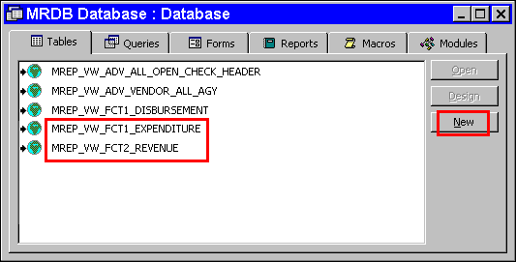

Creating a Query using the FCT1 Expenditure Table View
Now that we have the table views, we are ready to create the query to obtain the information our fiscal officer has requested from us.

Step 1 Select the Queries tab.

Step 2 Click the <NEW> button.

Step 3 On the New Query window. Highlight Design View.

Step 4 On the New Query window. Click the <OK> button. The Query is displayed in Design View and the Show Tables window is displayed in front it.

NEW QUERY
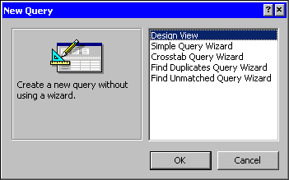

Show tables
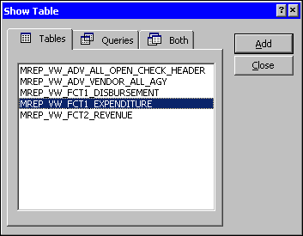

Step 5 On the Show Tables window. Highlight MREP_VW_FCT1_EXPENDITURE table view.

Step 6 On the Show Tables window. Click the <ADD> button.

Step 7 On the Show Tables window. Click the <CLOSE> button. The table view is added to the Query in the Design View.

Design View
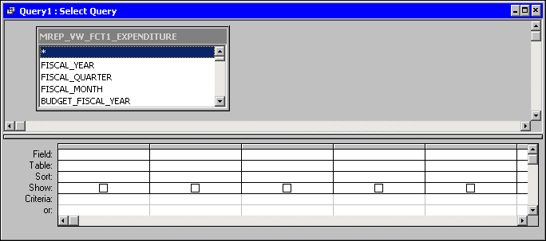

Properties Button
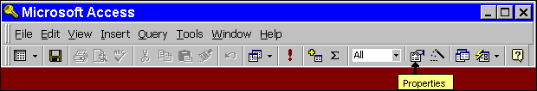

Step 8 On the Toolbar. Click the <PROPERTIES> button. The Query Properties window is displayed.

Query Properties
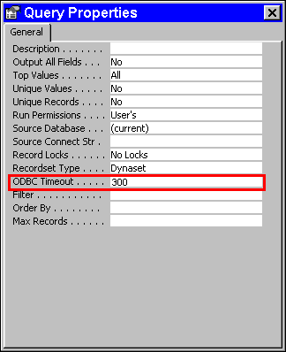

Step 9 In the ODBC TIMEOUT field. Highlight the defaulted 60. Type 300.

Step 10 On the Query Properties window. Click the 'X' in the upper right-hand corner. The Query Properties window closes and returns you back to the Query Design View window.

Step 11 On the Table Field List window. Highlight and double-click the following fields:

FISCAL_YEAR | PROG_BUDGET_UNIT
VENDOR_NUMBER | OBJECT
VENDOR_ADDRESS_IND | R_TRANSACTION_CODE
TRANSACTION_NUMBER | R_TRANSACTION_AGENCY
LINE_NUMBER | R_TRANSACTION_NUMBER
FUND | EXPENDITURE
AGENCY | LINE_DESCRIPTION

selecting Fields
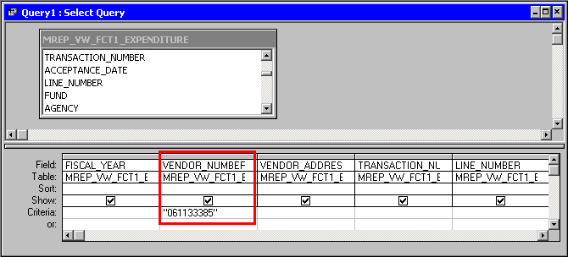

Step 12 In the VENDOR_NUMBER field and in the CRITERIA row. Type 061133385*.

Step 13 Click the <SAVE> button. The Save As dialog box is displayed.

Save As
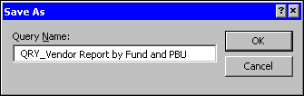

Step 14 In the QUERY NAME field. Type QRY_Vendor Report by Fund and PBU.

Step 15 Click the <OK> button.

Step 16 On the Toolbar. Click the <RUN> button. The query runs and the Query Results window is displayed.

Query Results
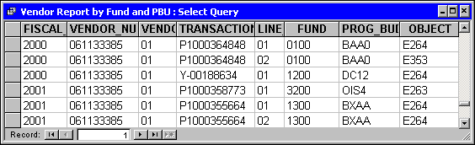

Step 17 On the Query Results window. Click the 'X' in the upper right-hand corner. The Query Results window closes.

We have now decided that the Agency's name on the query would be helpful to our fiscal officer. Let's go back and link to another table view and join the table views.

New Table
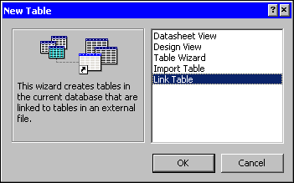

Adding Additional Table Views
Step 1 On the Table tab. Click on the <NEW> button.

Step 2 On the New Table window. Highlight Link Table.

Step 3 On the New Table window. Click the <OK> button.

Linking Table views
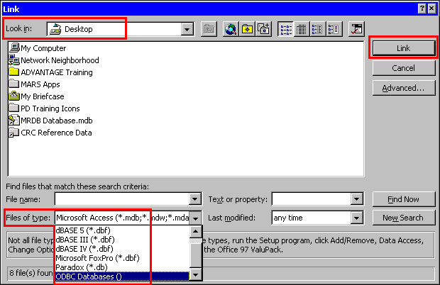

Step 4 On the Link window, in the FILES OF TYPE field. Select ODBC Databases().

Select data source
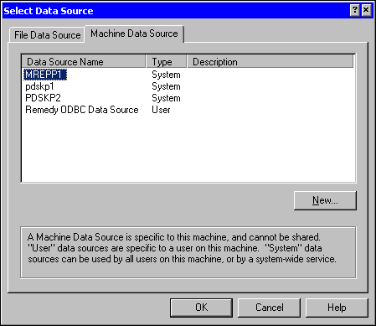

Step 5 On the Select Data Source window. Select the Machine Data Source tab.

Step 6 On the Machine Data Source tab. Select MREPP1.

Step 7 On the Select Data Source window. Click the <OK> button. The Oracle Logon window is displayed.

Step 8 On the Oracle Logon window in the USER ID field. Type Your USER ID.

Step 9 On the Oracle Logon window in the PASSWORD field. Type Your PASSWORD.

Step 10 On the Oracle Logon window. Click the <OK> button.

Link Tables
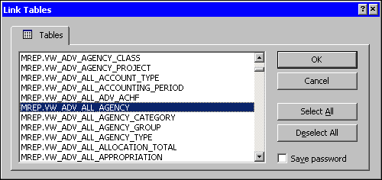

Step 11 On the Link Tables window. Select MREP_VW_ADV_ALL_AGENCY.

Step 12 On the Link Tables window. Click the <OK> button. The Select Unique Record Identifier window is displayed for each table view selected.

Select Unique Record Identifier
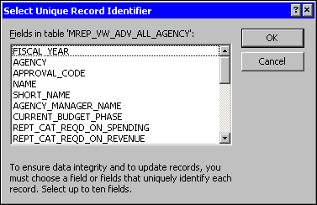

Step 13 On the Select Unique Record Identifier window. Click the <CANCEL> button.

We have successfully linked our MRDB table view. We are ready to create our query for the fiscal officer.

Queries tab
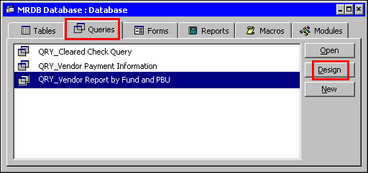

Step 14 Select the Queries tab.

Step 15 On the Queries tab. Highlight the Vendor Report by Fund and PBU query.

Step 16 On the Queries tab. Click the <DESIGN> button.

Show Tables Button
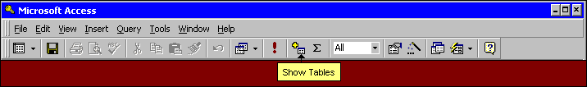

Step 17 On the Query Toolbar. Click the <SHOW TABLES> button.

Show table
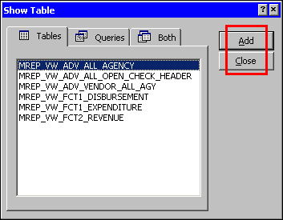

Step 18 On the Show Table window. Highlight MREP_VW_ADV_ALL_AGENCY.

Step 19 On the Show Table window. Click the <ADD> button and then the <CLOSE> button once the table is added.

Joining tables
Since there is a common field name on both of the tables we will add a join. To join fields that contain identical information highlight and drag the field from one table view to the field with like information in the table view to be joined.

Creating a join
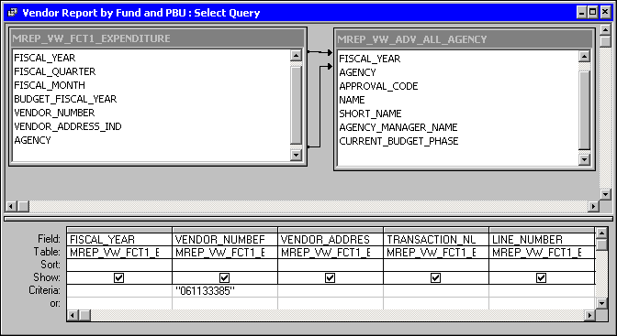

Step 20 On the Design View on the query in the MREP_VW_ FCT1_EXPENDITURE table. Highlight the FISCAL YEAR field hold your mouse button down and drag it to the FISCAL YEAR field in the MREP_ADV_ALL_AGENCY table view and release.

Step 21 On the Design View on the query in the MREP_VW_ FCT1_EXPENDITURE table view. Highlight the AGENCY field hold your mouse button down and drag it to the AGENCY field in the MREP_ADV_ALL_AGENCY table view and release.

Step 22 Highlight both lines created between the two tables and then double-click on them. You will have to do this one line at a time. The Join Properties window is displayed.

Join Properties
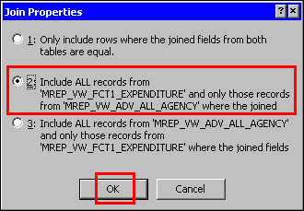

Since we want all the records from the FCT1 EXPENDITURE table view and only the NAME field from the ADV_ALL_AGENCY table, we will choose the second option on the Join Properties window.

Step 23 On the Join Properties window. Select the Number <2> radio button.

Step 24 On the Join Properties window. Click the <OK> button. Notice the arrow that appears.

Name field added
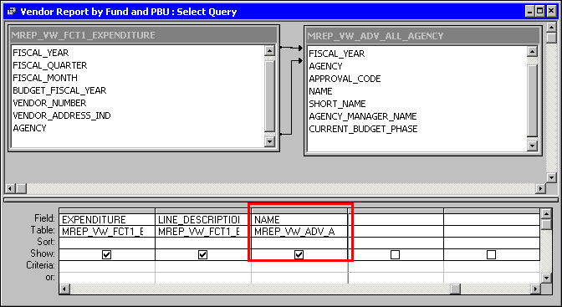

Adding a Field to a Query
We have created our query, join the necessary table views and now we need to add the agency’s name to the query.

Step 25 In the MREP_VW_ADV_ ALL_AGENCY table. Highlight the NAME field and double click.

Step 26 On the Design View of the query. Click the <SAVE> button.

Step 27 On the Toolbar. Select the <RUN> button. The Query Results window is displayed.

Step 28 On the Query Results window. Click the 'X' in the upper right-hand corner.

In working with linked tables it is important that the user know how to drop and add tables. We have added tables up to now. It is also important to know that any queries created using a table view will no longer work if the table view is deleted. Let's delete a table view and re-add it to our database.

Deleting a Table View
Step 1 On the Tables tab of the MRDB Database. Highlight the MREP_VW_FCT2_REVENUE table.

Step 2 On the Keyboard. Hit the <DELETE> button. A Warning dialog box is displayed.

DIALOG BOX
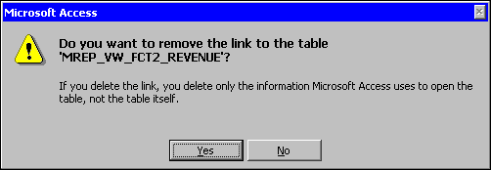

Step 3 On the Dialog Box. Click the <YES> button. The Revenue table view is deleted.

Exercise 1
Let's see how well you remember the steps in adding a table. Please take a few minutes and add the MREP_VW_FCT2_REVENUE table view back into the database.

Once you have completed adding the Revenue table view back into the database, we will create a query utilizing that table.

The Fiscal Officer has now decided that he would like to see if your section has made any sales. He would like it for FISCAL YEAR 2000, and broken down by FUND, and REVENUE CLASS. We will create the queries to obtain the necessary information. We will then export the data to Microsoft Excel to create our report.

Query tab
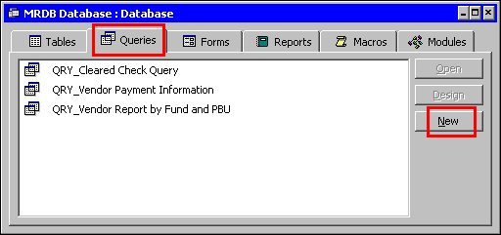

Creating a Query on the FCT2 Revenue Table View
Since you have already added the table view to the database, we will start with creating the query.

Step 1 Select the Queries tab.

Step 2 On the Queries tab. Click the <NEW> button.

New query

Step 3 On the New Table window. Highlight Design View.

Step 4 On the New Table window. Click the <OK> button. The Show Table window is displayed.

Show table

Step 5 On the Show Table window. Highlight the MREP_VW_FCT2_REVENUE table view.

Step 6 On the Show Table window. Click the <ADD> button and then the <CLOSE> button once the table is added.

Step 7 On the Toolbar. Click the <PROPERTIES> button. The Query Properties window opens.

Step 8 In the ODBC TIMEOUT field. Highlight the defaulted 60. Type 300.

Step 9 On the Query Properties window. Click the 'X' in the upper right-hand corner. The Query Properties window closes and returns you back to the Query Design View window.

Step 10 In the MREP_VW_FCT2_REVENUE table view. Highlight the following fields and double click:

FISCAL_YEAR | REVENUE_CLASS
FUND | REVENUE
REVENUE_SOURCE

FIELDS ADDED TO query
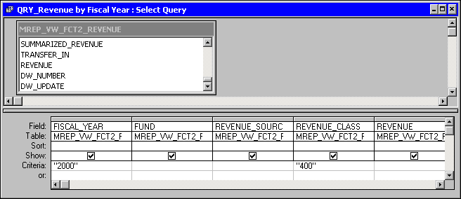

Step 11 In the FISCAL_YEAR field and the CRITERIA row. Type 2000.

Step 12 In the REVENUE_CLASS field and the CRITERIA row. Type 400.

Step 13 On the Design View of the query. Click the <SAVE> button. A Save As dialog box is displayed.

dialog box
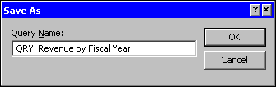

Step 14 In the Save As dialog box. Type QRY_Revenue by Fiscal Year.

Step 15 On the Save As dialog box. Click the <OK> button.

Step 16 On the Query Toolbar. Select the <RUN> button. The Query Results window is displayed.

Exporting Data
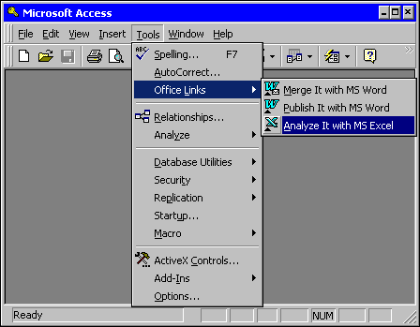

Exporting Data to Excel
Now that we have the data we need, we will export it to MS Excel to organize the data in a fashion that is acceptable for the Fiscal Officer.

Step 17 On the Menu Bar, select Tools: Office Links: Analyze it with MS Excel. Microsoft Excel opens and the data is displayed on a spreadsheet.

NOTE: Depending upon how the initial MS Access installation was achieved, some individuals may not have this portion of the Access program installed. To rectify this, you should contact your System Administrator and ask for the additional add on. If you do not have this add on you can use the 'copy and paste' method to get the data into Excel. Keep in mind that Excel has a limitation of 65,000 rows of data. However, column limitation will not be a problem.

Revenue data exported to excel
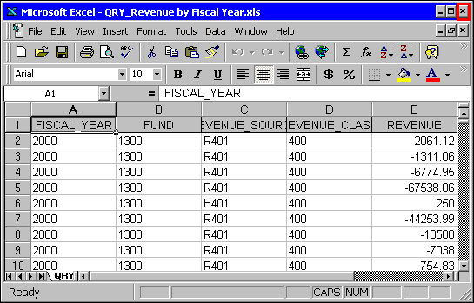

Once the data is in MS Excel, you can manipulate the data accordingly.

Step 18 On MS Excel window. Click the 'X' in the upper right-hand corner to close the application.

Step 19 On the Query Results window. Click the 'X' in the upper right-hand corner.


In this topic we have learned how to:

- Create a Query using the Design View

- How to Select Fields

- Setting Criteria

- Joining tables

- Export Data to MS Excel

- Saving and Running Queries



Are there any questions concerning the information covered in this topic?

