Topic 3 working with queries

purpose

The purpose of this topic is to familiarize the user with creating queries in Microsoft Access using the Design View and the Wizard. We will also discuss the MS Access query toolbar, menu, and properties functionality. We will join tables in a query and run queries using various criteria.

objectives

During this topic you will learn:

- Creating a Query using the Wizard

- Creating a Query using the Design View

- How to Select Fields

- Setting Criteria

- Joining tables

- Saving and Running Queries

Creating a Query with the Wizard
We are going to build the first query to provide us with all the detailed transactions of a particular vendor. There are multiple ways to build an Access query from tables. We will be looking at two; the Design View and Wizard. We will begin with the Wizard.

Query tab
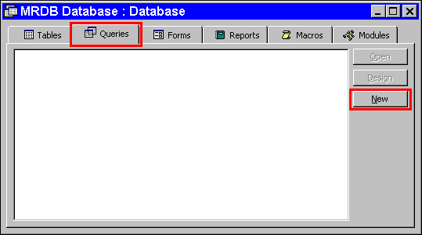

Step 1 On the MRDB Database. Click on the Query tab.

Step 2 Click on the <NEW> button.

New query
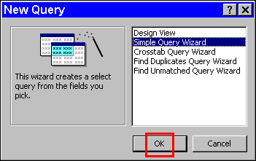

Step 3 On the New Query window. Highlight Simple Query Wizard.

Step 4 Click the <OK> button. The New Query window is displayed.

available fields
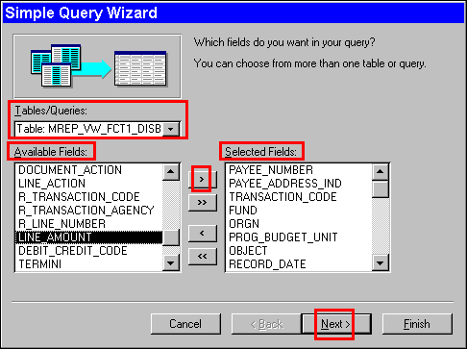

Step 5 In the Tables/Queries drop down box. Select the MREP_VW_FCT1_DISBURSEMENT table view.

Step 6 In the AVAILABLE FIELDS field. Select the following fields by either double-clicking on them or using the right arrow button:

PAYEE_NUMBER
PAYEE_ADDRESS_IND
TRANSACTION_NUMBER
FUND
ORGN
PROG_BUDGET_UNIT
OBJECT
RECORD_DATE
R_TRANSACTION_ NUMBER
R_LINE_NUMBER
LINE_AMOUNT

Step 7 Click the <NEXT> button. The Detail/Summary window is displayed.

detail button
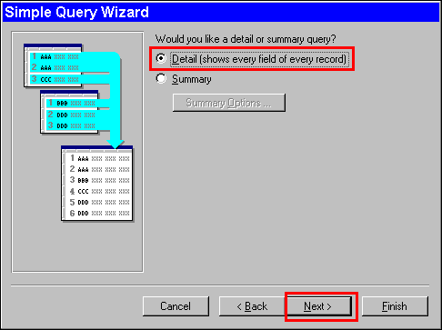

Step 8 In the DETAIL (SHOWS EVERY FIELD OF EVERY RECORD) field. Leave As Is.

Step 9 Click the <NEXT> button. The Title Option window is displayed.

title option
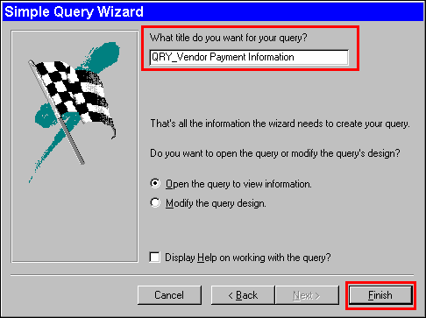

Step 10 In the TITLE field. Type Qry_Vendor Payment Information.

Step 11 Click the <FINISH> button. The Simple Query Wizard window closes. The query runs and the Query Results window is displayed.

Query Results Window
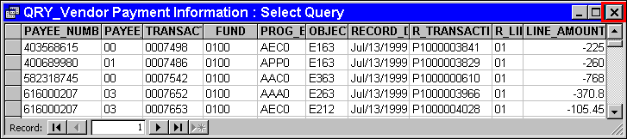

Query Toolbar
As with most software applications there are at least three different ways to accomplish any given task. Through out this course we will use the toolbar as the primary way to accomplish our goal. Therefore, let's take a few minutes and become familiar with the Query Toolbar before we go any further. We will briefly go over each one of these functions. The list below is provided to give you an overview of the toolbar.

Query Toolbar
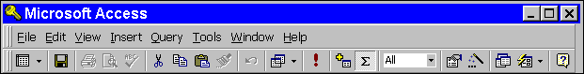

Function Definition
View Allows user to changes between design view, datasheet view, and SQL view.

Save Saves the query.

Query Type Allows you to select a query type.

Run Retrieves the information from the linked table views according to the CRITERIA fields.

Show Tables… Show all tables that have been linked.

Totals An Aggregate function with at least nine options.

Top Values Allows you to pick the number of top values.

Properties Allows particular functions to be set for the query.

Expression Builder Allows you to build a Expression within the query.

Database Window Moves you to the Database window.

New Object Allows you to add a new object.

Office Assistant Provides help for any number of topics.

Now that you understand the Query Toolbar, let's continue.

Step 12 Click on the 'X' in the upper right-hand corner. The Query Results window closes.

The first thing that should be done when building queries is to ensure that there is enough ODBC TIMEOUT to complete the query. The default timeout is only 60 seconds and that is not enough time to run a query that has MRDB tables linked in it. The ODBC TIMEOUT field can be edited on Query Properties window in the Design View.

design button
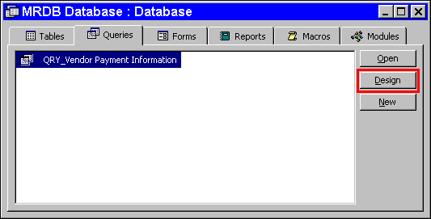

Step 13 On the Queries tab. Highlight Qry_Vendor Payment Information.

Step 14 Click the <DESIGN> button.

Properties
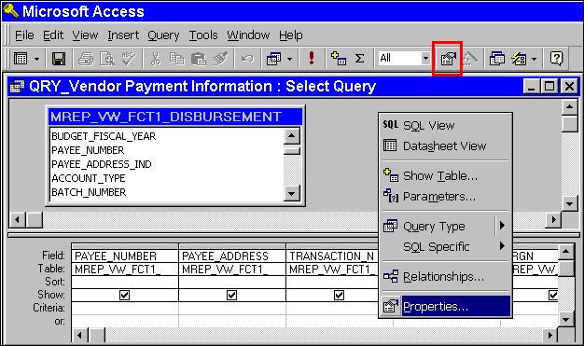

Step 15 In the Query Design View. Right click in the gray open area of the query.

Step 16 On the Query Toolbar. Click the <PROPERTIES> button.

Query properties window
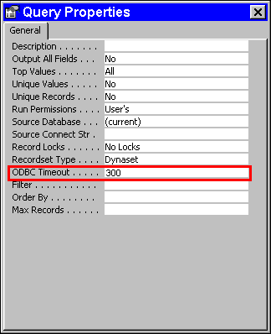

Step 17 In the ODBC TIMEOUT field. Type 300.

Step 18 On the Query Properties window. Click the 'X' in the top right-hand corner.

The next thing that we need to do to our query to make it more useful is to add a parameter. Parameters help us narrow down the search. If this is not done then every transaction will show up in our query. Parameters are good when you will use the same query or report to look up several different values. For example, the VENDOR NUMBER.

NOTE: When using the Like statement it is always a good idea to use the asterisk (*) with the data request. The asterisk (*) is a wildcard and when used in record selections will return all records with like values that are specified by the user. The asterisk (*) is not restricted to exact matches.

Setting Parameters
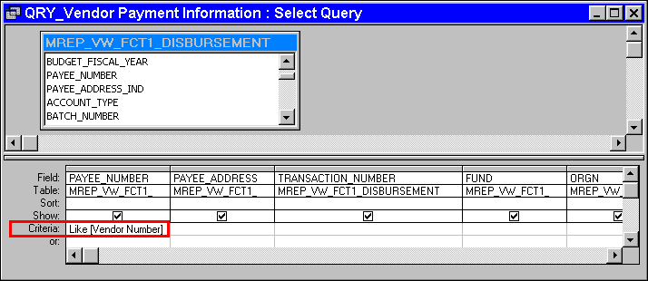

Step 19 In the Design View of the Query under the column PAYEE_NUMBER field and in the row CRITERIA. Type Like [Vendor Number].

NOTE: If any of the lines below the 'Criteria' line are used, ALL 'Criteria' will need to be copied to the line used. (Instructor will demonstrate.)

Step 20 On the Toolbar. Click the <RUN> button. The Enter Parameter Value window is displayed.

ENTER PARAMETER VALUE
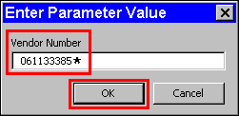

Step 21 In the VENDOR NUMBER field. Type 061133385*.

Step 22 Click the <OK> button. The Query Results window is displayed with the data for the specified VENDOR NUMBER in it.

Step 23 In the TRANSACTION_NUMBER field column. Write one of the 7-digit check number here: _ _ _ _ _ _ _.

Query Results
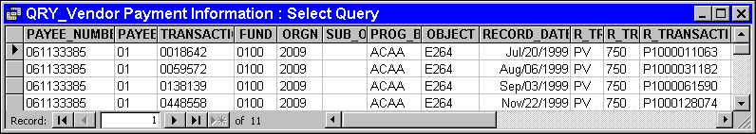

Step 24 On the Query Results window. Click on the 'X' in the right-hand corner. The Query Results window closes and a Save Dialog box is displayed.

NOTE: Each time you make a change to the Query Design View the Save Dialog box will appear.

Save Dialog Box
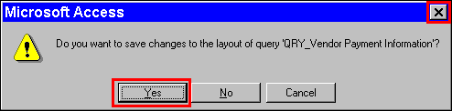

Step 25 Click the <YES> button. The Query Design View closes.


We have now completed our first query to obtain the vendor information we need for our scenario. The next query will we build will be titled Cleared Check Query. It is to look up check number to see if the money has cleared the bank. We want to ensure that all the checks written to the vendor has cleared the bank. We will build two additional queries using the Design View latter in this topic.

NEW QUERY
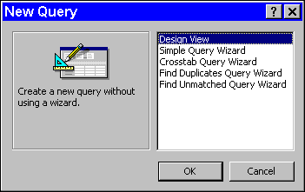

Creating a Query in the Design View
Step1 On the Queries tab. Click the <NEW> button.

Step 2 On the New Query window. The default is Design View. Leave As Is.

Step 3 Click the <OK> button. The Show Tables window is displayed.

Step 4 On the Show Tables window. Highlight MREP_VW_ADV_ALL_OPEN_CHECK_HEADER.

Step 5 On the Show Tables window. Click the <ADD> button.

Step 6 On the Show Tables window. Click the <CLOSE> button.

Step 7 On the Toolbar. Click the <PROPERTIES> button.

Step 8 In the ODBC TIMEOUT field. Highlight the defaulted 60. Type 300.

Step 9 On the Query Properties window. Click the 'X' in the upper right-hand corner.

Step 10 On the Table Field List window. Highlight and double-click the following fields:

BANK_ACCOUNT_CODE
CHECK_ID
CHECK_DATE
CHECK_AMOUNT
CLEARED_DATE
INTERCEPT_AMOUNT

Design View
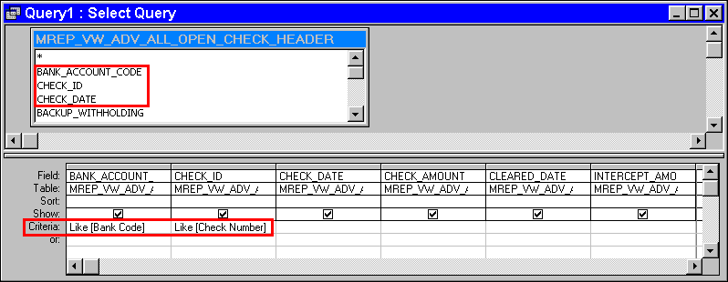

Step 11 In the BANK_ACCOUNT_CODE CRITERIA field. Type Like [Bank Code].

Step 12 In the CHECK_ID CRITERIA field. Type Like [Check Number].

Step 13 Click the <SAVE> button. The Save As Dialog Box is displayed.

Save As
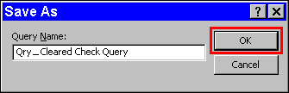

Step 14 In the QUERY NAME field. Type Qry _ Cleared Check Query.

Step 15 Click the <OK> button.

Step 16 On the Toolbar. Click the <RUN> button. The Bank Code Enter Parameter Value window is displayed.

Bank code parameter
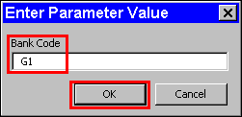

Step 17 In the BANK CODE field. Type G1.

NOTE: The selection criteria is always case sensitive.

Step 18 Click the <OK> button. The Check Number Enter Parameter Value window is displayed.

Step 19 In the CHECK NUMBER field. Type AD (all caps) then the number you wrote down on Page 9 followed by an asterisk (*).

Step 20 On the Enter Parameter Value window. Click the <OK> button.

check number parameter
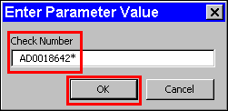

Query Results
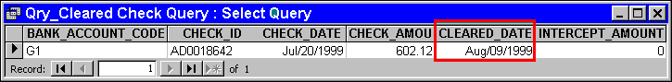

Step 21 On the Query Results window. Click the 'X' in the upper right-hand corner. The Query Results window closes.

NOTE: If the check has not cleared the bank, then the date will come back as January 01, 1900. This is because the CLEARED_DATE field has been formatted for a date on the table view and when no date is available it defaults to the first date which is January 01, 1900.

We need to ensure that all the desired fields are on the query. In our case, we now decide we need the vendor's name on the query. Let's go back and link to another table and discuss table joins and relationships.

New Table
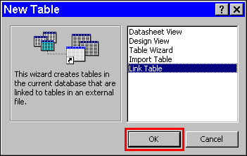

Adding Tables
Step 1 On the Table tab. Click on the <NEW> button.

Step 2 On the New Table window. Highlight Link Table.

Step 3 On the New Table window. Click the <OK> button.

Table link
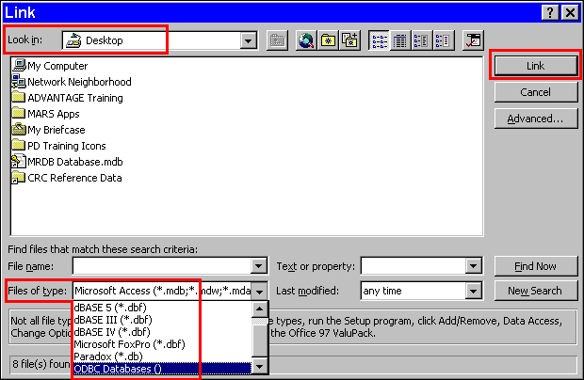
Step 4 On the Link window, in the FILES OF TYPE field. Select ODBC Databases().

Select data source
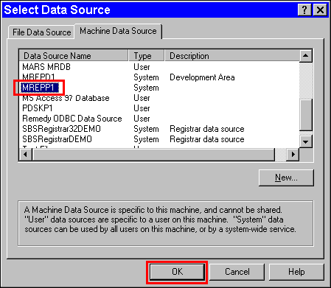

Step 5 On the Select Data Source window. Select the Machine Data Source tab.

Step 6 On the Machine Data Source tab. Select MREPP1.

Step 7 On the Select Data Source window. Click the <OK> button. The Oracle Logon window is displayed.

Oracle Logon
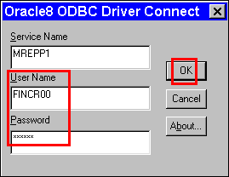

Step 8 On the Oracle Logon window in the USER ID field. Type Your USER ID.

Step 9 On the Oracle Logon window in the PASSWORD field. Type Your PASSWORD.

Step 10 On the Oracle Logon window. Click the <OK> button.

Link Tables
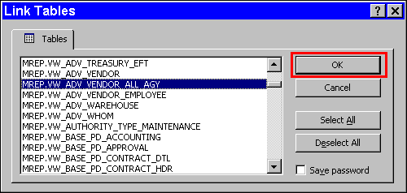

Step 11 On the Link Tables window. Select MREP.VW_ADV_VENDOR_ALL_AGY.

Step 12 On the Link Tables window. Click the <OK> button.

Select Unique Record Identifier
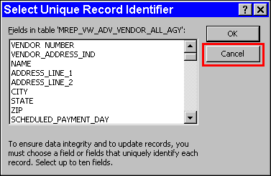

Step 13 On the Select Unique Identifier window. Click the <CANCEL> button.

Queries tab
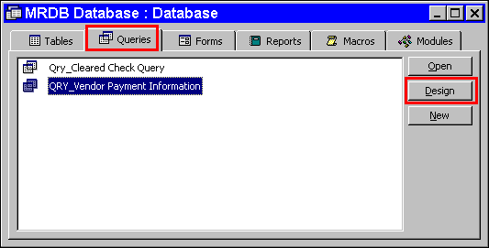

Step 14 Select the Queries tab.

Step 15 On the Queries tab. Highlight the Qry_Vendor_Payment Information query.

Step 16 On the Queries tab. Click the <DESIGN> button. The Query is displayed in the Design View.

Design View
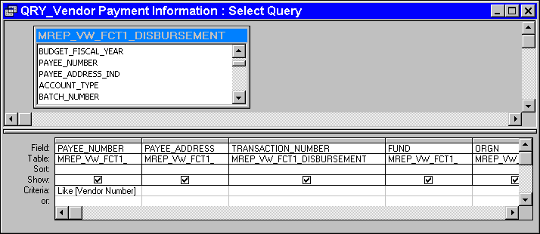

Show Tables button
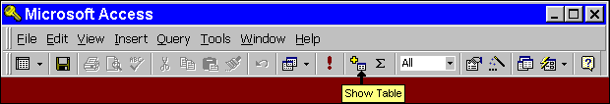

Step 17 On the Query Toolbar. Click the <SHOW TABLES> button.

Show table
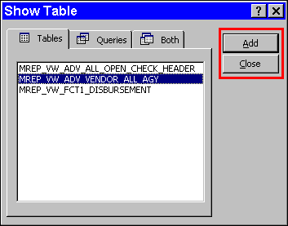

Step 18 On the Show Table window. Highlight the MREP_VW_ADV_VENDOR_ALL_AGY table view.

Step 19 On the Show Table window. Click the <ADD> button and then the <CLOSE> button once the table is added.

NOTE: You can double-click when desired table is highlighted on the Show Table window.

Joins and Relationships
When you have a query with multiple-tables, MS Access automatically joins the tables on the common field names. If there are no common field names, the table is added to the query but remains unjoined. To join fields that contain identical information but have different field names highlight and drag the field from one table to the field with like information in the table to be joined.

Relationships established at the table level take precedence over those done at the query level. If there are relationships created between tables, the join lines are automatically displayed when you add related tables in the query Design view. There are four groups of relationships between tables:

- One to one - used to relate one record to one record between tables

- One to many - used to relate one record to many records between tables

- Many to one - (also called the lookup table relationship) used to related many records to a single record between tables

- Many to many - (the hardest to understand) a pair of one-to-many relationships between two tables

You can create relationships in the Database window by selecting Tools then Relationships from the menu bar or clicking the Relationship button on the toolbar. When the Relationship window appears it is blank. You can add tables using the Show Tables button on the toolbar. To create a link between two tables, select the common field from one table and drag it over the common field in the other table, then drop it.

CAUTION: Join properties selected are extremely critical. The data extracted from the MRDB can be incorrect if the join is not properly accomplished. To be sure that the data retrieved is correct, select a known value and then run the query with the join in place, using the known value criteria. If a numeric match is accomplished then the join is correct. If the numeric values do not match the join is incorrect and must be changed.

Relationship flowchart

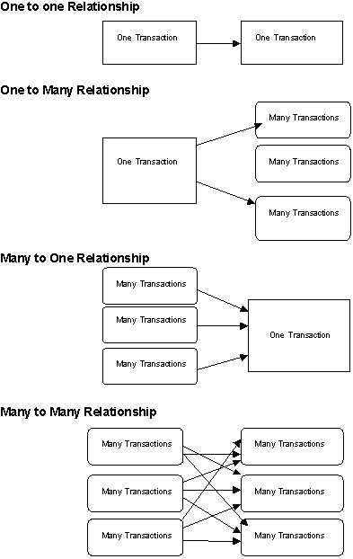

Tips for Successful Joins
- Order the tables so that the primary (FCT) table is first and the lookup (reference) table is second.

- Join all key fields. You may locate the key fields of the lookup (reference) table by using Data Dictionary.

NOTE: All key fields should be present on both tables to establish a successful join.

- Set the Join Properties on all key fields. For most joins you will select Option 2, the Left Outer Join.

- Double-check your results to ensure the join is working as anticipated.

Creating a join
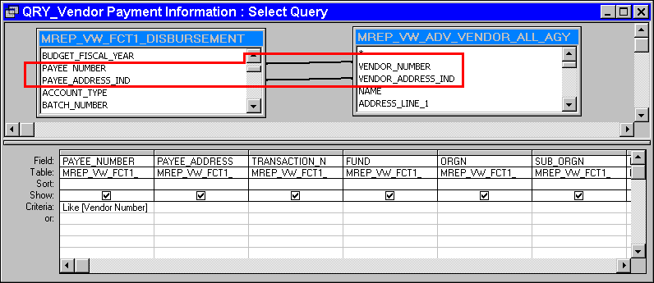

Step 20 On the Design View on the query in the MREP_VW_ FCT1_DISBURSEMENT table. Highlight the PAYEE NUMBER field hold your mouse button down and drag it to the VENDOR NUMBER field in the MREP_VW_ADV_VENDOR_ALL_AGY table and release.

Step 21 On the Design View on the query in the MREP_VW_ FCT1_DISBURSEMENT table. Highlight the PAYEE_ADDRESS_IND field hold your mouse button down and drag it to the VENDOR_ADDRESS_IND field in the MREP_VW_ADV_VENDOR_ALL_AGY table and release.

Step 22 Highlight the line created between the two tables and then double-click on it. The Join Properties window is displayed.

Join Properties
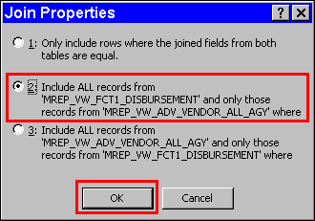

Since we want all the records from the FCT1 DISBURSEMENT table view and only the VENDOR NAME field from the ADV_VENDOR_ALL_AGY table view, we will choose the second option on the Join Properties window.

Step 23 On the Join Properties window. Select the Number <2> radio button.

Step 24 On the Join Properties window. Click the <OK> button. Notice the arrow that appears.

Remember that we had decided that we wanted the vendor’s name on our query. We have link to the appropriate table and have performed our join. Now we are ready to add that NAME field to our query.

Name field added
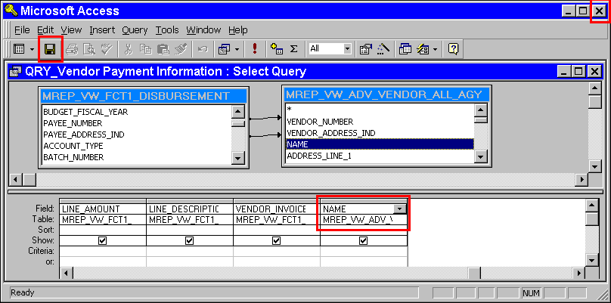

Adding a Field to a Query
Step 25 In the MREP_ADV_VENDOR_ALL_AGY table. Highlight the NAME field and double click.

Step 26 On the Design View of the query. Click the <SAVE> button.

Step 27 On the Design View of the query. Click the 'X' in the upper right-hand corner.



In this topic we have learned how to:

- Create a Query using the Wizard

- Create a Query using the Design View

- Select Fields

- Setting Criteria

- Joining Tables

- Saving and Running Queries



Are there any questions concerning the information covered in this topic?

