topic 2 creating a database

PURPOSE

The purpose of this topic is to familiarize you with creating databases in Microsoft Access using linked MRDB tables.

objectives

You will learn the following during this topic:

- Establishing a Data Source

- Creating MS Access databases

- Linking MRDB tables

- Saving MS Access databases
Before creating a database to house your MRDB tables, you will have to determine if you have an ODBC driver established or not. Your technical staff may have already established one for you, if so, you are ready to create your database. If not, you will need to follow the steps below to establish an ODBC driver for the MARS Management Reporting Database (MREPP1).

Creating a Data Source
Step 1 Click the <START> button located at the bottom left corner of your screen.

Step 2 On the Start Menu, select Settings: Control Panel.

Desktop
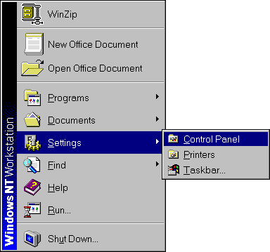

Control panel
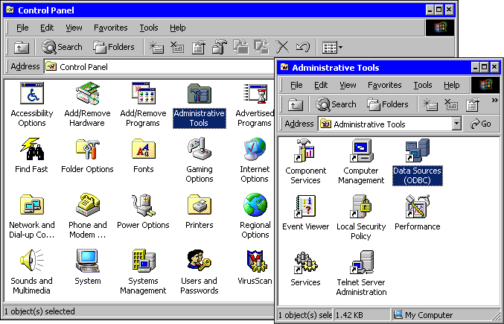

Step 3 On the Control Panel. Highlight Administrative Tools icon and double-click. The Administrative Tools folder is displayed.

Step 4 In the Administrative Tools folder. Highlight the Data Sources (ODBC) icon and double-click. The ODBC Data Source Administrator window is displayed.

Odbc data source administrator
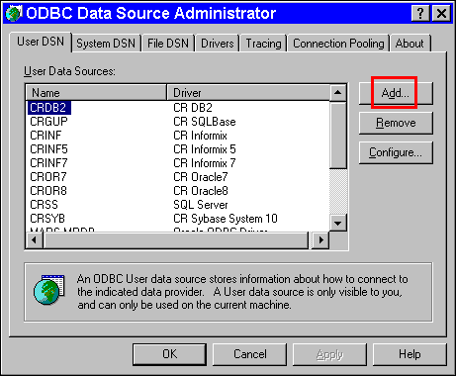

Step 5 On the ODBC Data Source Administrator window. Click the <ADD> button. The Create New Data Source window is displayed.

Create new Data Source
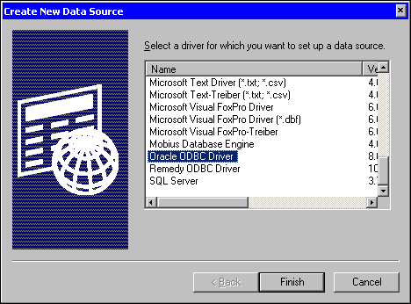

Step 6 On the Create New Data Source window. Select the Oracle ODBC 8.0 driver.

Step 7 Click the <FINISH> button. The Oracle8 ODBC driver Setup window is displayed.

Oracle8 ODBC driver Setup
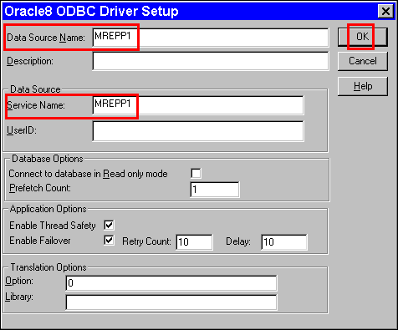

Step 9 In the DATA SOURCE NAME field. Type MREPP1.

Step 10 In the SERVICE NAME field. Type MREPP1.

Step 11 On the Oracle8 ODBC driver Setup window. Click the <OK> button.

Step 12 On the ODBC Data Source Administrator window. Click the <OK> button.

Step 13 On the Control Panel. Click the 'X' in the upper right hand corner.

Your Data Source has been established and you are ready to start linking to the MRDB table views.

NOTE: It is strongly recommended that you leave the USERID field blank.


For this course, your mission will be to create a Microsoft Access database utilizing MRDB table views to provide vendor information to your budget personnel. During this course you will perform the necessary functions within the MS Access database to accomplish your mission in an effective manner which will include creating and modifying queries, forms, and reports.

It would be to the user’s advantage to create one database to house all the MRDB table views necessary to do any queries, reports, or forms. In doing so, the user would only have to link to the MRDB table view once.

CREATE NEW DATABASE
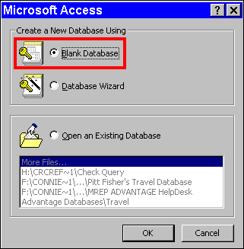

NOTE: Microsoft Access allows 1 GB for data per database.

Creating a New MS Access Database
Step 1 Open Microsoft Access.

Step 2 On the Microsoft Access window. Select Blank Database. The File New Database window is displayed.

Step 3 On the Create a New Database window. Click the <OK> button.

NOTE: If you have already created a database with the desired tables then you would select OPEN EXISTING FILES.

file new database
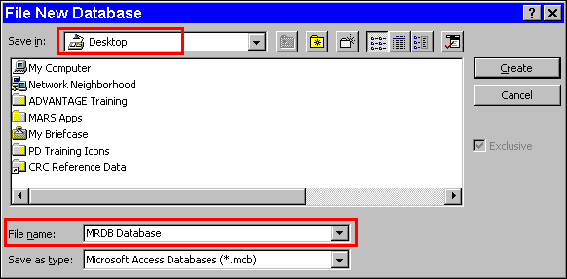

Step 4 In the SAVE IN: field. Select Desktop from the drop down box.

Step 5 In the FIELD NAME field. Type MRDB Database.

Step 6 Click the <CREATE> button. Your MRDB Database: Database is displayed.

Your database has been created and saved to your desktop. You are ready to add tables, queries, forms, and reports to your database.

mrdb database
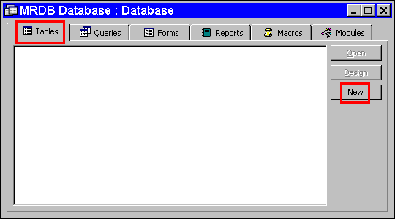

new table
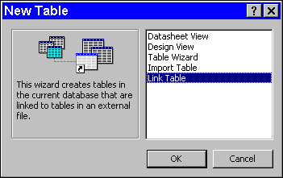

Step 7 On the Table tab. Click the <NEW> button.

Step 8 On the New Table window. Highlight Link Table.

Step 9 Click the <OK> button. The Link window is displayed.

link
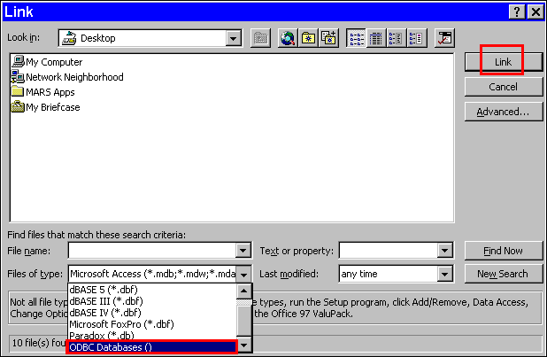

Data Source
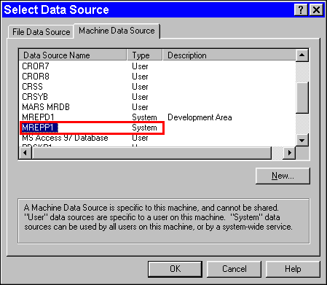

Step 10 In the FILES OF TYPE field. Select ODBC Databases(). The Select Data Source window is displayed.

Step 11 On the Select Data Source window. Select the Machine Data Source tab.

Step 12 On the Machine Data Source tab. Highlight MREPP1.

NOTE: If your machine does not have MREPP1 to chose, go back to the beginning of this topic and follow the steps to Add Data Source or contact your system administrator.

Step 13 Click the <OK> button. The Oracle8 ODBC Driver Connect window is displayed.

oracle logon screen
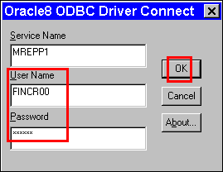

Step 14 On the Oracle8 ODBC Driver window. Enter Your USER ID.

Step 15 On the Oracle 8 ODBC Driver window. Enter Your ORACLE password.

Step 16 Click the <OK> button. The Link Tables window is displayed.

NOTE: The Oracle Logon window will appear each time you access a different table or go out of MS Access. If your password is not entered correctly or the system is in Restricted Mode, or the ODBC Timeout is not high enough you will receive the error message below. You can check the MARS News and Alert site at http://www.state.ky.us/agencies/adm/mars/alerts/marsnewsalerts.htm

Error message
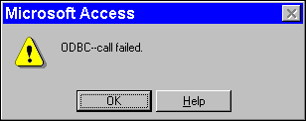

link tables
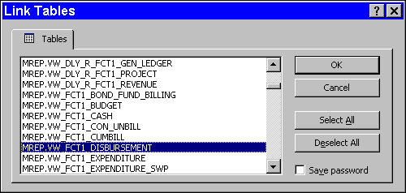

Step 17 On the Link Tables window. Highlight MREP. VW_ADV_ALL_OPEN_CHECK_HEADER.

Step 18 On the Link Tables window. Highlight MREP.VW_FCT1_DISBURSEMENT.

NOTE: You can highlight all the desired table views before clicking the <OK> button.

Step 19 On the Link Tables window. Click the <OK> button.

unique record identifier
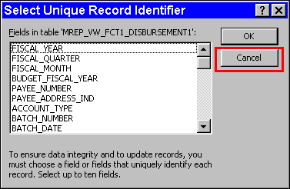

Step 20 On the Select Unique Record Identifier window. Click the <CANCEL> button each time this window is displayed.

NOTE: The Select Unique Record Identifier window appears for each table view selected. When the Select Unique Record Identifier window comes up for each table, it is important NOT to select any field, therefore, just click the <CANCEL> button.

mrdb database
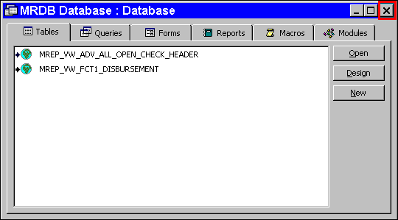

The selected tables appear on the Tables tab of the database.

Let's do one practice of closing and opening the database so that you can see where it is stored and how to retrieve it.

Step 21 Click the 'X' in the upper right-hand corner of the Microsoft Access window. The MRDB Database closes.

Open database from desktop
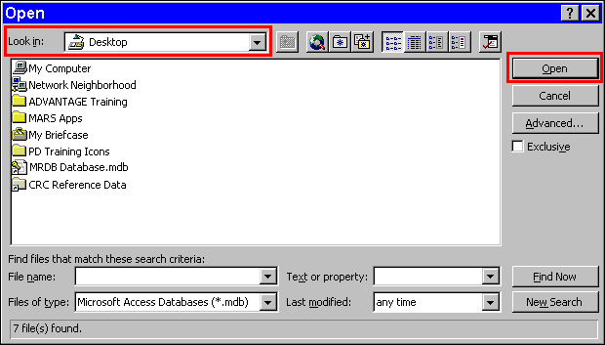

Step 22 On the Menu Bar, select File: Open Database.

Step 23 On the Open window. Select MRDB Database.

Step 24 Click the <OPEN> button. The MRDB Database is displayed.

Now that we have created our database and have link to some MRDB table views we are ready to create and run queries.



In this topic we have learned how to:

- Established a Data Source

- Create a database

- Link MRDB tables



Are there any questions concerning the information covered in this topic?

