topic 1 OVERVIEW

PURPOSE

The purpose of this topic is to familiarize you with the tables, views and naming convention within the Management Reporting Database (MRDB). This topic will also cover Oracle security and passwords, which is needed to access the MRDB data.

objectives

During this topic you will cover:

- MRDB Review
- MRDB Tables
- MRDB Views
- MRDB Structure and Naming Conventions
- Data Dictionary
- MRDB and Oracle Security

MRDB Review
The Management Reporting Database (MRDB) is the name given to an Oracle database where data is downloaded nightly from the Management Administrative Reporting System (MARS) system.

MRDB Tables
The downloaded data is placed into table spaces. The tables are broken out by business areas. Currently there are nine different business areas defined which include:

- General Accounting
- Budget
- Cash Flow
- Disbursement
- Expenditure
- Inventory
- Job Costing
- Grants/Project Billing
- Revenue

The MRDB tables contain both detail and summary level information. The detail information is at the line level while the summary rolls up to the document level.

As a transaction is processed in the ADVANTAGE Financial system through a document (a PV document for example), it may contain multiple lines. Each line within the document will then be posted in a ledger file. This information is selectively captured from ADVANTAGE Financial during the MRDB nightly cycle through a set of cleansing programs. The result of this process is then stored in the appropriate MRDB table space. An example of a MRDB table would be FCT1_Expenditure. This table contains expenditure transactions.

Currently there are approximately 350 tables within the MRDB. This number will continue to grow as new tables are built.

Basic users do not have direct access to the table spaces in the MRDB; therefore, risk of deleting information is improbable. So how do you get to the information contained within these tables? Let’s discuss views.

MRDB Views
Like most databases, the MRDB tables may contain certain information that is needed in order to perform routine maintenance, to ensure data integrity (i.e. record update/insert flags and date/time stamps). Such data serves no purpose to the general reporting audience. Therefore, views are created to provide a means of filtering out unnecessary data while providing the data elements needed to address reporting needs. A view may contain all or some of the columns used within a table or group of tables, depending on the reporting need.

The MRDB also contains views that have been created to support reporting templates such as those available within the Seagate reporting software.

Currently there are approximately 563 views within MRDB. Just like the tables, this number will continue to grow as new views are built to meet reporting needs.

MRDB Structure and Naming Convention
We have discussed the various types of tables and views available within the MRDB. Now lets take a closer look at the structure and naming convention of the MRDB. Becoming familiar with the MRDB structure and naming convention will assist you in identifying where to go to get the data you need for your report(s).

The types of tables currently available within MRDB include; daily tables, tier tables (known as Fact tables) and references tables.

The diagram below displays the hierarchical structure of the MRDB tables, views and report templates.

MRDB Structure and Naming Convention
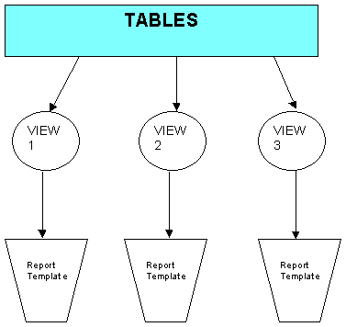

The information below provides you with the view prefix, a short definition of the view and what type of view it is.

VIEW INFORMATION

View Name Prefix | Short Description | Type of View
MREP.V#  (followed by a number, i.e. 750) | Created to meet agency specific needs. | Custom Data
MREP.VW_# (followed by a number, i.e. 1050) | Created to support the Seagate report template layouts. | Report Data View
MREP.VW_ADV | Provides ADVANTAGE Reference data. | Reference Data
MREP.VW_DLY | Provides ADVANTAGE Daily transaction data from previous business day. | Daily Data View
MREP.VW_FCT1 | Provides ADVANTAGE detail level data.  (Document and line level detail) | Tier I
MREP.VW_FCT2 | Provides ADVANTAGE summary level data. | Tier II
MREP.VW_FCT3 | Provides condensed summary level data of the ADVANTAGE FCT1 data. | Tier III
MREP.VW_PD | Provides Procurement Desktop (PD) data. | PD System Views

Let’s take a closer look at some of the MRDB views most commonly used.

Tier I – Line/Document Level Detail (FCT1 )
The Tier I table views are recognized by the prefix FCT1. For example, the Tier I Expenditure table view is named MREP.VW_FCT1_EXPENDITURE and contains the transaction line level information.

In some cases, two table views may be combined into a single view by the Central Finance Team. For example, the MREP.VW_FCT1_EXPENDITURE and MREP.VW_FCT1_PLANNING are combined to create the MREP.VW_FCT1_PLANNING_EXPENDITURE table view as shown in the image below:

FCT1 TABLE ViewS
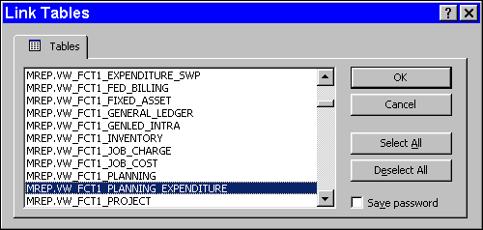

The FCT1 detail table views represent data at the document and line level. These table views are NOT uniquely keyed; they behave like a sequential file. Therefore, although it is physically possible to link two or more FCT1 table views, it is not recommended. The reason is because such a link produces unpredictable results. Tier I table views are so large that it is difficult to use them for referencing information in queries and reports. That is where Tier II table views comes into play.

Tier II – Summary Level Detail (FCT2 )
The Tier II table views are designed to present a summary of accounting information. These table views are actually a summary of the Tier I data. Tier II combines like information, making it easier to find the desired information. The image below reflects the Tier II Expenditure, Planning and Expenditure Planning table views.

FCT2 TABLE viewS
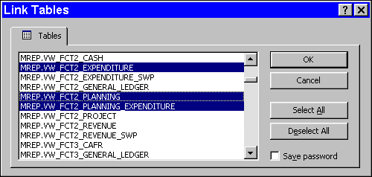

Tier II table views are keyed by their accounting distribution. If you are designing a query or report that does not need transaction and/or line level data, you will want to use a view of a FCT2 table view. FCT1 table views require a great deal of network resources and you only want to use them when line level data is absolutely necessary for your query or report.

Tier III Tables/Views – Line Level Detail (FCT3)
The FCT3 table views summarize the FCT1 table views at a higher level. The FCT3 table views summarize information to the Statewide Required Element level.

ADVANTAGE Reference Table Views
ADVANTAGE reference table views contain information that is redundantly used throughout the system. The use of reference table views eliminates the need to store this data in multiple places. Storing the data once and linking back to it as needed provides a more efficient means of utilizing the database storage. Examples of reference table views include but are not limited to; agency, agency class, fiscal year, object, object class, fund, etc. The information in these table views is downloaded into the MRDB and made available for reporting. Some users may prefer using the agency name within their report or query instead of the agency number; the use of reference table views makes this possible.

The ADVANTAGE reference table views are identified with the letters VW_ADV, while Procurement Desktop reference table views are identified by VW_PD_REF.

Knowing What Table View To Link
Knowing what table views to use is a big part of designing a query or report. A good starting point to assist you in identifying the type of data and view(s) needed would be to step through the following list of questions:

- What is the purpose or objective for the report? (i.e. identify all office supply expenditures)

- Is detail or summary level information needed? (i.e. Does my audience need to see line level information or rolled up totals)

- What type of data is needed? (i.e. expenditure, allotment)

- What fields are needed in the query/report? (i.e. fiscal year, fund, agency, org, object code, object class, amount, vendor name and number)

- Is year-to-date (YTD) or daily data needed?

By identifying the type of data needed you can narrow down the view selection. For example, if you were needing summary information you would not want to link to the MREP.VW_FCT1_EXPENDITURE table view. The MREP.VW_FCT2_EXPENDITURE table view provides the summary level information. However, if you are looking for detailed expenditure information, then the MREP.VW_FCT1_EXPENDITURE table view is what you would use.

Another tool available to assist you in identifying your data source is the Data Dictionary. The dictionary is a composite of definitions and data columns stored within MRDB. This tool will assist you in designing reports and queries by providing descriptive information about the data elements within the MRDB.

What Is the Data Dictionary?
The Data Dictionary is a composite of definitions for the views and data columns stored within the Management Reporting Database (MRDB) in MARS. The dictionary tool is intended to assist you in designing reports and queries through providing descriptive information about the data elements within the MRDB. In addition, the Data Dictionary can assist you in locating where within MRDB you can find the data you need.

How Can I Get to the Data Dictionary?
To access the Data Dictionary, you will need to add a shortcut on your desktop.

Step 1 Go to your desktop.

Step 2 On your desktop. Right click your mouse.

Step 3 On the Shortcut window. Select New: Shortcut.

Create Shortcut
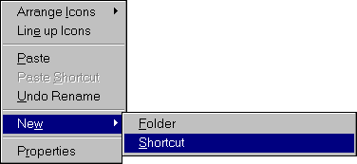

Step 4 In the Command line, key in or copy the appropriate directory path:

\\Kymarssa2\MRDBDataDict\DataDictProd.mde (for Access 97 users)

\\Kymarssa2\MRDBDataDict\MRDBData2000.mde (for Access 2000 users)

Step 5 Click the <Next > button.

NOTE: To copy the directory path into the Command line, highlight the path name listed above, on the Menu Bar, select Copy: Edit. Go back to your desktop, click in the Command line of the Create Shortcut screen, and hit the Ctrl V keys on your keyboard.

Create Shortcut Window
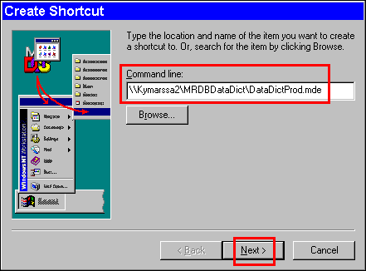

Step 6 In the SELECT A NAME FOR THE SHORTCUT field. Type Data Dictionary. This will label the icon shortcut on your desktop.

Step 7 On the Select a Title for the Program window. Click the <Finish> button. This will create a shortcut icon on your desktop for the Data Dictionary. To open the dictionary, just double click on the icon.

NOTE: The web site for MRDB is http://www.state.ky.us/agencies/adm/mars/mrdb.html You can go here and use the copy and paste method.

Select a Title for the Program
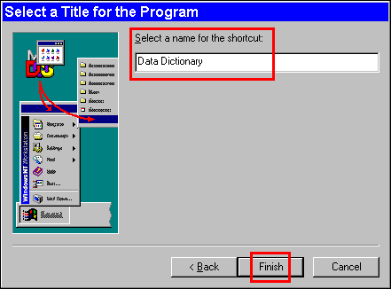

How Do I Use the Data Dictionary?
When you open the Data Dictionary, the database will offer you three different ways to access information.

Data Dictionary
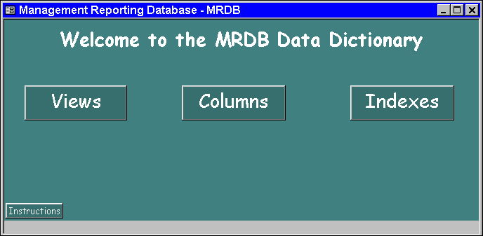

Following are descriptions of each of these three options and suggestions for using each one.

View Option
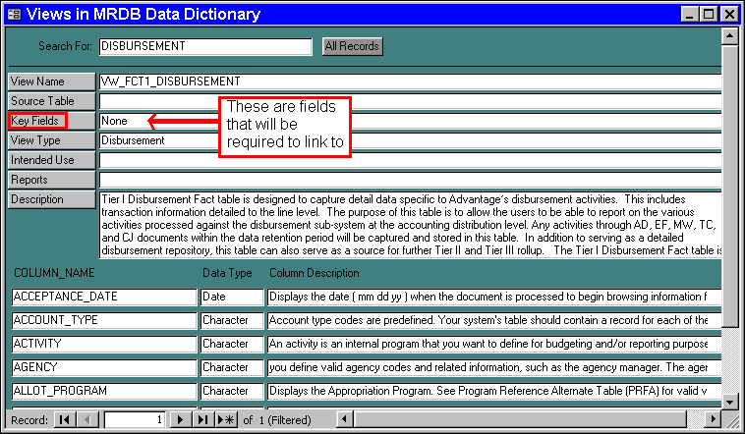

Views
This option provides a list of available views in MRDB. The VIEWS option should be used when you are attempting to find the data you need for your new report or query. You can search through a list of views within MRDB by selecting one of several different <SEARCH> buttons on the Views screen.

- Click on the <VIEWS> button from the MRDB Data Dictionary Welcome Screen

- Enter the search string that you want to look for in the SEARCH FOR field. Example: DISBURSEMENT.

NOTE: Data Dictionary will search for the FIRST word entered in the SEARCH FOR field.

- Click on the <SEARCH> buttons next to the field you want to search.

- The first matching view is displayed on the screen along with other information pertaining to that view. When multiple views exist, the Record field will reflect the number of views found. In the example above, there is a total of 1 matching view.

- If you want more information about a specific column within a view, simply click on the Column Name and additional information will appear.

Column option
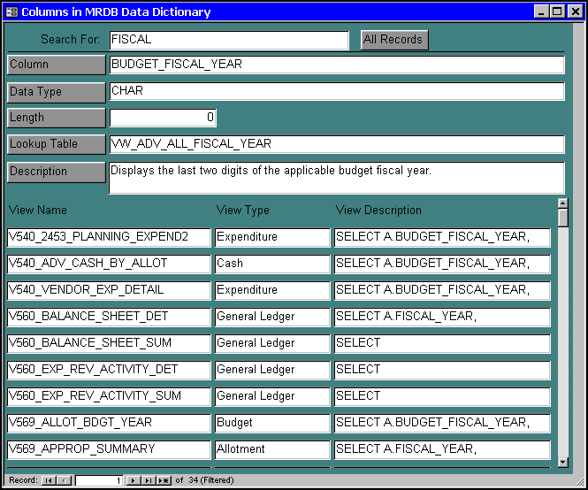

Columns
This option allows you to search against all the available columns within MRDB. It provides information such as the definition of the column, and lists any views where the column is used. You can search through a list of columns within MRDB by selecting one of several different Search Buttons on the Columns screen. To search using these buttons:

- Click on the <COLUMNS> button from the MRDB Data Dictionary Welcome Screen

- Enter the search string that you want to look for in the SEARCH FOR field. Example: FISCAL YEAR.

- Click on the <SEARCH> buttons next to the field you want to search.

- The first matching column is displayed on the screen along with other information pertaining to that column. When multiple columns exist, the Record field will reflect the number of columns found. In the example above, there are a total of 34 matching columns; the screen reflects the first column. To scroll through the remaining list of columns, click on the  button.

- If you would like more information about a specific view, simply click on the VIEW NAME and additional information will be displayed.

Indexes
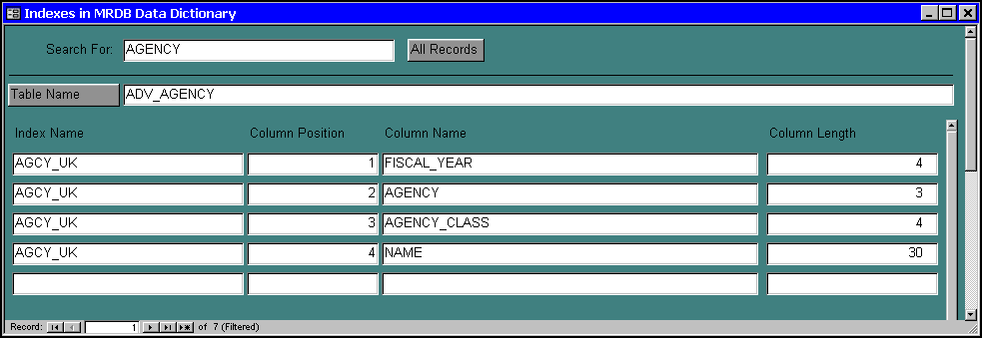

Indexes
This option provides a list of indexes within the MRDB. Use this option once you have decided which view(s) you want to use for a new report or query. This screen will tell you what indexes have been created for a specific table. By utilizing an index (selecting by or grouping by the columns in an index), you can greatly improve the run time of a report or query. You can search through a list of indexes within MRDB by selecting the <Table Name> button on the INDEXES screen. To search using these buttons:

- Click on the <INDEXES> button from the MRDB Data Dictionary Welcome Screen.

- Enter the search string that you want to look for in the SEARCH FOR field. Example: AGENCY.

- Click on the <TABLE NAME> button next to the field you want to search.

- The first matching table containing the index is displayed on the screen along with other information pertaining to that table. When multiple tables exist, the Record field will reflect the number of columns found. In the example above, there are a total of 7 matching tables that contain the specified index; the screen reflects the first table. To scroll through the remaining list of columns, click on the  button.

Exercise
Refer to the following example and use the Data Dictionary to select the appropriate table to complete the task.

The Property Officer for the Transportation Cabinet has come to you and asked you to gather the following information and present it to him in a report. He needs a report of all fixed assets for your agency for each location so that the Location Manager can verify the fixed assets for their particular building. The report will need these fields: DESCRIPTION, LOCATION, ORGANIZATION, ASSET VALUE, SERIAL NUMBER, and FIXED ASSET NUMBER with total values for each location and organization.

MRDB and ORACLE Password
Before you can link to MRDB you will need to obtain an Oracle User ID and password. If you do not have access to MRDB but would like to, see your agency's security lead.

The security for MRDB is defined within the ADVANTAGE Financial System. A user can only view the MRDB data that they have security to view within the ADVANTAGE Financial system.

When opening a table or establishing a new table link to the MRDB data using Microsoft Access the user is prompted with a log-on box. See the dialog box below:

Oracle Logon Dialog box
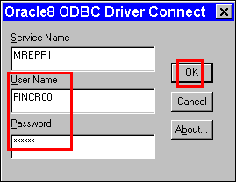

Users are advised to change their ORACLE password to prevent unauthorized access to their agency's data within the MRDB. This is a common business practice and should be observed by each agency.

Changing ORACLE Security
You can easily change your MRDB ORACLE password by accessing a web enabled form site @ https://kymarsswb.state.ky.us/oraclepwd/logon.asp

Change Oracle Password Window
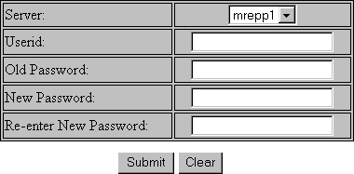

Step 1 In the SERVER field. Select MREPP1.

Step 2 In the USER ID field. Enter your MARS (RACF) USER ID.

Step 3 In the OLD PASSWORD field. Enter Your existing ORACLE password.

NOTE: If you don't know your existing ORACLE password, contact the State Security Officer or the Customer Resource Center.

Step 4 In the NEW PASSWORD field. Enter a password of choice. It is recommended that you make your password something you can remember but hard for others to figure out.

Step 5 In the RE-ENTER NEW PASSWORD field. Re-key the new password to verify it.

Step 6 Click the <SUBMIT> button when all information has been entered.

SUCCESSFUL ORACLE PASSWORD CHANGE
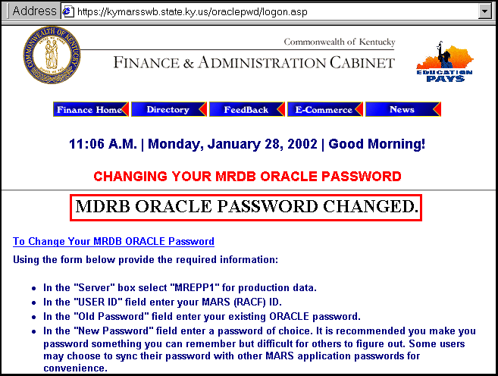

If you’ve successfully changed your password, then a message MRDB ORACLE PASSWORD CHANGED will appear at the top of the web page.

NOTE: The box around the text has been added for emphasis.

UNSUCCESSFUL ORACLE PASSWORD CHANGE
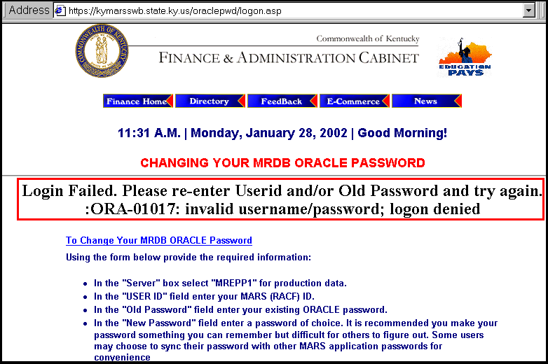

If an error occurred while attempting to change your password, the Login Failed… message will appear at the top of the web page. Simply re-enter your USERID and/or Old Password and New Password information, then click the <SUBMIT> button again.

NOTE: The box around the text has been added for emphasis.

After you’ve identified the components needed for your report and their location you are ready to access MRDB and establish a link to the appropriate views.



In this topic we have learned:

- MRDB Review
- MRDB Tables
- MRDB Views
- MRDB Structure and Naming Conventions
- The Data Dictionary
- MRDB and Oracle Security



Are there any questions concerning the information covered in this topic?

