Topic 5-Quarterly Federal Fund/Restricted

Fund Revision

Purpose:

Objectives
This topic provides information about how to prepare your Quarterly Federal Fund/Restricted Fund Receipt estimates in BRASS.

By the end of this topic, you will be able to:

- Describe the Quarterly Federal/Restricted Fund estimate process;

- Describe the Restricted Fund and Federal Fund structure;

- Describe the Quarterly Revision form in BRASS;

- Describe the Quarterly Revision views and reports; and,

- Describe the Quarterly Revision submission and review process.



Quarterly Revision Form in BRASS
“Inside the Form”
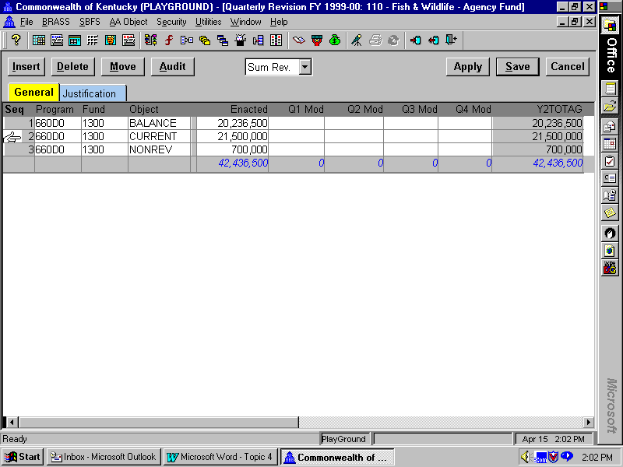

The Quarterly Federal/Restricted Fund Estimate Process

The biennial appropriations act requires that each agency submit to GOPM and LRC quarterly estimates of receipts and expenditures for Federal Funds and Restricted Funds. The information must be in electronic format and reflect current estimates compared to budgeted figures.

The Federal Funds and Restricted Funds Receipt estimates will be entered by agencies in BRASS into the Quarterly Federal Fund/Restricted Fund Receipt Revision form, to be referred to as the “Quarterly Revision Form.” Changes in Appropriations and Allotments are done using the Appropriation and Allotment Modification forms. The Quarterly Revision Form should be prepared and submitted concurrently with any Federal or Restricted Fund Appropriation Modification form.

The information about the Federal/Restricted Fund revised receipt estimates will not be passed on to ADVANTAGE Financial. The information from other BRASS budget execution forms will be passed on to ADVANTAGE Financial.

Quarterly Revision Form in BRASS
“Inside the Form”

The Quarterly Revision form should be completed and submitted only when changes in receipt estimates for Federal and Restricted funds are being reported (according to the quarterly schedule) and/or appropriation modifications are being requested. If there are no changes in either, then this form is not required.

Note: The only time this form would be submitted with a Quarter 1 Modification would be if an agency submitted this form prior to the beginning of a fiscal year for changes in 1st Quarter receipts of the next fiscal year.

If this form is submitted during the July through September period, the modification would be a Qaurter 2 Modification. If submitted during the October through December, the modificaton would be a Quarter 3 modification, and if submitted during January through March, it would be a Quarter 4 modification.

Quarterly Revision Form in BRASS
“Inside the Form”
Restricted Fund and Federal Fund Structure

Before we walk through the Quarterly Revision form, we want to revisit the BRASS Fund table as it relates to the Quarterly Revision form. As you know, this form only affects two Budgetary Funds: Restricted Fund and Federal Fund. A number of you represent agencies that have more than one MARS fund within a Budgetary Fund. The overhead shows you all of the MARS funds for these two Budgetary Funds.



MARS FUND BUDGETARY FUND

0100 General Fund General

1100 Road Fund Road

1300 Agency Revenue Fund Restricted
2100 Parks Fund Restricted
2200 State Fair Board Fund Restricted
2300 Industries for the Blind Fund Restricted
2400 Insurance Administration Restricted
2900 Kentucky Horse Park Restricted
3100 Fleet Management Fund Restricted
3200 Computer Services Fund Restricted
3500 Correctional Industries Fund Restricted
3600 Central Printing Fund Restricted
3700 Property Management Fund Restricted
3800 Risk Management Fund Restricted

1200 Federal Fund Federal
6200 Unemployment Insurance Fund Federal
The Funds you will select and use for the Quarterly Revision Form are reflected in the “MARS FUND” column. Examples are the 1300-Agency Revenue Fund, 2100-Parks Fund, 3500-Correctional Industries Fund.

There may be some unique situations where an Appropriation increase is associated with an updated receipt estimate for two funds within the Budgetary Fund. In those cases, there will be two Quarterly Revision forms prepared and submitted; one for each fund within the Restricted Fund.

Quarterly Revision FY1999-00

“Inside the Form”
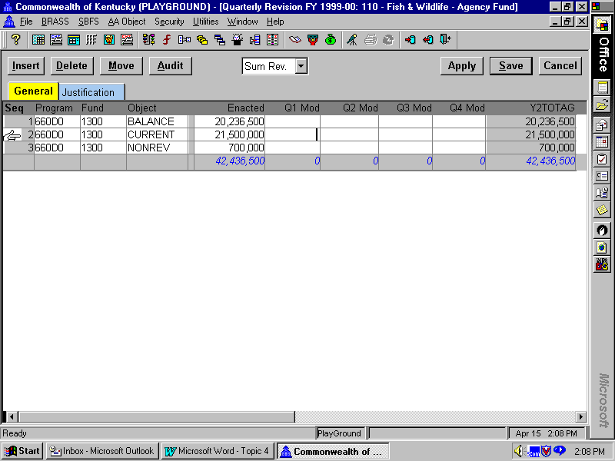
Quarterly Revision Form in BRASS

BRASS will have an entry form, entitled Quarterly Revision Form. This is the form where you will enter the enacted amounts and quarterly revisions of Federal and Restricted Fund Receipts. In BRASS, there will be only one Quarterly Revision Form for each discrete Fund and Appropriation program combination. This same form will be used EACH TIME that you need to prepare a quarterly submission. Note that in the Allotment Request, Appropriation Modification, and Allotment Modification Forms, you were instructed to select a NEW form each time you need to submit. For this form, you will always use the same form serial number except for the first time you use it in a given fiscal year.

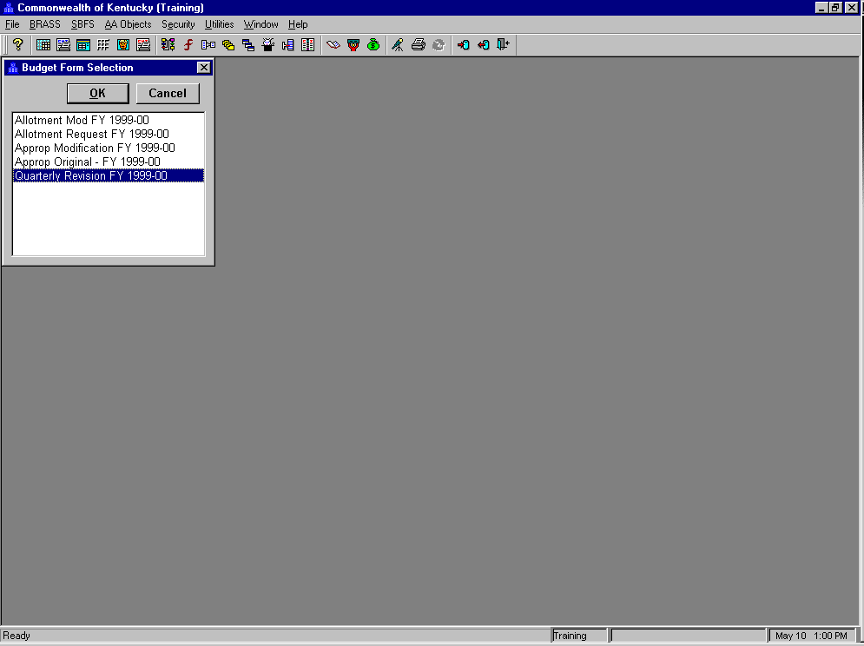
Budget Form Selection Screen
Data Attribute Selection Screen
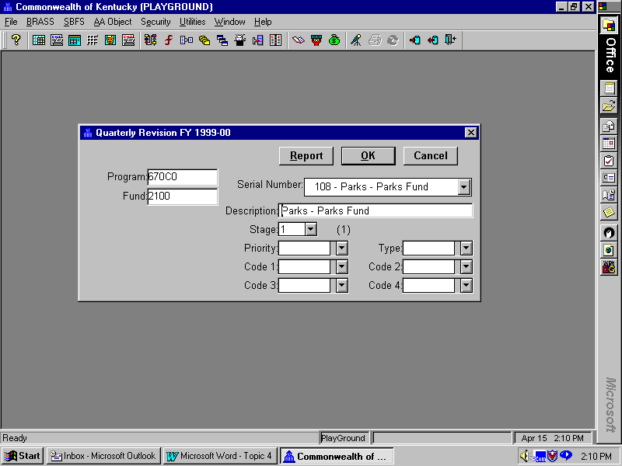

Let’s do a walkthrough of a Quarterly Revision Form.

In this walkthrough we will create a Quarterly Revision Form for a Restricted Fund appropriation unit.

Step 1 Select BRASS on the menu bar and from the drop-down list Click on Budget Forms.

Step 2 Select Quarterly Revision FY 1999-00 in the Budget Form Selection Box.

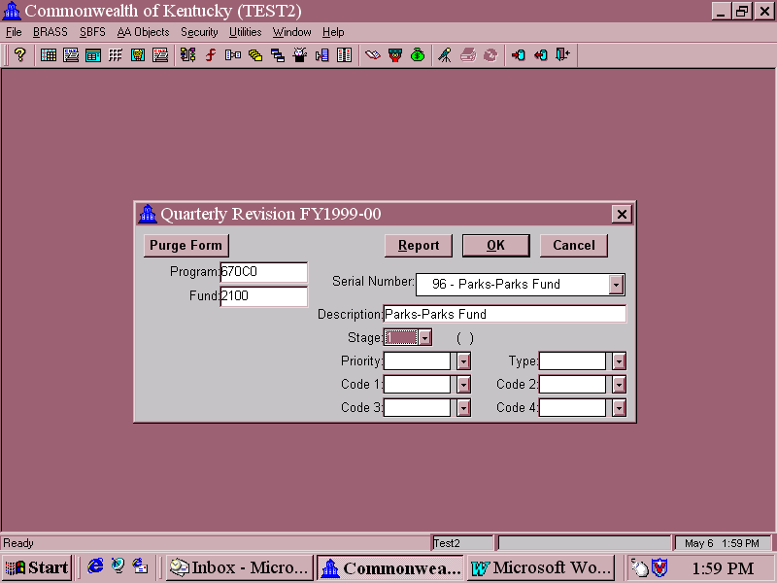

Data Attribute Selection Screen

We now have to populate the “Outside of the Form.”

Step 1 Program Field This is the field that is used to designate which Appropriation Program to use. Put your cursor in the Program field and type “☺☺☺”. Click on the Down Arrow and ☺☺☺☺☺ will be the first on the list. Your security level will determine the Programs that are available to you in the drop down list. You will choose the Non-Consolidating unit for the Appropriation program in ADVANTAGE.

When you are entering information at the ADVANTAGE Appropriation program, it will always have the following code structure:

Be sure to choose the 3 digit MARS Agency + 2 digit ADVANTAGE Appropriation Code

Step 2 Fund Field This is the field that is used to designate which Fund you are requesting with the Quarterly Revision Form. Put your cursor in the Fund field and Click on the Down Arrow and Select a Restricted or Federal Fund. All funds in the fund field will be in the drop down list.

Step 3 Serial Number Field Click on the Down Arrow and select “New”. Remember, the only time you will ever choose “New” for this form is the first time you create this form each fiscal year. The serial number for this form will be automatically assigned by the system.

Data Attribute Selection Screen

Any quarterly updates made to this Appropriation Program/Fund combination during a fiscal year will be done by selecting the same form. When you access the Quarterly Revision Form after the first instance, you can then go directly to the Serial Number Box, click on the Down Arrow, choose the appropriate serial number for your form, click on it and the Program and Fund fields will automatically populate. You are strongly recommended to keep a record of serial numbers and names for the forms that you create for your agency.

The Description Box is now on your screen after choosing “New.”

Step 4 Description Box Field This is the field where you will assign a name to your Quarterly Revision Form. You should incorporate the Fund and Program name to make it easier to find later. You have 30 spaces available inclusive of spaces.

Step 5 Stage Field Select Stage 1. Only one stage will be used for the Quarterly Revision Form. This stage will be used for all phases for this form: initial entry by agency staff, final agency approval, official submission, and central review.

Data Attribute Selection Screen

Only one stage is being used since the information included in the Quarterly Revision Form is supplemental information to the Appropriation and Allotment Modification Request Forms, when those requests involve an increase relating to a revised receipt estimate. If any changes need to be made to a form completed by an agency, then those changes will be made at Stage 1. Leaving the stage available to agency users, will also enable the agency to use the Quarterly Revision Form throughout the fiscal year.

Remember, the information entered in this form will NOT be passed to ADVANTAGE Financial.

Step 6 Leave the following fields blank.
Priority
Code 1
Code 2
Code 3
Code 4
Type
These fields are reserved for future use.

Step 7 Click <OK>. The Quarterly Revision Form that you just named will be created. We have just created a form that will have these particular data attributes on the inside of the form.

Quarterly Revision FY1999-00
“Inside the Form”
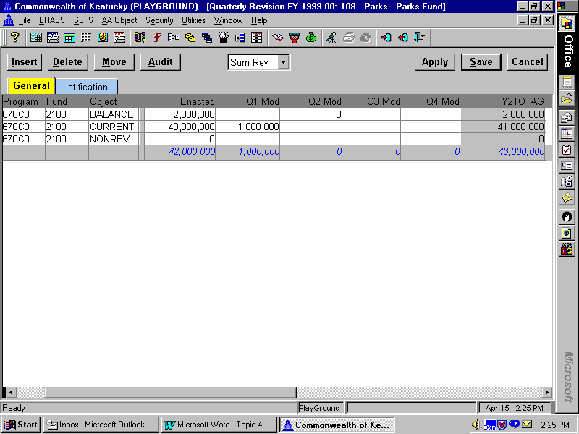

Let’s now populate the Quarterly Revision Form. (Notice the serial number and name across the top of the form)

Step 1 The cursor will be in the Program Field. Type in “☺☺☺” and Click on the Drop Down arrow. All the ☺☺☺ Programs will appear on the drop-down list. Select “☺☺☺☺☺”.

Step 2 Move your cursor to the Fund Field and Click on the Down Arrow. The only fund available in the drop down list will be the fund we chose on the “Outside of the Form.” This will be the fund that was chosen for this particular Quarterly Revision Form. If you need to make revisions to another type of fund, a new instance of the Quarterly Revision Form has to be created.

Step 3 Move your cursor to the Object Field and Click on the Down Arrow. You will have three choices from which to choose: BALANCE – Beginning Balance, CURRENT – Current Receipts, and NONREV - Non-revenue receipts. Since there is a balance forward for this program, Click on BALANCE.

Step 4 Move your cursor back to the Seq field of the first line and Click on Insert. This will add another line.

Step 5 Move your cursor to the Object Field and Click on the Down Arrow. This time Click on CURRENT, since this program has current receipts.

Step 6 Repeat Steps 1 and 2 to populate the program and fund fields.

Quarterly Revision FY1999-00
“Inside the Form”

Step 7 We now want to enter values in the Enacted column.
BALANCE $ 2,000,000
CURRENT $40,000,000

IMPORTANT: The values you enter in the Enacted Column for each Fund and Appropriation Program combination should be the actual amount from the enacted budget for that fiscal year 1998-99. These values should match, as revised, the information published in the Budget of the Commonwealth each biennium.

Step 8 At the top-center of the form there is a field that displays “Net Cost.” This is a drop-down box with several choices. The choices control how the column totals in a form are displayed. Since all lines or objects entered in the Quarterly Revision form are revenue lines/objects, then the “red” lines at the bottom of the form should add to the total of the three lines: Balance Forward, Current Receipts, Non-Revenue Receipts. This will be very helpful in viewing totals directly from the form. Click on the Drop down arrow in that box. Select Sum Rev. Notice how this changed the column totals from negative to positive.

Step 9 Click the Apply button. Notice the Total column at the right end of the form changed from $0 to the value you just entered in each line.

Quarterly Revision FY1999-00
“Inside the Form”

