
Let’s complete the entries for these fields:

Step 7 Description: Enter a 30 character descriptive name for this instance of this form.

Note: Your description should include the Program name (abbreviated) or code and Fund and a number indicating the first, second or subsequent modification for this Appropriation to make it easier to find later if you must pause and then resume work on this form. When you create an online form, BRASS will assign a Serial Number to it, even if you do not enter any numbers in the form and cancel it. As long as you’re in the same stage (see below), you can access this instance of the form again using its serial number and name. You are urged to keep a record of serial numbers and names for the forms that you create for your agency. Remember, the serial number and name of the form must be on your written request to GOPM.

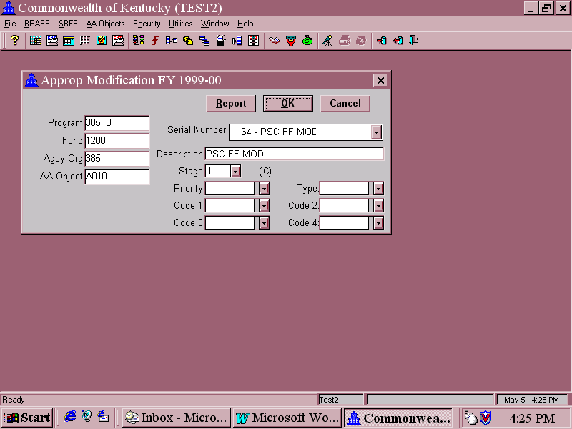


“Outside of the Form”


It is important that you understand stages in BRASS. Stages are used to distinguish between various users at different points in the budget execution and preparation processes. Your access to stages for online budget forms is determined by your security profile.

Four (4) stages are used to process the Appropriation Modification Request Form:
Stage 1 Initial entry by agency staff.
Stage 2 Final agency approval official submission.
Stage 3 GOPM review.
Stage 4 GOPM approval.

Hint: You can tell what stage a particular form is at from the ( ) to the right of the Stage field. If the form has been used before and saved, the number in the parentheses shows the stage the form was last saved in. If this is the first time this form has been created but not used (New), the parentheses will be blank.

“Outside of the Form”

Subsequent users advance forms to the next stage once they are completed. Once a completed form is ready to submit, the agency will notify its assigned GOPM analyst per Commonwealth procedures. GOPM will access the form online and advance it to the next stage.

IMPORTANT: Once the form has been advanced to the next stage, you cannot access it again in an earlier stage. You will not even see it on the drop down menu of serial numbers and descriptions unless your form security access level allows access to that stage. (This explains why you will always choose (New) to modify an appropriation.)

Step 8 Enter a Stage by clicking the button to the right of the Stage field and highlight the stage that you want. Your are the initial creator of this Appropriation Modification Request, so you will use Stage 1.

Note: The Priority, Type, and Code 1-4 fields are reserved for future use.

Step 9 Once you have entered a description and a stage, click OK. The online entry form screen appears.

Sample Appropriation Modification Request Form
“Inside the Form”

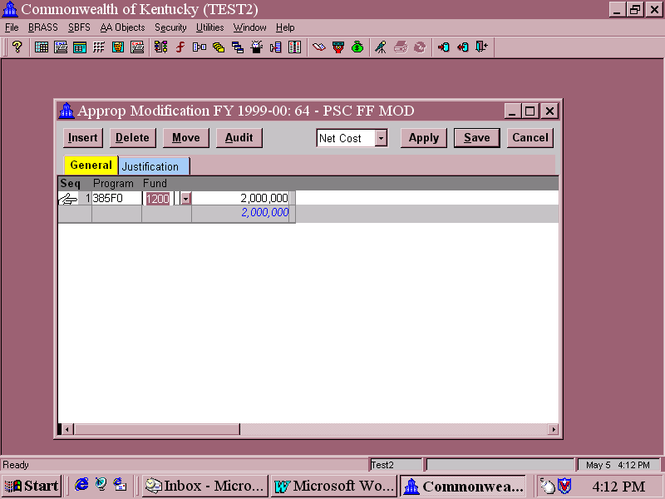
Populating the Form

Let’s populate the Form.

When the form first appears on the screen, the cursor will be in the Program field and the button will be visible. To complete the form, you will move your mouse pointer and click or tab to the fields for Program, Fund, and the column for entering the change. In this example, Program 385FO and Fund 1200 were selected on the outside of the form (the Data Selection Attribute Screen), so this will be the only Non-Consolidating choice in the entry form itself.

In the column for entering changes, you will enter the amount of the change to the appropriation. Example: If the current appropriation is $250,000, and you need it to be $300,000, you would enter $50,000 – not $300,000. VERY IMPORTANT!!!

If you want to reduce an appropriation, you can enter a negative change simply by preceding the number entry with a minus sign, as in –50000.

Do not enter commas and dollar signs, and use whole numbers only – no pennies.

Sample Appropriation Modification Request Form
“Inside the Form”

When a Reason for Change dialog box appears, enter an explanation for why the number has changed, click OK, and continue working. When the user changes an entry and clicks on the Apply button, the Reason for Change box appears.

Net Cost field – This is a drop down box with several choices. The choices allow both revenues and expenditures to be entered on the same form. It is not used in the Appropriation Modification form, so do not change it here.

Apply – This button saves your work but does not close the form.

Save – This button saves your work and exits the form.

Cancel – This button exits the form without saving. All entries made since the last time you hit the Apply button or the Save button will be lost.

Submission of the completed form – The online form must be processed through all stages in order to be loaded into ADVANTAGE. When you have completed all entries in the Appropriation Modification form and saved it in Stage 1, notify the Stage 2 user that the form is ready to be advanced to Stage 2.

Sample Appropriation Modification Request Form
“Inside the Form”

Note: Depending on your agency’s procedures and your security profile, you may also be the Stage 2 user, or someone else in your agency may have that responsibility.

The Stage 2 user will access the form online, entering Stage 2 in the Stage field. Following review and approval of the modification request, the Stage 2 user will notify the agency’s assigned GOPM analyst that the request is ready to be officially submitted.

The GOPM analyst will access the form online and advance it to the next stage (Stage 4). Following GOPM review and approval, GOPM will advance the form to the final stage. GOPM will also forward the appropriation modification request to LRC for review. After all approvals, the change will then be loaded into ADVANTAGE by GOPM.

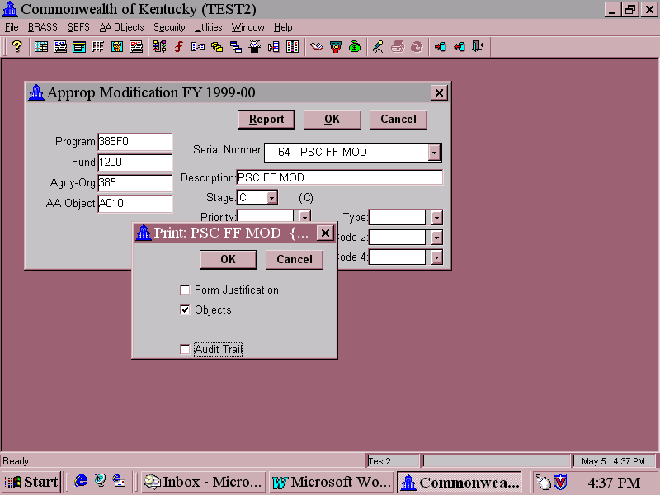

Appropriation Modification Form Report

GOPM will access the form online and advance it to the next stage (Stage 3). Following GOPM review and approval, GOPM will advance the form to Stage 4. The change will then be loaded into ADVANTAGE.

Form Reports – After you have saved the form (but before advancing it to the next stage), you can access a report showing what was entered in the form for your records. If your computer is connected to a printer, you can also print the report. To do this, call up the form access screen, choose the correct instance of the form (by serial number; did you remember to make a record of the serial number?) and click on Report.

When you click Report, a dialog box with several choices for different report views is overlaid on the form access screen.

Form Justification: This form does have a justification tab and selecting this box will provide you with a report showing what was entered on the form justification tab. The Commonwealth's procedures are that a letter or memorandum is required that explains and justifies an appropriation and allotment increase associated with a revision in a Restricted or Federal Fund appropriation. This justification tab can be used by an agency to add notes for each time this form is used.

Appropriation Modification Form Report

Objects: This view will show the amount entered in the form by object.

Audit Trail: The Audit Trail view is not available for this form since this information is not posted into ADVANTAGE Financial.

Click or unclick the boxes for the report views you want to see and click OK. For this example, only the Objects view was chosen.
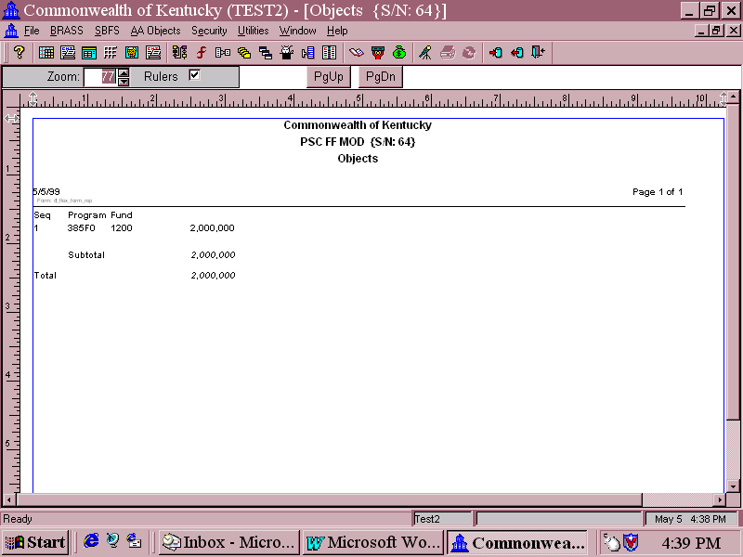

Report View for the Appropriation Modification Form

The title line at the top displays the following information:

- Form Name (Approp Modification FY1999-00)
- Serial Number of this instance of the form (64; write it down!)
- Description that was entered for this instance of the form (PSC FF Mod).

The reports will appear on your computer screen, cascaded over the form access screen. You can move between the report views that you chose, or to back the form access screen by clicking on the screen you want to be in front. Using the Window menu in BRASS, you can also tile the views next to each other.

The Zoom feature allows you to enlarge or shrink the report view window. It is currently set at 77 percent. To change it, click on the up or down arrows to the right of the 77 until the window is the desired size.

To print a report view, click on it to move it to the front. Go to the File menu in BRASS and click on Print.
This page intentionally left blank.

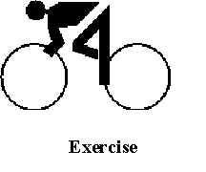

You will now create an Appropriation Modification Request Form using the information provided. You are a financial manager for a Cabinet. Because of a reorganization, the current year General Fund-Operating appropriation for your agency must be increased from $20,625,600 to $20,825,600. Prepare an Appropriation Modification Request in BRASS to modify the appropriation.

Step 1: Log on to BRASS and select the BRASS on the menu bar.

Step 2: Select Budget Forms.

Step 3: Select the correct Appropriation Modification form from the Budget Form Selection Window and click OK.

Step 4: Complete the Data Attribute Selection Screen and click OK. The fields should have the following values:
Program: ☺☺☺☺☺
Fund: 0100 General Fund-Operating
Agency: ☺☺☺
AA/Object: A004
Serial #: New
Description: Students’ choice
Stage: Stage 1 – Agency request

Step 5: Complete the Appropriation Modification Form. The fields should have the following values:

Program: ☺☺☺☺☺ – selected on the outside of the form]
Fund: [0100 – selected on the outside of the form]
Amt of Change: $200,000

Step 6: Click Save.

This page intentionally left blank.



Do you have any questions about creating an Appropriation Modification Request Form?

Now, let’s answer a few questions.

1. Who is responsible for setting up the initial Appropriations in BRASS from the enacted Appropriation bills?

A. Each Commonwealth agency
- Staff from the Governor’s Office for Policy and Management
- Staff of the Legislative Research Commission
- American Management Systems, Inc.

This page intentionally left blank.

2. Who initiates changes in approved Appropriations?

- Each Commonwealth agency
- Staff from the Governor’s Office for Policy and Management
- Staff of the Legislative Research Commission
- American Management Systems, Inc.

- If you want to modify an appropriation from $75,000 to $100,000, what do you enter in the online budget form?

- $100,000
- $25,000
- 100000
- 25000

- Once you have completed the Appropriation Modification Request Form, how do you submit it for approval?

- Print it out and mail it to GOPM
- Email the file to GOPM
- Notify GOPM that it is ready to be submitted
- You don’t—the answer is NO.

This page intentionally left blank.


1. Who is responsible for setting up the initial Appropriations in BRASS from the enacted Appropriation bills?

- Each Commonwealth agency
- Staff from the Governor’s Office for Policy and Management
- Staff of the Legislative Research Commission
- American Management Systems, Inc.

Answer: B. GOPM enters the appropriations from the enacted appropriations bill.

2. Who initiates changes in approved Appropriations?

- Each Commonwealth agency
- Staff from the Governor’s Office for Policy and Management
- Staff of the Legislative Research Commission
- American Management Systems, Inc.

Answer: A. Each agency will initiate changes or modifications to appropriations.

This page intentionally left blank.

- If you want to modify an appropriation from $75,000 to $100,000, what do you enter in the online budget form?

- $100,000
- $25,000
- 100000
- 25000

Answer: D. You would enter the change in the appropriation in numerical format. Format elements such as dollar signs and commas will be added by the system.

- Once you have completed the Appropriation Modification Request Form, how do you submit it for approval?

- Print it out and mail it to GOPM
- Email the file to GOPM
- Notify GOPM that it is ready to be submitted
- You don’t—the answer is NO.

Answer: C. You notify GOPM and they will pull the form to the next Stage.

This page intentionally left blank.



In this topic, you learned about:

- The appropriation modification process for operating budgets,

- Completing the Appropriation Modification Request Form,

- Submitting and reviewing the Appropriation Modification Request Form, and

- Passing information from BRASS into ADVANTAGE Financial.

In the next topic, you will learn about:

- The Quarterly Federal/Restricted Fund estimate process,

- The Restricted Fund and Federal Fund structure,

- The Quarterly Revision Form, Views, and Reports, and

- The Quarterly Revision Form submission and review process.

