Topic 4 - Appropriation Modification Requests for Operating Budget Execution

Purpose:

Objectives

This topic provides information about the appropriation modification process and how to prepare Appropriation Modification Request forms.

By the end of this topic, you will be able to:

- Describe the modification process for operating budget appropriations,
- Complete a Appropriation Modification Request form,
- Describe the Appropriation Modification Request submission and review process, and
- Describe how Appropriation Modification information gets passed to ADVANTAGE Financial.



Operating Budget Execution Process

Appropriation Modification Requests and
Allotment Modification Requests

Agency creates Appropriation Modification Request an Allotment Modification Request in BRASS.

Appropriation Modification Request and Allotment Requests are reviewed, modified and approved by GOPM using BRASS.

Appropriation Modification Request and Allotment Modification Requests that impact an Appropriations are reviewed by LRC.
Appropriation Modification Request and Allotment Modification Request forwarded into ADVANTAGE Financial from BRASS.


Appropriations

After the Biennial Budget Preparation process has been completed and the Appropriation bills have been enacted and signed by the Governor, the Governor’s Office for Policy and Management (GOPM) will set up the initial operating budget appropriations in accordance with the Appropriation bills, using an Appropriation Request form. The initial appropriation process is a GOPM process that does not require any action on the part of Commonwealth agencies.

Appropriation Modifications

If an Appropriation must be modified later during the year, an Appropriation Modification Request form must be completed in BRASS and processed. This process is usually initiated by the agencies.

Agencies initiate the appropriation modification request process through written communication with GOPM. This communication outlines the reason for the modification and the amount of the change. The agency also prepares an Appropriation Modification Request form in BRASS.

Operating Budget Execution Process

Appropriation Modification Requests and
Allotment Modification Requests

Appropriation Modification Request and Allotment Requests are reviewed, modified and approved by GOPM using BRASS.
Appropriation Modification Request and Allotment Modification Requests that impact an Appropriations are reviewed by LRC.
Appropriation Modification Request and Allotment Modification Request forwarded into ADVANTAGE Financial from BRASS.
Agency creates Appropriation Modification Request an Allotment Modification Request in BRASS.
Appropriation Modification Request Process

Appropriation modification requests follow the process below:

- A written request for an Appropriation Modification is submitted by an agency to GOPM and a copy to LRC. That written request must include the serial numbers and names of the Appropriation Modification Request and the Quarterly Restricted/Federal Fund Revision form (where applicable).

- An Appropriation Modification Request Form is completed in BRASS by agencies and submitted to GOPM.

- Depending on your agency’s procedures, there may be an optional review and approval stage by an agency supervisor before the BRASS request form is submitted to GOPM.

- GOPM then reviews, modifies (if applicable), and approves the Appropriation Modification.

- The Appropriation Modification Request is also forwarded to LRC for review.

- GOPM forwards the change into the ADVANTAGE financial system.


BRASS Form Selection Window
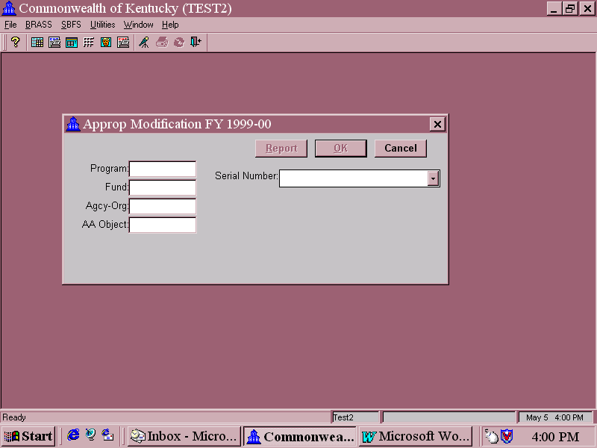
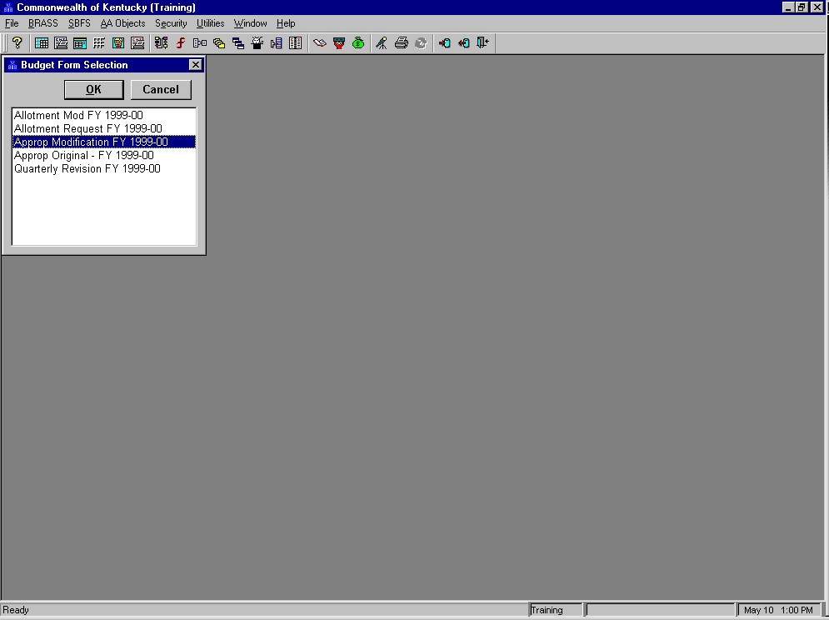
Data Attribute Selection Screen
Appropriation Modification Request Form Example

The screen print shows the Budget Form Selection Screen and the Data Attribute Selection Screen.

The Data Attribute Selection Screen is where you enter the Program, Fund, and Agency of the Appropriation you wish to modify. It is often called the “Outside of the Form”.

We will walk through completing the form in a few minutes, but first let’s take a brief look at some of the key fields in the entry form:

The title line at the top of the entry form displays the following information:
- Form Name (Appropriation Modification FY 1999-00)
- Serial Number of this instance of the form (64)
- Description that was entered for this instance of the form.

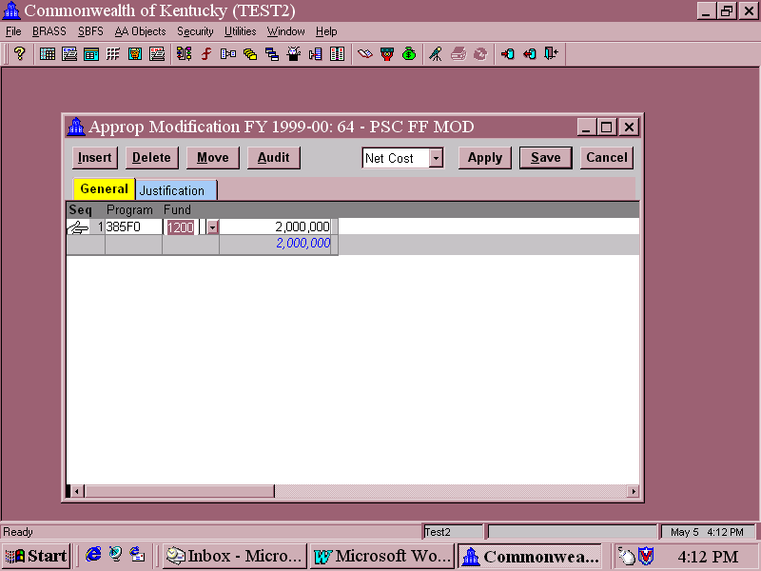
Sample Appropriation Modification Request Form
“Inside the Form”

The 1st entry line of the form contains fields for Program and Fund for the appropriation you wish to modify. To complete the form, you will move your mouse pointer and click or tab to these fields and enter the values for each field.

In the column after Fund, you will enter the amount of the change to the appropriation.

Example: If the current appropriation is $2,000,000 and you are modifying it to $4,000,000, you will enter $2,000,000. Very Important!!!

Sample Appropriation Modification Request Form
“Inside the Form”

The buttons below the title line perform the following functions:

Insert – When you enter the form, the hand pointer is on Line 1. If you are modifying several appropriations within this Cabinet and fund, you can do it on different entry lines on the same form. To add additional lines, click on Insert.

Delete – If you find you need to delete a line that you’ve entered, click the mouse pointer on that line, and then click the mouse pointer on Delete.

Move – This button is used to rearrange the order of the lines in the form. Click on the line that you wish to move and then click your mouse pointer on Move. The mouse pointer will change shape to a circle with a diagonal line in it. Move the cursor to the location you want to move the line to and click your mouse button. The line will move to the new location.

(Note: It is possible in BRASS to move a line below the total line. However, if you do this, the total will not change, so if you’re not careful, your form will begin to look very odd.)

Sample Appropriation Modification Request Form
“Inside the Form”

Audit – This button is used to access the audit trail for BRASS forms. The audit trail is only created when the form is saved and posted to the database. The Appropriation Modification form was designed to post to the database only in the final stage, just prior to copying the value to ADVANTAGE. Thus, this button is not operational for the Appropriation Modification form.

For forms that do save and post in more than one stage, the audit trail lists each transaction (line in the budget form) by stage in reverse order, with a User ID and date/time stamp of when the entry was made.

You will also see the audit trail feature working when you change a number previously entered in a saved form. A Reason for Change dialog box will appear.

Budget Form Selection Window



Accessing an Appropriation Modification Request Form

Let’s do a walkthrough to create an Appropriation Modification Request Form for a Federal Fund appropriation.

The first step is to access the correct online budget form. To do this, you will complete the following steps:

Step 1 On the Menu Bar: Select BRASS.

Step 2 Select Budget Forms.

You should now see the Budget Form Selection window:

Step 3 Select the Approp Modification FY1999-00 form. Move the mouse pointer to Approp Modification FY1999-00 and click once to highlight the form. Click on OK.

The data attribute selection screen to the form appears:

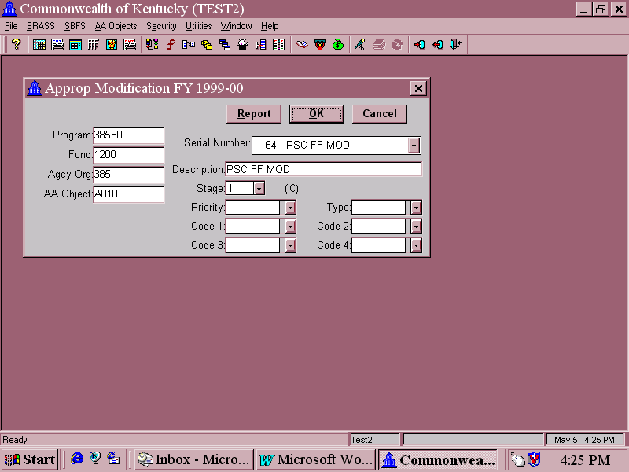

“Outside of the Form”

Completing the Budget Form Access Screen

Step 1 Enter the 5-character Program of the appropriation you are requesting to modify. Your instructor will provide this information.

Navigation tip: Moving the mouse pointer to an open field and clicking will bring up a drop down menu that shows the choices for that field. (Your security will determine the Programs that are available to you on the drop down menu.)

Step 2 Enter the Fund of the appropriation you are requesting to modify. Move your mouse pointer to the Fund field and click to bring up the drop down list of funds from which to choose. For this training workshop, you will enter 1200 Federal Fund.

Step 3 Agency-Org field. Enter the 3-digit Agency of the appropriation you are requesting to modify.

Step 4 AA Object field. Enter the AA Object for this modification. Click on the Down Arrow and Select “A010 Other Appropriation Revision”.

This page intentionally left blank.

Important Note: Remember that drop-down lists include Non-Consolidating and Consolidating Chart of Accounts data elements at the level defined for each budget form. BRASS will permit you to select a Consolidating element, but the form cannot be saved. The program list will include every Non-Consolidating data element at the form level and below. You must make sure you are choosing the correct codes. For the Program field of the Appropriation Modification Request Form access screen (outside the form), you must make sure you choose a 5-character Appropriation Program code. For the Agency/Org field, you will always choose a 3-digit agency code.

This page was intentionally left blank.




What is the difference between Non-Consolidating and Consolidating Chart of Accounts elements?

Non-Consolidating entities are the levels at which budgets and expenditures or revenues are recorded, which is why they are also referred to as “Posting” entities. Consolidating entities do not have any data directly recorded in them. Data in Consolidating entities are rolled up from subordinate, Non-Consolidating entities.

“Outside of the Form”

Step 5 Serial Number field. Click on the button to the right of the Serial Number field and choose (New).

Why do you select (New) every time you need to modify an appropriation?

See the discussion on Stages, below, to learn why.

Step 6 Place your mouse pointer on (New) and click to highlight it.

When you highlight (New) and click on it, several additional fields appear below the Serial Number field.

“Outside of the Form”

Also notice that the OK button is now highlighted.

What happens if you click on OK now?

Click on it now to see what happens:

“Outside of the Form”

