Topic 3- Allotment Modification Requests for Operating Budget Execution

Purpose:

Objectives
This topic provides information about the allotment modification request process and how to prepare Allotment Modification Request forms. The MARS: Budget and Cash Control course discusses capital budget modifications.

By the end of this topic, you will be able to:

- Describe the operating budget Allotment Modification Request,
- Describe the process of completing an Allotment Modification Form for the operating budget,
- Describe the process of submitting an operating budget Allotment Modification Form for the appropriate review process,
- Describe the process of approvals for operating budget Allotment Modifications, and
- Describe the process of how operating budget Allotment Modifications are passed into the Advantage Financial System (AFS).



Allotment Modification Request Process

Agency creates Allotment Modification Requests in BRASS.

Allotment Modification Requests are reviewed, modified (if applicable) and approved by GOPM using BRASS.

Allotment Modifications are forwarded to Advantage Financial from BRASS.


Allotment Modifications

Prior to the beginning of each fiscal year, agencies submit a schedule of quarterly allotments of appropriations as required by KRS 48.610. As we all know, changes take place with these allotments between the time of the Enacted Budget and the end of the fiscal year. Allotment modifications are done through the authority of KRS 48.600-48.630 and the provisions in the Appropriations Acts.

Allotment Modification Requests
If an Allotment must be modified during the year, an Allotment Modification Form must be completed in BRASS and processed. The agencies will discuss perceived allotment changes as they materialize with their GOPM analyst.

Agencies initiate the allotment modification request process through written communication with GOPM. This communication outlines the reason for the allotment modification and the amount of change. A copy of this written request is transmitted to LRC. The agency will follow the Allotment Modification Request process and guidelines on preparing the allotment modification information.



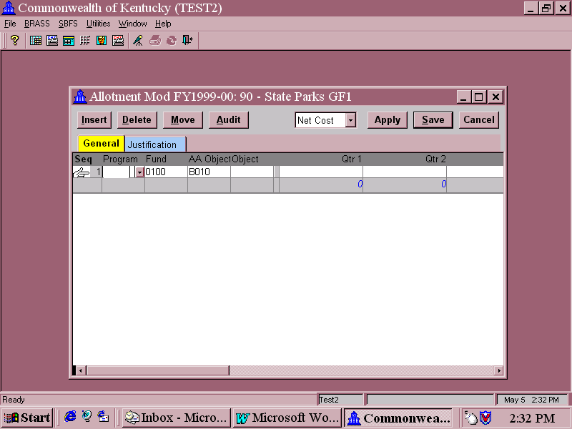

Allotment Modification Form

“Inside the Form”

Some operating budget modifications will not affect the appropriation and some modifications will affect both the appropriation and allotments. Modifications may be needed, for example, to move allotments among the four quarters, move General Fund allotments among Object Types, from one program to another program within an appropriation unit, or an agency may receive a new federal grant during the course of the year.

Allotment Modification Request forms follow the process below:

- Allotment Modification forms are entered in BRASS by agencies.
- Depending on your agency’s procedures, there may be an optional review and approval stage by agency management before the BRASS request form is submitted to GOPM.
- Agency submits written request to GOPM for the allotment modification, including the Serial Number and Description of the BRASS Allotment Modification form(s) applicable.
- Once it is approved, GOPM then reviews, modifies (if applicable), and approves the allotment modification.
- GOPM forwards the change into the ADVANTAGE financial system.

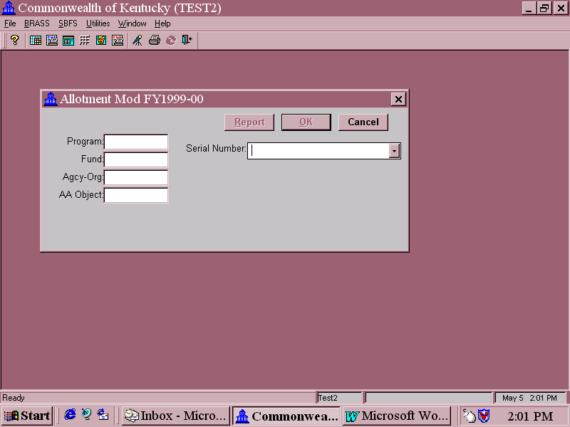
Data Attribute Selection Screen

Allotment Modification Request Form Example

The screen shots show the Budget Form Data Attribute Selection Screen for the Allotment Modification Form and an actual Allotment Modification Request Form for a specified program.

The Budget Form Data Attribute Selection Screen for the Allotment Modification Form is where you enter the Program, Fund, Agency/Org, Appropriation Allotment Object, and Serial Number for the allotment modification request. Again, this is called the “Outside of the Form.”

Let’s look at a few of the key fields:

The BRASS Allotment Program Roll-up Code is 670C0_AL. Remember that the 670 represents the MARS agency code and the C0 represents the MARS appropriation code. This will be followed by _AL.

The Fund Code is the same four-digit fund code that would be used in Advantage Financial.

The Agency-Org designates which Agency to use. This should be the same Agency that is represented in the first three characters of the Program field. This is your MARS Agency code.

Data Attribute Selection Screen

The AA Object, in this case the allotment object you are modifying, in most cases you will use B010 (Other Revisions) when modifying an allotment.

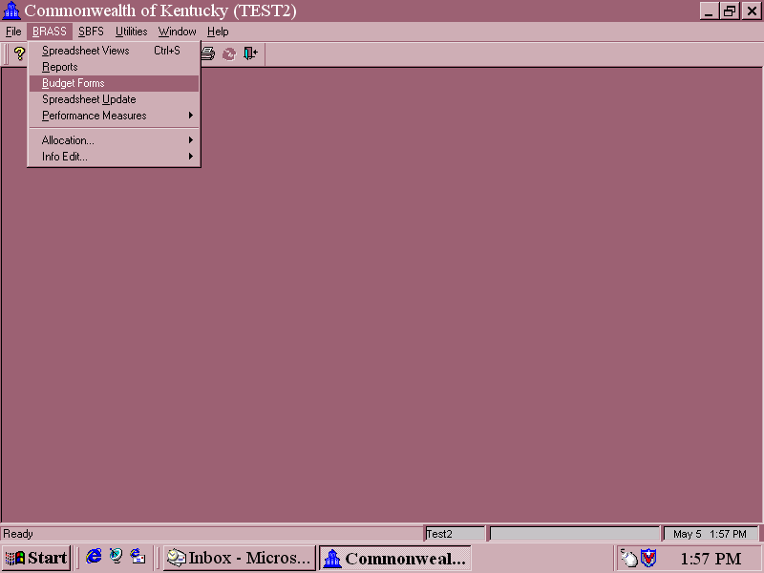
BRASS Menu Option

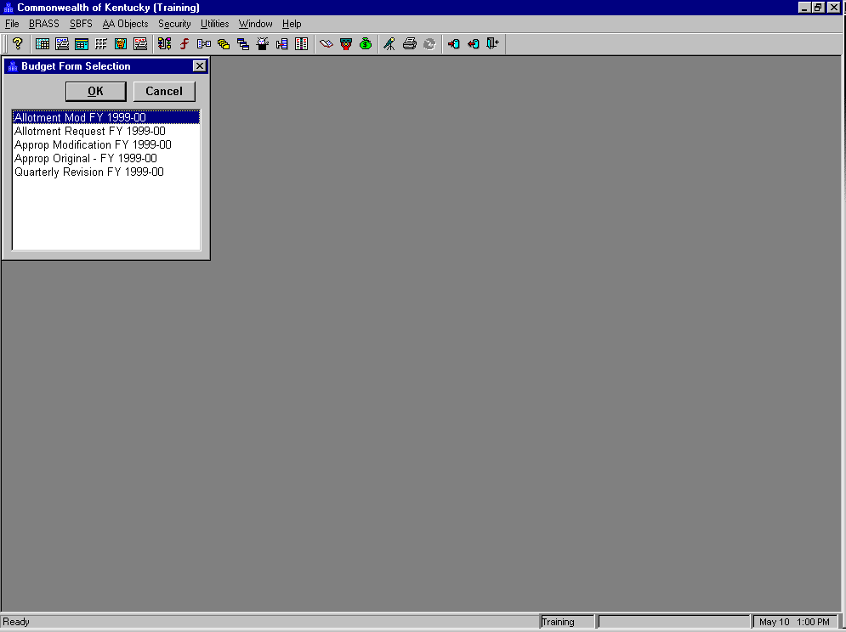
Budget Form Selection Window


Accessing an Allotment Modification Request Form

Let’s do a walkthrough to create an Allotment Modification Request Form for a General Fund Allotment Program account.

The first step is to access the correct Budget Form. To do that, you would complete the following steps:

Step 1 On the Menu Bar: Select BRASS.

Step 2 Select Budget Forms

You should now see the Budget Form Selection Window. Let’s select the Allotment Modification Form.

Step 3 Select Allotment Mod FY 1999-00

The Budget Form Data Attribute Selection Screen for the Allotment Modification Form should now be displayed.

The Budget Form Data Attribute Selection Screen will appear with the name of the form you selected in the header. This is the screen you use to identify attributes such as Allotment Program and Fund. Again, this is referred to as the “Outside the Form” screen.

Let’s populate this screen:

“Outside of Form” Dialog Box

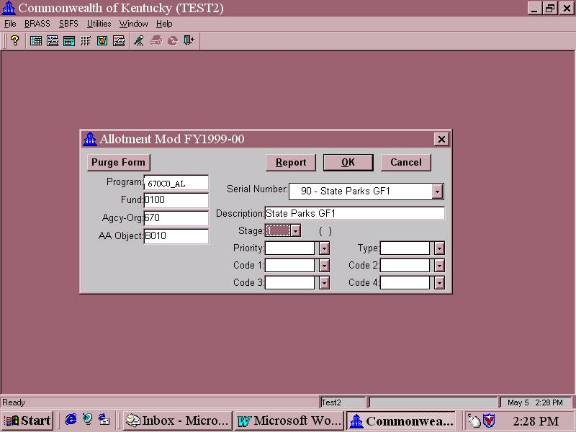

Accessing an Allotment Modification Request Form

Step 1 PROGRAM field. This is the field that is used to designate which Allotment Program to use. Click on the Down Arrow and Type “☺☺☺”. The program table choices are displayed in the drop-down list.

Notice how the menu list goes directly to the first Program for Agency ☺☺☺.

Step 2 Choose “☺☺☺☺☺_AL”. All Allotment Modification Form Program choices represent the Consolidating unit at the 7th level. You will know it is a Consolidating (or roll-up) unit when you see the subscript “_” in the code. This provides the flexibility to select all allotment programs for any one Fund type when completing the form. You can enter modifications for multiple allotment programs, object types, and allotment periods within the same form.

“Outside of Form” Dialog Box

Let’s continue populating the fields to create an Allotment Modification Request form.

Step 3 FUND field. This is the field that is used to designate which Fund you are requesting with the allotment modification. Click on the Down Arrow and Select “0100 General Fund”. Note that this 0100 is the same fund code used for General Fund in Advantage Financial.

“Outside of Form” Dialog Box

Step 4 AGENCY-ORG field. This is the field that is used to designate which MARS Agency to use. This should be the same Agency that is represented in the first three characters of the Program Field. This is your MARS Agency Code. Click on the Down Arrow and Select “☺☺☺”.

There are a lot of other codes available for selection, they will be used with the BRASS’ Salary Benefit Forecasting feature. Remember to only select the 3-digit MARS Agency code.

Step 5 AA OBJECT Field. This is the field where the Allotment Object is selected for this allotment modification. Click on the Down Arrow and Select “B010”, Other Allotment Revision.

Step 6 SERIAL NUMBER Field. If you are creating a new form, you would select new and a serial number will be assigned by the system. If you are accessing a form that has already been created, then you would choose the correct serial number from the drop-down list. Click on the Down Arrow and Select “New.”

“Outside of Form” Dialog Box

Important Note: You will always choose “New” each time you create an Allotment Modification. The ONLY time you will ever choose an existing serial number is when work is still ongoing in an Allotment modification form that has not yet been submitted to GOPM.

The Allotment Modification Forms created will always show up in the drop-down list but after the requests have been submitted to GOPM, the agency will not be able to access those forms.

The next step is Critically Important. The Description Field is where you will assign a name to you Allotment Modification Request form. This name cannot be changed. This is the name that will always be assigned to this Allotment Modification Request form. Remember, each Fund will have a different form. Another reason why it is important is because the Description Name will be the way you can identify which Allotment Modification you are working on while in the Form.

“Outside of Form” Dialog Box

Step 7 DESCRIPTION Field. You may enter up to 30 characters with spaces. A good “rule of thumb” would be to enter the Allotment Program followed by the Fund abbreviation. Type in a description for your Allotment Modification.

Step 8 STAGE Field. This field indicates which stage the document is in during the process cycle. Click on the Down Arrow and Select “Stage 1.” This represents the Agency Stage for the Allotment Modification Request process.

Step 9 Leave the following fields blank.

Priority
Code 1
Code 2
Code 3
Code 4
Type

Step 10 Click <OK>. The Allotment Modification Request form that you just named will be created. We have just created a form that will have these particular data attributes on the inside of the form.

Allotment Modification Form

“Inside the Form”

Now, we will populate the Allotment Request Modification Form.

The Allotment Modification Request Form

The Allotment Modification Request form that you just created is now on your screen with the name of the modification that you entered previously in the Description Field when you were populating the “Outside of the Form.” It now has a system assigned number along with the name across the title bar of the form.

The Fund, and AA Object defaulted inside the form as you chose those on the “Outside of the Form.” Even though you can’t change them, this was done to help the user to see these two fields while in the form.

Important: Any allotment program within a Fund and appropriation combination can be selected on this form. For example, allotment modifications due to a reorganization could include every General Fund Allotment program with each Object Type (Personal Services, Operating, etc.).
Each line on the Allotment Modification Request form can correspond to a Program/Fund/AA Object type combination.

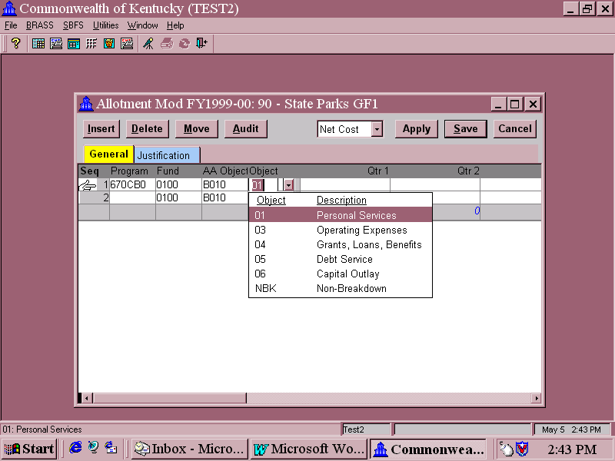
Allotment Modification Form

“Inside the Form”

